|  |  |  |  |
| --- | --- | --- | --- |
|  | United Nations | ECE/TRANS/WP.29/GRE/2024/8 | |
| Description: _unlogo | **Economic and Social Council** | | Distr.: General  6 February 2024  Original: English |

**Economic Commission for Europe**

Inland Transport Committee

**World Forum for Harmonization of Vehicle Regulations**

**Working Party on Lighting and Light-Signalling**

**Ninetieth session**

Geneva, 29 April – 3 May 2024

Item 7 (b) of the provisional agenda

**Device UN Regulations: UN Regulation No. 149 (Road illumination devices)**

Proposal for a Supplement to the 01 series of amendments to UN Regulation No. 149

Submitted by the experts from the International Automotive Lighting and Light-Signalling Expert Group [[1]](#footnote-2)\*

The text reproduced below was prepared by the experts from the International Automotive Lighting and Light-Signalling Expert Group (GTB) with the aim to clarify the markings. The proposed modifications to the current text of the UN Regulations are marked in bold for new or strikethrough for deleted characters.

I. Proposal

*Add new paragraphs 3.3.2.4.8. and 3.3.2.4.9.,* to read:

**“3.3.2.4.8. On headlamps meeting the requirements of this Regulation in respect of the passing beam of Class C and the driving beam of Class B, "HCR" may be marked as the symbols for passing beam and driving beam.**

**3.3.2.4.9. On headlamps meeting the requirements of this Regulation in respect of both the passing beam and the driving beam and they have same Classes BS, CS or DS, the letters "CR-BS" for Class BS headlamps or "WCR-CS" for Class CS headlamps or "WCR-DS" for Class DS headlamps.”**

*Paragraph 3.3.2.5.,* amend to read:

“3.3.2.5. The approval number, the symbols and the additional symbols shall be placed close to the circle and either above or below the letter “E”, or to the right or left of that letter. The digits of the approval number shall be on the same side of the letter “E” and face the same direction. **Unless otherwise specified, each symbol shall be marked individually in accordance with Table 1.**”

*Annex 13, Figure A13-I,* amend to read:

*“*

|  |  |
| --- | --- |
| Figure A13-I - Marking example 1    a = see Par. 3.3.1.2.1. of this Regulation | The device bearing the approval marking shown on the left is an installation unit of an AFS approved in the Netherlands (E4) under approval number 19243 pursuant to this Regulation.  The number after 149R indicates that approval was granted in accordance with the requirements of this Regulation **as amended by the 01 series of amendments** ~~in its original form (00)~~.  The functions identification symbols show that the approval was granted in respect of the driving beam (R) and the Class C and Class V passing beam. The double pointed arrow shows that the passing beam is suitable for both traffic systems by means of an appropriate adjustment of the setting of the optical element or the light source on the vehicle. Class C passing beam, Class V passing beam and driving beam comply to bend lighting provisions, as indicated by the letter "T". The score above the letter "R" indicates that the driving beam function is provided by more than one installation unit on that side of the system.  Number 30 indicates that the maximum luminous intensity of the driving beam is between **1.24∙105 and 1.45∙105** ~~123,625 and 145,125~~ candelas. |

”

*Annex 13, Figure A13-II,* amend to read:

“

|  |  |
| --- | --- |
| Figure A13-II - Marking example 2 | The lamp bearing the approval marking shown on the left is a passing beam headlamp (C) for left-hand traffic only (arrow) using a plastic lens (PL) approved in Austria (E12) pursuant to this Regulation ~~149R~~ as amended by the 01 series of amendments (149R01) **grouped** ~~combined~~ with a front position lamp (A) as set in the original series of amendments (00) of UN Regulation No.148 (148R00) ~~the Regulation on Light Signalling Devices 148R~~. Both lamps (functions) are approved under approval number 4554. |

”

*Annex 13, Figure A13-III,* amend to read:

“Figure A13-III

**Marking example 3-a**

**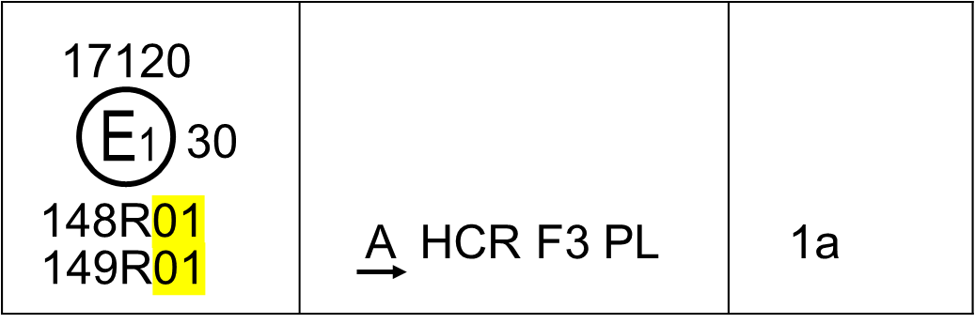**

**Marking example 3-b**

**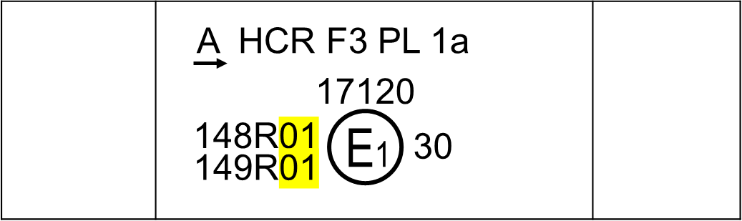**

*Note*: The examples 3-a and 3-b in Figure A13-III correspond to a lighting device bearing an approval marking comprising:

(a) A front position lamp approved in accordance with the **01**~~00~~ series of amendments to UN Regulation No. 148. The horizontal arrow indicates the side on which the required photometric specifications are met up to an angle of 80° H;

(b) A **passing beam** ~~headlamp,~~ of Class **C**~~B~~, designed for right-hand traffic only and a driving beam~~,~~ **of Class B** with a maximum intensity comprised between **1.24∙105 and 1.45∙105** ~~123,625 and 145,125~~ candelas (as indicated by the number 30), approved in accordance with the requirements of this Regulation, as amended by the **01**~~00~~ series of amendments and incorporating a lens of plastic material;

(c) A front fog lamp approved in accordance with the **01**~~00~~ series of amendments of this Regulation and incorporating a lens of plastic material;

(d) A front direction indicator lamp of category 1a approved in accordance with the **01**~~00~~ series of amendments to UN Regulation No. 148. ”

*Annex 13, Figure A13-IV,* amend to read:

“Figure A13-IV

**Marking example 4**

This example corresponds to an adaptive front-lighting system composed of two installation units for the left side of the vehicle and one installation unit for the right side.

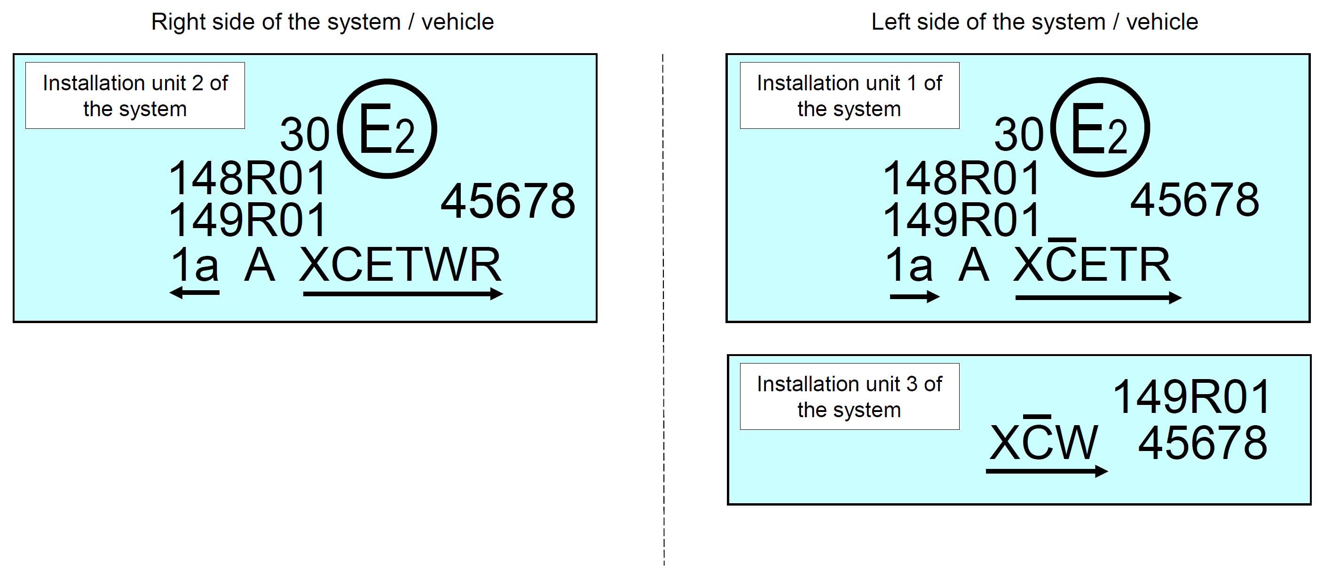

The system bearing the above approval markings meets the requirements of this Regulation (**01 series of amendments to** ~~original version of~~ the Regulation) in respect of both a passing beam for left-hand traffic and a driving beam with a maximum intensity comprised between **1.24∙105 and 1.45∙105** ~~123,625 and 145,125~~ candelas (as indicated by the number 30) grouped with a front direction indicator lamp of category 1a and a front position lamp approved in accordance with the **01**~~00~~ series of amendments of UN Regulation No. 148.

The installation unit 1 of the system (left side) is designed to contribute to the Class C passing beam and the Class E passing beam.  The score above the letter "C" indicates that on that side more than one installation unit contributes to the Class C passing beam.  The letter "T" to the right following the listed symbols indicates that each, the Class C passing beam and the Class E passing beam are providing a bending mode.

The installation unit 3 of the system (left side) is designed to provide the second part of the Class C passing beam of that side (as indicated by the score above the letter "C") and a Class W passing beam. For this additional lighting unit, a circle surrounding the letter "E" followed by the distinguishing number of the country is not necessary.

The installation unit 2 of the system (right side) is designed to contribute to the Class C passing beam, a Class E passing beam, both with bending mode and a Class W passing beam.

*Note*: In the above example, the different installation units of the system shall bear the same approval number. ”

*Add a new Figure A13-V in Annex 13,* to read:

“Figure A13-V

**Marking example 5**

**This example corresponds to a headlamp with Class DS passing beam and Class DS driving beam.**

**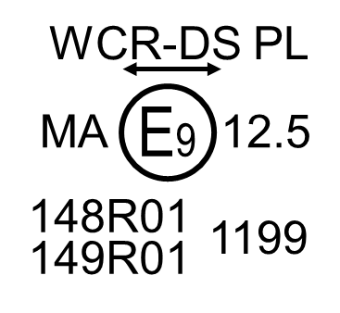**

**The lamp bearing the approval mark shown above identifies a headlamp with a passing beam and a secondary driving beam of Class DS (WCR-DS) with a maximum intensity comprised between 4.84∙105 and 6.45∙105 candelas (as indicated by the number 12.5) using a plastic lens (PL) pursuant to this Regulation as amended by the 01 series of amendments (149R01) grouped with a front position lamp for category L vehicle (MA) approved in accordance with the 01 series of amendments to UN Regulation No. 148 (148R01). All three lamps (functions) are approved in Spain (E9) under approval number 1199. ”**

*Add a new Figure A13-VI in Annex 13,* to read:

“Figure A13-VI

**Marking example 6**

**This example corresponds to a headlamp with Class CS passing beam and Class DS driving beam.**

**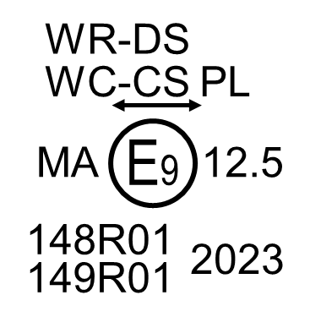**

**The lamp bearing the approval mark shown above identifies a headlamp with a passing beam of Class CS (WC-CS) and a secondary driving beam of Class DS (WR-DS) with a maximum intensity comprised between 4.84∙105 and 6.45∙105 candelas (as indicated by the number 12.5) using a plastic lens (PL) pursuant to this Regulation as amended by the 01 series of amendments (149R01) grouped with a front position lamp for category L vehicle (MA) approved in accordance with the 01 series of amendments to UN Regulation No. 148 (148R01). All three lamps (functions) are approved in Spain (E9) under approval number 2023. ”**

*Annex 13, Figure A13-V (former),* renumber and amend to read:

“Figure A13-**VII**~~V~~

**Light source module marking example**

MD E3 17325

The light source module bearing the identification code shown in Figure A13-**VII**~~V~~ has been approved together with a lamp approved in Italy (E3) under approval number 17325. ”

*Annex 13, Figure A13-VI (former),* renumber and amend to read:

“Figure A13-**VIII**~~VI~~

**Lighting unit marking example**

ALU E43 1234

The additional lighting unit bearing the identification code shown in Figure A13-**VIII**~~VI~~ has been approved together with a headlamp initially approved in Japan (E43) under approval number 1234. ”

II. Justification

1. The symbols identifying road illumination functions have been reviewed in the 01 series of amendments to UN Regulation No. 149. However, it is still unclear in the current text how to mark them on the lamps.

2. Some countries and regions, such as India, Taiwan, etc. refer to the requirements of the 00 series of amendments to UN Regulation No. 149, or older regulations, as they have not introduced the requirements of the 01 series of amendments. In order to avoid the redundant burden to mark the symbols of both the 00 and 01 series of amendments on the lamp, such as “HCR” or “HR and C”, the consistency of the symbols between the 00 and the 01 series of amendments should be allowed when possible.

3. The figures in Annex 13 showing examples still referring to the 00 series of amendments to UN Regulation No. 149 have been corrected to indicate the 01 series of amendments; the explanations have been updated accordingly.

4. UN Regulation No. 149 also includes the requirements of passing beam designed to provide symmetrical “cut-off” line, but there are no examples in Annex 13.

5. In order to solve these problems, this proposal intends to clarify the markings by amending the main text and the contents of Annex 13.

1. \* In accordance with the programme of work of the Inland Transport Committee for 2024 as outlined in proposed programme budget for 2024 (A/78/6 (Sect. 20), table 20.5), the World Forum will develop, harmonize and update UN Regulations in order to enhance the performance of vehicles. The present document is submitted in conformity with that mandate. [↑](#footnote-ref-2)