|  |  |  |  |
| --- | --- | --- | --- |
|  | United Nations | ECE/TRANS/WP.15/AC.1/2024/4 | |
| _unlogo | **Economic and Social Council** | | Distr.: General  14 December 2023  Original: English |

**Economic Commission for Europe**

Inland Transport Committee

**Working Party on the Transport of Dangerous Goods**

**Joint Meeting of the RID Committee of Experts and the  
Working Party on the Transport of Dangerous Goods**

Bern, 25-28 March 2024

Item 5 (b) of the provisional agenda

**Proposals for amendments to RID/ADR/ADN:**

**New proposals**

Modification of transitional measures for acetylene cylinder marking

Transmitted by European Industrial Gases Association (EIGA)[[1]](#footnote-2)\*,[[2]](#footnote-3)\*\*

I. Introduction

1. In document ECE/TRANS/WP.15/AC.1/2021/24/Add.1, submitted to the September 2021 Joint Meeting, the Ad Hoc Working Group on the Harmonization of RID/ADR/ADN with the United Nations Recommendations on the Transport of Dangerous Goods proposed changes to RID/ADR on the marking of acetylene cylinders which were subsequently adopted by the Joint Meeting.

2. Since 1 July 2023, the changes to 6.2.2.7.3 (k) and (l) together with 1.6.2.19 require additional marking for existing acetylene cylinders.

3. While EIGA agreed to the proposed changes, their application has been proven impossible for certain types of non-UN pressure receptacles (cylinders).

4. A large number of such cylinders do not have the space required for this additional marking, due to their design: marking on reinforced areas that are too small, or marking on steel plates that are also too small for the new requirements.

5. Marking on the cylinder shell is not allowed since this can cause damage to the porous mass inside the cylinders. Therefore, the existing reinforced areas are the only place where new marking can be performed.

6. Examples of acetylene cylinders where applying the mark is impossible.

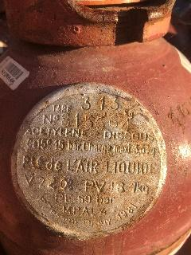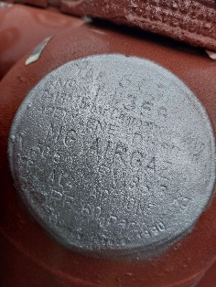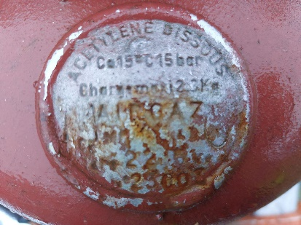 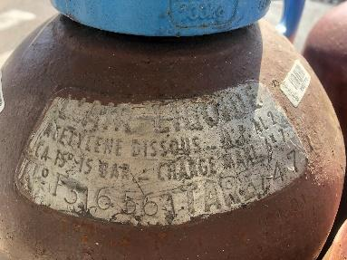 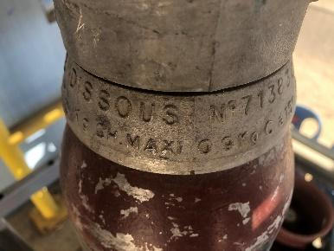 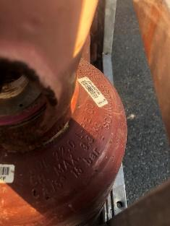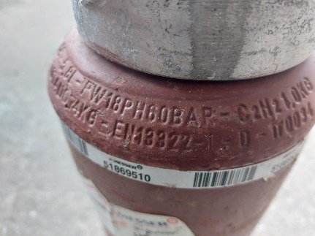

II. Proposal

7. EIGA proposes a new transitional measure as follows:

“1.6.2.XX Acetylene cylinders, which are non-UN pressure receptacles, constructed before 1 July 2023 which are not marked in accordance with 6.2.2.7.3 (k) or (l) applicable from 1 January 2023 may continue to be used.”

III. Justification

8. This amendment has no safety implications since industry has been working safely without this marking before it became mandatory.

9. Making the engraving on a non-designated location on the cylinder is a risk for the porous material and is forbidden. Damaging the porous material would be a safety risk to the cylinder.

10. Marking with a sticker would not be durable due to exposure to weather conditions.

1. \* A/78/6 (Sect. 20), table 20.5. [↑](#footnote-ref-2)
2. \*\* Circulated by the Intergovernmental Organisation for International Carriage by Rail (OTIF) under the symbol OTIF/RID/RC/2024/4. [↑](#footnote-ref-3)