UN/SCETDG/63/INF.21
Committee of Experts on the Transport of Dangerous Goods
and on the Globally Harmonized System of Classification
and Labelling of Chemicals

Sub-Committee of Experts on the Transport of Dangerous Goods 14 November 2023
Sixty-third session
Geneva, 27 November-6 December 2023
Item 3 of the provisional agenda
Listing, classification and packing
Transport of liquid organic hydrogen carrier - new special provision to UN No. 3082 – additional information on document ST/SG/AC.10/C.3/2023/40
Submitted by the expert from Germany
I. Introduction
1. In this informal document, Germany would like to provide additional information and explanations on official document ST/SG/AC.10/C.3/2023/40.
II. Discussion
2. There are various transport options for hydrogen. Hydrogen can be transported under high pressure as a gas, in refrigerated liquefied form or chemically bound to liquid carrier substances, so-called liquid organic hydrogen carriers (LOHC). One of the substances to which hydrogen can be chemically bound is benzyltoluene.
3. Benzyltoluene is a substance that has been well known for a long time and is assigned to UN No. 3082 ENVIRONMENTALLY DANGEROUS SUBSTANCE, LIQUID, N.O.S. as a dangerous good of Class 9. Six hydrogen molecules can be chemically bound to one benzyltoluene molecule in accordance with the following scheme (hydrogenation).

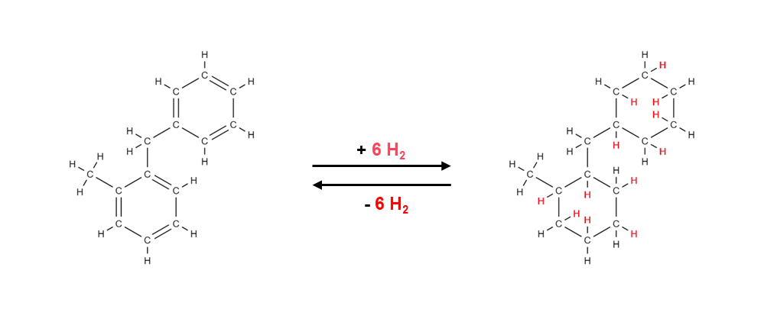

4. Special reaction conditions are necessary to later release the chemically bound hydrogen. In this specific case, the chemical bonds are released with the help of a catalytic system at temperatures of 250 °C. This means that the chemically bound hydrogen cannot be released under transport conditions.
5. The problem, which Germany has furthermore considered from the point of view of safety, is the fact that in the process of binding hydrogen to the hydrogen carrier (hydrogenation) traces of hydrogen in physically dissolved form, i.e. not chemically bound, can remain in the hydrogen carrier. These traces of hydrogen that are only physically dissolved may potentially be released during transport.
6. To obtain reliable insights and to be able to carry out a well-founded safety assessment of the possible scenarios, the Physikalisch-Technische Bundesanstalt (PTB, National Metrology Institute of Germany) has carried out experimental tests. These tests were aimed at determining whether the release of the physically dissolved traces of hydrogen can lead to the formation of explosive atmospheres.
7. For the tests conducted at the PTB, extreme test conditions (worst case scenarios) were chosen. The degree of filling of the autoclave was 90 per cent and the samples were first cooled down to -30 °C and subsequently heated to 70 °C to achieve the greatest possible gas release (hydrogen).
III. Results
8. The tests showed that only for untreated samples and only under the above extreme conditions there is a small risk of formation of explosive atmospheres. In all other cases, no ignitions were detected.
9. The safety assessment was performed based on the provisions for Class 4.3 “Substances which in contact with water emit flammable gases”. For assigning substances to Class 4.3, the provisions contain a limit value for the gas evolution rate of 1 L (flammable gas) / kg (substance) in one hour. Against this background, a limit value for the physically dissolved hydrogen content of 0.5 L / kg (LOHC) is considered appropriate to ensure safe transport of hydrogen in liquid organic hydrogen carriers (LOHC).
10. Germany would like to explicitly point out again that within the context of these comparative assessments different processes with systematically different limit values were considered. On the one hand, there is a chemical reaction (formation of flammable gases in contact with water) that can go on more or less continuously during the entire transport operation. On the other hand, there is a gas release process that is completed when the amount of the dissolved gas has escaped from the liquid hydrogen carrier.
11. The restrictive limit value for the physically dissolved hydrogen content of 0.5 L / kg (LOHC) can be achieved with reasonable effort by means of measures such as targeted degassing or optimization of the process parameters. It is also possible to monitor the limit value by testing representative samples or by an online gas analysis.

