Economic Commission for Europe
Inland Transport Committee
Working Party on the Transport of Dangerous Goods
114th session 19 October 2023
Geneva, 6-10 November 2023
Item 5 (b) of the provisional agenda
Proposals for amendments to annexes A and B of ADR:
Miscellaneous proposals
Marking of a tank-vehicle carrying UN 1202, UN 1203 and UN 3475
Transmitted by FuelsEurope
I. Introduction
1. In recent years we have noticed a strong increase in the consumption of E85-Superethanol fuel. This fuel is composed of between 50% and 85% ethanol and at least 15% gasoline (according to EN 15293). This product is carrying under UN 3475.
2. If a tank-vehicle carries several products including UN 3475, it needs:
(a) orange-coloured plates at the front and the rear; and
(b) orange-coloured plates with hazard identification number and UN number for each of the substances carried in a compartment.
So when the tank-vehicle has 10 compartments, it means 22 orange-coloured plates for the transport unit.
3. Current tank-trailers are not designed to have an orange-coloured plate in front of each compartment; therefore, orange-coloured plates are positioned on the hose holder and not necessarily in front of the compartments. So, some current trailers can’t fully comply with 5.3.2.1.2 of ADR.
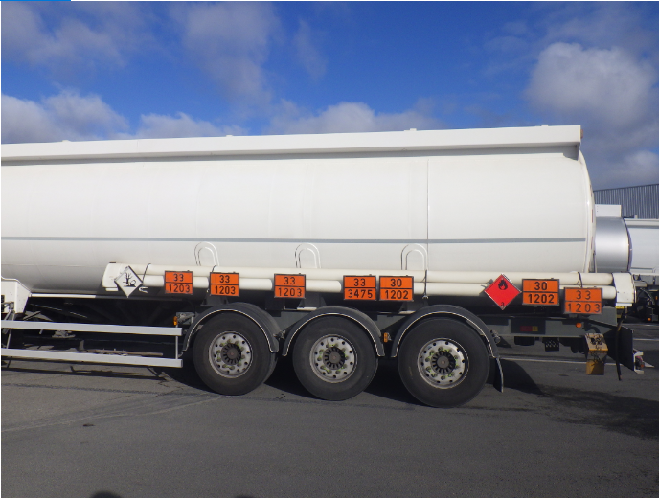

4. Tank contents and volume are reliably indicated by the roll index (see below)
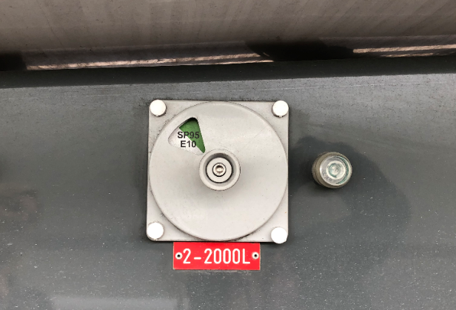
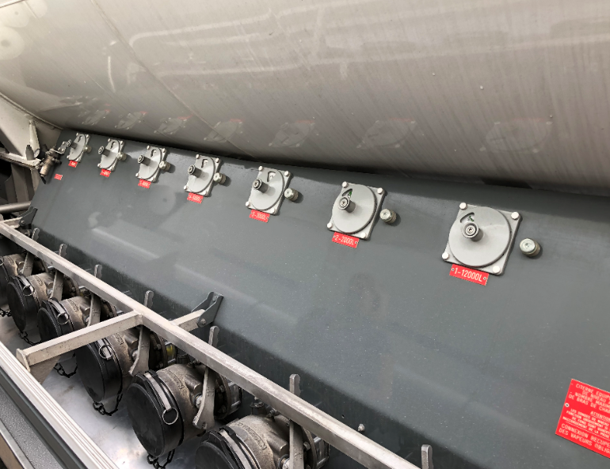
5. In the event of a fire, it is advisable to intervene on fires involving polar products (UN 3475) with an alcohol-resistant foam concentrate called AR. The AR foam concentrate is now widely used in Europe and used by emergency services to cover the risks associated with the transport of pure ethanol.
II. Proposal
6. Amend the 5.3.2.1.3 of ADR to read (new wording is underlined):
For tank-vehicles or transport units having one or more tanks carrying substances with UN Nos. 1202, 1203, 1223, 3475 or aviation fuel classified under UN Nos. 1268 or 1863, but no other dangerous substance, the orange-coloured plates prescribed in 5.3.2.1.2 need not be affixed if the plates affixed to the front and rear in accordance with 5.3.2.1.1 bear the hazard identification number and the UN number prescribed for UN Nos 3475, and if it is not carried the most hazardous substance carried, i.e. the substance with the lowest flash-point.
III. Justification
7. The aim of this modification is to facilitate the transport of UN 3475 with other products by simplifying the marking.
It will also improve the compliance of current trucks, while clearly informing firefighters of the presence of Superethanol in the tank.

