Economic Commission for Europe
Inland Transport Committee
Working Party on the Transport of Dangerous Goods 4 September 2023
Joint Meeting of the RID Committee of Experts and the
Working Party on the Transport of Dangerous Goods
Geneva, 19–27 September 2023
Item 5(b) of the provisional agenda:
Proposals for amendments to RID/ADR/ADN:
New proposals
Test periods for battery-vehicles filled in accordance with packing instruction P200
Transmitted by the European Industrial Gases Association (EIGA)
Introduction
1. The 2015 edition of RID/ADR was amended to permit certain gases of P200 to have their test periods extended from ten to fifteen years. This was aimed for individual cylinders and also cylinders mounted in bundles of cylinders.
2. Extensive work was carried out by an informal intersessional working group of the Joint Meeting to arrive at the final proposal, see document ECE/TRANS/WP.15/AC.1/2013/42 and supporting informal documents.
3. At the time of the proposal in document ECE/TRANS/WP.15/AC.1/2013/42 it was decided not to extend the work to cover the elements in battery-vehicles until experience had been gained with single cylinders and bundles of cylinders.
4. Since the 2015 edition of RID/ADR has come into effect, the extended test regime for both single cylinders and bundles of cylinders has been adopted in many countries. EIGA has so far not received any reports of cylinders or bundles of cylinders being rejected due to operation issues after the extension to a fifteen-year test interval has been introduced.
5. For current application, EIGA members have investigated retest data of 300 type 1 battery vehicles with 60.000 type 1 receptacles, with the following documented facts:
- No rejection of tubes due to operation issue. Only one manufacturing defect was found after 10 years
- The battery vehicles with type 1 cylinders as pressure elements, had zero reject rate, except for the specific battery vehicle design which caused external element corrosion during use and these designs were detected within the first 10 years of service and stopped. Still, only 43 of 56.000 cylinders were rejected. The reject criterium was in all cases problems with the neck ring and collar as result of the dismounting process.
- It was demonstrated that for battery vehicle design for which external corrosion was detected or suspected, that the corresponding elements were removed from service during the first 10 years in use.
- Due to the fact that all battery vehicles are assembled by a few manufacturers these figures can be seen as a good overview of the type 1 battery vehicles in service.
- A good and acceptable battery vehicle design take in consideration the risk of external corrosion of the elements and the other accessories.
- A bad design results in external corrosion, which will be detected during the first 10 years in service.
6. Based on these positive results of investigation, EIGA proposes that the fifteen-year test interval is extended to include battery-vehicles constructed with either seamless steel cylinders or seamless steel tubes, and containing only either UN 1046 HELIUM, COMPRESSED or UN 1049, HYDROGEN, COMPRESSED. EIGA invites the delegates for comments during this Joint Meeting.
Overview of battery-vehicles
7. A battery-vehicle is defined as:
"Battery-vehicle" means a vehicle containing elements which are linked to each other by a manifold and permanently fixed to this vehicle. The following elements are considered to be elements of a battery-vehicle: cylinders, tubes, bundles of cylinders (also known as frames), pressure drums as well as tanks destined for the carriage of gases as defined in 2.2.2.1.1 with a capacity of more than 450 litres;
8. Battery-vehicles are a well-established means of carrying large volumes of certain compressed gases that are generally not as convenient to be transported as a refrigerated liquefied gas. Typically, the gases transported in battery-vehicles are UN 1046 HELIUM, COMPRESSED and UN 1049, HYDROGEN, COMPRESSED. The main reason UN 1046 and UN 1049 are carried as a compressed gas is that their liquefaction temperature is very close to absolute zero and thus requires special equipment to handle these very low temperatures.
9. Examples of battery-vehicles are shown in the appendix to this document. Battery-vehicles can typically contain 400 type 1 cylinders or 10 type 1 tubes. The method of construction is that the elements, cylinders or tubes, are secured to the chassis of the trailer and the elements connected by manifold piping. Depending on the configuration there could be individual valves on each element, or valves to isolate a bank of cylinders or tubes.
10. The mode of operation of a battery-vehicle is that they are filled at an increasing, but limited number of dedicated specialist filling centres, driven to the point of use and connected to a process and remain in-situ until the product has been used. These filling centres can be easily detected and certified for filling battery vehicles. There is always a residual pressure left in the battery-vehicle due to a number of factors, one is that the process a battery-vehicle is connected to requires a pressure greater than atmospheric pressure, and by maintaining a positive pressure so that product purity is ensured. Battery-vehicles usually do not have residual pressure valves as these can impede the flow in case of high-volume applications, but if there is a risk of contamination from a customer process safeguards will be put in place on the installation to which the battery-vehicle is connected to. Such process could include a gas product analysis before each filling. It should be noted that under 1.4.3.7.1 (d) (ii) of the RID/ADR there is a requirement for the unloader “Immediately following the unloading of the tank, vehicle or container; Ensure the closure of valves and inspection openings.” This is an additional safeguard to ensure a residual pressure. Battery-vehicles almost always remain in one product service.
Principles
11. The principles for extending the retest period from ten to fifteen years is based upon those that were used for individual cylinders and bundles of cylinder. These are summarised in the following paragraphs.
12. The proposed increase in periodicity only applies to UN 1046 HELIUM, COMPRESSED and UN 1049, HYDROGEN, COMPRESSED. These gases have been selected due to the following:
(a) The vast majority of products transported in battery-vehicles are either UN 1046 or UN 1049.
(b) The applications that require UN 1046 and UN 1049 are almost always of very high purity, well in excess of the requirements of 2.4 of paragraph 13 of P200. The applications include electronics component production, medical and food processing. Consequently, analysis of the contents of the battery-vehicle prior to filling is usually carried out to ensure product purity.
13. Facilities that fill battery-vehicles will apply a documented and certified quality system which will be monitored by the competent authority. Filling shall only be carried out by these approved facilities.
14. For all battery-vehicles operating under a fifteen-year inspection regime the battery-vehicle will be checked before filling for a positive pressure.
15. The owner of battery-vehicles that are eligible for a fifteen-year inspection regime shall establish procedures to ensure that the battery-vehicles are only filled in approved filling centres.
16. Battery-vehicles constructed with composite elements are excluded from this proposal.
Pre-fill inspection and monitoring of battery-vehicles
17. Battery-vehicles are subject to pre-fill inspections. Instead of using the EN 13385, EIGA propose a new chapter 2.8 for the prefill inspection of type 1 cylinders/tubes. See section ‘’Proposal’’. These checks are in addition to the inspections required for the automotive components.
18. Due to the nature of battery-vehicles, their location is always known, that is either being loaded or in transit or being unloaded.
Risk analysis consideration
19. EIGA members have considered if there are increased risks in extending the test interval from ten to fifteen years for battery-vehicles and their conclusions are that subject to the pre-fill inspection being carried out there is no increased risk.
20. The reason for this conclusion is that the following requirements will be carried out under an approved quality system:
(a) The prefill check on the external condition of the battery-vehicle remains a critical part of the overall filling process to ensure the safety of the battery-vehicle.
(i) This is important as battery-vehicles are filled a number of times between the periodic inspections.
(ii) The majority of damage to battery-vehicles is from external influences.
(iii) The most hazardous part of a battery-vehicles life is during filling, when it is subjected to the highest stress due to internal pressure.
(b) The presence of a positive pressure is checked prior to every fill thereby ensuring that outside contamination will not have entered into the battery-vehicle during customer use.
(c) The above points will be reinforced by only allowing the filling of battery-vehicles at filling locations that have been approved to fill battery-vehicles with the extended test interval.
21. As mentioned above in paragraph 12 (b) the purity requirements for the products are very stringent.
Retest procedures for battery vehicles with type I elements
22. The EIGA members are not seeing any missing standards for retesting of such battery vehicles. The battery vehicles will be disassembled, and the elements follow a retest procedure as defined and standardised for cylinders/tubes. The valves and fitting will be checked by following the valve refurbishment standards and the manifold is following the procedure as defined in the bundle retest standard.
Methodology of how to extend 10 to 15 years
23. As battery-vehicles are subject to detailed inspections including the requirements of EN 13385 and monitored for the residual product and gas quality and as there are quality systems in place the test intervals may be extended. Based on this, it would appear to be appropriate to implement the extended test interval for battery-vehicles from the date of the last periodic inspection, if the requirements for the extended period have already been met since then. In this case it should not be necessary to wait for the next periodic inspection; the next inspection is due 15 years after the last inspection, even if it was done prior to the new regulation.
Safety
24. No safety issues are foreseen as the battery-vehicles will continue to be subject to the prefill inspection requirements as mentioned in the new chapter 2.8.
Enforceability
25. Enforceability is not considered to present any obstacles due to the close monitoring of battery-vehicles during loading, unloading and carriage.
Proposal for changes to 4.1.4.1
26. In this proposal new text is shown underlined and deleted text is shown as strikethrough.
27. All the proposed changes relate to packing instruction P200 in 4.1.4.1.
Add to paragraph (10):
“ub: The interval between periodic tests may be extended to 15 years for battery vehicles comprising of seamless steel tubes, seamless steel cylinders or bundles of such cylinders if the provisions of paragraph (13) of this packing instruction are applied.”
In paragraph (13):
(13) In the first sentence replace “cylinders and bundles of such cylinders may be granted in accordance with special packing provisions ua or va of paragraph (10) if the following provisions are applied” by “cylinders and bundles of such cylinders, battery vehicles comprising of seamless steel tubes, seamless steel cylinders or bundles of such cylinders may be granted in accordance with special packing provisions ua or va of paragraph (10) or ub in case of battery vehicles, if the following provisions are applied:”.
(13) 1.2 in the first sentence replace “cylinders or bundles of cylinders shall apply to the competent authority for granting the 15 year interval” by “cylinders or bundles of cylinders or battery vehicles comprising of such tubes or cylinders shall apply to the competent authority for granting the 15 year interval”.
(13) 1.3 replace “cylinders” by “cylinders or seamless steel tubes”
(13) 1.3 after “EN ISO 7866; or” add “EN ISO 11120; or”
(13) 1.3 In the second sentence replace “Other cylinders manufactured before” by “Other cylinders or seamless steel tubes manufactured before”.
(13) 1.3 In the note add the first sentence “this provision is considered to be fulfilled if the cylinder or tube has been reassessed”.
(13) 1.3 after the note replace the last sentence of the chapter 1.3 “Cylinders, bundles of cylinders marked with” by “ Seamless steel and aluminium alloy cylinders, bundles of such cylinders or a battery vehicle comprising of such tubes or cylinders marked with”.
(13) 1.4 In the first sentence, replace “Bundle of cylinders shall be constructed” by “Bundles of cylinders or battery vehicles comprising of seamless steel tubes shall be constructed”.
Then replace “contact between cylinders along” by “contact between cylinders and tubes along”.
Then replace “cylinders does not result in external corrosion” by “cylinders shall does not result in external corrosion”.
Then replace “the risk of corrosion to the cylinders” by “the risk of corrosion to the cylinders and tubes”.
(13) 1.4 At the end of the chapter add the sentence “Design of battery vehicle, which have demonstrated over more than a ten year service period, no external corrosion has occurred are acceptable for an interval of a 15 year periodic inspection period”.
(13) 1.5 Replace “The owner shall submit documentary evidence to the competent authority demonstrating that the cylinders comply” by “The owner shall submit documentary evidence to the competent authority demonstrating that the seamless steel and aluminium alloy cylinder, bundle of such cylinders, battery vehicle comprising of tubes, the cylinders or bundle of such cylinders comply”.
(13) 1.6 replace “15 year interval for periodic inspection for the cylinders or bundles of cylinders” by, “ 15 year interval for periodic inspection for seamless steel aluminium alloy cylinders, bundles of such cylinders, battery vehicles comprising of tubes, cylinders or bundles of such cylinders.
(13) 1.6 Replace “the competent authority shall keep a copy” by “the competent authority shall keep retain a copy”.
(13) 1.6 Replace “the competent authority shall keep a copy. The owner shall retain the documents for as long as the cylinders are authorised for a 15 year interval. “ by “the competent authority shall keep retain a copy. The owner shall retain the documents for as long as the cylinders and tubes are authorised for a 15 year interval.
(13) 1.6 in the note, replace “ A group of cylinders” by “A group of seamless steel and aluminium alloy cylinders or seamless steel tubes of cylinders”.
(13) 2.1 Replace “ Cylinders, bundles of cylinders having been granted at 15th years” by “ Cylinders, or bundles of such cylinders or battery vehicles comprising of such tubes or cylinders having been granted a 15 year.
(13) 2.1 Replace “this packing instruction and the requirement and responsibility of EN ISO 24431:2016 or EN 13365-2002 as applicable are fulfilled and correctly applied” by” this packing instruction and the prefill inspection as described in para 2.8 requirement and responsibility of EN ISO 24431:2016 or EN 13365-2002 as applicable are fulfilled and correctly applied “.
(13) 2.3 insert a new text for 2.3
Replace:
“Seamless steel cylinders fitted with RPVs and bundles of seamless steel cylinders equipped with main valve(s) with a residual pressure device having been granted a 15 year interval for periodic inspection shall be checked prior to every fill in accordance with a documented procedure which shall at least include the following:
- Open the cylinder valve or bundle of cylinders main valve to check for residual pressure;
- If gas is emitted, the cylinder or bundle of cylinders may be filled;
- If no gas is emitted the functioning of the residual pressure device shall be checked;
- If the check shows that the residual pressure device has retained pressure the cylinder or bundle of cylinders may be filled;
- If the check shows that the residual pressure device has not retained pressure, the internal condition of the cylinder or bundle of cylinders shall be checked for contamination:
- If no contamination is detected, the cylinder or bundle of cylinders may be filled following repair or replacement of the residual pressure device;
- If contamination is detected, a corrective action shall be carried out.”
By:
“Battery-vehicles having been granted a 15-year interval for periodic inspection shall be checked prior to every fill in accordance with a documented procedure which shall at least include the following:
- A check procedure or device to check for residual pressure
- If residual pressure is present, the battery-vehicle may be filled;
- If the check shows that the battery-vehicle does not have residual pressure the internal condition of the elements of the battery-vehicle shall be checked for contamination;
- If no contamination is detected, the battery vehicle may be filled
- If contamination is detected, a corrective action shall be carried out”
(13) New 2.4 correspond to previous chapter 2.3
“Seamless steel cylinders fitted with RPVs and bundles of seamless steel cylinders equipped with main valve(s) with a residual pressure device having been granted a 15 year interval for periodic inspection shall be checked prior to every fill in accordance with a documented procedure which shall at least include the following:
- Open the cylinder valve or bundle of cylinders main valve to check for residual pressure;
- If gas is emitted, the cylinder or bundle of cylinders may be filled;
- If no gas is emitted the functioning of the residual pressure device shall be checked;
- If the check shows that the residual pressure device has retained pressure the cylinder or bundle of cylinders may be filled;
- If the check shows that the residual pressure device has not retained pressure, the internal condition of the cylinder or bundle of cylinders shall be checked for contamination:
- If no contamination is detected, the cylinder or bundle of cylinders may be filled following repair or replacement of the residual pressure device;
- If contamination is detected, a corrective action shall be carried out.”
(13) New 2.5 correspond to previous chapter 2.4
“To prevent internal corrosion, only gases of high quality with very low potential contamination shall be filled into cylinders or bundles of cylinders. This is deemed to be fulfilled, if the compatibility of gases/material is acceptable in accordance with EN ISO 11114-1:2020 and EN ISO 11114-2:2013, and the gas quality meets the specifications in EN ISO 14175:2008 or, for gases not covered in the standard, a minimum purity of 99.5 % by volume and a maximum moisture content of 40 ml/m³(ppm). For nitrous oxide the values shall be a minimum purity of 98 % by volume and a maximum moisture content of 70 ml/m³ (ppm).”
(13) New 2.6 correspond to previous chapter 2.5
“The owner shall ensure that the requirements of 2.1 to 2.4 are fulfilled and provide documentary evidence of this to the competent authority on request, but at least every three years or when significant changes to the procedures are introduced.”
(13) New 2.7 correspond to previous chapter 2.6
“If a filling centre is situated in a different Contracting Party to ADR, the owner shall provide to the competent authority, on request, additional documentary evidence that the filling centre is monitored accordingly by the competent authority of that Contracting Party to ADR. See also 1.2.”
(13) In 2.8 add this new chapter
“In addition to the standard prefill inspection, requirements, which are specified hereafter, specific checks, shall be done for presence of residual pressure and absence of external corrosion. Before filling a battery vehicle, it shall be verified by visual examination that:
- The battery vehicle is permitted to be filled in the country of the filling station.
- The necessary data in accordance with ADR is permanently marked or labelled on the battery vehicle.
- The battery vehicle has an unexpired periodic inspection date.
- The battery vehicle is compatible with the nature of the gas (see ISO 11114-1) and filling pressure or filling weight.
- The cylinder/tube supports or bundle frames are free from damage which will affect the mechanical integrity of the battery vehicle.
- The restraining systems that prevent the cylinder/tube from moving are secure and the cylinder/tube have not moved whilst in service.
- The visible surfaces of cylinder/tube are free of any signs of dents, cuts, gouges, fire damage or any other signs of damage. Rejection criteria shall be applied in accordance with EN ISO 18119. Where a cylinder/tube is damaged, that cylinder/tube shall be isolated and identified. In the case of fire damage cylinder/tube within the battery vehicle shall be inspected and any suspect cylinder/tube shall be revalidated or rejected.
- The main outlet connection is free from contamination and is undamaged and has the correct thread for the gas to be filled.
- After being connected to the filling hose, the cylinder/tube valves, where fitted, and any isolating shut-off valves are in the open position; purging is recommended; during this operation check for residual pressure* and for gas quality as applicable.
*Note: to identify flow rate on the vent line (noise), which could be created by a failed bursting disc.
- Additionally a check of the main outlet valve shall be carried out to ensure that the valve operates properly.
- Before filling the battery vehicle for flammable gases, an earthing connection shall be made between the filling point and the battery vehicle in order to achieve electrical continuity before the filling process commences.
- During filling it shall be verified, e.g. by use of a leak detection solution, that no apparent leaks exist on the valves.
- Prior to disconnection, the hose assembly shall be vented and purged in accordance with the applicable instructions in a manner that prevents the vented gas from causing any form of hazard.
- After filling it shall be verified that;
  - The pressure is correct verse the reference temperature.
  - Valves are closed
  - The fill hose has been disconnected from the battery vehicle.
  - The main outlet valve is not leaking.
  - Connections are plugged.
  - The battery vehicle has been correctly labelled for the nature of the gas and any transport requirements.
  - All immobilising and earthing equipment has been disconnected.
  - No loose equipment remains on the battery vehicle.”
(13) 3.1 Replace “Cylinders and bundles of cylinders already in use” by “ Cylinders and bundles of cylinders and battery vehicles with seamless steel, aluminium alloy cylinders, tubes or bundles of such cylinders already in use”.
(13) 3.2 Replace “If a cylinder with a 15 year interval” by “If a cylinder or tube with a 15 year interval”.
(13) 3.4 Replace “ Cylinders or bundles of cylinders having been granted” per “Cylinders or bundles of cylinders and battery vehicles having been granted”.
(13) 4 In the first sentence, replace “ Cylinders and bundles of cylinders having been granted” per “ Cylinders and, bundles of cylinders and battery vehicles having been granted.
(13) 4 In the second sentence, replace “cylinders or bundles of cylinders” per “ cylinder, bundles of cylinders or battery vehicles comprising of tubes, or bundle of such cylinders.

Appendix
Examples of battery-vehicles
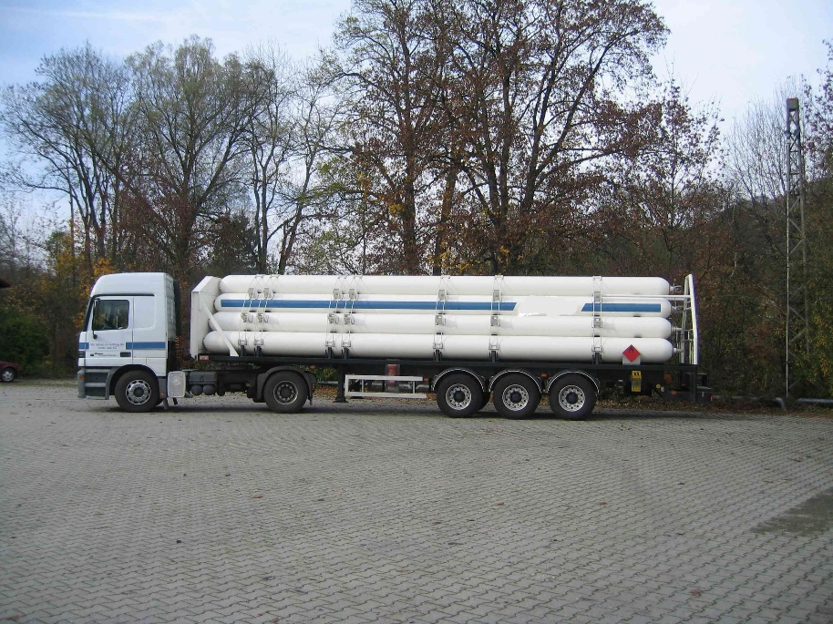
Battery-vehicle constructed with seamless steel tubes
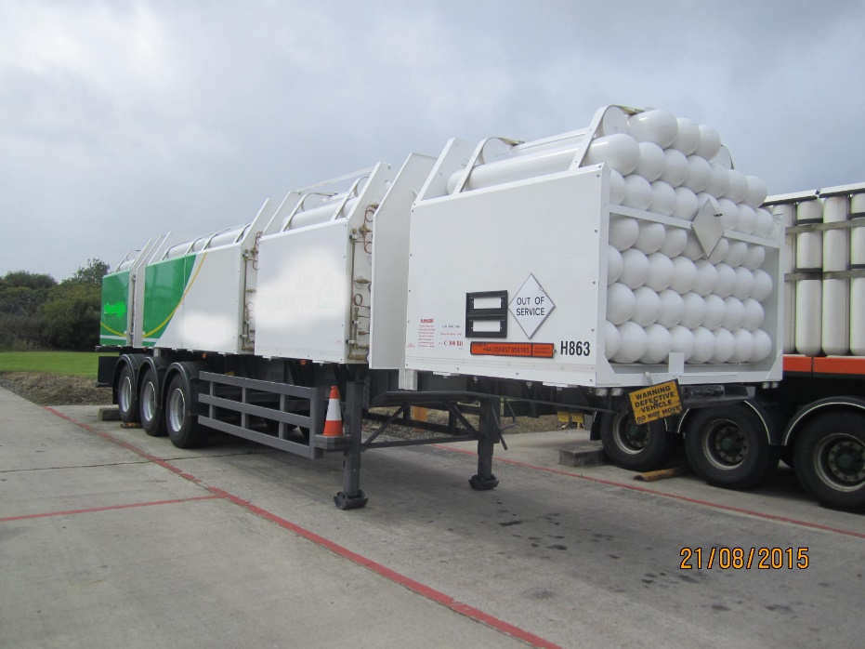
Battery-vehicle constructed with seamless steel cylinders

