|  |  |  |  |
| --- | --- | --- | --- |
|  | United Nations | ECE/TRANS/WP.11/2023/10 | |
| United Nations logo | **Economic and Social Council** | | Distr.: General  3 August 2023  English  Original: French |

**Economic Commission for Europe**

Inland Transport Committee

**Working Party on the Transport of Perishable Foodstuffs**

**Eightieth session**

Geneva, 24–27 October 2023

Item 6 of the provisional agenda

**ATP Handbook**

Amendments to the comments to paragraph 4 of annex 2, appendix 1 of the ATP Handbook: Location of temperature measurement probes during transport

Transmitted by the Government of France

Introduction

1. The placement of evaporators during construction can produce measurements that are distorted in comparison with “standard” configurations imagined when the locations were defined for the temperature sensors used for temperature control during transport.

2. The furthest opening is not necessarily opposite the refrigeration unit (there may be a side door, or an evaporator placed in the middle of the body and blowing across it, or located at the rear of the body and blowing towards the front, etc.).

3. If, owing to insufficient air flow, the cargo starts to warm up, the surrounding air layer will continue to be cooled and will stagnate at the bottom. There is thus a risk of delayed detection of the air temperature deviation from the upper part of the body.

Illustration of the current version from the ATP manual:

|  |  |  |
| --- | --- | --- |
|  | | |
| Uniform air speed | Reduced air speed | Zero air speed |
| (excluding specific airflow improvement system) | | |

I. Proposed amendment to the ATP Handbook

4. In annex 2, appendix 1, Comments to annex 2, appendix 1, paragraph 4, it is proposed to replace the current sentence: “*In the case of upper cold air distribution systems, near (to the left or right of) the bottom of the doorway furthest away from the refrigeration unit;*” with:

“*In the case of upper cold air distribution systems, near (to the left or right of) the corner furthest from the evaporator outlets, at the top (in the upper quarter of the height);*”

Illustration of proposed modification:

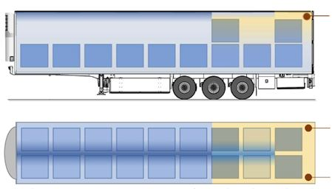

|  |  |  |
| --- | --- | --- |
| Uniform air speed | Reduced air speed | Zero air speed |
| (excluding specific airflow improvement system) | | |

II. Impact

5. This amendment makes the temperature recordings during transport more realistic and thus more reliable.