Economic Commission for Europe
Inland Transport Committee
Working Party on the Transport of Dangerous Goods 16 August 2023
Joint Meeting of the RID Committee of Experts and the
Working Party on the Transport of Dangerous Goods
Geneva, 19–27 September 2023
Item 2 of the provisional agenda:
Tanks
Water chamber in vacuum-operated waste tanks
Transmitted by the Government of Germany
Summary
Executive summary: In Germany and in other member countries, vacuum-operated waste tanks are fitted with a water chamber, where necessary. Within the scope of the standardization work on standard EN 14025, issues regarding legal compliance have arisen.
Action to be taken: Examine whether vacuum-operated tanks can be fitted with a water chamber and, if so, under what conditions.
Related documents: CEN/TC 296/WG 3, Document N 465 “WG 3 answers to prEN 14025 Collated Comments 2023-01-11”.

1. In Germany, vacuum-operated waste tanks have optionally been fitted with water chambers for many years. To our knowledge, this has also been done in other member countries. The water in the water chamber is used, in particular in the event of an accident, for cleaning and rinsing, where there is no external water supply. So far, no incidents related to the operation of the water chamber have become known.
2. The water chamber is operated without pressure and is either constructed as an external water chamber (attached to the tank end), as a compartment of the shell or as an internal water chamber (see sketches below). The calculations are performed in accordance with standard EN 14025 or, for parts that cannot be calculated in accordance with this standard, in accordance with EN 13445-3. Due to the better driving dynamics and centre of gravity height, in Germany, an internal water chamber is often installed.
3. For the session of CEN/TC 296/WG 3 in February 2023, Germany had submitted, among other things, proposals to include requirements to be met by the internal water chamber (e.g. in the case of an explosion pressure shock resistant design of the tank) in prEN 14025. The proposals were initially rejected by WG 3, as some experts were of the opinion that internal water chambers do not comply with RID/ADR (Chapter 6.10).
4. Germany believes that the internal water chamber also complies with the provisions. The body of the water chamber is considered a shell of the vacuum-operated tank whose respective minimum wall thicknesses are calculated in accordance with RID/ADR or EN 14025. Also, the additional strain put on the tank end by the water chamber can be calculated in accordance with EN 13445-3. If the vacuum-operated tank is to be explosion pressure shock resistant, the internal water chamber also has to be designed for the external explosion pressure, and the impact of the water chamber on the shell has to be considered when assessing the explosion pressure shock resistance.
5. The Joint Meeting’s working group on tanks is asked to examine whether fitting vacuum-operated tanks with water chambers complies with the provisions and whether corresponding provisions should be included in RID/ADR or EN 14025.

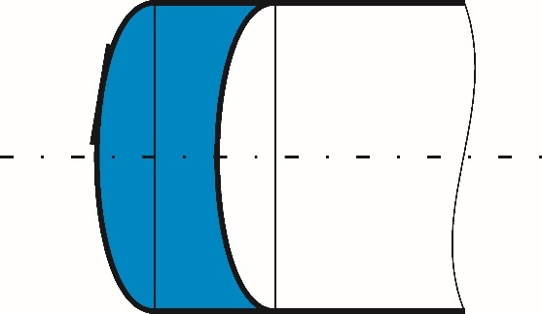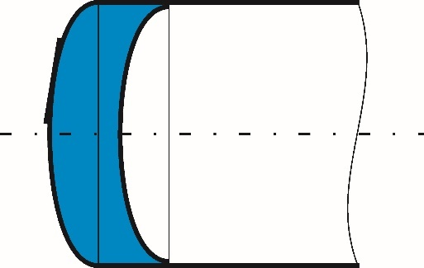
- Water chamber attached to the tank end b) Water chamber as a tank compartment

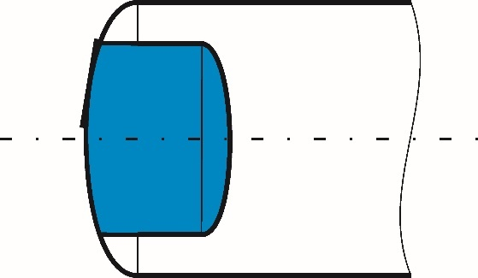
- Internal water chamber

