UN/SCETDG/62/INF.41

Committee of Experts on the Transport of Dangerous Goods
and on the Globally Harmonized System of Classification
and Labelling of Chemicals 4 July 2023
Sub-Committee of Experts on the Transport of Dangerous Goods
Sixty-second session
Geneva, 3-7 July 2023
Item 3 of the provisional agenda
Listing, classification and packing
Precedence of classes - corrections to 2.0.3.1 and 2.8.2.4 to align with 2.6.2.2.4.1
Transmitted by the experts from Canada and the Republic of Korea
This informal paper presents amendments to paper ST/SG/AC.10/C.3/2023/11 with changes indicated in strikethrough for deletions and in bold for new text.
Introduction
1. The precedence of classes in the Model Regulations is clearly outlined in 2.0.3. However, when a substance meets the criteria of Class 8 with an inhalation toxicity to dusts and mists in the range of packing group (PG) I, there are some discrepancies in determining if Division 6.1 or Class 8 takes precedence. As such, different clauses can lead to different primary class allocations. Therefore, consignors do not have a consistent way of determining the precedence of class in this situation.
2. Although this may seem like editorial corrections, Canadian consignors have faced real challenges because of the conflicting allocations of primary in these situations.
3. This proposal builds on the issues highlighted in informal document INF.14 of the sixty-first session, submitted by the Republic of Korea.
Explanation
4. For a substance that meets the criteria for Class 8 and has an inhalation toxicity to dust and mists in the range of PG I (“Substance A”), the current text of the Model Regulations leads to contradictory allocations to a primary class.
5. The following schematic demonstrates the appropriate allocation of the primary class for “Substance A” as defined in the note of 2.6.2.2.4.1.
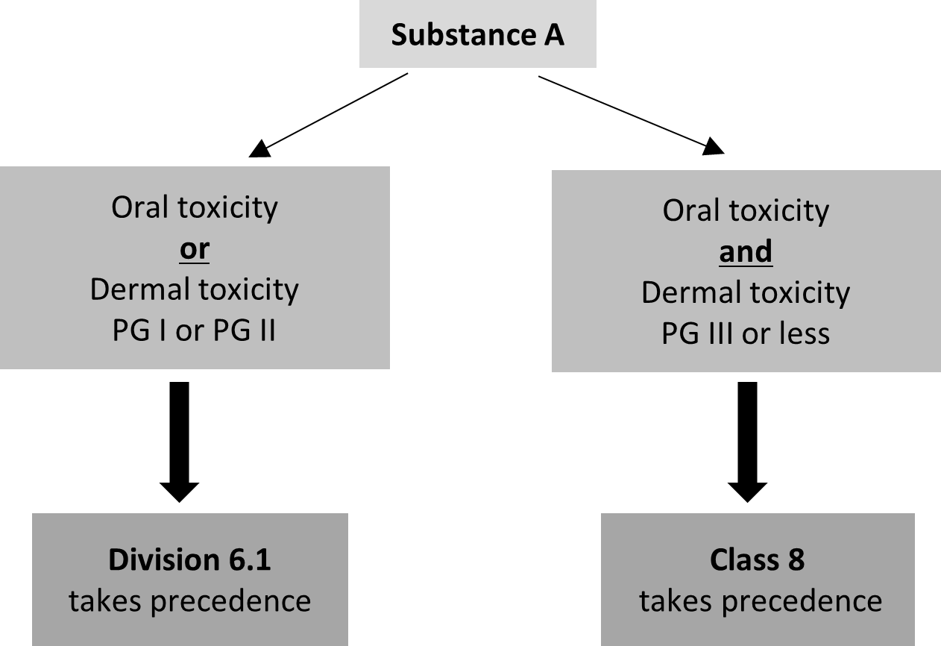
Oral toxicity
PG I or PG II
or
Dermal toxicity
PG I or PG II
Oral toxicity
PG III or less
and
Dermal toxicity
PG III or less
Substance A
Class 8
takes precedence
Division 6.1
takes precedence
6. In accordance with the note of 2.6.2.2.4.1, if a substance meets the criteria for PG I or PG II for either dermal toxicity or oral toxicity, then Division 6.1 takes precedence. Therefore, for Class 8 to take precedence, both dermal toxicity and oral toxicity must be in the range of PG III or less. If either of them (dermal toxicity or oral toxicity) is not in the range of PG III or less, then Division 6.1 must take precedence as stated above.
Proposal
7. To ensure a uniform approach to the determination of the precedence of classes, the following changes are proposed (deleted text in strikethrough and new text in underline):
8. Amend footnote 3 of 2.0.3.1 to read as follows:
“³ Except substances or preparations mixtures meeting the criteria of Class 8 having an inhalation toxicity of dusts and mists (LC₅₀) in the range of packing group I, but toxicity through oral ingestion and or dermal contact only in the range of packing group III or less, which shall be allocated to Class 8 (see note under 2.6.2.2.4.1 and 2.8.2.4).”
9. Amend the Note in 2.6.2.2.4.1 to read as follows:
“NOTE: Substances or mixtures meeting the criteria of Class 8 and with an inhalation toxicity of dusts and mists (LC50) leading to packing group I are only accepted for an allocation to Division 6.1 if the toxicity through oral ingestion or dermal contact is at least in the range of packing group I or II. Otherwise, an allocation to Class 8 is made when appropriate (see footnote 3 under in 2.0.3.1 and 2.8.2.4).”
10. Amend 2.8.2.4 to read as follows:
“2.8.2.4 A s Substances or mixtures meeting the criteria of Class 8 having an inhalation toxicity of dusts and mists (LC₅₀) in the range of packing group I, but toxicity through oral ingestion or and dermal contact only in the range of packing group III or less, shall be allocated to Class 8 (see footnote 3 under in 2.0.3.1 and note under 2.6.2.2.4.1).”

