UN/SCETDG/62/INF.10
Committee of Experts on the Transport of Dangerous Goods
and on the Globally Harmonized System of Classification
and Labelling of Chemicals

Sub-Committee of Experts on the Transport of Dangerous Goods 8 June 2023
Sixty-second session
Geneva, 3-7 July 2023
Item 2 (b) of the provisional agenda
Explosives and related matters:
Improvement of test series 8
Further validation of test series 8: applicability of test series 8 (d)
Submitted by the Responsible Packaging Management Association of Southern Africa (RPMASA)
Introduction
1. At the fifty-seventh, fifty-eighth, sixtieth and sixty-second session of the Sub-Committee of Experts on the Transport of Dangerous Goods, the Institute of Makers of Explosives (IME) have submitted various documents (UN/SCETDG/57/INF.13, UN/SCETDG/58/INF.8, ST/SG/AC.10/C.3/2022/18, and ST/SG/AC.10/C.3/2023/16) on the suitability of the 8(d) vented pipe test for the use with ammonium nitrate emulsions (ANEs). These documents proposed ANEs that satisfy the acceptance criteria of the 8(e) CanmetCERL Minimum Burning Pressure (MBP) test, should not be subjected to the 8(d) vented pipe test.
2. The current situation is that if ANEs are to be transported in bulk in portable tanks, they must also be subjected to the 8(d) test to determine suitability for containment in portable tanks as an oxidizing substance. This document provides additional experimental data to support the continued use of the 8(d) test to predict the bulk behaviour of ANEs when subjected to a large fire under confined, vented conditions.
3. Additional figures referred to in this document may be found in the annex hereto.
Background
4. The inclusion of the use of the 8(e) CanmetCERL MBP test for ANEs that give false positives during the 8(c) test has been accepted into the Manual of Tests and Criteria, provided that the reaction time in test 8(c) is longer than 60 s and the water content of the ANE in question is greater than 14%.
5. In document ST/SG/AC.10/C.3/2022/18, IME has proposed that the 8(e) also be used as a replacement for the 8(d) test for ANEs. This is based on the results obtained from the numerical modelling, which was used to determine the behaviour of ANEs, under the following conditions:
• Transient heat flux of 24 kW/m²
• Ullage of 90% and 10%
The modelling was performed using a set volume and specific energy input. ANE kinetics and AN crust formation were input parameters. It was concluded that ullage had little effect on the heat transfer penetration. This is mainly ascribed to the thermal diffusivity that is small and the high viscosity of the ANE inhibiting convection within the ANE. The simulation also showed minimal temperature change in the emulsion. The conclusion was that there is a very low probability of ignition as the fire would die out once the fuel has been consumed.
6. At the sixtieth session of the Sub-Committee, RPMASA had submitted a paper (UN/SCETDG/60/INF.42) on the validation of the 8(d) vented pipe test for use with ANEs.
Discussion
7. ANEs have been transported in bulk since the 1980s and there have been several fires during transport. In Western Australia in October 2022 a tanker transporting an ANE detonated after approximately 2 hours of exposure to a fire. It was reported that this ANE was an approved ANE that has been subjected to test series 8. The outcome of the investigation is still pending and therefore no conclusions based on this event can be made at this stage. This event is discussed in detail in the annexure of document ST/SG/AC.10/C.3/2023/16, submitted by IME.
8. Further to the testing described in UN/SCETDG/60/INF.42, RPMASA undertook to conduct additional test work. Four additional UN Test Series 8(d) tests were conducted as well as two additional fast cook-off test. A modified tanker test, which will be described in more detail below, was also conducted.
9. It was decided to apply the NATO standard Fast Heating Munition test procedures AOP-4240 to assess the reaction of the ANEs to heat fluxes that take place when the ANE is subjected to a large liquid hydrocarbon fuel pool fire. This test method is used to test insensitive munitions and thus the standard test method was modified to accommodate the use of ANEs. This is known as the fast cook-off test. A 10 m steel pipe (270 mm in diameter and pipe wall thickness of 5 mm) was positioned on a table with a steel grid. The pipe was filled with the ANE sample. The steel trough was filled with 4200 litres of paraffin up to a level of 300 mm below the base of the pipe. Thermocouples were placed at various levels inside the pipe. See annex for test setup diagram. The samples tested are present in Table 1.

Table 1: Composition of ANE Samples
Prior Formulations Tested
Sample | Oxidiser Composition | Fuel Phase | Water Content (% m/m) | Fudge Point  (°C)
ANE 1 | Dual salt | Recycled oil + Paraffinic oil + Surfactant | 14.29 | ±45
ANE 2 | Single salt | Paraffinic oil + Surfactant | 16.10 | ±55
ANE 3 | Multiple salt | Paraffinic oil + Surfactant | 14.30 | ±63
Formulations Tested in 2023
ANE 4 | Single salt | Recycled oil + Paraffinic oil + Surfactant | 16.10 | ±55
ANE 5 | Single salt | Paraffinic oil + Surfactant | 15.51 | ±72
ANE 6 | Single salt | Paraffinic oil + Surfactant | 20.45 | ±52
ANE 7 | Single salt | Paraffinic oil + Surfactant | 24.19% | ±45

Table 2: Summary of test results
Sample | Fast cook-off | Vented pipe test 8(d)
ANE 1 | Detonated | +
ANE 2 | Vented | -
ANE 3 | Vented* | -*
ANE 4 | Detonated | +
ANE 5 | Not tested | -
ANE 6 | Detonated | +
ANE 7 | Vented | -
* These tests were repeated 3 times to confirm repeatability of the test

10. The large scale fast cook-off test has demonstrated that the type of event is affected by both the oxidiser and the fuel phase composition. The inclusion of recycled oil in the fuel phase always resulted in a detonation reaction. The water content of the ANE does not affect the outcome of the reaction, as seen in the test results of ANE’s 5, 6 and 7.
11. When comparing the nature of the event seen in the fast cook-off tests there seems to be a correlation to the nature of the event seen in the 8(d) test, as presented in Table 2. The internal temperature of the ANE during both the 8(d) and the fast cook-off tests were monitored and shows a similar convection behaviour. During the 8(d) test and the fast cook-off test, the heat distribution is over a large surface area hence exposing the ANE to a greater amount of heat energy. During both the 8(d) and the fast cook-off tests, it was noted that ANE temperature increases rapidly to a point where the ANE will undergo either rapid venting of the entire contents, deflagration, or detonation.
12. In document ST/SG/AC.10/C.3/2022/18, it was noted that the low thermal diffusivity, as well as the highly viscous nature of ANEs, inhibits convection in the emulsion phase. The temperature of the ANE was monitored in all test conducted. From the thermal data given in Figure 7 to Figure 19, it is evident that in a relatively short period of time (7-10 minutes from when the first temperature thermocouple starts to show an increase in temperature) that all of the temperature thermocouples display similar temperature readings. With the low thermal conductivity of ANEs, this is only possible if there is significant convection of the ANE within the pipe.
13. To further validate the results presented above, the team undertook to conduct a test that more accurately represents the configuration of a tanker. For this test, a pup tanker trailer was obtained and modified to suit the requirements and constraints of the test range. The pup was filled with approximately 500-600 kg ANE 3.

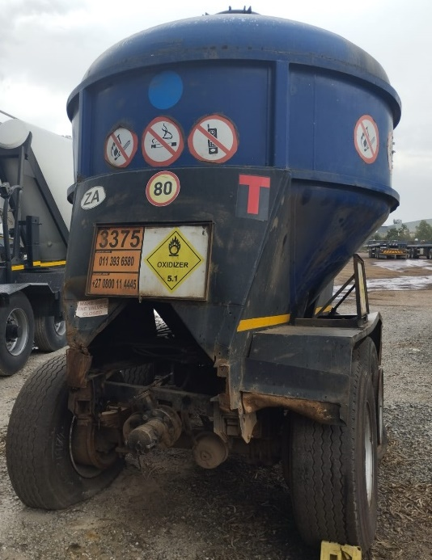
Figure 1: Pup tanker trailer before modification

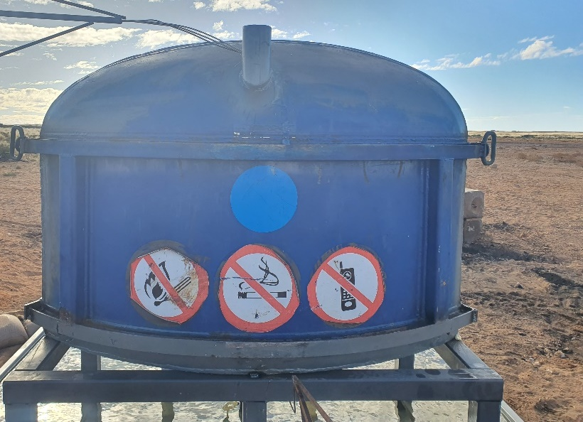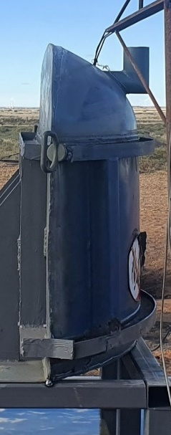
1.570m
1.100m
0.340m
Figure 2: Pup tanker trailer after modification

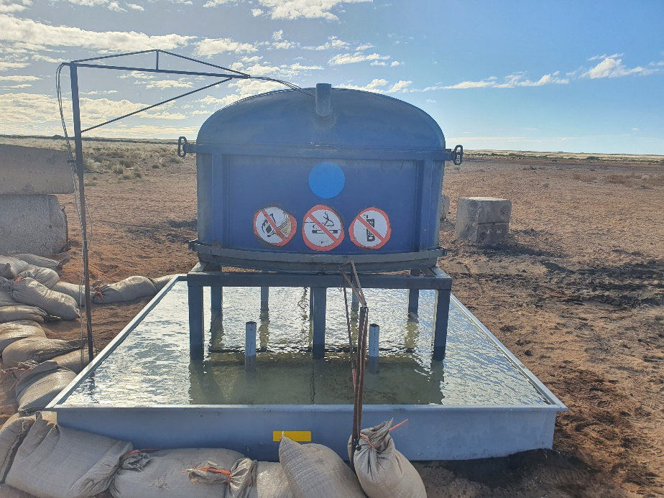
Figure 3: Modified tanker test setup

14. Thermocouples were placed inside the ANE during the test to establish if convective heating takes place within a tanker arrangement. From the data it is noted that the temperature throughout the tanker increased linearly up to approximately 250 °C. After approximately 12 minutes, venting of the product started to take place and continued throughout the test, with increasing intensity. Final venting and rupture of the tanker took place after approximately 22 minutes. Based on the data (as seen in Figure 20 in the annex), it is noted that after approximately 8 minutes the temperatures of the internal thermocouples were converging. This phenomenon can only take place if convection took place during the test.

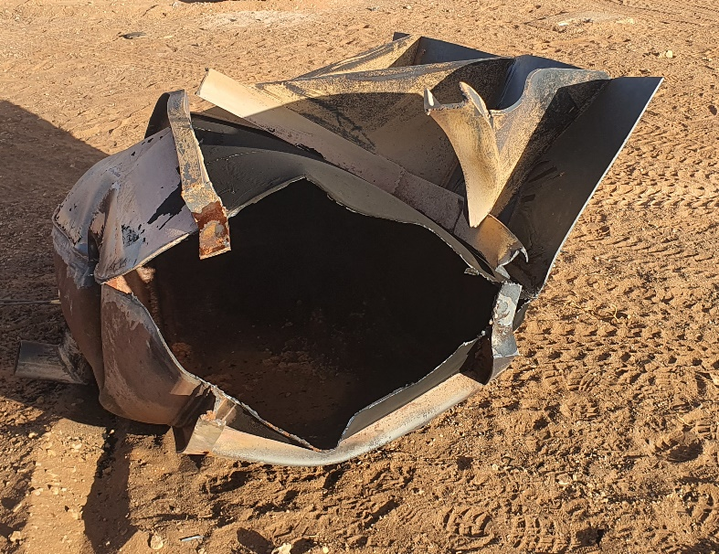
Figure 4: Modified tanker after test

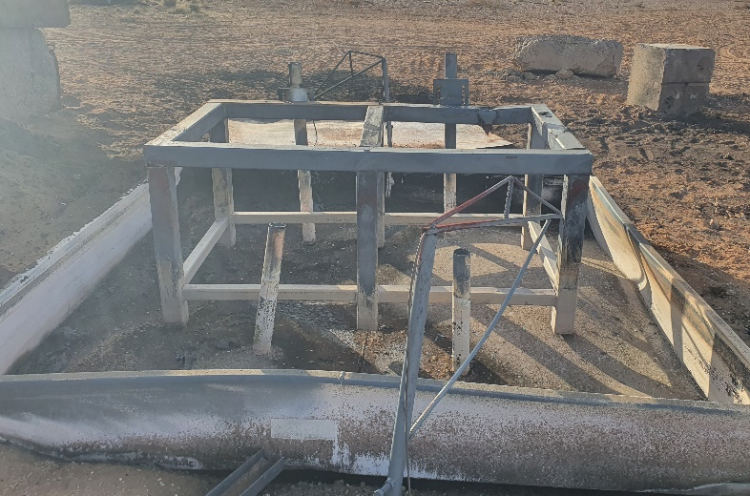
Figure 5: Modified tanker stand after test
Proposal
15. At this stage, the proposal is for the continued use of the 8(d) test. Based on the argument presented herein, it is proposed that the 8(d) test remains in use, as this test shows the characteristic of ANE when subjected to extreme thermal conditions. Knowing the characteristic behaviour of ANE in undefined conditions will be advantageous in identifying plausible consequences as a result of unforeseen thermal events during transportation.
16. Further to the above, it is proposed that additional work be scheduled for ANE samples to be tested.

Annex
Fast cook-off test setup diagram and test results

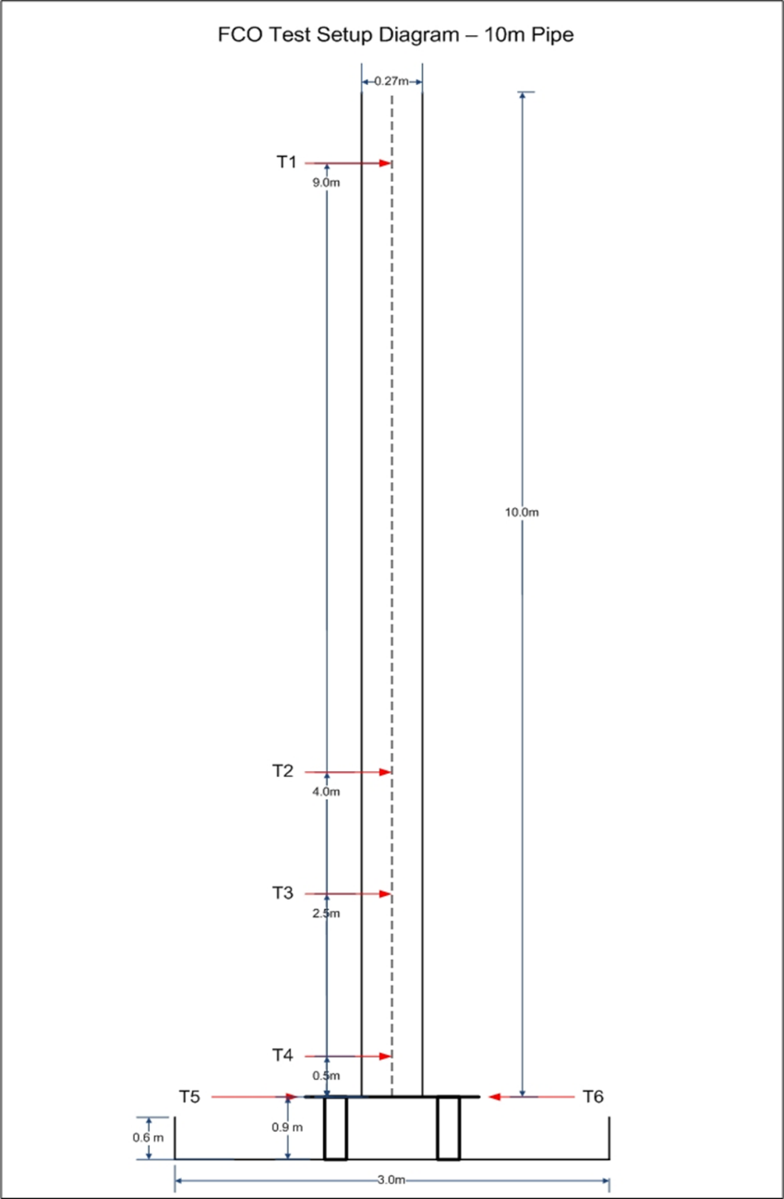
Figure 6: Fast cook-off test set-up

Fast cook-off test: thermal traces

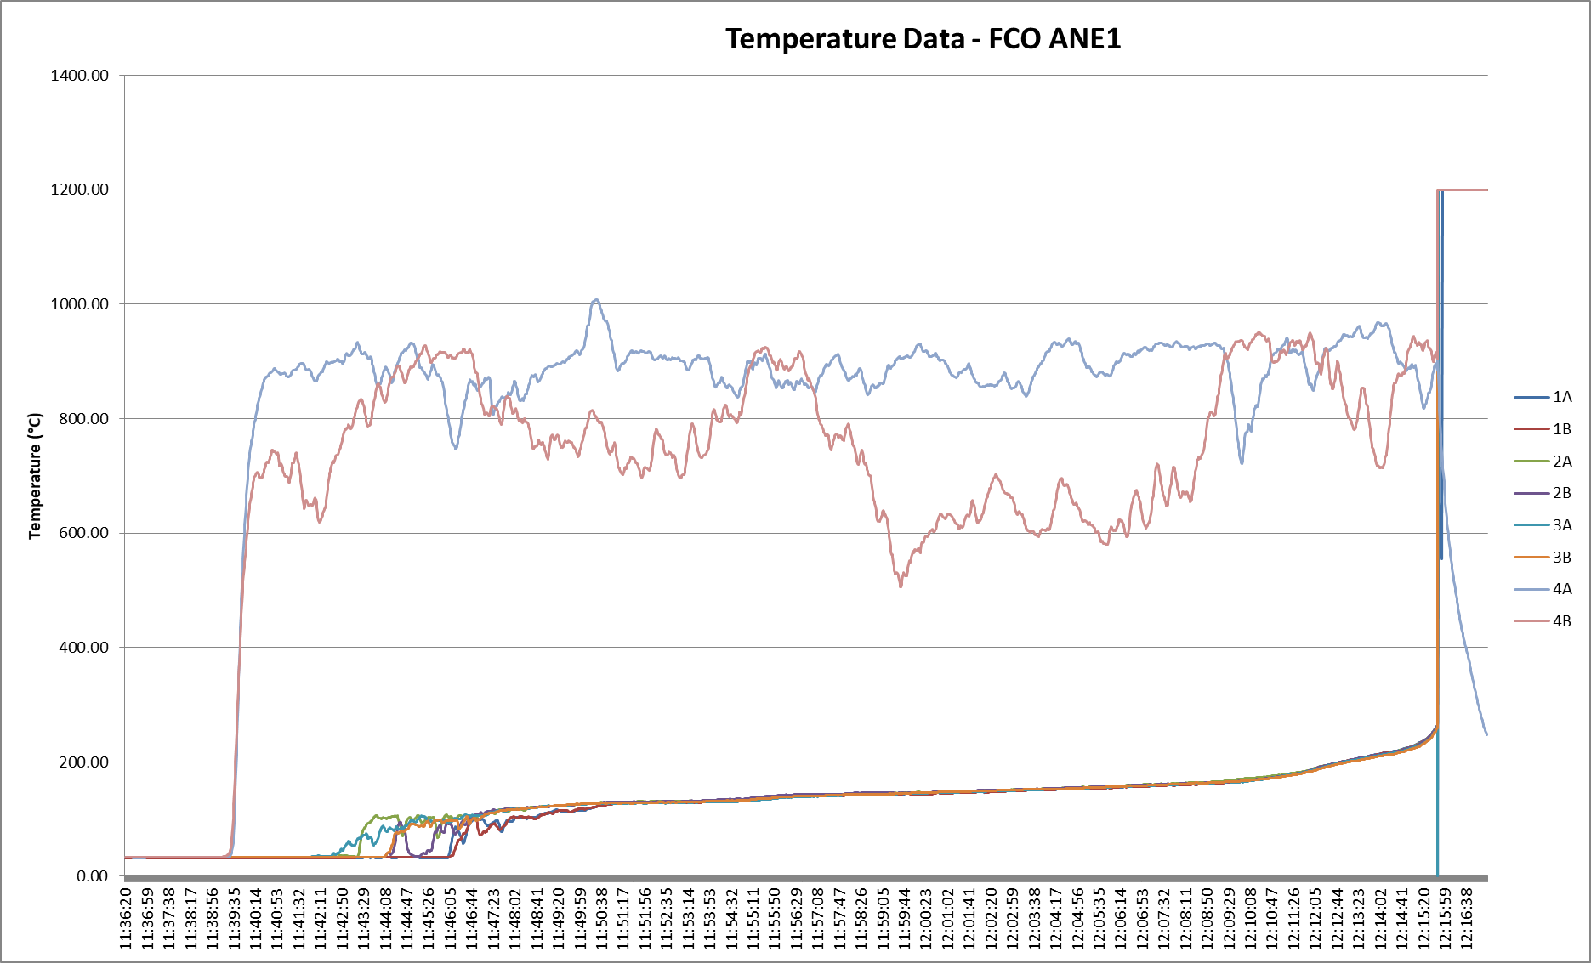
Figure 7: Fast cook-off temperature data for ANE 1
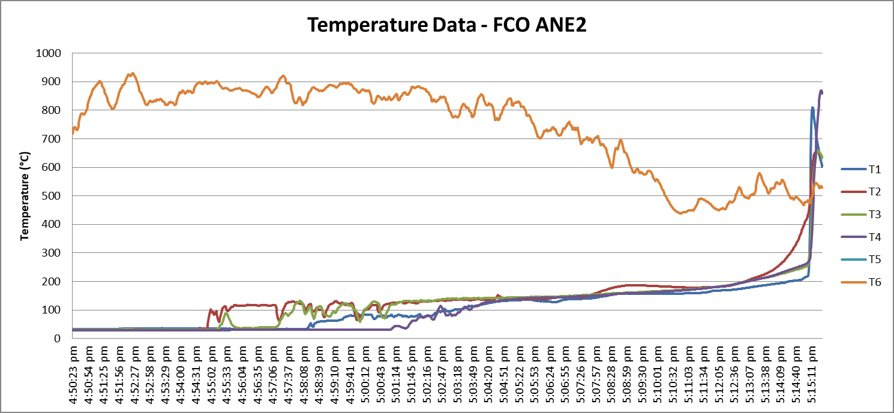
Figure 8: Fast cook-off temperature data for ANE 2

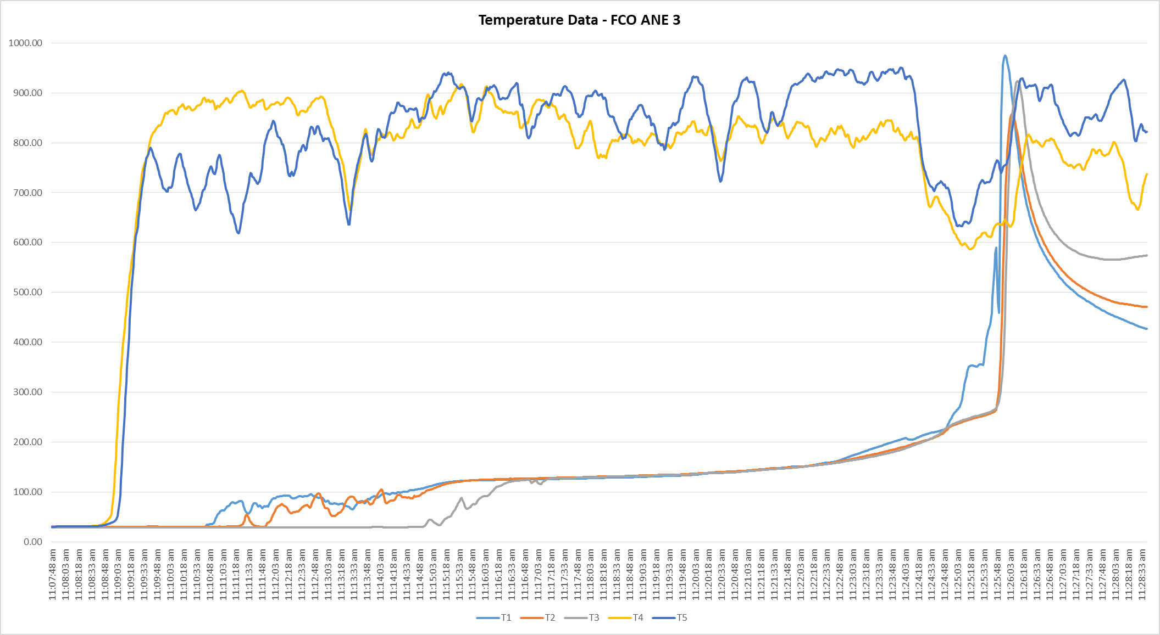
Figure 9: Fast cook-off temperature data for ANE 3

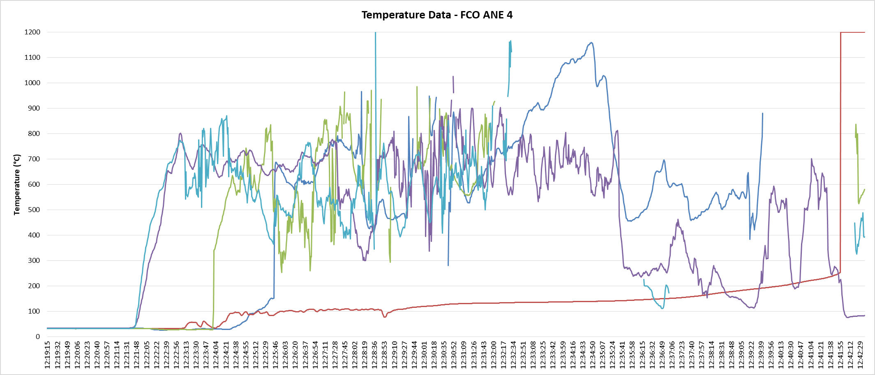
Figure 10: Fast cook-off temperature data for ANE 4

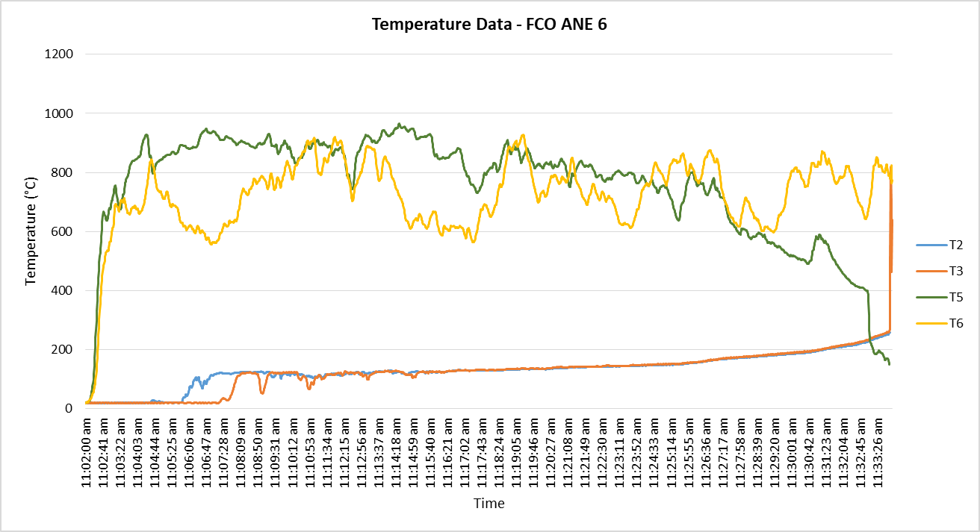
Figure 11: Fast cook-off temperature data for ANE 6

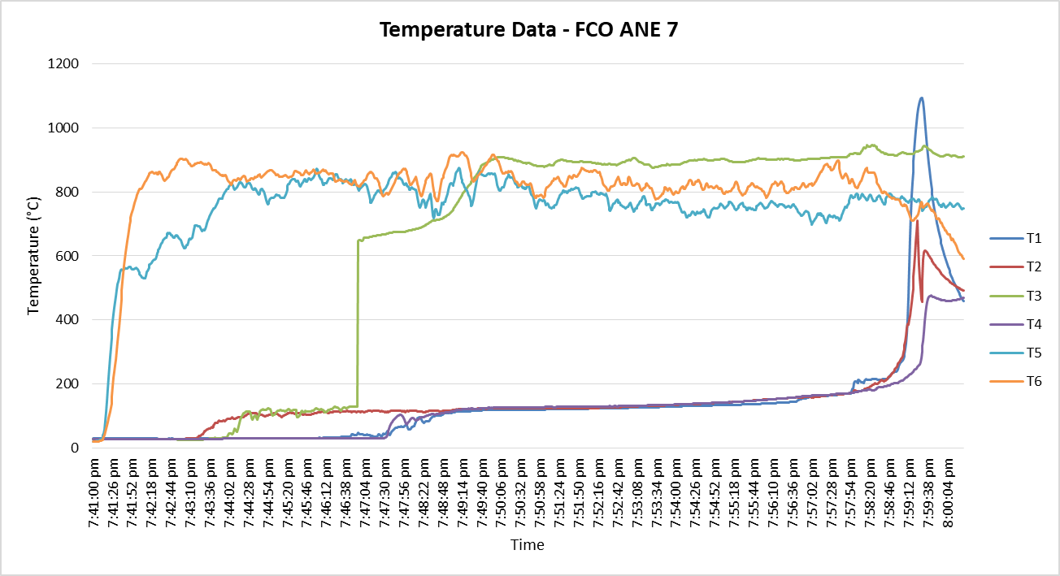
Figure 12: Fast cook-off temperature data for ANE 7

8(d) test thermal trace
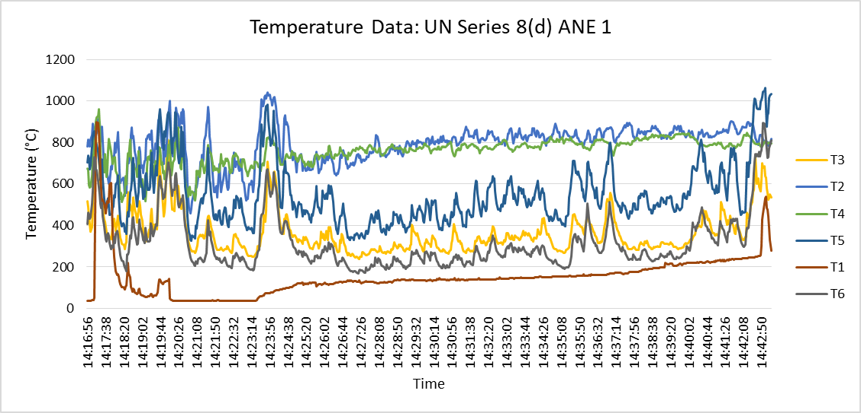
Figure 13: Temperature data for 8(d) of ANE 1

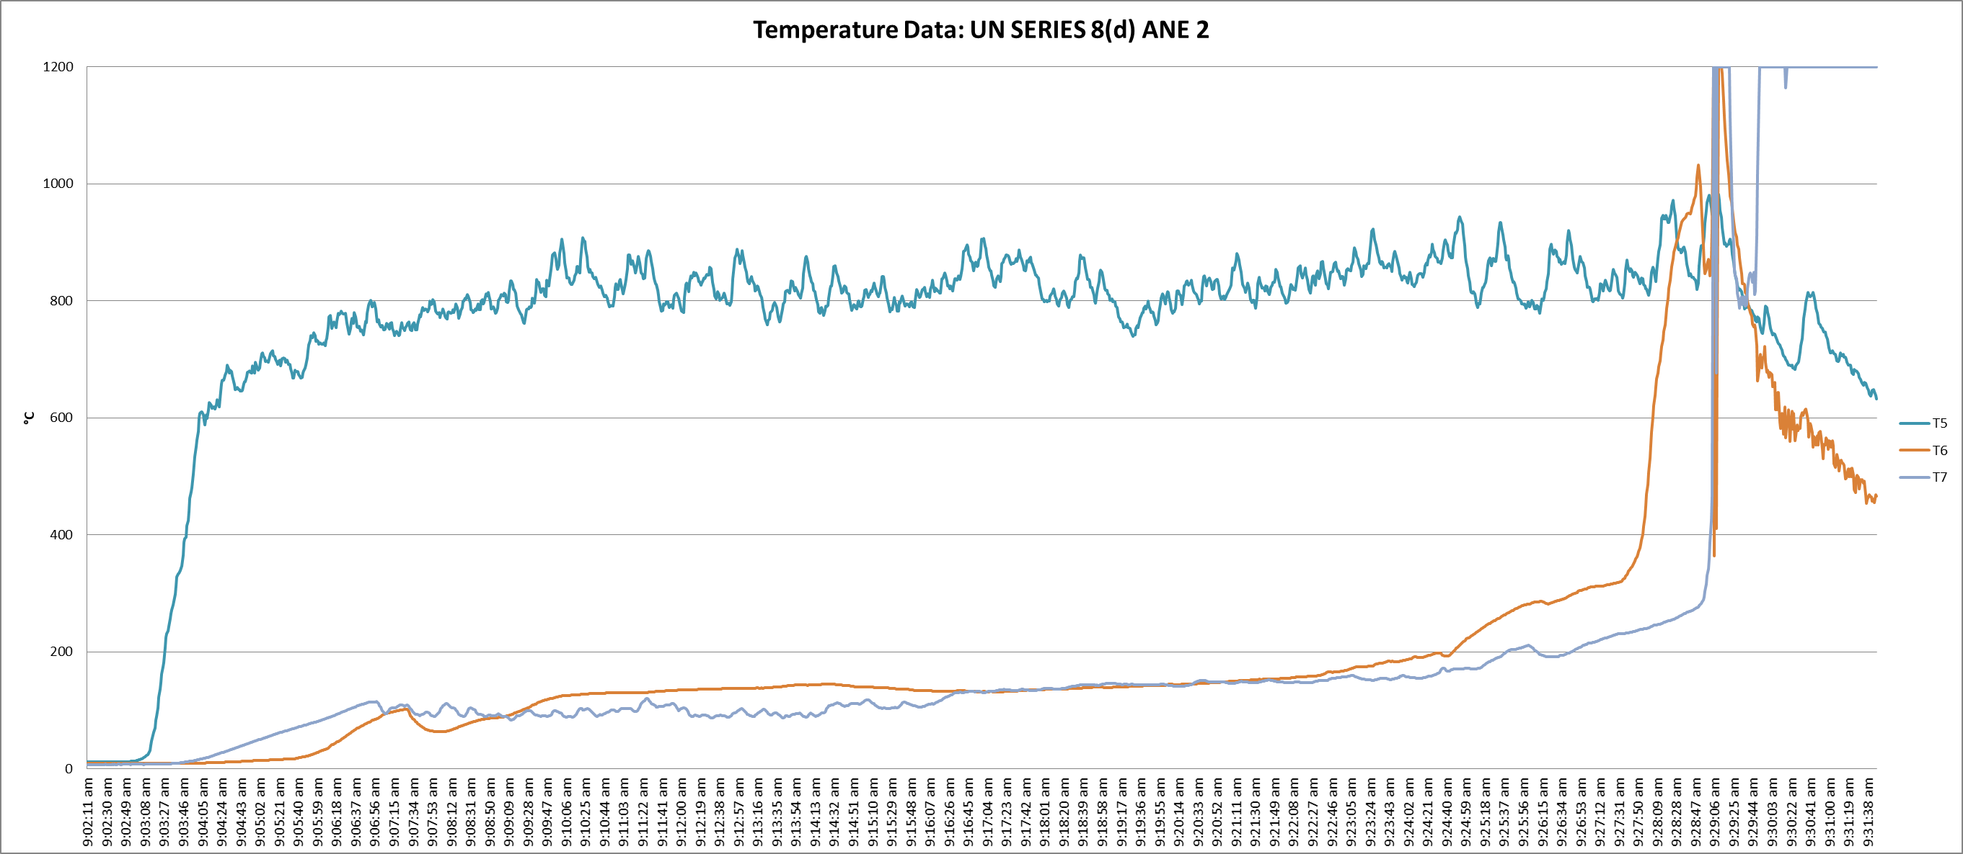
Figure 14: Temperature data for 8(d) of ANE 2

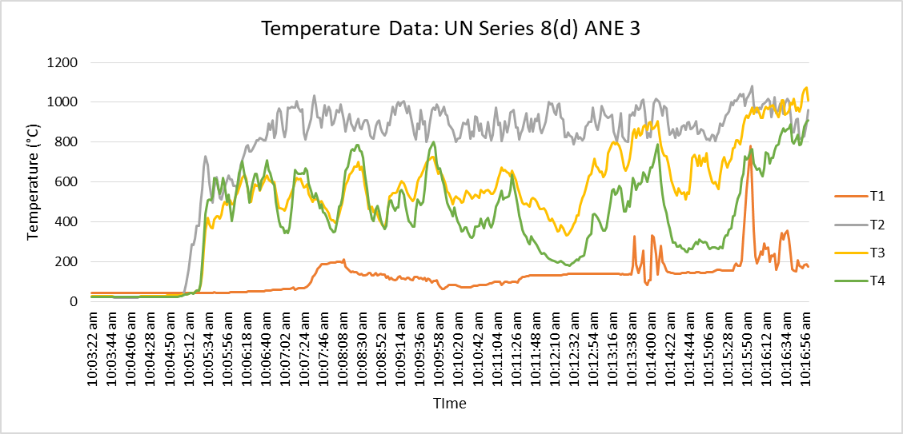
Figure 15: Temperature data for 8(d) of ANE 3

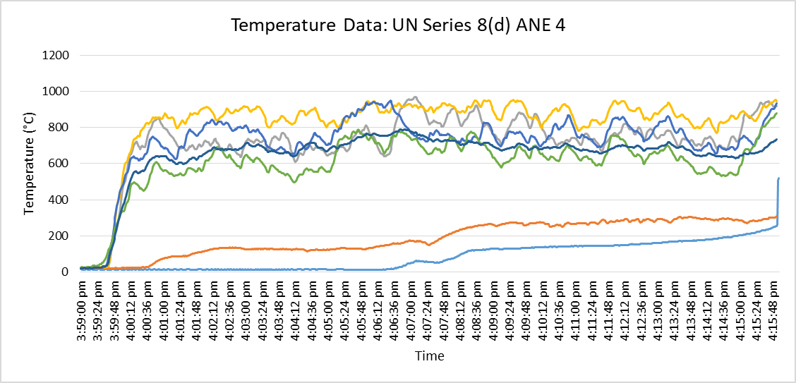
Figure 16: Temperature data for 8(d) of ANE 4

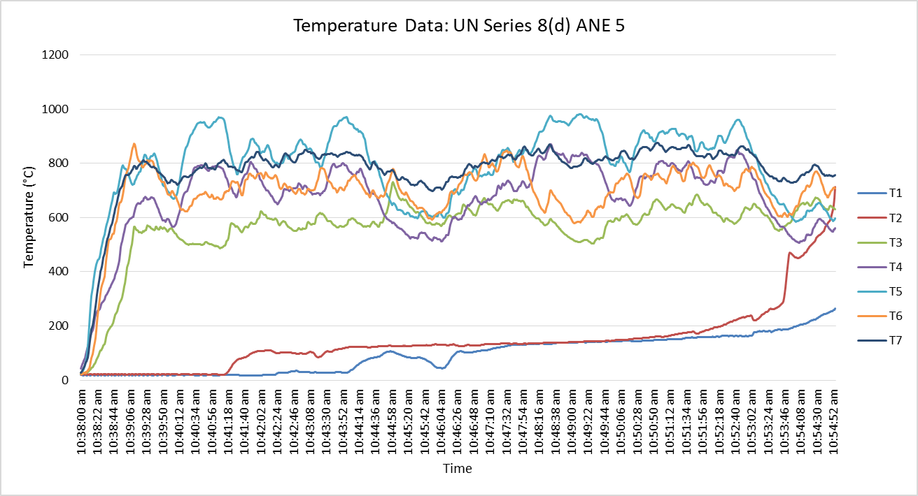
Figure 17: Temperature data for 8(d) of ANE 5

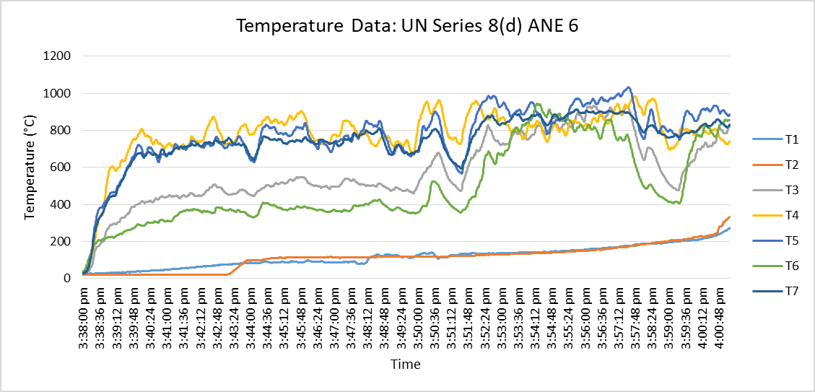
Figure 18: Temperature data for 8(d) of ANE 6

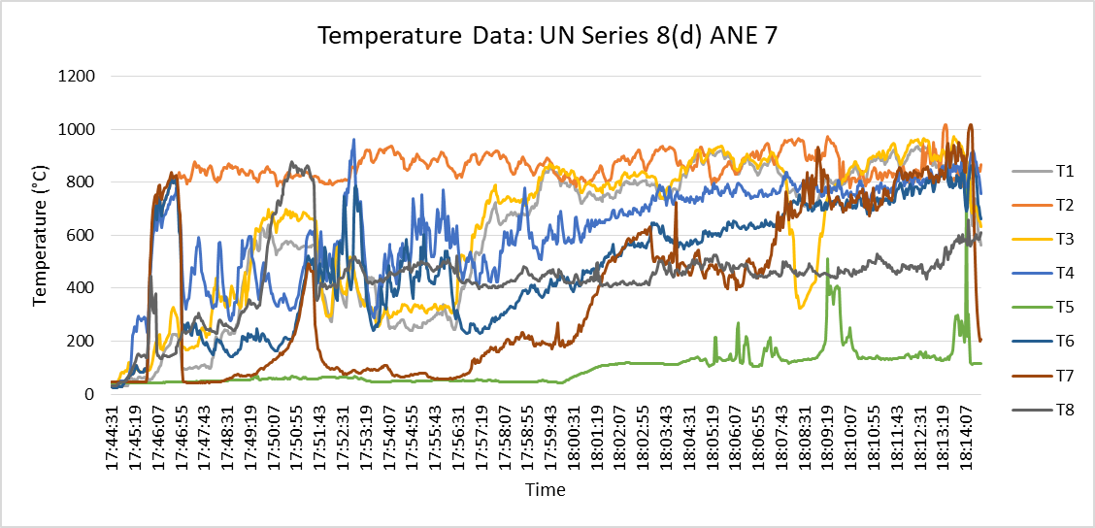
Figure 19: Temperature data for 8(d) of ANE 7

Modified tanker test: thermal trace

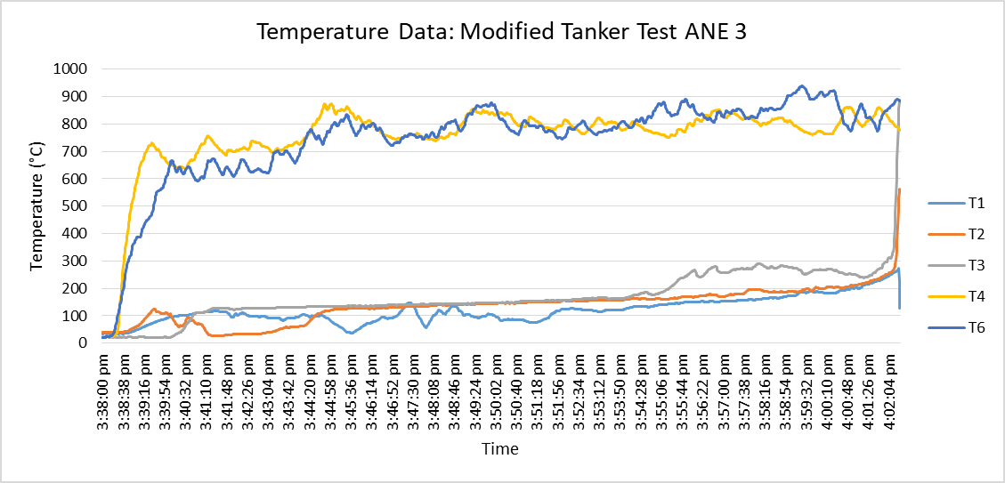
Figure 20: Temperature data for modified tanker test of ANE 3

