|  |  |  |  |
| --- | --- | --- | --- |
|  | United Nations | ST/SG/AC.10/C.3/2023/16 | |
| _unlogo | **Secretariat** | | Distr.: General  20 April 2023  Original: English |

**Committee of Experts on the Transport of Dangerous Goods  
and on the Globally Harmonized System of Classification  
and Labelling of Chemicals**

**Sub-Committee of Experts on the Transport of Dangerous Goods**

**Sixty-second session**

Geneva, 3-7 July 2023

Item 2 (f) of the provisional agenda

**Explosives and related matters:   
review of packaging and transport requirements  
for ammonium nitrate emulsions**

Proposal to remove the requirement of test series 8(d) for assessing the suitability of ammonium nitrate emulsions for transport in portable tanks

Transmitted by the Institute of Makers of Explosives (IME)[[1]](#footnote-2)

Introduction

1. Ammonium nitrate emulsions (ANEs) have been transported in bulk containers on road since the 1980s. There have been several fires reported during transport of bulk ANEs that have not resulted in an explosion. Figure 3 (see annex) shows an example of an ANE trailer fire that did not lead to an explosion. Only one known event in all that time resulted in a detonation.

2. IME has reservations about the reliability of test series 8(d) to predict the bulk behavior of ANEs in incidents where they are involved in fires for two reasons. First, past modeling showed that the 8(c) Koenen test can yield false positives. The 8(d) test is in effect a scaled up Koenen Test. Second, a recent incident in Western Australia involving an ANE resulted in a detonation, showing that the 8(d) test can yield false negatives.

3. ANEs, in particular emulsions, have a high water content which provides an inerting medium as well as a heat sink. This high water content results in a substance that has a high minimum burning pressure (MBP). The MBP is measured in the test series 8(e) for ANEs.

4. This document proposes that those ANEs that are subject to and satisfy the 8(e) test be excluded from the 8(d) test.

5. All figures referred to in this document may be found in the annex hereto.

Background

6. For ANEs to be included in division 5.1 they need to pass test series 8(a), 8(b), and 8(c), or if the substance failed the 8(c) test and had a time to reaction in 8(c) longer than 60 seconds and a water content greater than 14 % they need to pass the test series 8(a), 8(b), and 8(e). In addition, test series 8(d) has been included as a method to assess suitability of the ANE for containment in portable tanks.

7. At the sixtieth session of the Sub-Committee, IME submitted official document ST/SG/AC.10/C.3/2022/18 providing numerical modeling results, covering transport of ANEs in stainless steel portable tanks, supporting the findings published in informal document INF.8 (fifty-eighth session) showing the heat, momentum and mass transport phenomena that take place within a tank containing an ANE that is subject to an external fire. The model, based on heat and fluid flow determined experimentally from truck tire and diesel fuel scenarios, included kinetics of the decomposition of ANE and the formation of a crust (mainly AN) during a fire scenario.

8. The modeling results supported observations in the field in which no detonation resulted from involving fires. When the model was applied to ANE formulations that failed the 8(d), similar results were generated. This provides a scientific basis for the proposal to exclude the requirement of the 8(d) test for ANEs that pass the 8(e) test on the grounds that the 8(d) test can produce false positives for certain ANEs.

Discussion

9. Until recently, transport fires with ANEs have not resulted in an explosion. A transport fire in Western Australia in October 2022 showed the effect of prolonged heating of the ANE. There was an explosion of the ANE after approximately two hours of exposure to fire. This event is described in the annex to this document.

10. According to the Australian Department’s communique[[2]](#footnote-3) "the trailer was correctly loaded with authorized ANE”. It is presupposed that this means that the ANE was subjected to the 8(d) test and passed it, as the test is required by Western Australia’s competent authority.

11. The ANE transport event in Western Australia indicates that ANEs that have been assessed in test series 8(d) and are approved for transport in portable tanks as an oxidizing substance can explode during a fire event. The outcome calls into question the reliability of the 8(d) test on the grounds that it can produce false negatives.

12. ANEs, in particular emulsions, typically have 60-75 % ammonium nitrate, with the rest being predominantly water. Water provides both an inerting medium as well as a heat sink due to its high heat of evaporation. However, if the ANE is subjected to prolonged heating, the water will evaporate, leaving behind a hot and reactive mass of ammonium nitrate and any organic material that has not vaporized during the heating. An explanation for the event in Western Australia is that the ANE, after approximately two hours of exposure to fire, exploded because the resulting mass was mostly ammonium nitrate in the form of a molten decomposing mass.

13. Ammonium nitrate solid, transported as UN 1942 and UN 2067, requires only test series 2. Its behavior under heating is well understood, and the focus during storage is to eliminate sources of heat. During transport, should there be a fire, the emergency procedure mandates evacuation since there is a likelihood that the product could explode.

14. In the event of a fire during transport involving an ANE, the response mandated is also evacuation. Since ANEs contain water, this inerting medium provides additional time for the evacuation process. The ANE event in Western Australia, for example, showed that the fire burned for two hours before there was an explosion. In contrast, the progression to an explosion from fires involving solid ammonium nitrate has been in the order of 20-30 minutes, noting that not all fires progress to an explosion.

15. The MBP, which is measured in the 8(e) test provides insight into the behaviour of an ANE. The MBP is a direct function of water – increasing in value as the water content is increased. In event of a transport emergency, as in the case of a fire, an ANE with a higher MBP will provide a longer evacuation time.

Proposal

16. ANEs that satisfy the acceptance criteria of the 8(e) test should not need to be subjected to the 8(d) test and should be considered suitable for containment in portable tanks as oxidizing substances since their MBPs far exceed the pressures at which portable tanks will fail.

17. Amend footnote b of table 18.1 in section 18.2 of the Manual of Tests and Criteria (MTC) as shown below (new text is indicated in underlined text):

“ b *These tests are intended for evaluating the suitability of ANEs for containment in portable tanks as an oxidizing substance. ANEs that satisfy the acceptance criteria of Test 8 (e) need not be subjected to Test 8 (d) as they are already considered suitable for containment in portable tanks as an oxidizing substance*.”

18. Amend the first paragraph of section 18.7.1.1 of the MTC as shown below (new text is indicated in underlined text):

“This test is not intended for classification but is included in this Manual for evaluating the suitability for containment in portable tanks as an oxidizing substance. ANEs that satisfy the acceptance criteria of Test 8 (e) need not be subjected to Test 8 (d) as they are already considered suitable for containment in portable tanks as an oxidizing substance.”

19. Amend the first paragraph of section 18.7.2.1 of the MTC as shown below (new text is indicated in underlined text):

“This test is not intended for classification but is included in this Manual for evaluating the suitability of a candidate for "ammonium nitrate emulsion or suspension or gel, intermediate for blasting explosives", to be contained in portable tanks as an oxidizing substance. ANEs that satisfy the acceptance criteria of Test 8 (e) need not be subjected to Test 8 (d) as they are already considered suitable for containment in portable tanks as an oxidizing substance.”

20. Amend section 18.8.1.1 of the MTC as shown below (new text is indicated in underlined text):

“18.8.1.1 Introduction

This test is used to determine the sensitiveness of a candidate ammonium nitrate emulsion or suspension or gel, intermediate for blasting explosive, to the effect of intense localized thermal ignition under high confinement. This test can be performed in case of a positive ("+") result in Test 8(c) when the time to reaction in this test has exceeded 60 seconds and the substance has a water content greater than 14 %.

This test is also applicable for determining the suitability of ANEs for containment in portable tanks as an oxidizing substance.”

21. Amend section 18.8.1.4.1 of the MTC as shown below (new text is indicated in underlined text):

“18.8.1.4.1 The result is considered positive ("+") and the substance should not be classified in Division 5.1 if the MBP is less than 5.6 MPa (800 psig). Substances with MBPs equal to or greater than 5.6 MPa (800 psig) are considered suitable for containment in portable tanks as an oxidizing substance (see 18.8.1.1).”

Annex

Transport fire in Western Australia in October 2022

1. On 24 October 2022 the rear trailer of a road train traveling on the Great Central Highway approximately 150 km east of Laverton (Western Australia), containing approximately 34 tonnes of ANE [compliant with Test Series 8(a)-(d)], caught fire on the rear passenger side wheels. Following failed attempts to extinguish the tire fire the driver disconnected the rear trailer and evacuated to a safe distance. Approximately 2 hours post start of the fire, an explosion occurred, destroying the trailer (Figures 1 and 2)[[3]](#footnote-4). A crater (approximately 15 m x 17 m wide and 1 m deep) formed, and shrapnel was found up to 800 m from the centre of the explosion. No injuries or fatalities resulted from the explosion. This event is the first ANE Transport truck fire incident where an explosion was observed. An investigation by the Western Australia Department of Mines is still ongoing.

**Figure 1: Cloud resulting from ANE trailer explosion (Western Australia)**[[4]](#footnote-5)

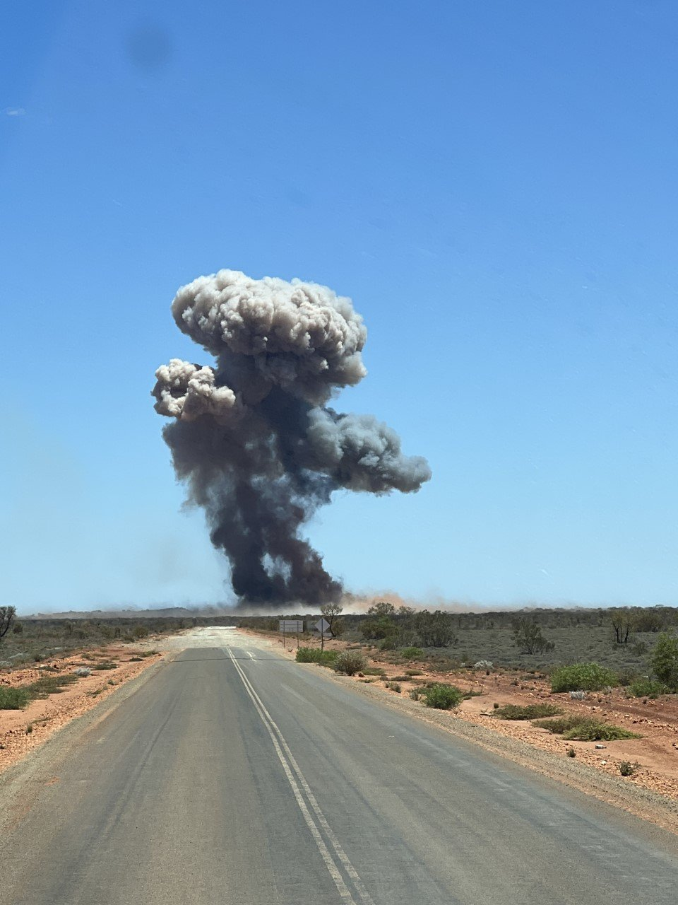

**Figure 2: Crater resulting from ANE trailer explosion (Western Australia)**

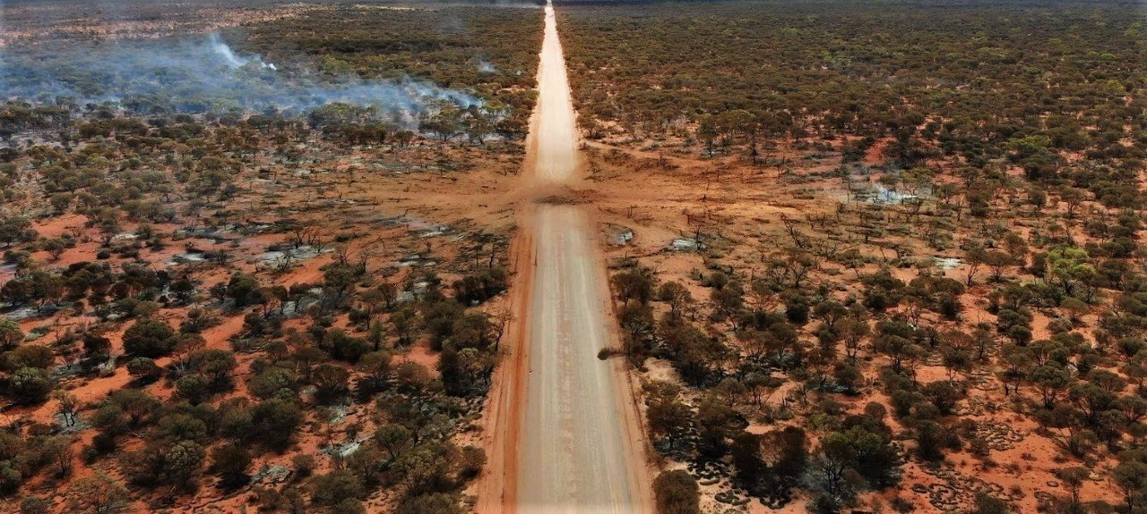

**Figure 3: ANE transport incident 12 March 2018 in Queensland (SAFEX Incident Notice IN18-01)**

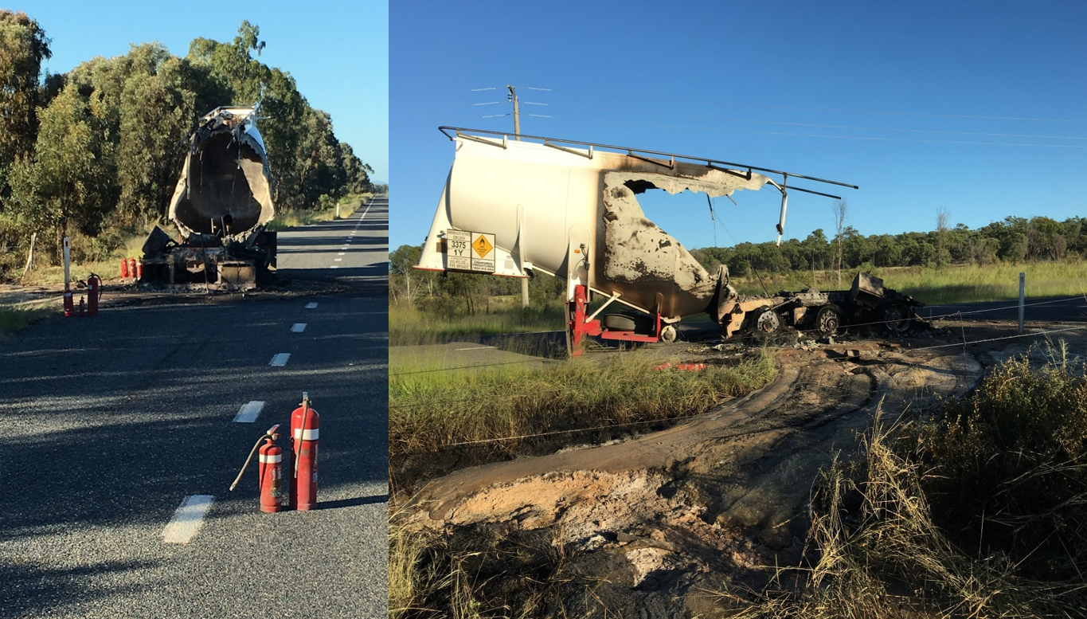

1. A/77/6 (Sect. 20), table 20.6 [↑](#footnote-ref-2)
2. [Incident alert - Ammonium nitrate emulsion tanker trailer explosion (dmp.wa.gov.au)](http://www.dmp.wa.gov.au/Documents/Dangerous-Goods/DGS_IncidentAlert_ANETanker.pdf) [↑](#footnote-ref-3)
3. Government of Western Australia – Department of Mines, Industry Regulation and Safety DGS – Incident Alert, November 8, 2022; https://www.abc.net.au/news/2022-11-03/truck-explosion-wa-goldfields-mining-blasting-/101609164 [↑](#footnote-ref-4)
4. https://www.abc.net.au/news/2022-11-03/truck-explosion-wa-goldfields-mining-blasting-/101609164 [↑](#footnote-ref-5)