|  |  |  |  |
| --- | --- | --- | --- |
|  | United Nations | ST/SG/AC.10/C.3/2023/9 | |
| _unlogo | **Secretariat** | | Distr.: General  11 April 2023  Original: English |

**Committee of Experts on the Transport of Dangerous Goods  
and on the Globally Harmonized System of Classification  
and Labelling of Chemicals**

**Sub-Committee of Experts on the Transport of Dangerous Goods**

**Sixty-second session**

Geneva, 3-7 July 2023

Item 6 (d) of the provisional agenda

**Miscellaneous proposals for amendments to the Model Regulations**

**on the Transport of Dangerous Goods: Other miscellaneous proposals**

Proposal for the maximum permitted stacking load applicable for overpack with intermediate bulk containers

Transmitted by the expert from China[[1]](#footnote-2)

Introduction

1. In 6.5.2.2.2 of the Model Regulations, the maximum permitted stacking load applicable for intermediate bulk containers (IBCs) shall be displayed on a symbol as shown in figure 6.5.1 or figure 6.5.2 below. The symbol shall be durable and clearly visible.

**Figure 6.5.1 Figure 6.5.2**

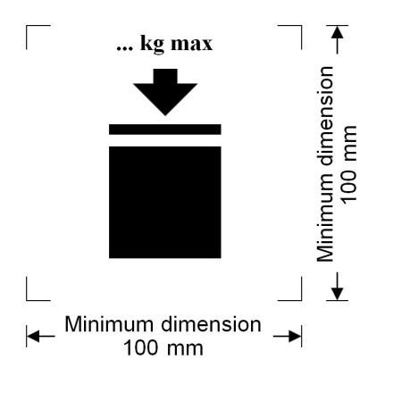 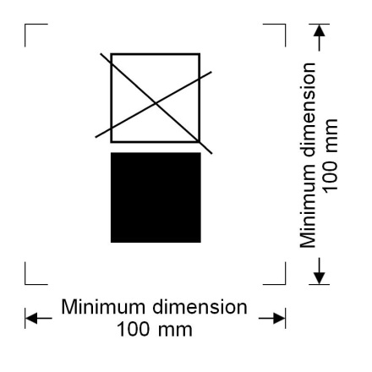

Minimum dimension

100 mm

Minimum dimension

100 mm

Minimum dimension

100 mm

Minimum dimension

100 mm

IBCs capable of being stacked IBCs NOT capable of being stacked

Here is an example:

|  |  |  |
| --- | --- | --- |
|  |  |  |

2. But when an overpack is used, the symbol appearing on IBCs inside the overpack may not be clearly visible. It may cause safety risk if the special handling instructions is not shown on the outside of the overpack, especially for the IBCs like 13L2 (coated textile) or 13M1 (multiwall paper).

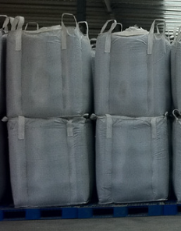3. Obviously, when an overpack is used, the IBCs may be stacked in the overpack. The maximum permitted stacking load for the whole overpack may be different from that of any single IBC inside. So, it should be required that the maximum permitted stacking load for the whole overpack shall be displayed in addition.

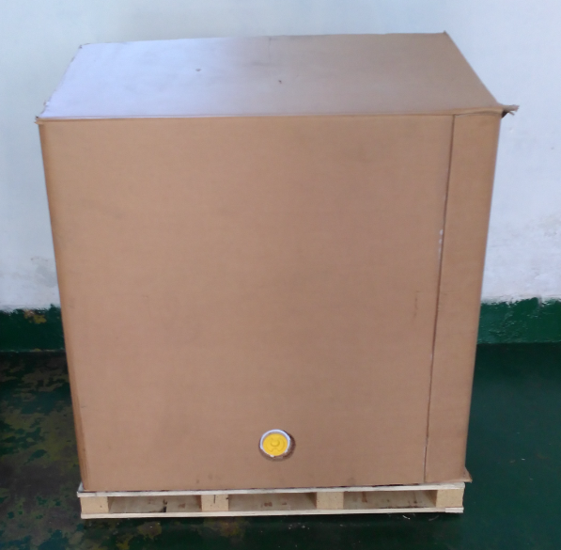

？

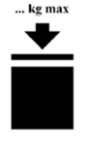



Proposal

4. China proposes to amend 5.1.2.1 and 6.5.2.2.2 to read as follows (the deleted text appears in ~~strikethrough~~ and new text in **bold underlined**):

“5.1.2.1 Unless marks and labels representative of all dangerous goods in the overpack are visible, the overpack shall be:

(a) marked with the word “OVERPACK”. The lettering of the “OVERPACK” mark shall be at least 12 mm high; ~~and~~

(b) labelled and marked with the proper shipping name, UN number and other marks, as required for packages by Chapter 5.2, for each item of dangerous goods contained in the overpack~~.~~**; and**

**(c) displayed on a symbol as shown in Figure 6.5.1 or Figure 6.5.2 about the maximum permitted stacking load for the whole overpack when IBCs packages inside the overpack.**

Labelling of overpacks containing radioactive material shall be in accordance with 5.2.2.1.12.

***NOTE:*** The size requirement for the “OVERPACK” mark shall apply as from 1 January 2016.”

“6.5.2.2.2 The maximum permitted stacking load applicable **for IBCs and overpack with IBCs** shall be displayed on a symbol as shown in Figure 6.5.1 or Figure 6.5.2. The symbol shall be durable and clearly visible.”

1. A/77/6 (Sect. 20), table 20.6 [↑](#footnote-ref-2)