Proposal for amendments to UN Regulation No. 13
Proposal for a Supplement to the 11, 12 and the 13 series of amendment to UN Regulation No.13 (Heavy vehicle braking)

I. Proposal
Paragraph 5.1.2.4.3.1., amend to read:
“5.1.2.4.3.1. It shall be deemed to comply with the requirements in paragraphs 5.1.2.4.1. and 5.1.2.4.2., if the vehicle equipped with the endurance braking system is able to store and/or dissipate (e.g. with an extra-endurance brake) the energy of the maximum negative vertical height difference (requiring energy storage capacity in the traction battery), limited to the energy level as required to fulfil the requirements in paragraphs 5.1.2.4.1. and 5.1.2.4.2., that can be reached by the vehicle (consuming stored energy in the traction battery on the journey towards the relevant negative vertical height difference), considering the current electric state of charge, using methods such as a global navigation satellite systems combined with a topography model and an intelligent battery management system.
This shall be demonstrated to the satisfaction of the Technical Service, including through the test specified in Annex 4, paragraph 1.8.2.5 (a) and submission of detailed documentation explaining the strategies implemented in the system and how this ensures endurance braking requirements can always be met.”

II. Justification
1. A query was raised in WP.15 (ECE-TRANS-WP15-113-GE-inf6e) over the amendments made by supplement 18 of the 11 series of amendments to Regulation No.13. This introduced special requirements on endurance brakes for vehicles utilising for those using regenerative braking systems. This was adopted at WP.29 as WP.29/2021/12 (ECE-TRANS-WP29-2021-012e) and based on GRVA-07-71-rev1 (ECE/TRANS/WP.29/GRVA-07-73r1e).
2. OICA provided details to WP.15 (ECE-TRANS-WP15-113-GE-inf16e) as to the expected testing regime.
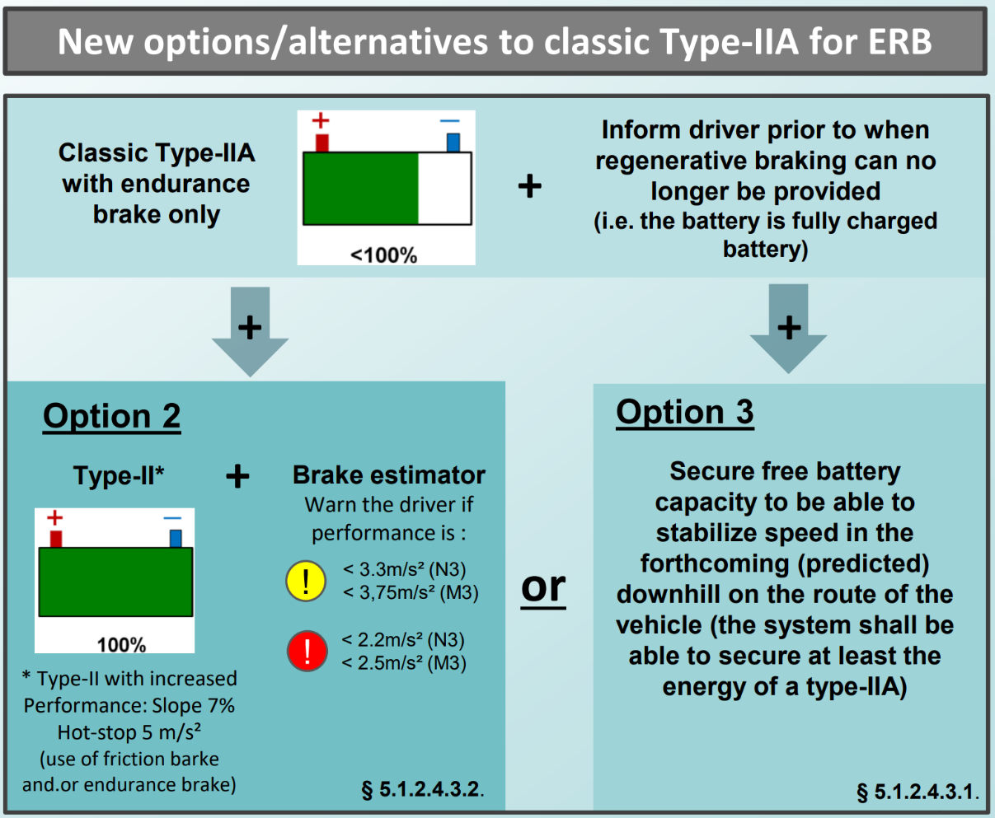
3. In reviewing the adopted provisions, the UK does not consider that it is abundantly clear that the Type IIA test should always be performed at least in the case where the battery is in a state of charge that it is expected absorb the energy from the decent of the vehicle.
4. The proposal is a clarification to make the current understanding more precise. It is also noted that the drafting around these provisions is not ideal and that more work is needed to ensure that the requirements are understandable and not open to misinterpretation.

