UN Regulations Nos. 13 & 13-H Electrical Brake System Drafting Guidance
Introduction
CLEPA has indicated that new braking technology, employing both electric control transmission and electric energy transmission, is under development. They have been working extensively on an amendment for UN Regulation No. 13 (R.13) to permit the use of this technology on vehicles of categories M₂, M₃, N₂ and N₃. Separately, interest is growing in the use of such technology on vehicles of categories M₁ and N₁; this will require amendments to UN Regulation No. 13-H (R13H). N₁ vehicles may be approved to either R.13 or R.13H and so, ideally, R.13 and R.13H should remain aligned.
The requirements for brake system architecture in both R.13 and R.13H provide for vacuum, hydraulic, hydraulic with stored energy, and pneumatic systems. There is also provision for electric control transmission which can be coupled with a pneumatic energy transmission. Up to this time, the work undertaken for R.13 envisages braking systems where the whole of the brake transmission (control and energy) is electric. However, there is also interest in hybrid transmissions where an electric transmission may be combined with a hydraulic or a pneumatic transmission. In addition, any regulatory amendment must recognise that the transmission may utilise electric or electronic signals.
The draft proposals to amend R.13 provide for a system architecture that has similarities with pneumatic systems of today. However, the move toward battery electric vehicles provides opportunities for a different approach where the battery pack provided for the traction motors may also provide energy for the vehicle’s safety systems, (e.g., brakes and steering).
At the GRVA Workshop on Electro-Mechanical Braking (Brussels, 29-30 March 2023), proposals were made to introduce definitions for, Energy Source, Energy Supply and Energy Reserve. These terms are used in both R.13 and R.13H and are largely understood for the systems of today. However, this understanding does not easily translate to the new technology that is envisaged. The ambition for the definitions was to provide clarity and guidance for adaptation to technical advance. However, it was considered that, even with new definitions, barriers may still exist that limit innovation. It was suggested that expressing the core performance criteria of the regulations, at least during the drafting process, may offer a way forward.
The following text sets out seven principles and describes how they could be used to help draft provisions for new technology while still respecting the intent of the regulation. They are intended to be performance based and to avoid restrictions that may be implied by definitions. They are not intended for inclusion in the regulation but, if used as part of the drafting exercise, they may help identify suitable descriptive text for inclusion at a later stage.
The value of the principles can only be fulfilled if the drafting group has insight into the architecture envisaged for the new braking technology. The examples given are based upon what has been shared to date.

Current Systems
The most basic requirement of a motor vehicle braking system is that it is comprised of two independent circuits each acting on at least two wheels. Together the circuits must ensure service brake performance and, individually each circuit must be capable of providing secondary brake performance.
For braking systems that rely on the use of reserves of energy, controlled by the driver, to apply an actuating force at the brake, each of the independent circuits of the braking system must have its own independent reserve of energy.
Reserve of Energy should not be confused with energy reservoir. In Annex 7 of R13 there is reference to an Energy Storage Device. In Part A and Part B (pneumatic and vacuum systems respectively), Energy Storage Device is qualified as meaning “energy reservoir”. In Part C (Hydraulic braking systems with stored energy) it is qualified as meaning “energy accumulator”. It is clear that the reservoir/accumulator is a device that stores a reserve of energy. This understanding is directly translatable to a storage device in an electric braking system.
Written to accommodate known technology, both R.13 and R.13H (which was derived from R.13) expect that the reserves of energy will remain at a value that permits continuous compliance with the performance requirements of the regulations. Hence, in addition to the braking circuits and their reserves, the regulations specify the minimum performance of an energy supply that will replace the energy consumed by the braking system. It is further expected that this supply will be available at all times that the vehicle’s engine is running; the supply relies upon a source of energy.
A failure in any of the circuits must be warned to the driver. In addition, energy reserves must be monitored and, in the event that they fall to a level at which the brake system performance is compromised, the driver must be warned.

The essential principles of the regulations are therefore that a braking system employing stored energy:
- May have a vacuum, hydraulic, pneumatic, electric, or mixed medium transmission.
- The transmission must comprise at least two independent braking circuits each acting on a minimum of two wheels.
- Each of those circuits must have its own independent reserve of energy, each contained in its own energy storage device (reservoir or accumulator).
- The value of each reserve of energy (e.g., pressure) must be monitored, and a warning system must be provided to alert the driver if the value falls below a level at which the prescribed braking performance cannot be ensured.
- At all times that the vehicle is able to be driven (or be in motion), and there are no faults present in the system, the total value of the reserves of energy has to be sufficient to satisfy the performance requirements of regulations.
- When isolated from its supply, the total reserve of energy must allow a defined number of full brake applications to be made and for there still be sufficient energy remaining to ensure secondary braking performance is available.
- The energy reserve of each circuit must be maintained at a level that can ensure secondary brake performance should a fault/failure occur in the other circuit.

(Note: For current technology “full brake application” is understood to mean that the control valve is fully open to permit the brake system to consume the maximum amount of energy required for a brake actuation. A new understanding is necessary for electrical brake systems. This must recognise differences in how energy is consumed by the brake).
In drafting provisions for new technology, it shall be ensured that these principles are fulfilled.

Three examples are shown below that assess the basics of a system against these principles:

Example 1: Pneumatic System
A simple interpretation of the regulatory requirements, for a pneumatic (compressed air) system, is shown in Figure 1.

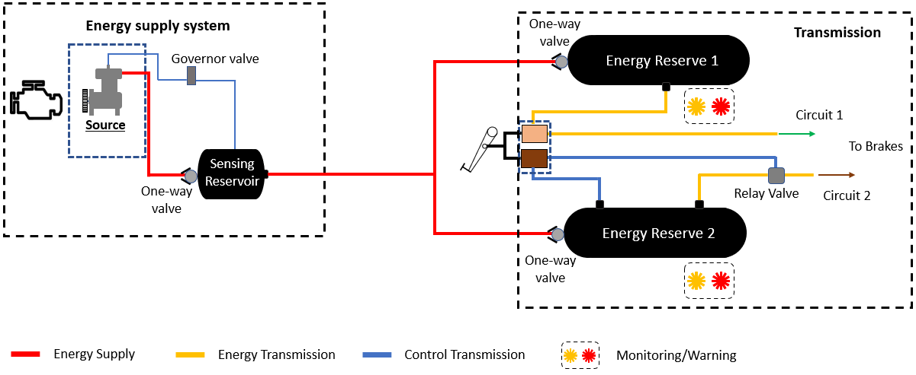
Figure 1. Simple brake arrangement (system relying on an energy reserve controlled by the driver).

Principle 1. The transmission of the braking system is:

vacuum /hydraulic / pneumatic / electric / mixed medium

Principle 2. The transmission must comprise at least two independent braking circuits each acting on a minimum of two wheels.

One-way valves in the energy supply, and a dual control valve, ensure the independence of circuits 1 and 2. Not shown, but each circuit acts on at least two wheels.

Principle 3. Each of those circuits must have its own independent energy reserve.

One-way valves fitted to each of two reservoirs provide separation of the two reserves,

Principle 4. The value of each reserve must be monitored, and a warning system must be provided to alert the driver if the value falls below a prescribed level.

The pressure in each reservoir is continuously monitored and an appropriate warning activated if that pressure drops to a value where the brake system performance is compromised. The effectiveness of the braking system under these failure warning conditions can be assessed during type-approval.

Principle 5. At all times that the vehicle is able to be driven (or be in motion), and there are no faults present in the system, the total value of the energy reserves has to be sufficient to satisfy the performance requirements of regulations.

An energy source (compressor), mechanically driven from the vehicle’s engine, is managed by a governor valve to provide energy to the energy reserve and maintain it between upper and lower limits. The function and effectiveness can be verified at type-approval (Annex 7).

Principle 6. When isolated from its supply, the total energy reserve must allow a defined number of full brake applications and still be sufficient to ensure secondary braking at the end.

This is a matter of the dimensioning of the reservoir, the reserve, and the brake actuators. It can be verified at type-approval (Annex 7).

Principle 7. The energy reserve of each circuit must be maintained at a level that can ensure secondary brake performance should a fault/failure occur in the other circuit.

The provision of one-way valves or, more typically today, system protection valves, in the brake circuits ensures a single fault cannot affect both circuits. The dimensioning of the components of the individual circuits provides for the system performance. Compliance can be tested as part of type-approval (Annex 4).

Example 2: Electric System A.
Modelled on a “conventional” pneumatic arrangement as foreseen by the CLEPA proposal for R.13.

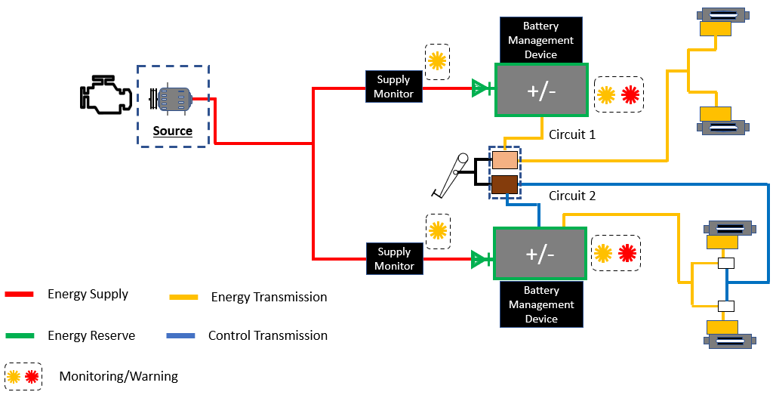
Figure 2. Electric braking system with internal combustion engine

In the above example different energy supply systems could be envisaged. These may require additional language in the regulations, including specific performance requirements, but would not affect compliance with the core principles. See below:

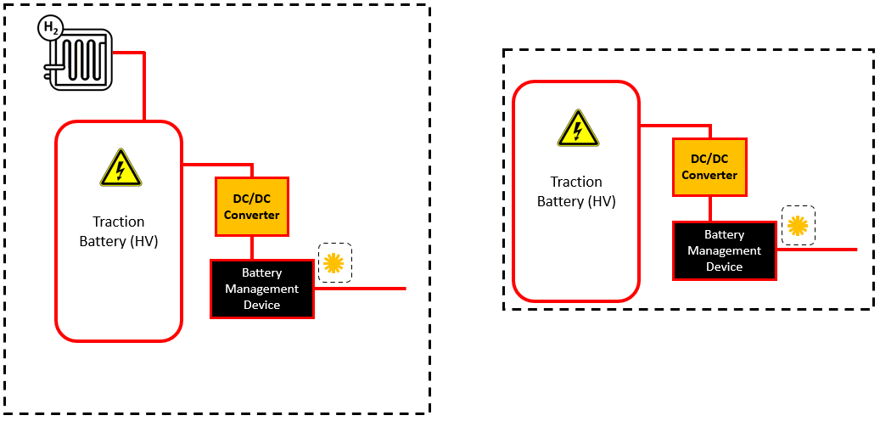

Figure 3. Alternative electrical energy supply systems

Principle 1. The transmission of the braking system is:

vacuum / hydraulic / pneumatic / electric / mixed medium

Principle 2. The transmission must comprise at least two independent braking circuits each acting on a minimum of two wheels.

Diodes, located in the energy supply to the energy storage devices (e.g., batteries), and a dual control valve, ensure the independence of circuits 1 and 2. Not shown, but each circuit acts on at least two wheels.

Principle 3. Each of those circuits must have its own independent energy reserve.

Diodes, located in the energy supply to the energy storage devices (e.g., batteries), ensure functional separation of the two energy reserves.

Principle 4. The value of each reserve must be monitored, and a warning system must be provided to alert the driver if the value falls below a prescribed level.

The CLEPA proposal provides for the energy to be based on the value of both Watts and Joules. These values are to be monitored and warnings provided if the values drop to a level at which the brake system performance is compromised.

In addition, the proposal includes a requirement to warn the driver if the value from the supply system is insufficient to maintain the values in the energy storage devices (e.g., batteries).

It has to be established how the actual values will be set and how they will be measured and monitored.

Principle 5. At all times that the vehicle is able to be driven (or be in motion), and there are no faults present in the system, the total value of the energy reserves has to be sufficient to satisfy the performance requirements of regulations.

An energy source (alternator), driven from the vehicle’s engine, is managed to provide energy to the energy storage devices (e.g., batteries) and maintain the reserves between upper and lower limits. This supply is monitored, and a warning provided to the driver if the supply is deficient. This function will be verified at type-approval.

It has to be established how this value will be set and how it is measured and monitored.

Principle 6. When isolated from its supply, the total energy reserve must allow a defined number of full brake applications and still be sufficient to ensure secondary braking at the end.

This is a matter of the dimensioning of the reserve and the brake actuators. It has to be verified at type-approval (Annex 7).

It is necessary to be explicit regarding what is expected by a “full brake application” as this will necessarily be different to the understanding when assessing pneumatic systems.

Principle 7. The energy reserve of each circuit must be maintained at a level that can ensure secondary brake performance should a fault/failure occur in the other circuit.

This a matter of dimensioning and the provision of circuit protection devices. The regulatory provisions must be such that this can be tested as part of type-approval (Annex 4).

Example 3: Electric System B. New Concept

In this new concept the traction battery has a dual function. It is an energy supply for circuit 1 and an energy transmission for both circuits 1 and 2.

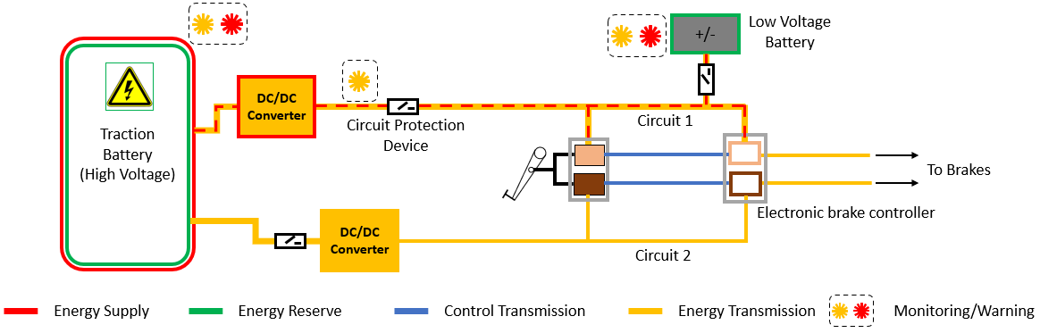
Figure 4. System concept for passenger car and light commercial vehicles.

Principle 1. The transmission of the braking system is:

vacuum / hydraulic / pneumatic / electric / mixed medium

Principle 2. The transmission must comprise at least two independent braking circuits each acting on a minimum of two wheels.

The energy transmission of both circuit 1 and 2 use a single energy reserve (contained within the traction battery) this seems contrary to the regulation. However, circuit 1 has an independent energy reserve that can provide energy to the transmission should a fault occur in the supply from the traction battery.

Challenge 1 – if the supply to circuit 1 was interrupted by a DC/DC failure, the low voltage battery (top right) would supply the energy transmission of circuit 1. Both circuit 1 and 2 would continue to operate.

Challenge 2 – A failure of the traction battery would result in the loss of energy to circuits 1 and 2, but the low voltage battery in circuit 1 (and protected would be available to ensure secondary braking.

Challenge 3 – An electrical failure in any part of the supply or transmission risks damaging both circuit 1 and 2. Protection devices are present downstream of the DC/DC converter of circuit 1 and in the feed/supply to the low voltage battery. In circuit 2 the protection device is located upstream of the DC/DC converter. These protection devices would need to meet regulatory criteria to ensure effectiveness.

This requires more study, the introduction of specific performance-based requirements, and validation procedures.

Nevertheless, it seems that the arrangement could meet the principle of having two independent braking circuits. Special consideration must be given to “redundancy” – this term is used often but can have different meanings.

Principle 3. Each of those circuits must have its own independent energy reserve.

There are two separate energy reserves but are they truly independent? The low voltage reserve is reliant on the supply function of the traction battery and in normal operation both circuits 1 and 2 will use energy from the traction battery for their operation. However, the low voltage battery is available and, under conditions where the traction battery is compromised and unable to supply energy to the energy transmission of circuit 1, the circuit will be provided with energy from the low voltage battery.

Has this a parallel with the system protection valve used today in pneumatic systems? Modern pneumatic systems do not use one-way valves as shown in figure 1. Instead, a system protection valve is employed. This valve allows the two energy reserves to interact and provide an energy reserve balance while the total energy value is above a critical limit. Only when that limit is reached does the system protection valve isolate circuit 1 from circuit 2.

This requires more study, but it seems that the intention of the regulation is met by this new arrangement, however a regulatory provision would need to be drafted to provide surety.

Principle 4. The value of each reserve must be monitored, and a warning system must be provided to alert the driver if the value falls below a prescribed level.

Here, the requirement for monitoring of the reserves of each circuit (Watts and Joules), and the provision for driver warning signals, remains. Consideration has to be given regarding how that requirement is worded today and whether additional text is required for this particular arrangement.

It is understood that the neither the high voltage (traction) or the low voltage battery will have physical separation of the energy reserve available to the braking system. This may affect how the monitoring and warnings are provided. See the next section.

Principle 5. At all times that the vehicle is able to be driven (or be in motion), and there are no faults present in the system, the total value of the energy reserves has to be sufficient to satisfy the performance requirements of regulations.

The use of the traction battery for both the energy supply and the energy transmission raises a concern given the high demand on that battery from the traction motors. It will be necessary to ensure that the traction battery can guarantee the necessary availability of energy for the energy supply and the energy transmission at all times – even when the supply for the traction motor(s) has been fully consumed.

This will require provisions to be drafted in the regulations, including a validation procedure. Subject to those provisions it seems the intention of Principle 4 can be met.

Principle 6. When isolated from its supply, the total energy reserve must allow a defined number of full brake applications and still be sufficient to ensure secondary braking at the end.

This links to the consideration of Principle 5.

Provisions need including in Annex 7 so that the traction battery (and the low voltage battery) are dimensioned in such a way that the guaranteed energy reserve for the braking system is sufficient for this requirement. The provision would need to provide for the traction battery to be conditioned such that, during the assessment, the brake transmission receives only the energy that is guaranteed to be available.

Provided such a condition can be fulfilled, it seems the intent of Principle 6 can be met.

Principle 7. The energy reserve of each circuit must be maintained at a level that can ensure secondary brake performance should a fault/failure occur in the other circuit.

This a matter of dimensioning and the provision of circuit protection devices. The regulatory provisions must be such that this can be tested as part of type-approval (Annex 4).

Provided such a condition can be fulfilled, it seems the intent of Principle 7 can be met.

Energy reserve employing the residual energy of a storage device.
In a battery electric vehicle, the energy demand on the traction battery by the traction motors is likely to be the highest of any demand. At the point at which the traction battery is no longer able power the traction motors (the energy reserve is too low to be effective) there will remain a residual amount of energy in the reserve.

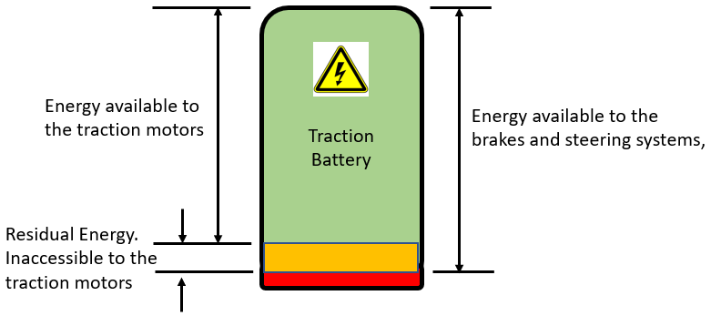
Figure 5. Natural partitioning of a battery.
Can this residual energy be considered to be an independent reserve for the purposes of a single braking circuit?
Can the value of the residual energy reserve be guaranteed?
Is this the point at which the independence of the two circuits, one powered by the low voltage battery and the other by the residual energy of the traction battery, has to be ensured?
Can the performance requirements of Annex 7 (R13), in respect to brake performance with the supply is stopped, be fulfilled when there is only residual energy available?
Can the battery be suitably conditioned to allow for the assessment of it as an energy reserve for the braking (and steering?) system?

