Proposal for:
Supplement 10 to the 07 Series of Amendments,
Supplement 02 to the 08 Series of Amendments and
Supplement 03 to the 09 Series of Amendments
of UN Regulation No. 14 (Safety-belt anchorages)

This proposal is based on informal document GRSP-72-25 and aims at adding alternative anchorage positions to UN Regulation No. 14 in order to enable extended use positions. Amendments to the text of UN Regulation 14 are indicated in bold or strike-through.

I. Proposal
Paragraph 2.2., amend to read:
"2.2. "Vehicle type" means a category of power-driven vehicles, which do not differ in such essential respects as the dimensions, lines and materials of components of the vehicle structure or seat structure to which the safety-belts anchorages are attached."
Paragraph 5.1.1., amend to read:
"5.1.1. The H point is a reference point as defined in paragraph 2.3 of Annex 4 of this Regulation, which must be determined in accordance with the procedure set out in that Annex."
Paragraph 5.1.1.2., amend to read:
"5.1.1.2. The R point is the seating reference point defined in paragraph 2.4 of Annex 4 of this Regulation."
Paragraph 5.1.2., amend to read:
"5.1.2. The three-dimensional reference system is defined in Appendix 2 of Annex 4 of this Regulation."
Insert new paragraph 5.1.7. to 5.1.7.4., to read:
"5.1.7. Additional definitions for extended use positions:
5.1.7.1. The H_{R}-point is a reference point corresponding to the H_{R}-point referred to in paragraph 5.6.1.2 of this Regulation and shall be determined for all extended use positions.
5.1.7.2. The T_{R}-line is a reference line corresponding to the T_{R}-line referred to in paragraph 5.6.1.2 of this Regulation and shall be determined for all extended use positions.
5.1.7.3. The E_{R}-plane is a reference plane corresponding to the E_{R}-plane referred to in paragraph 5.6.2.1 of this Regulation and shall be determined for all extended use positions.
5.1.7.4. The angles α_{1R} and α_{2R} are respectively the angles between the plane E_{R} corresponding to the E_{R}-plane referred to in paragraph 5.6.2.1 of this Regulation, and planes perpendicular to the center vertical longitudinal plane of the seat and passing through the H_{R}-point and the points L₁ and L₂.
If the seat is adjustable, this requirement shall be fulfilled also for the H_{R}-points of all extended use positions, as indicated by the vehicle manufacturer."
Insert new paragraph 5.6. to 5.6.5., to read:
"5.6. Alternative locations of seat belt anchorages for seats which can be used in extended use positions defined by the vehicle manufacturer
The manufacturer may define extended use positions for the seats outside their normal use positions, if the following requirements are met:
5.6.1. General requirements
5.6.1.1. The belt anchorages for any one belt may be located either wholly in the vehicle structure or in the seat structure or any other part of the vehicle or dispersed between these locations.5.6.1.2. For positions outside their normal use positions, the H_{R}-point, the torso line T_{R} and the torso angle ε_{TR} are results from the displacement of the seat cushion and / or the backrest and / or other upholsteries that may influence the position of the three dimensional H-point machine.
For the determination of the alternative locations of seat belt anchorages, the H_{R}-point, the torso line T_{R} and the torso angle ε_{TR} are used.
5.6.1.3. The belt anchorages shall be located inside the following areas, if the seat is adjusted to the additional positions of use.
5.6.2. Location of the effective lower belt anchorage (see Figure 3 of Annex 3)
5.6.2.1. The reference plane E_{R} is a plane, which is perpendicular to the longitudinal center plane of the seat and varies by the amount of the change in inclination of the seat cushion λ_{ER}, resulting from the adjustment of the seat from the R-point (for normal positions of use) to the H_{R}-point (for extended use positions).
The angles α_{1R} and α_{2R} are the respective angles between the reference plane E_{R} and planes perpendicular to the vertical longitudinal center plane of the seat, passing through the H_{R}-point and the points L₁ and L₂.
5.6.2.1.1. Front seats, vehicle category M₁
In motor vehicles of category M₁ the angle α_{1R} (other than buckle side) shall be within the range of 30 to 80 degrees and the angle α_{2R} (buckle side) shall be within the range of 45 to 80 degrees. Both angle requirements shall be valid for extended use positions of the front seats. Where at least one of the angles α_{1R} and α_{2R} is constant (e.g. anchorage fixed at the seat) in all extended use positions, its value shall be 60 ± 10°.
5.6.2.1.2. Rear seats, vehicle category M₁
In motor vehicles of category M₁ the angles α_{1R} and α_{2R} shall be within the range of 30 to 80 degrees for all rear seats. If rear seats are adjustable the above angles shall be valid for all extended use positions.
5.6.2.1.3. Front seats, vehicle categories other than M₁
In motor vehicles of categories other than M₁ the angles α_{1R} and α_{2R} must be between 30 and 80 degrees for all extended use positions of the front seats. Where in the case of front seats of vehicles having a maximum vehicle mass not exceeding 3.5 tonnes at least one of the angles α_{1R} and α_{2R} is constant in all extended use positions, its value shall be 60 ± 10° (e.g. anchorage fixed at the seat).
5.6.2.1.4. Rear seats and special front or rear seats, vehicle categories other than M₁
In vehicles of categories other than M₁, in the case of
- Bench seats and
- Other rear seats,
angles α_{1R} and α_{2R} may be between 20° and 80° in any extended use position. Where in the case of front seats of vehicles having a maximum vehicle mass not exceeding 3.5 tonnes at least one of the angles α_{1R} and α_{2R} is constant in all normal positions of use, its value shall be 60 ± 10° (e.g. anchorage fixed at the seat).
In the case of seats, other than front seats, of vehicles in categories M₂ and M₃, the angles α_{1R} and α_{2R} shall be between 45 and 90 degrees for all extended use positions.
5.6.2.1.5. If the effective lower safety-belt anchorages L₁ and L₂ are not affected by the displacement of the seat cushion from the R-point for normal use positions to the H_{R}-point for extended use positions, the angles α_{1R} and α_{2R} shall be referenced to a horizontal plane and not to the E_{R}-plane.
5.6.2.2. The distance between the two vertical planes parallel to the center vertical longitudinal plane of the vehicle and each passing through a different one of the two effective lower belt anchorages L₁ and L₂ of the same safety-belt shall not be less than 350 mm.
The center longitudinal plane of the seat shall pass between points L₁ and L₂ and shall be at least 120 mm from these points (see Figure 1 (lower part of the drawing) of Annex 3 of this Regulation).
5.6.3. Location of the effective upper belt anchorages (see Figure 3 of Annex 3)
The position of the effective upper belt anchorage point(s) shall be within the permissible area shown in Figure 3 of Annex 3 to this Regulation starting from the H_{R}-point.
Starting from the H_{R}-point, the permissible area for the effective upper belt anchorage point(s) is determined with the following segment distances and planes:
A_{L1} A segment of the torso line T_{R} measured in an upward direction from H_{R} and 563 mm long and ending in the point A_{P1};
A_{L2} segment distance of 152.4 mm length, measured vertically upwards from the A_{P1} point and ending in the point A_{P2}
A first plane A_{E1}, inclined backwards by 40° from the horizontal, is created backwards from point A_{P1}.
A second plane A_{E2} is created perpendicular to the longitudinal center plane of the seat between points A_{P1} and A_{P2}.
A third plane A_{E3}, inclined horizontally by 80° forwards, is created backwards from point A_{P2}.
The permissible area for the effective upper belt anchorage point(s) is located behind the three planes A_{E1}, A_{E2} and A_{E3}.
5.6.4. The value of S shall not be less than 140 mm.
5.6.5. If the effective upper belt anchorage point in this additional adjustment position is below the plane set out in paragraph 5.4.3.6 of this Regulation of the normal use position, the manufacturer shall demonstrate to the Technical Service, that the strength of the upper belt anchorage point is ensured.
This verification can be carried out, for example, as follows
(a) Testing according to paragraph 6 and verification by paragraph 7 of this Regulation or
(b) Testing according to Annex 7 of this Regulation.
During the test referred to in sub-paragraph (a) and (b), the effective upper belt anchorage point(s) shall be within a permissible area specified in Figure 4 of Annex 3 of this Regulation. For the purpose of this test, the seats may also be in extended use positions as described in paragraph 6.1.2 of this Regulation.
Based on the H_{R}-point, determine the permissible area shown in Figure 4 of Annex 3 to this Regulation for the effective upper belt anchorage point(s) during the test with the following segment sections and planes:
B_{L1} A segment of the torso line T_{R} measured in an upward direction from H_{R} and 450 mm long, ending with the point B_{P1}
B_{L2} A segment distance of 450mm length, measured from the H_{R}-point perpendicular to the E_{R}-plane upwards, ending with the point B_{P2}
A first plane B_{E1} is created backwards perpendicular to the torso line T_{R} and perpendicular to the longitudinal center plane of the seat at point B_{P1}.
A second plane B_{E2} is created upwards perpendicular to the E_{R}-plane and perpendicular to the longitudinal center plane of the seat at point B_{P2}.
A shell surface B_{E3} is created with a radius of 450mm in the H_{R}-point between the points B_{P1} and B_{P2} perpendicular to the longitudinal center plane of the seat.
The effective upper belt anchorage point(s) shall not move below or in front of the planes B_{E1} and B_{E2} as well as shell surface B_{E3} during the test. “
Paragraph 6.1.2., amend to read:
“6.1.2. The seats shall be fitted and placed in the position for driving or use chosen by the technical service responsible for conducting approval tests to give the most adverse conditions with respect to the strength of the system. The position of the seats shall be stated in the report. The seat-back shall, if its inclination is adjustable, be locked as specified by the manufacturer or, in the absence of any such specification, in a position corresponding to an effective seat-back angle as close as possible to 25° for vehicles of categories M₁ and N₁ and to 15° for vehicles of all other categories.
When using the seat(s) in an extended use position specified in paragraph 5.6 of this Regulation, the seat(s) shall be in the position identified by Technical Service in consultation with the manufacturer to give the most adverse conditions with respect to the strength of the system. If the inclination of the seat cushion and/or backrest is adjustable, they have to be locked as specified by the manufacturer. The position of the seats shall be indicated in the test report.”
Paragraph 7.1., amend to read:
“7.1. All the anchorages shall be capable of withstanding the test prescribed in paragraphs 6.3 and 6.4. Permanent deformation, including partial rupture or breakage of any anchorage or surrounding area, shall not constitute failure if the required force is sustained for the specified time. During the test, the minimum spacings for the effective lower belt anchorages specified in paragraph 5.4.2.5. and the requirements of paragraph 5.4.3.6. for effective upper belt anchorages shall be respected.
When using the seat(s) in extended use positions specified in paragraph 6.1.2. of this Regulation, all anchorages shall be capable of withstanding the tests prescribed in paragraphs 6.3 and 6.4.
Permanent deformation, including partial rupture or breakage of any anchorage or surrounding area, shall not constitute failure if the required force is sustained for the specified time. During the test, the minimum spaces specified in paragraph 5.6.2.2 of this Regulation for the lower effective belt anchorages and the requirements of paragraph 5.6.3 for the upper effective belt anchorage shall be respected. “
Paragraph 7.1.1., amend to read:
“7.1.1. For vehicles of category M1 of a total permissible mass not exceeding 2.5 tonnes, if the upper safety-belt anchorage is attached to the seat structure, the effective upper safety-belt anchorage shall not be displaced during the test forward of a transverse plane passing through the R point and point C of the seat in question (see Figure 1 of Annex 3 to this Regulation)
For vehicles other than mentioned above, the effective upper safety-belt anchorage shall not be displaced during the test forward of a transverse plane inclined 10° in forward direction and passing through the R point of the seat.
When using the seat(s) in extended use positions specified in paragraph 6.1.2. of this Regulation, the effective upper safety-belt anchorage shall not be displaced during the test forward of plane B_{E2} (see Figure 4 of Annex 3 to this Regulation)
The maximum displacement of the effective upper anchorage point shall be measured during the test.
If the displacement of the effective upper anchorage point exceeds the above-mentioned limitation, the manufacturer shall demonstrate to the satisfaction of the technical service that there is no danger to the occupant. As an example, the test procedure according to UN Regulation No. 94 or a sled test with corresponding pulse may be carried out to demonstrate a sufficient survival space.

Insert new Annex 3, Figures 3 and 4, to read:
“Figure 3
Areas of location of effective belt anchorages according to paragraph 5.6.2 and 5.6.3 of this Regulation for extended use positions
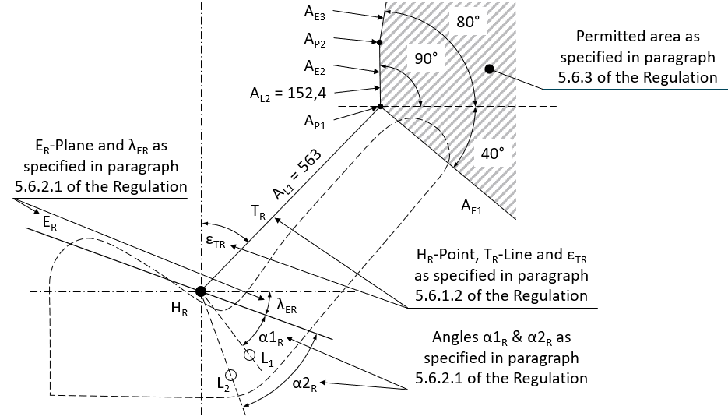
All dimensions are in mm”

“Figure 4
Permitted area of location for upper effective belt anchorages according to paragraph 5.6.5 of this Regulation for other use positions than normal ones
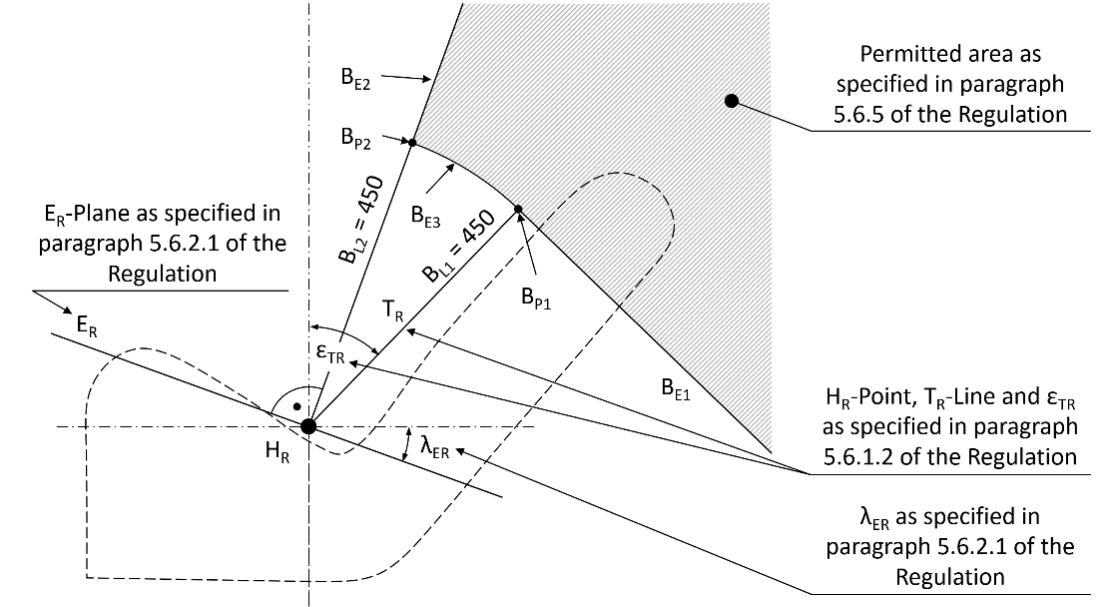
All dimensions are in mm”
Annex 6 - Appendix 1, amend to read:
"Annex 6 - Appendix 1
Location of lower anchorages — Angle requirements only
Seat |  | M₁ | Other than M₁
Front*, Φ | buckle side (α₂, α_{2R}) | 45° - 80° | 30° - 80°
 | other than buckle side (α₁, α_{1R}) | 30° - 80° | 30° - 80°
 | angle constant | 50° - 70° | 50° - 70°
 | bench - buckle side (α₂, α_{2R}) | 45° - 80° | 20° - 80°
 | bench - other than buckle  side (α₁, α_{1R}) | 30° - 80° | 20° - 80°
 | adjustable seat with seat back angle < 20° | 45° - 80° (α₂)*  20° - 80°(α₁)* | 20° - 80°
Rear ≠, Φ |  | 30° - 80° | 20° - 80° Ψ
Notes:
≠: outboard and centre.
*: if angle is not constant see paragraph 5.4.2.1.
Ψ: 45° - 90° in the case of seats on M₂ and M₃ vehicles.
Φ: For extended use positions (see paragraph 5.6. of this Regulation)"

Annex 7, Paragraph 1., amend to read:
"1. SCOPE
This annex describes a dynamic sled test that can be performed as an alternative to the safety-belt anchorages static strength test prescribed in paragraphs 6.3 and 6.4 of this Regulation.
This alternative can apply at the request of the car manufacturer in the case of a group of seats where all the seating positions are equipped with 3-point safety-belts to which thorax load limiter functions are associated and when the group of seats additionally comprises a seating position for which the upper safety-belt anchorage is located on the seat structure.
When using the seat(s) in extended use positions specified in paragraph 6.1.2 of this Regulation, this alternative can apply at the request of the car manufacturer to a group of seats where all the seating positions are equipped with 3-point safety-belts to which thorax load limiter functions are associated and if the upper belt anchorage(s) for a seat in this row are also located on the seat structure.”
Annex 7, Paragraph 2.1., amend to read:
"2.1. In the dynamic test prescribed in paragraph 3. of this annex, there shall be no rupture of any anchorage or surrounding area. A programmed rupture necessary for the functioning of the load limiter device is however permitted.
The minimum spacings for the effective lower anchorages specified in paragraph 5.4.2.5 of this Regulation, and the requirements for the effective upper anchorages specified in paragraph 5.4.3.6 of this Regulation and, when applicable, completed by the following paragraph 2.1.1, shall be respected.
When using the seat(s) in extended use positions specified in paragraph 6.1.2 of this Regulation, the minimum spaces specified in paragraph 5.6.2.2 of this Regulation for the lower effective belt anchorages and the requirements of paragraph 5.6.5 for the upper effective belt anchorage shown in Figure 4 to Annex 3 to this Regulation shall be respected.”
Annex 7, Paragraph 2.1.1., amend to read:
"2.1.1. For vehicles of category M₁ of a total permissible mass not exceeding 2,5 tonnes, the upper safety-belt anchorage, if attached to the seat structure, shall not be displaced forward of a transverse plane passing through the R point and point C of the seat in question (see Figure 1 of Annex 3 to this Regulation).
For vehicles other than mentioned above, the upper safety-belt anchorage shall not be displaced forward of a transverse plane inclined 10° in forward direction and passing through the R point of the seat.
When using the seat(s) in extended use positions specified in paragraph 6.1.2 of this Regulation, the upper safety-belt anchorage shall not be displaced during the test forward of plane B_{E2} (see Figure 4 of Annex 3 to this Regulation), if the upper safety-belt anchorage is located on the seat structure.”
II. Justification
The amendments in paragraphs 2.2., 5.1.1., 5.1.1.2. and 5.1.2. have just an editorial background correcting a missing phrase (2.2.) and the reference to the Annex 4 as the content moved to R.E.3.
The overall idea and final goal is to enable alternative seating positions (with a higher seatback inclination than today) during driving, see also GRSP-72-25. The intention of the introduced amendment is to allow occupants the use of alternative seating positions only if this will not cause any conflict with the content of other UN Regulations, which possibly need to be amended as well. Therefore, this proposal is seen as a first step and introduces requirements to the seat-belt anchorages as described in the new proposed paragraphs 5.1.7., 5.6., 6.1.2. and 7.1.
To introduce alternative seating positions into UN Regulation No. 14 provisions for the permitted area for the lower and upper belt-anchorages before the strength test and provisions for the permitted area of the upper belt anchorages during and after the test are needed.
For the permitted area before the test the upper area is based on FMVSS 210 as this would enable sufficient mounting positions even when the seatback has a higher inclination. For the lower anchorage points the permitted angle ranges shall be the same as in current UN Regulation No. 14, but they need to be tilted with the seat cushion (λ_{ER}), if the lower anchorage points are located on the seat structure.
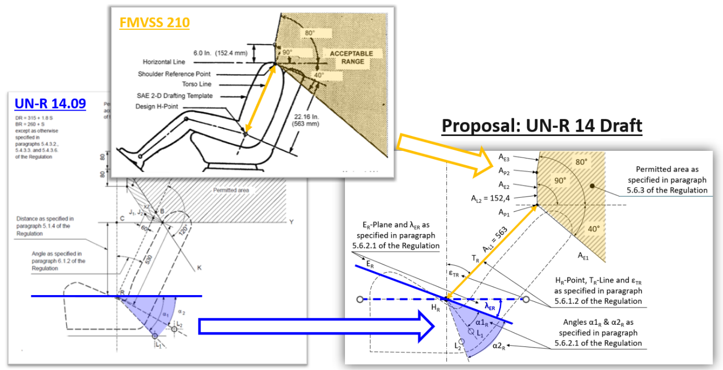

For the permitted area during and after the test, a new area must be defined for the upper belt anchorages as otherwise the current provisions regarding the CY-line can very likely not be fulfilled. The idea is to create a permitted area, whose lower boundary is limited to a distance of min. 450 mm around the H_{R} point.
