Proposal for the 04 Series of Amendments to UN Regulation No. 129 (Enhanced Child Restraint Systems) *
Submitted by the expert from the Netherlands
The text reproduced below was prepared by the Ad Hoc Group on CRS, aiming to introduce definitions, requirements and a test procedure for lower tether anchorages. The modifications to the existing text of the UN Regulation by document ECE/TRANS/WP.29/GRSP/2023/13 are marked in “bold black“ for new or strikethrough for deleted characters. The modifications made by this document are marked in “(bold) blue” for new or strikethrough for deleted characters.

- Proposal

Paragraph 2.12., amend to read:
"2.12. "Anti-rotation device". Means a device intended to limit the rotation of the Enhanced Child Restraint System during a vehicle impact and in the case of i-Size ECRS consisting of:
- A top-tether strap; or
- A support-leg.
Meeting the requirements of this Regulation and fitted to an ISOFIX anchorage system and ISOFIX top tether anchorages or vehicle floor contact surface meeting the requirements of UN Regulation No. 14 or UN Regulation No. 145.
An "Anti-rotation device" for a "specific vehicle" Enhanced Child Restraint System may comprise a top tether, a support leg, lower tether strap(s) or, any other means capable of limiting the rotation.
Paragraph 2.14., amend to read:
"2.14. "Tension relieving device" means a system, which allows to release the device that adjusts and maintains the tension in the ISOFIX top tether strap or in the lower tether strap(s)."
Insert new paragraphs 2.63. to 2.63.6., to read:
"2.63. "Lower tether anchorage (LTA)" is an anchorage on the vehicle seat track, or on or close to the vehicle floor to which a lower tether bracket can be attached or is integrated. The lower tether bracket may or may not be part of the vehicle approval.
2.63.1. "Lower tether" is a type of anti-rotation device intended to restrict the rearward rotation of a rearward-facing ECRS.
2.63.2. "Lower tether strap" is a webbing strap (or equivalent) which extends from the back of a Specific Vehicle ECRS to the lower tether anchorage in the vehicle and which is equipped with an adjustment device, a tensioning-relieving device and a lower tether connector.
2.63.3. "Lower tether connector" means a device intended to be attached to a lower tether bracket.
2.63.4. "Lower tether hook" means a connector typically used to attach a lower tether strap to a lower tether bracket and which is the same and has the same dimensions as the ISOFIX top tether hook as defined in figure 3 of Annex 4 of Regulation 145.
2.63.5. "Lower tether bracket" means the bracket that is attached to or integrated with the lower tether anchorage.
2.63.6 "Generic lower tether bracket" means the bracket provided by the ECRS manufacturer together with the ECRS, to be attached under the rail of the front seat to the hole defined as LTA, indicated by the vehicle manufacturer."
Paragraph 4.14., amend to read:
"4.14. Additional markings
The following information may be conveyed by pictograms and/or text. The marking shall indicate:
…
(c) The position and if necessary, the routing of top tethers, lower tethers, or other means of limiting Enhanced Child Restraint System rotation requiring action by the user, shall be indicated using one or more of the following symbols as appropriate:
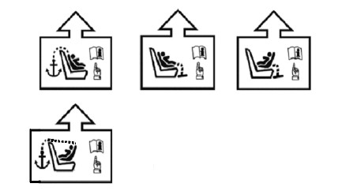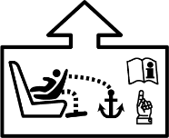"

Paragraph 6.3.4.1., amend to read:
"6.3.4.1. Top tether connector
The top tether connector shall be an ISOFIX top tether hook as shown in Figure 3(c), or similar devices that fit within the envelope given by Figure 3(c). The same connector shall also be used as the lower tether hook (if applicable; see paragraph 6.3.6.)."
Insert new paragraph 6.3.4.2.1., to read:
"6.3.4.2.1. The ISOFIX top tether straps shall fulfil the requirements specified in paragraphs 6.7.4.2. to 6.7.4.4."
Paragraphs 6.3.4.2.1 to 6.3.4.2.2.(former), renumber as paragraphs 6.3.4.2.2 to 6.3.4.2.3.
paragraph 6.3.4.2.3.2., amend to read:
6.3.4.2.2. No-slack indicator
The ISOFIX top tether strap or the ISOFIX Enhanced Child Restraint System shall be equipped with a device that will indicate that all slack has been removed from the strap. The device may be part of an adjustment and tension relieving device and shall meet the requirements of paragraph 6.7.2.
Former paragraph 6.3.4.2.3., renumber as paragraph 6.3.4.2.4. and amend to read:
"6.3.4.2.4. Dimensions
Engagement dimensions for ISOFIX top tether hooks / lower tether hooks are shown in Figure 3(c).
…
Figure 3(c)
ISOFIX top tether or lower tether connector (hook type) dimensions…………"

Paragraph 6.3.5., amend to read:
“6.3.5. i-Size Enhanced Child Restraint System support-leg and support-leg foot requirements
Support leg and support leg foot requirements for i-Size ECRS and also for Specific Vehicle ECRS that are tested on the test bench according to paragraph 6.6.4.1.2.1
i-Size These Enhanced Child Restraint Systems fitted with support-legs shall comply in all positions of use (e.g. in case of length adjustable attachment, base, etc. the shortest and longest position) with the geometrical provisions defined in this paragraph and its subparagraphs.
…”
Insert new paragraphs 6.3.6. to 6.3.8., to read:
"6.3.6. Specific vehicle belted Enhanced Child Restraint System lower tether strap specifications
6.3.6.1. The lower tether straps shall fulfil the requirements specified in paragraphs 6.7.4.2. to 6.7.4.4.
6.3.6.2. Lower tether strap length
Enhanced Child Restraint System lower tether strap length shall be at least 900 mm including lower tether connector.
6.3.6.3. Lower tether no-slack indicator
The lower tether strap of the Enhanced Child Restraint System shall be equipped with a device that will indicate that all slack has been removed from the strap. The device may be part of an adjustment and tension relieving device and shall meet the requirements of paragraph 6.7.2
6.3.6.4. Lower tether Retractor
An automatically locking retractor can be used to replace the provision for adjustment and release of the tension in the lower tether strap and the no slack indicator. In this case the retractor shall fulfil the requirements specified in paragraph 6.7.3.1.
6.3.6.5. Dimensions
Engagement dimensions for lower tether connectors (hook type) are shown in paragraph 6.3.4.2.4., Figure 3 (c).
6.3.7. Generic lower tether bracket and mounting material specifications (for applications where the vehicle manufacturer provides the generic anchorages).
6.3.7.1. The generic lower tether brackets supplied by the manufacturer of the child restraint, shall be accompanied by mounting instructions including required torque application and a note that this shall be done by qualified personnel only.
6.3.7.2. Dimensions bracket:
(a) The generic lower tether bracket shall have dimensions according to Figure 3 (f);
(b) The outer edges of the lower tether bracket shall be at least blunted.
Figure 3 (f)
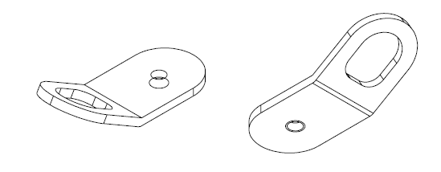
Generic Lower Tether Bracket

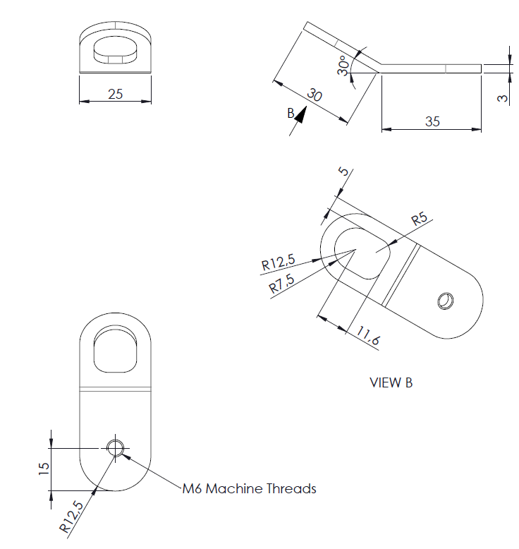
View B
M6 Machine Threads
6.3.7.3. Mounting material bracket
The mounting material shall consist of:
(a) M6x8 flange buttonhead hexagon socket-cap screw see figure 3 (g);
(b) M6 washer; see figure 3 (h);
(c) M6 -8 shoulder washer; see figure 3 (i).

Figure 3 (g)
M6x8 Flange Buttonhead Hexagon Socketcap Screw (ISO 7380-2)
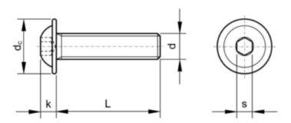
Specs M6x8
L 8 mm
d_{c} 13.6 mm
k 3.3 mm
d M6
S 4 mm
Stainless steel A2
Figure 3 (h)
M6 washer
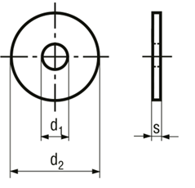
Specs M6 washer
d₁ 6.4 mm
d₂ 18 mm
S 1.6 mm

Figure 3 (i)
M6 -8 shoulder washer
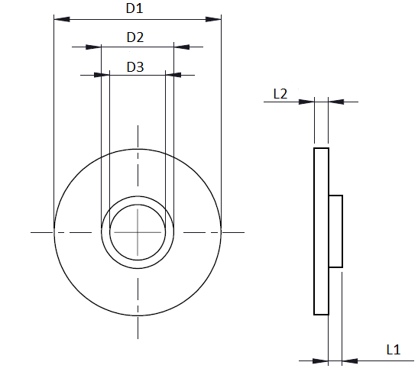
Specs M6 -8 shoulder washer
D1 18 mm
D2 7.8 ± 0.1 mm
D3 6 mm
L1 1.5 mm
L2 1.5 mm

6.3.8. Strength test generic lower tether bracket
6.3.8.1. Force application
Apply a force of 2,500 N ± 50 N to each generic lower tether bracket, by means of a representative lower tether strap 38 mm ± 3 mm wide that is fitted at one end with suitable hardware for applying the force and at the other end with a lower tether hook for the attachment to the lower tether bracket. For anchorages designed to be used for two adjacent CRS positions, or in case of a single LTA, the force shall be 5,000 N ± 100 N. At the request of the manufacturer the anchorages may be tested at higher loads as long as they fulfil the requirements.
6.3.8.2. Force direction
Two tests shall be performed; See figure 3 (j) and 3 (k)
- the force shall be applied in a direction of 55° ± 5° against plane AB, measured in a plane parallel to the rigid surface XY, and a direction of 45° ± 5° against the rigid surface XY, measured in plane AB; rotation around the anchorage point to vehicle (2) shall be prevented.
see figure 3 (j);
(b) the force shall be applied in a direction perpendicular (90 ± 5°) to the rigid surface XY.

Figure 3 (j)
Test 1
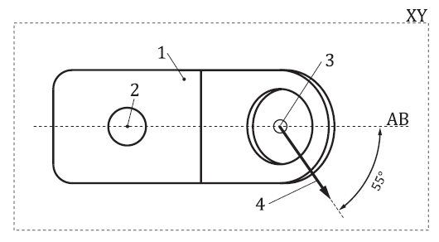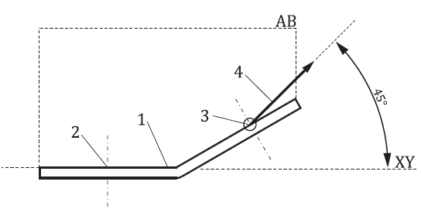
Key: 1. generic lower tether bracket (not actual design).
2. anchorage point to vehicle.
3. anchorage point lower tether hook.
4. test 1 - force direction.
5. the XY plane is located on top of the bracket (thus loading the thread inside the bracket)

Figure 3 (k)
Test 2
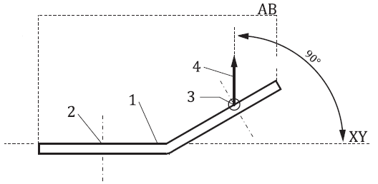

Key: 1. generic lower tether bracket (not actual design).
2. anchorage point to vehicle.
3. anchorage point lower tether hook.
4. test 2 – force direction.
5. the XY plane is located on top of the bracket (thus loading the thread inside the bracket)

6.3.8.3. The load shall be attained within 30 s, and shall be maintained for a minimum of 0.2 s.
6.3.8.4. When testing in accordance with paragraphs 6.3.8.1. to 6.3.8.3., excursion is not limited, and permanent deformation of the generic lower tether bracket with respect to the rigid structure it is attached to is acceptable provided that the anchorage does not break or separate from the rigid structure."
Paragraph 6.6.4.1.2.1., amend to read:
6.6.4.1.2.1. Enhanced Child Restraint Systems according to paragraph 2.7. and in conformity with paragraph 6.3. of this Regulation and which fit in at least an envelope defined in UN Regulation No. 16, Annex 17, Appendix 2, on the test bench prescribed in Annex 6 and in conformity with paragraph 7.1.3.1. of this Regulation or in the relevant vehicle body shell in conformity with paragraph 7.1.3.2. of this Regulation. In case the vehicle seat acts as the sole anti-rotation device, the dynamic test shall be performed in the relevant vehicle body shell.
Paragraph 6.6.4.4.1.2.1., amend to read:
"6.6.4.4.1.2.1. Head excursion: no part of the head of the dummy shall pass beyond the planes
…
Where a test is conducted with paragraphs 6.6.4.1.6.1.1. or paragraph 6.6.4.1.6.1.2. or paragraph 6.6.4.1.8.2. above, only the second test results without 100 mm diameter bar will be considered. A tolerance of +10 per cent shall be applied to the head excursion value distance between the Cr point and plane DF, and the dummy should not pass beyond the plane HI, parallel to plane DE."
Figure 5, amend to read:
"Figure 5
Test Arrangement for a Rearward-Facing Device, not supported by the dashboard
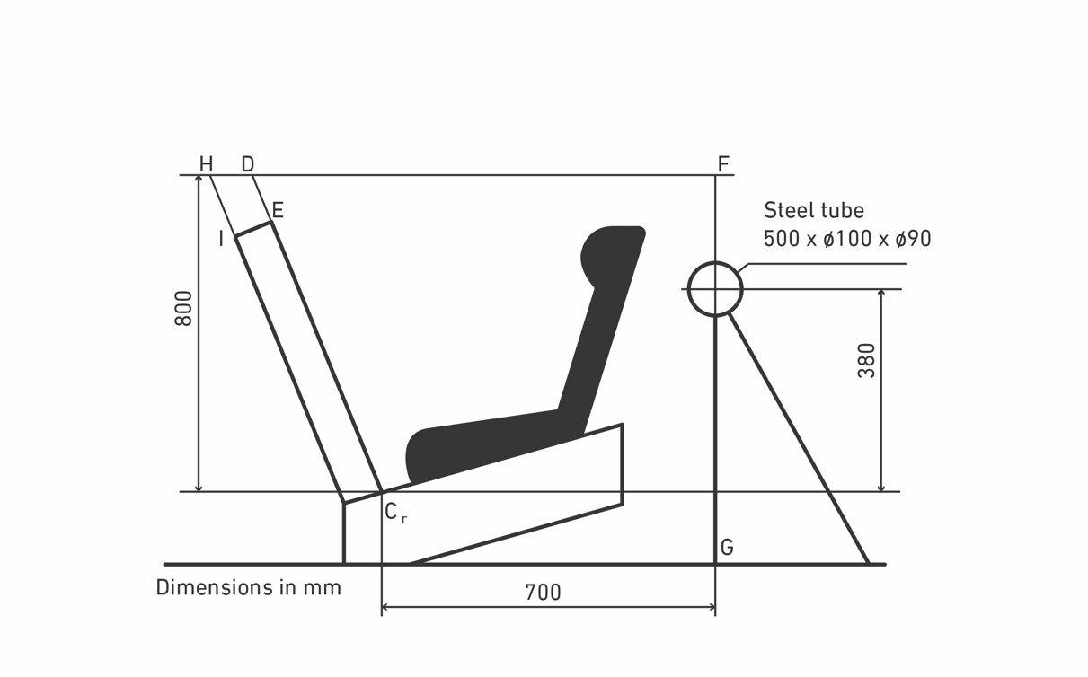"
Dimensions in mm
Steel tube
Paragraph 6.7.4.3.2., amend to read:
"6.7.4.3.2. In addition, the breaking load shall be not less than 3.6 kN for the restraints of i-Size Enhanced Child Restraint Systems."

Paragraph 7.1.3.5.2.3., amend to read:
7.1.3.5.2.3. Installation of an Integral Enhanced Child Restraint Systems "Universal Belted" Seat or Specific Vehicle Belted Seat on the Test Bench
……
Extract all webbing from the retractor spool and rewind the excess webbing keeping a tension of 4 ± 3N in the belt between the retractor and the pillar loop. The spool shall be locked before the dynamic test.
If present, the top tether or lower tether shall be adjusted to achieve a tension load of 50 ± 5N. Alternatively, and if present, the support-leg shall be adjusted according to the enhanced child restraint system manufacturer's instructions.
If present, the lower tether bracket(s) shall be mounted on the positions in accordance with annex 6, appendix 2, figure 5. The installation of the bracket(s) shall be in accordance with the user manual.
….
The dummy shall be placed in the Enhanced Child Restraint System separate from the
seat-back of the chair by a flexible spacer.

Insert new paragraphs 16.13. to 16.15., to read:
"16.13. As from 1 September 2026, Contracting Parties applying this Regulation shall not be obliged to accept UN type-approvals to the preceding series of amendments, first issued after 1 September 2026.
16.14. As from 1 September 2027, Contracting Parties applying this Regulation shall not be obliged to accept type-approvals issued to the preceding series of amendments to this Regulation.
16.15. Notwithstanding paragraphs 16.13 and 16.14, Contracting Parties applying the UN Regulation shall continue to accept, and grant extensions to, UN type-approvals issued according to the preceding series of amendments to the UN Regulation, for the Enhanced Child Restraint Systems which are not affected by the changes introduced by the 04 series of amendments."
Annex 2, amend to read:
"Annex 2
- Arrangements of the Approval Mark
…"
Replace "03" by "04" series of amendments throughout the text.
Annex 6, Appendix 2, amend to read:
"Annex 6 - Appendix 2
Arrangement and Use of Anchorages on the Test Trolley
1. The anchorages shall be positioned as shown in the Figure below.
2. Enhanced Child Restraint Systems in the i-Size universal, specific and restricted categories shall use the following anchorage points: H₁ and H₂.
3. For testing of Enhanced Child Restraint Systems with top tether, the anchorage G₁ or G₂ shall be used.
4. In the case of Enhanced Child Restraint Systems utilising a support-leg, the Technical Service shall select the anchorages to be used according to paragraph 3. above and with the support-leg adjusted as specified in paragraph 7.1.3.6.3. of this Regulation.
5. For the testing of Enhanced Child Restraint Systems with lower tether(s), the floor shall be placed in its lowest position. LTA 4 is to be used in case the top tether anchorage from the seat in front is used. Otherwise LTA 2 and LTA 3; see figure 5. Generic lower tether brackets to be used for the dynamic test in case they are provided by the CRS manufacturer.
56. The structure carrying the anchorages shall be rigid. The upper anchorages shall not be displaced by more than 0.2 mm in the longitudinal direction when a load of 980 N is applied to them in that direction. The trolley shall be so constructed that no permanent deformation shall occur in the parts bearing the anchorages during the test."

Annex 6, Appendix 2, figure 5, amend to read:
"Figure 5
Top View – Bench with Lower strap Tether Anchorages
(LTA 1, LTA 2, LTA 3 and LTA 4)
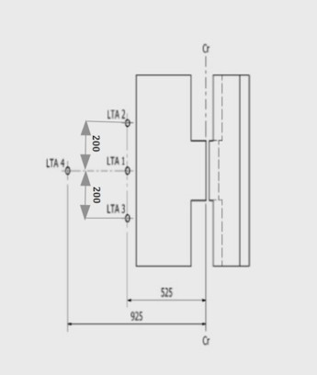

Dimensions in mm; Tolerance general: +/- 2 mm."

Annex 24, amend to read:
"Annex 24
Additional Attachment points Required for Securing Rearward Facing Enhanced Child Restraint System, of the Category Specific Vehicle Belted, to Motor Vehicles
1. This annex applies only to the additional anchorages for attaching Enhanced Child Restraint in the Specific vehicle Belted category or to bars or other special items used to secure child-restraining devices to the bodywork, whether or not they make use of UN Regulation No. 14 or UN Regulation No. 145, on ISOFIX anchorage systems, ISOFIX top tether anchorages, lower tether anchorages and i-Size seating positions.
2. The anchorages shall be determined by the manufacturer of the child restraint system and details shall be submitted for approval to the Technical Service conducting the tests.
The manufacturer of the child restraint system shall describe how the child restraint system attaches to different vehicles and shall submit this to the Technical Service conducting the tests for its assessment.
The manufacturer of the child restraint system shall consult the information supplied by the vehicle manufacturer, as supplied according to UN Regulation No. 16, Annex 17, Appendix 3 and/or the vehicle handbook, e.g. with regard to allowing the use of additional anchorages and a support leg before inclusion of the vehicle type in the vehicle list.
The Technical Services may consider information obtained from the vehicle manufacturer.
3. The manufacturer of the child restraint shall provide the necessary parts for fitting the anchorages generic lower tether brackets (if any) and a special plan for each vehicle showing their exact location.
4. The child restraint manufacturer shall indicate if the anchorages required for attaching the restraint to the vehicle structure are in accordance with the position and strength requirements of paragraph 3. onwards in the recommendation given to Governments intending to adopt specific requirements relating to anchorages for child restraints used in passenger cars."
Annex 27, amend to read:
"Annex 27
List of Minimum Contents for The Test Reports included in the Type Approval Application
This annex contains a list of the minimum content and information that shall be provided in the test reports that are included in the Type Approval Application. How this information is presented in the Type Approval Application shall be the choice of the Technical Service, i.e. the layout, format, order of the information may be changed.
ECRS Description
 | ECRS Category (3.2.2.) | Stature Range | Orientation | Attachment
Category 1
Category 2
Category 3
………….

…

6.3.3. |  | ISOFIX attachments
6.3.3.2. |  | Dimensions
 | 6.3.3.3. | Partial latching indication
 | 6.3.3.3. | The ISOFIX Enhanced Child Restraint System shall incorporate means by which there is a clear indication that both of the ISOFIX attachments are completely latched with the corresponding ISOFIX lower anchorages. | latch indicator |  | [Y/N]
 | 6.3.3.3. | The indication means may be audible, | check |  | [Y/N]
 | 6.3.3.3. | tactile or | check |  | [Y/N]
 | 6.3.3.3. | visual or | check |  | [Y/N]
 | 6.3.3.3. | a combination of two or more. | check |  | [Y/N]
 | 6.3.3.3. | In case of visual indication, it shall be detectable under all normal lighting conditions. | check |  | [Y/N]
 | 6.3.4. | ISOFIX Enhanced Child Restraint System top tether strap specifications
 | 6.3.4.1. | Top tether connector
 | 6.3.4.1. | The top tether connector shall be ISOFIX top tether hook as shown in Figure 3(c), or similar devices that fit within the envelope given by Figure 3(c).  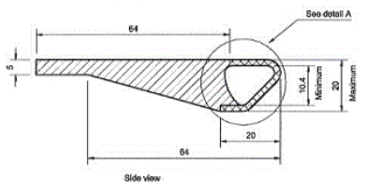  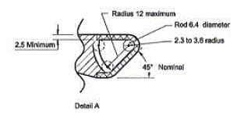  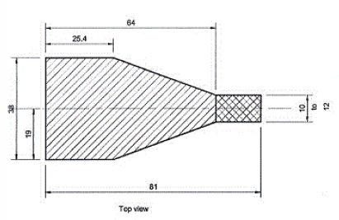  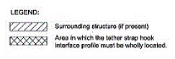  Figure 3(c): ISOFIX top tether or lower tether connector (hook type) dimensions |  |  | [Y/N]
 | 6.3.4.2. | ISOFIX top tether strap features
 | 6.3.4.2. | The ISOFIX top tether strap shall be supported by webbing (or its equivalent), having a provision for adjustment and release of tension. | check |  | [Y/N]
 | 6.3.4.2.1. | The ISOFIX top tether straps shall fulfil the requirements specified in paragraphs 6.7.4.2. to 6.7.4.4. |  |  | [pass/  fail]
 | 6.3.4.2.12. | ISOFIX Top tether strap length  ISOFIX Enhanced Child Restraint System top tether strap length shall be at least 2,000 mm. | TT strap length  [mm]
 | 6.3.4.2.23. | No-slack indicator  The ISOFIX top tether strap or the ISOFIX Enhanced Child Restraint System shall be equipped with a device that will indicate that all slack has been removed from the strap. The device may be part of an adjustment and tension relieving device. | check |  | [Y/N]
 | 6.3.4.2.34. | Dimensions  Engagement dimensions for ISOFIX top tether hooks are shown in Figure 3(c). | check

Insert new paragraphs 6.3.6. to 6.3.8., to read:

6.3.6. | Lower tether strap specifications
6.3.6.1. | The lower tether straps shall fulfil the requirements specified in paragraphs 6.7.4.2. to 6.7.4.4. |  | [pass/  fail]
6.3.6.2. | Lower tether strap length:  Enhanced Child Restraint System lower tether strap length shall be at least 900 mm including lower tether connector. | LT strap length  [mm]
6.3.6.3. | Lower Tether No-slack indicator:  The lower tether strap or the Enhanced Child Restraint System shall be equipped with a device that will indicate that all slack has been removed from the strap. The device may be part of an adjustment and tension relieving device. | check | [Y/N]
6.3.6.4. | Lower tether Retractor:  An automatically locking retractor can be used to replace the provision for adjustment and release of the tension in the lower tether strap and the no slack indicator.  In this case the retractor shall fulfil the requirements specified in paragraph 6.7.3.1. | check | [Y/N]  [pass/  fail]
6.3.6.5. | Dimensions  Engagement dimensions for lower tether hooks are shown in paragraph 6.3.4.2.4., Figure 3(c). | check

6.3.7. | Generic lower tether bracket specifications
6.3.7.1. | The generic lower tether brackets supplied by the manufacturer of the child restraint, shall be accompanied by mounting instructions including required torque application and a note that this shall be done by qualified personnel only. | Torque [Nm] | [pass/  fail]  …
6.3.7.2. | Dimensions bracket:  (a) the generic lower tether bracket shall have dimensions according to Figure 3 (f);  (b) the outer edges of the lower tether bracket shall be at least blunted. | check  check
6.3.7.3. | mounting material bracket  the mounting material consists of:  (a) M6x8 flange buttonhead hexagon socketcap screw; see figure 3 (g);  (b) M6 washer; see figure 3 (h);  (c) M6 -8 shoulder washer; see figure 3 (i). | check  check  check

6.3.8. | Generic lower tether bracket strength test
6.3.8.1. | Force application  Apply a force of 2,500 N to each generic lower tether bracket, by means of a representative lower tether strap 38 mm ± 3 mm wide that is fitted at one end with suitable hardware for applying the force and at the other end with a lower tether hook for the attachment to the lower tether bracket. For anchorages designed to be used for two adjacent CRS positions, or in case of a single LTA, the force shall be 5,000 N. | Measured force  [N]
6.3.8.2. | Force direction  Two tests are performed; See figure 3 (j) and 3 (k):  (a) The force shall be applied in a direction of 55° ± 5° against plane AB, measured in a plane parallel to the rigid surface XY, and a direction of 45° ± 5° against the rigid surface XY, measured in plane AB; see figure 3 (j);  (b) The force shall be applied in a direction perpendicular (90 ± 5°) to the rigid surface XY. | check | [pass/  fail]
6.3.8.3. | The load shall be attained within 30 s, and shall be maintained for a minimum of 0.2 s. | check | [pass/  fail]
6.3.8.4. | When testing in accordance with paragraphs 6.3.8.1. to 6.3.8.3., excursion is not limited, and permanent deformation of the generic lower tether bracket with respect to the rigid structure it is attached to is acceptable provided that the anchorage does not break or separate from the rigid structure. | check | [pass/  fail]

…

* The measurement procedures shall follow those of ISO 6487 with SAE J211 sign convention."
II. Justification
1. This proposal, together with simultaneous proposals updating UN Regulation No. 16 and UN Regulation No. 145 aims at:
(a) Introducing definitions and requirements for lower tether anchorages;
(b) Only facilitating attachment by means of the ISOFIX top tether connector;
(c) Facilitating four options: anchorage provided in the vehicle, anchorage and bracket provided in the vehicle (including integral solution whereby the connector can be directly hooked to the seat rail) and top tether anchorage of the front seat used as LTA, at the discretion of the vehicle manufacturer;
(d) not allowing other constructions whereby straps around vehicle seats, straps around seat rails, etc. are used.
2. See GRSP-71-19, distributed at the seventy-first session of the Working Party on Passive Safety (GRSP) for background information.
3. This proposal does not mandate the use of LTAs; but if LTAs are used as an anti-rotation device, the requirements shall be unambiguous, and the user shall be sufficiently informed.
4. The use of rearward-facing child restraints of age groups >1.5 is recommended by the medical society (age groups 0, 1 and 1.5 are already covered by i-Size). The most common and dangerous car accidents are frontal collisions. They represent the accidents where the highest speeds and the greatest forces are at play. When a child is forward-facing and a frontal collision occurs, the child is flung forward in the seat, being caught by the harness. This puts stress on the neck, the spine and the internal organs. Rearward facing seats counteract this forward movement, the child would sink into the car seat. This distributes the force more evenly across their backs and causes far less stress on "bendy" parts of the body. To prevent rotation during the rebound phase, Lower Tethers have long been used as "anti-rotation device".
5. By making use of an anti-rotation device with lower tethers straps the tests without lower tether straps in use, should be carried out when there is no mechanism or audible and visual warning system. Since the lower tether straps are relevant to stop the rotation in a rear impact, the relevant plane DF can be passed with an additional 10 per cent, in the same way as defined for forward facing tests with plane AB. For the passage of plane DE, a new plane HI parallel to plane DE is defined, to make the assessment well defined. This is in line with the ‘misuse’ test without top tether where the excursion limit is also increased by 10 per cent.
- Paragraph 6.3.5. includes provisions for the dimensions of the support leg and support leg foot. As indicated this applies to i-Size ECRS; it was noticed though that when a support leg is used on a non-i-Size ECRS, the same provisions should apply. Therefore paragraph 6.3.5. was amended to reflect this.
- Since there are vehicles on the market already equipped with LTAs not meeting the requirements of the Regulation or approved as such, there is a need to introduce transitional provisions and therefore a new series of Amendments.
- The additional sentence in paragraph 6.6.4.1.2.1. clarifying how ISOFIX ECRS should be dynamically tested was removed again from this document. This would allow the new 04 series of amendments to R129 proposed in GRSP-73-18 to focus on provisions for ECRS with lower tethers. The principle of the sentence on ISOFIX ECRS; namely, to clarify that an ISOFIX ECRS that relies on the vehicle seat as the sole anti-rotation device must be dynamically tested on each vehicle body shell specified on the CRS fitting list, still stands. However, a larger amendment of paragraph 6.6.4.1.2. had been proposed by CLEPA in Informal Document GRSP-73-42. The time in between GRSP-73 and the submission date of official documents to GRSP-74 will be used to optimise the proposed wording.

* In accordance with the programme of work of the Inland Transport Committee for 2023 as outlined in proposed programme budget for 2023 (A/77/6 (Sect. 20), table 20.6), the World Forum will develop, harmonize and update UN Regulations in order to enhance the performance of vehicles. The present document is submitted in conformity with that mandate.

