Proposal for Amendment 3 of the GTR9
Submitted by the Chair (Republic of Korea) of the Informal Working Group on the Deployable Pedestrian Protection Systems of UN Global Technical Regulation No. 9.

The text reproduced below was prepared by the experts from the Informal Working Group on the Deployable Pedestrian Protection Systems of UN Global Technical Regulation No. 9.
It is to amend the Proposal for Amendment 3 of GTR9 and proposed modifications to the current text of the Working Document ECE/TRANS/WP.29/GRSP/2023/6e are marked in bold for new or strikethrough for deleted characters.

- Proposal
Part I, Statement of Technical Rationale and Justification,
"C. Phase 3,
Paragraph 233., amend to read:
The IWG-DPPS had held the following meetings:
….
(w) 12-13 April 2023; virtual
(y) 24 April 2023; virtual

Paragraph 279., amend to read:

279. The IWG DPPS understood that HBM simulations were the common method for determination of the HIT. In order to ensure comparability and applicability of HBM for that purpose, a qualification procedure for HBMs was developed within a subgroup of the IWG DPPS, [led by the experts of Austria and OICA. All Generic Vehicle models used for the qualification are made available [as Addendum 54 of Mutual Resolution No. 1 (M.R.1) of the 1958 and the 1998 Agreements ECE/TRANS/WP.29/1101 by Austria].]

Insert new paragraph 281, amend to read:
281. A subgroup of the IWG on DPPS investigated the corridors required for the qualification of human body models for HIT and WAD determination. It was unanimously agreed that realistic HIT and WAD strongly depend on biofidelic whole-body kinematics of the HBM. However, a required location of the acetabulum (AC) at the time of head impact, as e.g. described by means of a corridor, is not seen as an appropriate kinematic criterion. It was thus, for the time being, abstained from introducing AC corridors for the HBMs at HIT; however, the values will be recorded for monitoring purposes and evaluated during a possible next phase of GTR9 towards the introduction of significant, meaningful kinematic criteria for biofidelic and reliable HBM trajectories.

Paragraph 281 (former), renumber as paragraph 282 and amend to read:
282. In order to create an independent baseline, reference simulations have been used to determine requirements and tolerances described in the Annex 2 "Qualification Process of HBMs for Pedestrian HIT-Determination". The HBMs that were used for these reference simulations have been validated by comparing their simulation responses (HIT, kinematics) with PMHS tests. [The background concerning the validation of reference HBMs are submitted at the seventy-third session of GRSP (GRSP-73-03.] The background concerning the validation of reference HBMs are available in Addendum 6 of Mutual Resolution No. 1 (M.R.1) of the 1958 and the 1998 Agreements ECE/TRANS/WP.29/1101.

Paragraphs 282 to 290 (former), renumber 283 to 291, and insert new paragraph 292, amend to read:
292. The IWG discussed several approaches to define tolerances for the validation tests of the different height and time values specified by the manufacturer.
Two main sources for tolerances were identified: a) the variation of parts due to production process (geometry, assembly, material properties, micro gas generator propellant), b) different methods to measure the Sensing Time during compliance testing.
Experts of VDA explained that Deployment Height, Deployed Position and Deployment Time strongly depend on the variation of parts and their assembly so that a great portion of the specified values are related to the specified tolerances during production processes. Therefore, a percentage of the specified values would appear to be most convenient as tolerances for Deployment Height, Deployed Position as well as Deployment Time.
VDA added that the scatter of Sensing Time, on the other hand, strongly depends on the procedure of time measurement (electronical, visual, etc.) in the test lab. It was recommended to introduce tolerances on this measurement as absolute values. Therefore, a time corridor around the specified Sensing Time was introduced.

Paragraphs 291 to 294 (former), renumber 293 to 296, and insert new paragraph 297, amend to read:
297. For the dynamic test option, the IWG investigated possible misinterpretations of the calculated and actual launching time of the headform impactor during dynamic tests. Since the fire delay between the initiation of the launch of the headform and the triggering of the DPPS actuators is, amongst other things, based on the HIT of the HBM on the undeployed DPPS (HIT_s), but the actual headform impact takes place on the deploying DPPS (see Fig. 1 (a)), the actual launching duration will deviate from the calculated one, as depicted in Fig 1 (b).
This needs to be taken into account in the course of verification of ambient conditions for dynamic tests.

Fig. 1 (a): Transfer of real-life accident situation with deploying DPPS to ambient conditions for impactor testing.

Fig. 1 (b): Effect of DPPS Deployment on Launching Duration Headform Impactor (Example).

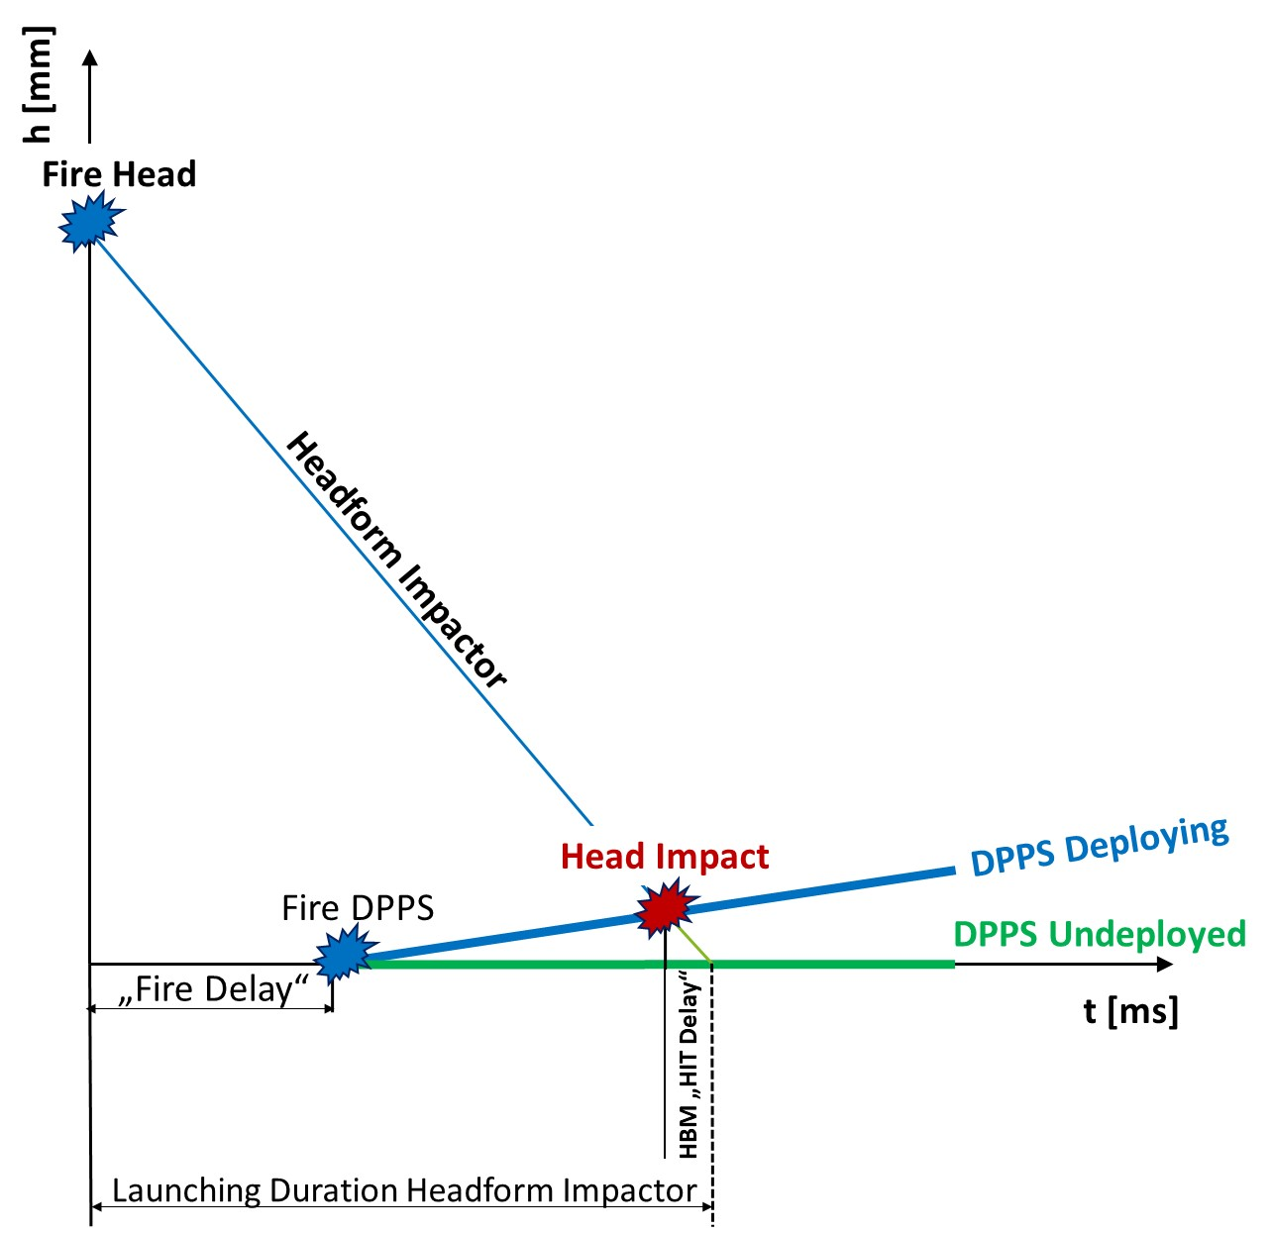
Fig. 1 (b): Effect of DPPS Deployment on Launching Duration Headform Impactor (Example).
Paragraphs 295 to 298 (former), renumber as paragraphs 298 to 301.

Insert new section 10, amend to read:
10. List of documents discussed in the TF-DPPS and IWG-DPPS on UN GTR NO. 9 Amendment 3

Doc. No. | Rev. | Name
DPPS-1-01 |  | 1st Meeting Agenda
DPPS-1-02 | 1 | Minutes of the First Meeting
DPPS-1-03 |  | Task Force Outline
DPPS-1-04 |  | Test Procedure of Deployable Systems for Pedestrian Protection (Korea)
DPPS-1-05 | 1 | OICA proposal based on GRSP-58-31 as revised during the meeting – 20170227
DPPS-1-06 |  | Comments on Scope (Japan)
DPPS-1-06-Appe |  | Comments on Scope – Appendix (Japan)
DPPS-1-07 |  | Euro NCAP Pedestrian Testing Protocol v8.3 December 2016 (Germany)
DPPS-1-08 |  | JNCAP Ped Active Device Test Protocol (unofficial) (Japan)
DPPS-1-09 |  | Testing Deployable Bonnet Systems within Euro NCAP (Germany)
DPPS-1-10 |  | Bonnet Deflection of Deployable Bonnet Systems (Germany)
DPPS-1-11 |  | Industry Understanding on Rulemaking (OICA)
DPPS-1-12 |  | Input bonnet deflection discussion (OICA)
DPPS-2-01 | 1 | 2nd meeting agenda
DPPS-2-02 | 1 | Minutes of the 2nd meeting
DPPS-2-02-Annexe |  | Annex to the minutes of the 2nd meeting: Attendance list
DPPS-2-03 | 3 | Requirements Overview DPPS (Korea)
DPPS-2-04 |  | Prerequisites for Deployable Bonnet Systems in Deployed State (Germany)
DPPS-2-05 | 1 | Comments on OICA proposal (Japan)
DPPS-2-06 |  | Comments on document TF-DPPS/1/05 Rev. 20170227 (Japan)
DPPS-2-07 |  | Comments BASt on OICA Input Presentation (Germany)
DPPS-2-08 |  | OICA comment for static and dynamic test (OICA)
DPPS-2-09 |  | Marking of Deployable Bonnets: Differences of Bonnet Marking Positions and Challenges in Performance Assessment (OICA)
DPPS-2-10 |  | Explanation JNCAP details for Items for DPPS Amendment (Japan)
DPPS-2-11 |  | Development Head Test Procedure (Germany)
DPPS-2-12 |  | Text for validation of simulation methods (OICA)
DPPS-2-13 |  | Comments on document TF-DPPS/2/04 (OICA)
DPPS-2-14 |  | Development of a Head Impact Test Procedure for Pedestrian Protection (Germany)
DPPS-2-15 |  | Validity of a Headform to be used for a Specific Impact Test Speed Condition (Japan)
DPPS-2-16 |  | Comments on document TF-DPPS/2/13 (Germany)
DPPS-3-01 | Corr 1 | 3rd meeting agenda
DPPS-3-02 | Corr 1 | Minutes of the 3rd meeting
DPPS-3-03 |  | Definition of sensing area (Japan)
DPPS-3-04 |  | Proposal for Definition of Head Impact Test Area (Japan0
DPPS-4-01 | 1 | 4th meeting agenda
DPPS-4-02 |  | Minutes of the 4th meeting
DPPS-4-03 |  | Scope and Limitations of the PDI-2 (OICA)
DPPS-4-04 |  | Static and Dynamic Testing of Deployable Systems (OICA)
DPPS-4-05 |  | Marking + Deployed Position (OICA)
DPPS-4-06 |  | JASIC proposals for document TF-DPPS/1/05-Rev.1 (Japan)
DPPS-4-07 |  | Validity of Applying the Current Headform at Low Impact Speed (Japan)
DPPS-4-08 |  | Dynamic Headform Test (Synchronization) (Korea)
DPPS-4-09 |  | Discussion Issues for DPPS Testing (Korea)
DPPS-4-10 |  | Alternative Determination of Head Impact Time (BGS)
IWG-DPPS-1-01 |  | 1st IWG-DPPS meeting agenda
IWG-DPPS-1-02 | 1 | 1st IWG-DPPS meeting notes
IWG-DPPS-1-03 |  | IWG-DPPS Terms of Reference
IWG-DPPS-1-04 | Corr 1 | Presentation of the Euro NCAP CoHerent Project (Tu Graz)
IWG-DPPS-1-05 |  | Comments: Deploy Height vs. Fully Deployed (OICA)
IWG-DPPS-1-06 |  | Comments: Dynamic Testing (OICA)
IWG-DPPS-1-07 |  | Comments: Pedestrian Sensing Impactor (OICA)
IWG-DPPS-1-08 |  | ACEA Input: Definition of Sensing Width (ACEA)
IWG-DPPS-1-09 |  | Summary of Compliance Test Procedure for Pedestrian Protection (Korea)
IWG-DPPS-1-11 |  | Head Impact Time of Human Body Models (BASt)
IWG-DPPS-2-01 | 1 | 2nd IWG-DPPS meeting agenda
IWG-DPPS-2-02 | 1 | 2nd IWG-DPPS Meeting notes
IWG-DPPS-2-03 |  | Summary Report Meeting 14 June 2018 (Sub-group Prerequisites)
IWG-DPPS-2-04 | 2 | Contracting Parties' positions on DPPS amendments
IWG-DPPS-2-05 | 2 | Proposal: Decision on Deployed Testing of DPPS (OICA)
IWG-DPPS-2-06 | 1 | Proposal for a Rev. 4 of Document TF-DPPS/2/03
IWG-DPPS-2-07 |  | Summary of SAE Standard for Full-Scale Pedestrian Dummy (Japan)
IWG-DPPS-2-08 |  | Quick check of proposed logic to not activate DPPS outside of sensing width (OICA)
IWG-DPPS-2-09 |  | 2nd IWG-DPPS Attendance list
IWG-DPPS-2-10 |  | JLR Presentation on synchronisation comparison (OICA)
IWG-DPPS-3-01 |  | 3rd IWG-DPPS Agenda
IWG-DPPS-3-02 |  | 4th IWG-DPPS Minutes
IWG-DPPS-3-03 |  | Leg impactors and HBM simulation comparison for detection (CONCEPT)
IWG-DPPS-3-04 |  | Study of Application of Upper Leg form to sensing test (Japan)
IWG-DPPS-3-05 |  | Principle of a test procedure for Human Body Model numerical simulation (OICA)
IWG-DPPS-3-06 |  | Attendance list
IWG-DPPS-4-01 | 1 | 4th IWG-DPPS Agenda
IWG-DPPS-4-02 | 1 | Draft minutes +BAST comments
IWG-DPPS-4-03 |  | Task 27 (deploy bonnet) (OICA)
IWG-DPPS-4-04 |  | System Information Requirement (South Korea)
IWG-DPPS-4-05 |  | Sensing width proposal (OICA)
IWG-DPPS-4-06 |  | Upper Leg Form Sensing Update (JASIC)
IWG-DPPS-4-07 |  | Ped Dummy Test Procedure proposal (OICA)
IWG-DPPS-4-08 |  | Marking of bonnet deployed/undeployed (OICA)
IWG-DPPS-4-09 |  | Attendance list
IWG-DPPS-5-01 |  | Draft agenda
IWG-DPPS-5-02 |  | Draft minutes
IWG-DPPS-5-03 |  | Marking (South Korea)
IWG-DPPS-5-04 |  | 1st tentative draft
IWG-DPPS-5-05 |  | Intended height test condition (JASIC)
IWG-DPPS-5-06 |  | Sensing Impactors comparison (JASIC)
IWG-DPPS-5-07 |  | Basis for General Wording Proposal (Germany)
IWG-DPPS-5-08 |  | GRSP & WP29 report
IWG-DPPS-5-09 |  | Detection Area Width (Germany)
IWG-DPPS-5bis-01 |  | Draft agenda
IWG-DPPS-5bis-02 |  | Draft skype minutes
IWG-DPPS-5bis-03 |  | IDIADA -HIT calculation feedback (Spain)
IWG-DPPS-5bis-04 |  | HIT calculation feedback (JASIC)
IWG-DPPS-5bis-05 |  | ULF study 2013 (Altran)
IWG-DPPS-5bis-06 |  | ULF study 2013-conclusion for detection (Altran)
IWG-DPPS-6-01 | 2 | 6th DPPS draft agenda
IWG-DPPS-6-02 |  | 6th IWG-DPPS Minutes
IWG-DPPS-6-03 |  | V2 of draft text proposal (IDIADA)
IWG-DPPS-6-04 |  | Sensing Impactor for DPPS (Germany)
IWG-DPPS-6-05 |  | HIT-WAD calculation (South Korea)
IWG-DPPS-6-06 | 2 | HIT-WAD _Timing (OICA)
IWG-DPPS-6-07 |  | Positioning of Ped HBM-v0 (OICA)
IWG-DPPS-6-08 |  | Draft text proposal- updated (JASIC)
IWG-DPPS-6-09 |  | Marking-up sketches (OICA)
IWG-DPPS-7-01 |  | draft agenda
IWG-DPPS-7-02 |  | IWG-DPPS 7-draft minutes
IWG-DPPS-7-03 |  | Dynamic Static Test (South Korea)
IWG-DPPS-7-04 |  | Test Area (South Korea)
IWG-DPPS-7-05 |  | Draft-Annex (South Korea)
IWG-DPPS-7-06 |  | THUMS Overview (Toyota)
IWG-DPPS-7-07 |  | Positioning of Ped HBM (OICA)
IWG-DPPS-7-08 |  | GHBMC_M50-PS_Mo (GHBMC)
IWG-DPPS-7-08add |  | GHBMC addendum-publications (GHBMC)
IWG-DPPS-7=09 |  | Flex-PLI as Sensing Impactor for UN-R127 - Contact Fidelity (Germany)
IWG-DPPS-7-10 |  | Detection Area Width (Germany)
IWG-DPPS-7-11 |  | Generic-Vehicle-Models (TU Graz)
IWG-DPPS-8-01 |  | IWG - draft agenda
IWG-DPPS-8-02 |  | Draft minutes
IWG-DPPS-8-03 |  | Draft text Annex 2 organisation (Korea)
IWG-DPPS-8-04 |  | FlexPLI Biofidelity for Detection - intermediate report (BASt/BGS)
IWG-DPPS-9-01 |  | Draft Agenda
IWG-DPPS-9-02 | 2 | Official minutes
IWG-DPPS-9-03 |  | GTR9 Preamble for FlexPLI as detection impactor (BASt/BGS)
IWG-DPPS-9-04 |  | Proposal GTR9 DPPS Sensor Detection (BASt/BGS)
IWG-DPPS-9-05 |  | UNR127 amendment justification for FlexPLI as detection impactor (BASt/BGS)
IWG-DPPS-9-06 |  | GRSP report
IWG-DPPS-9-07 |  | Dynamic Static Test comparison (Korea)
IWG-DPPS-9-08 |  | Comments on Korea Proposal for Draft Amendment (Japan)
IWG-DPPS-9-09 |  | Proposal for Condition of Activation of DPPS (Japan)
IWG-DPPS-9-10 | 1 | OICA – HIT simulation (OICA)
IWG-DPPS-9-11 |  | Sensing FlexPLI Impactor Final Evaluation (BASt – BGS)
IWG-DPPS-9-12 |  | Comment on IWG-DPPS-9-09 (BASt)
IWG-DPPS-10-01 |  | Draft Agenda
IWG-DPPS-10-02 |  | Draft Minutes
IWG-DPPS-10-03 |  | IDIADA -Explanation_pressure_data-requirement (Spain)
IWG-DPPS-10-04 |  | Leg_Head_Impact_Location_JASIC (Japan)
IWG-DPPS-10-05 |  | HIT-HBM -TB024 simplification for Regulation (OICA)
IWG-DPPS-10-06 |  | Ped-HBM-Certification for HIT Draft (OICA)
IWG-DPPS-10-07 |  | Decision list
IWG-DPPS-10-08 |  | UN webpages proposals to store Generic Vehicle Models (UN Secretariat)
IWG-DPPS-10-09 |  | Detection Area- Lateral offset of head-Accident Data (BASt)
IWG-DPPS-11-01 |  | Draft Agenda
IWG-DPPS-11-02 |  | Draft Minutes
IWG-DPPS-11-03 |  | Pedestrian Kinematic Assumptions GTR9 (Japan)
IWG-DPPS-11-04 |  | Suggestion on Introduction of HIT Numerical Simulation (Japan)
IWG-DPPS-11-05 |  | Clarification of IWG-DPPS scope (BASt)
IWG-DPPS-11-06 |  | Comment for Detection Area (ACEA)
IWG-DPPS-11-07 |  | Decision list
IWG-DPPS-12-01 |  | Draft agenda
IWG-DPPS-12-02 | 1 | Minutes
IWG-DPPS-12-03 |  | Sensitivity Analysis Pressure Data Requirement (IDIADA)
IWG-DPPS-12-04 |  | Sensitivity Analysis Pressure Data Requirement-GTR9 (IDIADA)
IWG-DPPS-12-05 |  | Pressure Data Requirement-UNR127 (IDIADA)
IWG-DPPS-12-06 |  | Comments on Priority of HIT Prediction Method (Japan)
IWG-DPPS-12-07 |  | Pedestrian Kinematic Assumptions GTR9 (Japan)
IWG-DPPS-12-08 |  | Detection Area II (VDA_SMMT-CCFA)
IWG-DPPS-12-09 | 1 | Clarification for HIT Regression (VDA-SMMT-CCFA)
IWG-DPPS-13-01 |  | Draft agenda
IWG-DPPS-13-02 | 1 | Minutes
IWG-DPPS-13-03 | 1 | Updated Decision_List
IWG-DPPS-13-04 |  | Consolidated draft proposal of DPPS GTR9 amendment -210906
IWG-DPPS-13-05 |  | revised 5-04 Pressure Data Requirement (IDIADA)
IWG-DPPS-13-05 | 1 | Rev1 wording for CP options
IWG-DPPS-13-06 |  | System Specifications Proposal (IDIADA)
IWG-DPPS-13-07 |  | Participant list
IWG-DPPS-14-01 | 1 | Official agenda
IWG-DPPS-14-02 |  | Draft minutes
IWG-DPPS-14-03 |  | Comment on HIT calculation-tool and HIT-WAD diagram (Japan)
IWG-DPPS-14-04 |  | Sensing-width (VDA-CCFA)
IWG-DPPS-14-05 |  | DPPS-HBM qualification procedure status (IWG subgroup)
IWG-DPPS-15-01 | 1 | Draft agenda
IWG-DPPS-15-02 |  | Draft & official minutes
IWG-DPPS-15-03 |  | HBM qualification for GTR draft (TF-HBM subgroup)
IWG-DPPS-15-04 | 3 | Draft1 & 2 technical requirements,  then working ECE-TRANS-WP.29-GRSP-2022-02e tech requirements
IWG-DPPS-15-05 | 1 | Preamble
IWG-DPPS-16-01 | 1 | Draft & official agenda
IWG-DPPS-16-02 | 1 | Draft & official minutes
IWG-DPPS-16-03 |  | Draft Preamble
IWG-DPPS-16-04 |  | Modified ECE-TRANS-WP.29-GRSP-2022-02e tech requirements
IWG-DPPS-16-05 |  | Annex2_pedestrian_Human_Body_Model_qualification
IWG-DPPS-16-06 |  | Annex3_HIT_determination_simulation
IWG-DPPS-16-07 |  | Proposal HIT vs TRT requirement- OZ
IWG-DPPS-16-08 |  | HIT vs TRT Explanation- OZ
IWG-DPPS-16-09 |  | HBM-Simulations_Flow-Chart_AB
IWG-DPPS-16-10 |  | Condition_for_Static_Test_in_Overshoot_Duration_JAMA
IWG-DPPS-17-01 | 1 | Draft agenda
IWG-DPPS-17-02 |  | Draft minutes
IWG-DPPS-17-03 |  | GRSP-71-26e - DPPS status report
IWG-DPPS-17-04 |  | Decision list
IWG-DPPS-17-05 |  | Status_Nr_Simulation subgroup
IWG-DPPS-17-06 |  | Annex2_Pedestrian_Human_Body_Model_Qualification
IWG-DPPS-17-07 |  | Annex3_HIT_Determination_Simulation
IWG-DPPS-17-08 |  | Draft preamble
IWG-DPPS-17-09 |  | modified ECE-TRANS-WP.29-GRSP-2022-02e tech requirements
IWG-DPPS-17-10 |  | Overall Flowchart DPPS_ALIGNED with Annex 23
IWG-DPPS-18-01 | 1 | Draft & official agenda
IWG-DPPS-18-02 | 1 | Draft & official minutes
IWG-DPPS-18-03 |  | Annex2_Pedestrian_Human_Body_Model_Qualification
IWG-DPPS-18-04 |  | Annex3_HIT_Determination_Simulation
IWG-DPPS-18-05 |  | modified ECE-TRANS-WP.29-GRSP-2022-02e tech requirements
IWG-DPPS-18-06 |  | Deployment test procedure doubts
IWG-DPPS-18-07 |  | Sensing width-anonymised - Industry
IWG-DPPS-18-08 |  | LAB_Pedestrian_DPPS_area detection width.pptx
IWG-DPPS-18-09 |  | Action list
IWG-DPPS-18-10 |  | Draft Wording Preamble GTR9 wrt Detection Area.docx
IWG-DPPS-18-11 |  | Decision list
IWG-DPPS-18-12 |  | Status Annexes 2 3 Subgroup
IWG-DPPS-18-13 |  | Vehicle width additional fender - definition of RVW
IWG-DPPS-19-01 | 1 | Draft & official agenda
IWG-DPPS-19-02 | 1 | Draft & official minutes
IWG-DPPS-19-03 |  | IDIADA wording subgroup results
IWG-DPPS-19-04 |  | Marking undeployed
IWG-DPPS-19-05 |  | Technical requirements 9Nov
IWG-DPPS-19-06 |  | Preamble (17-08 merged with 18-10)
IWG-DPPS-19-07 |  | Action list
IWG-DPPS-19-08 |  | Annex3_HIT_Determination_Simulation
IWG-DPPS-19-09 |  | Annex2_Pedestrian_Human_Body_Model_Qualification
IWG-DPPS-20-01 | 1 | Draft & official agenda
IWG-DPPS-20-02 | 1 | Draft & official minutes
IWG-DPPS-20-03 |  | Action list
IWG-DPPS-20-04 |  | Preamble 16Nov22
IWG-DPPS-20-05 |  | Technical requirements 16Nov22
IWG-DPPS-20-06 |  | (OZ) Proposal Overshoot Phase
IWG-DPPS-20-07 |  | (BH-IDIADA)_Dynamic Testing Sync
IWG-DPPS-21 |  | ECE-TRANS-WP.29-GRSP-2023-xx final GTR0-03 proposal IWG-DPPS.docx
IWG-DPPS-21 |  | ECE-TRANS-WP29-GRSP-2023-yy MR1 Amend-4 from IWG-DPPS.docx
IWG-DPPS-21-01 | 1 | Draft & rev1 agenda
IWG-DPPS-21-02 | 1 | Draft & official minutes
IWG-DPPS-21-03 |  | Action list
IWG-DPPS-21-04 |  | Preamble GRSP-72-08
IWG-DPPS-21-05 |  | Technical requirements GRSP-72-09
IWG-DPPS-21-06 |  | Status report GRSP-72-11
IWG-DPPS-21-07 | 7 | consolidated draft.rev1-7- updated 24Jan-15 Feb.2023
IWG-DPPS-21-07 |  | consolidated final - updated 15 Feb.2023
IWG-DPPS-21-08 |  | Dummy_comparison_with_HBM_rev1 Japan-draft
IWG-DPPS-21-09 |  | Dummy_proposal_for_text_of_preamble Japan
IWG-DPPS-21-10 | 7 | Proposal Overshoot Phase (BAST)
IWG-DPPS-21-11 | 1 | Decision_List & Decision_List with text check
IWG-DPPS-21-12 | 1 | smallest_HBM (BAST)
IWG-DPPS-21-13 | 1 | Comments to Document Comparison bet. HBMs (Annex 2) and Pedestrian Dummy (BAST)
IWG-DPPS-21-14 | 1 | only_Annex2-3 update (CKlug)
IWG-DPPS-22 |  | ECE-TRANS-WP.29-GRSP-2023-06e.pdf GTR9-03 Proposal
IWG-DPPS-22 |  | ECE-TRANS-WP.29-GRSP-2023-07e.pdf MR1 Addendum 5 proposal
IWG-DPPS-22-01 |  | Draft agenda
IWG-DPPS-22-02 | 1 | Draft & official minutes
IWG-DPPS-22-03 |  | Head impact time verification (VDA)
IWG-DPPS-22-04 |  | consolidated Doc with all changes GTR and UNR- 13Apr23
IWG-DPPS-22-05 |  | AC in preamble proposal
IWG-DPPS-22-06 |  | Action list updated
IWG-DPPS-23-01 |  | Draft agenda
IWG-DPPS-23-02 |  | Draft minutes
IWG-DPPS-23-03 |  | Test Rig Synchronization for DPPS
IWG-DPPS-23-04 |  | Overall Flowchart DPPS_23
IWG-DPPS-23-05 |  | consolidated doc with all changes GTR and UNR 24Apr23
IWG-DPPS-23-06 |  | modified_ECE-TRANS-WP29-1101-Amend-5
IWG-DPPS-23-07 |  | OZ small group on tolerances Proposal on 28Apr2023
IWG-DPPS-23-08 | 1 | GRSP-73-10 MR1-Amend4 Addendum5 GVM consolidated 28Apr, 11May
IWG-DPPS-23-09 | 1 | GRSP-73-11 MR1-Amend5 Addendum6 HBM informal 28Apr
IWG-DPPS-23-10 | 1 | GRSP-73-12 GTR9-03 informal doc
IWG-DPPS-23-11 | 1 | GRSP-73-13 IWG-DPPS final status report

Part II, Text of the Regulation,
Paragraph 3, amend to read:
"3. Definitions

Paragraph 3.30., amend to read :
"3.30. ["Outer surface" means those components of the vehicle within the headform test areas, which may be contacted by the pedestrian in case of an accident. The outer surface may include the bumper, the bonnet, the fenders, but also external airbags or other components. within the headform test areas.]"

Figure 11, enlarge CoB written spaces, amend to read :

"Figure 11
Determination of the Detection Test Area (see paragraph 3.19): examples
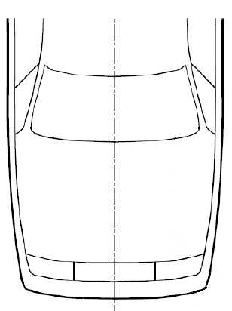
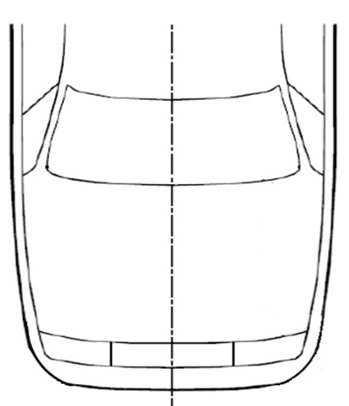
CoB -42mm (l+r)
Detection Test Area
Detection Test Area
CoB -42mm (l+r)
CoB (l)
CoB (l)
CoB (r)
CoB (r)
Relevant Vehicle Width (RVW)
75% of RVW
Relevant Vehicle Width (RVW)
75% of RVW
CoB -42mm (l+r) > 75% of RVW
CoB -42mm (l+r) < 75% of RVW

Paragraphs 5.2. and 6.2.4., amend to read:
"5.2. Headform tests
[When/If the manufacturer stipulates that the vehicle shall be] tested as a DPPS, the test conditions and requirements in Annex 1 shall apply.

6.2.4. [When/If the manufacturer stipulates that the vehicle shall be] tested as a DPPS, the vehicle shall be adjusted as specified in the test procedure defined in Annex 1."

In Annex 1,
Paragraph 1.6., amend to read:
1.6. Verification of the prerequisites for deployed static tests: Deployed Position, Maximum Deployment Height, Sensing Time and Deployment Time, as illustrated in the deployment time history curve (see Figure 1-1 of this Annex).
The values specified by the manufacturer shall be verified by using appropriate tracking means, such as high-speed videos, accelerometer, or laser at the reference points as indicated by the manufacturer (on the lifting devices). The tolerance for the Sensing Time is -5ms/+3ms on the specified value, whereas the other tolerances are ±20 percent onfor the specified values respectively. If a measured value is within the defined tolerances, the value specified by the manufacturer shall be used. Otherwise, the measured values shall be used for the test.

Paragraphs 1.7.1.1. and 1.7.2., delete the brackets:
1.7.1.1. For the system deployment verification, sensor activation tests with the flexible lower legform impactor, as specified in paragraph 6.3.1.1 of this regulation, shall be performed [within the detection test area] at the DPPS lower deployment velocity threshold.

1.7.2. [A] test with the flexible lower legform impactor shall be performed at nominal speed at vehicle centreline (Y0).

Paragraph 2.2.1., amend to read:
2.2.1 For dynamic testing, only ST shall be verified. If the measured ST is within a tolerance of -5ms/+3ms, the value specified by the manufacturer shall be used. Otherwise, the measured value shall be used for the test. For dynamic testing, only ST shall be verified.

Paragraph 4.2.1.3., delete former text and figure and amend to read:
4.2.1.3. Fire Delay
The test facility shall ensure that the head impact occurs at the correct time relative to the deployment of the DPPS, taking into account the HIT_s for the corresponding WAD of the head impact point from Figure 1-3 and ST, as shown in the example in Figure 1-4 (a) below.
„Fire Delay“ is the elapsing time between the initiation of the headform launch and the initiation of the DPPS deployment module.
It is determined according to the equation:
Fire Delay = Launching Duration Headform Impactor – (HIT_s – ST).
The “Launching Duration Headform Impactor” is rig-specific and is the time period between launching of the headform impactor and the theoretical time of head impact on the undeployed DPPS. Due to the DPPS deployment during testing, the actual launching duration of the headform impactor is expected to differ from the launching duration headform impactor (time difference: see example in Figure 1-4 (b)).

In Annex 1 – Appendix, replace former figure as follows:
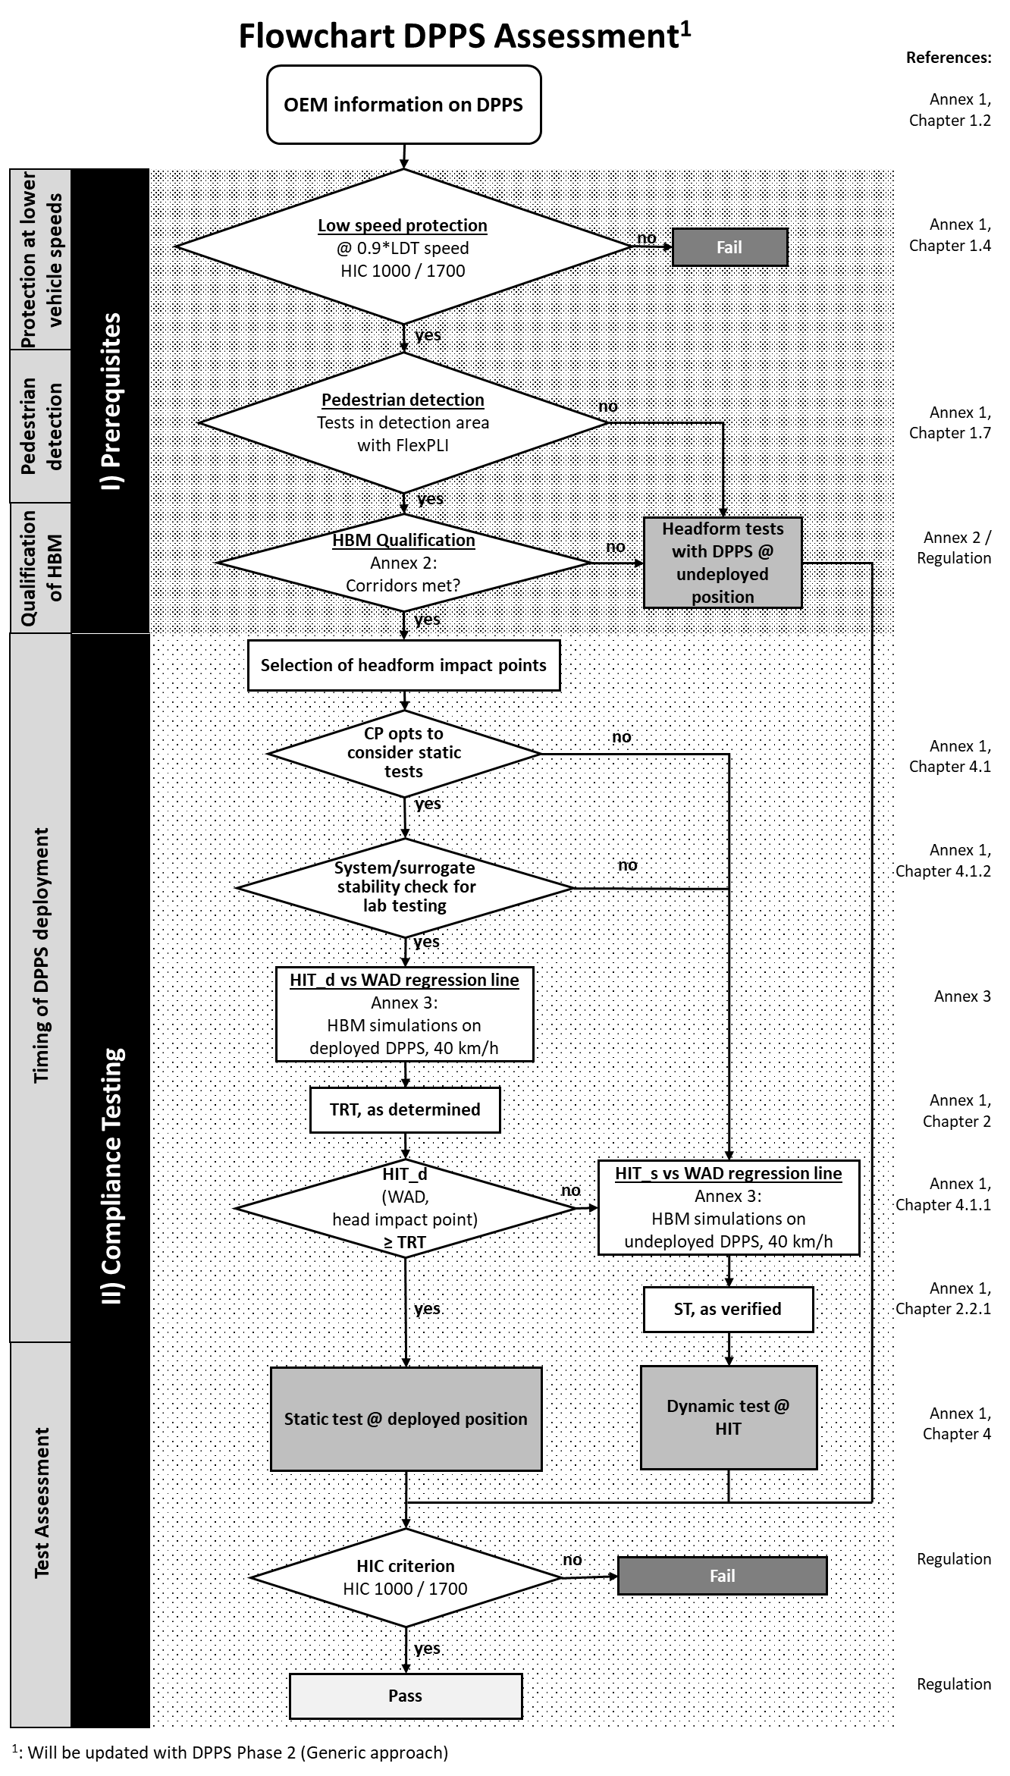

In Annex 2,
1.2. Definitions
…

Paragraph 1.3., continue numbering e to i (former a to g) and amend to read:
1.3. General Requirements
Only those HBM statures have to be qualified which are required for the HIT determination simulations described in Annex 3, paragraph 2.2.
The pedestrian Human Body Model that is qualified is the very same model as used for HIT-Determination simulations. This applies to:
- Version of the Human Body Model;
- Node-Position of every single node of the Human Body Model;
- If available:
- identical initial element stresses/strains;
- identical initial contact penetrations/contact forces;
- Identical material cards (including fracture mode), contact cards, control cards and constraints.

Furthermore, it is important that all simulations (qualification and HIT-Determination) are performed with consistent settings. This applies to:
(ea) Solver-Version; and type (e.g. processing type, precision, parallelisation);
(b) Solver-Platform ([Shared Memory Parallel processing (SMP), Massively Parallel Processing (MPP)]);
(c ) Solver-Precision (Single, Double Precision);
(fd) The time-step used for simulations;
(ge) Time-step settings (relating to initial and dynamic mass scaling);
(hf) Contact settings (between Human Body Model and Vehicle);
(ig) Control settings which are affecting the pedestrian model.

Paragraph 2.6, tables replaced and amend to read:
2.6. Reference Results for Qualification Simulations

From the qualification simulations with the generic vehicle models, HIT values and the location of HC and – only for AM50, also AC- at the time of head impact shall be compared with the references in Tables 2-3, 2-4 and 2-5.

These tables have been created using simulations with validated HBMs (see Appendix B). as Addendum 6 of Mutual Resolution No. 1 (M.R.1) of the 1958 and the 1998 Agreements ECE/TRANS/WP.29/1101.

The trajectories are measured relative to the generic vehicle model, which means that the x-displacement of the generic vehicle has to be subtracted from the measured x coordinates HCx and ACx in the global coordinate system. For HCz and ACz the global z-coordinates are used.

[Table 2-3: 50th Percentile Male (AM 50)
GV Type | Velocity (km/h) | HIT (ms) |  | HCx (mm) |  | HCz (mm)
 |  | Min | Max | Min | Max | Min | Max
FCR | 30 | 152 | 197 | -1438 | -1005 | 1019 | 1117
 | 40 | 127 | 150 | -1489 | -1105 | 1006 | 1158
 | 50 | 107 | 121 | -1504 | -1179 | 1024 | 1169
RDS | 30 | 163 | 199 | -1574 | -1104 | 931 | 1125
 | 40 | 133 | 156 | -1659 | -1191 | 931 | 1178
 | 50 | 112 | 127 | -1665 | -1283 | 981 | 1183
SUV | 30 | 127 | 144 | -1000 | -624 | 1092 | 1193
 | 40 | 101 | 116 | -1032 | -737 | 1103 | 1187
 | 50 | 86 | 99 | -1110 | -799 | 1109 | 1191

Table 2-4 Six-Year-Old (6YO)
GV Type | Velocity (km/h) | HIT (ms) |  | HCx (mm) |  | HCz (mm)
 |  | Min | Max | Min | Max | Min | Max
FCR | 30 | 60 | 79 | -388 | -325 | 909 | 942
 | 40 | 49 | 61 | -427 | -358 | 905 | 954
 | 50 | 43 | 50 | -457 | -387 | 889 | 972
RDS | 30 | 65 | 81 | -478 | -362 | 857 | 914
 | 40 | 52 | 63 | -495 | -409 | 852 | 923
 | 50 | 44 | 54 | -524 | -449 | 848 | 929
SUV | 30 | 35 | 50 | -154 | -97 | 1010 | 1033
 | 40 | 28 | 39 | -183 | -134 | 1024 | 1050
 | 50 | 18 | 36 | -218 | -160 | 1023 | 1089

Table 2-5 5th Percentile Female (AF 05)
GV Type | Velocity (km/h) | HIT (ms) |  | HCx (mm) |  | HCz (mm)
 |  | Min | Max | Min | Max | Min | Max
SUV | 30 | 90 | 102 | -622 | -447 | 1042 | 1133
 | 40 | 69 | 82 | -679 | -496 | 1046 | 1126
 | 50 | 59 | 70 | -736 | -527 | 1048 | 1127
]
95th Percentile Male (AM 95)
AM 95 does not need to be specifically qualified. AM 95 models which can be used are all derived from AM 50 models and therefore the AM9 5 only has to meet the positioning requirements and no specific qualification simulations need to be performed.

In Table 2-7 , amend to read:
Total weight | kg |  |  | -5% +10%

In Table 2-8, replace all square brackets […] by round brackets (…).
Appendix B, to be deleted.

In Annex 3:
Table 3-3 and 3-4, replace all square brackets […] by round brackets (…).

