Proposal for Amendment 4 of the Mutual Resolution No. 1 (M.R.1) of the 1958 and the 1998 Agreements
Submitted by the Chair (Republic of Korea) of the Informal Working Group on the Deployable Pedestrian Protection Systems of UN Global Technical Regulation No. 9.
The text reproduced below was prepared by the experts of the Informal Working Group (IWG) of the Deployable Pedestrian Protection Systems (IWG-DPPS) on UN Global Technical Regulation No. 9 to amend the Addendum 5 on provisions for the DPPS Generic Vehicle (GV) Models. The modifications of the existing text of the Working Document ECE/TRANS/WP.29/GRSP/2023/7e are marked in bold for new or strikethrough for deleted characters. The modifications of _rev1 compared to GRSP-73-10e are highlighted in “blue”.
Contents, amend to read:
"Contents
Page
Preamble
I. Statement of technical rationale and justification
II. Mutual Resolution (M.R.1) of the 1958 and 1998 Agreements concerning the description
and performance of test tools and devices necessary for the assessment of compliance of
wheeled vehicles, equipment and parts according to the technical prescriptions specified in Regulations and global technical regulations
1. Scope
2. General provisions
3. Specific provisions
Appendix
Addendum 1 - [Reserved for Bio Rear Impact Dummy (BioRID) specifications]
Addendum 2 - Specifications for the Construction, Preparation and Certification of the
World Side Impact 50th percentile adult male anthropomorphic test device
(WorldSID 50th male)
Addendum 3 - Specifications for the Construction, Preparation and Certification of the
flexible Pedestrian Legform Impactor (FlexPLI)
Addendum 4 – [Reserved for Q Dummies]
Addendum 5 – Generic Vehicle (GV) models for qualification of HBMs for HIT determination simulations
Section II,
Paragraphs 3. and 3.1., Specific provisions, amend to read:
3. Specific provisions
3.1. The table below details the individual addenda to this Mutual Resolution in which details of the design, construction, maintenance and preparation of the test devices or equipment can be found.
ECE/TRANS/WP.29/1101 | Generic name of the Test Tool | Regulation(s) requiring the test Tool Device | Global technical regulation(s) requiring the Test Tool or Device | Date of adoption of the Addendum
…  - Addendum 1 to M.R.1 | (Reserved)  BioRID Dummy | … | … | …
Amend.1  - Addendum 2 to M.R.1 | WorldSID 50th male Dummy | No. 135 | No. 14 | 12 Nov. 2014
Amend.2  - Addendum 3 to M.R.1 | FlexPLI | No. 127 | No. 9
Amend.3  - Addendum 4 to M.R.1 | (Reserved)  Q Dummy | … | … | …
Amend.4  - Addendum 5 to M.R.1 | GV models | No. 127 | No. 9 | [ ]
"
Appendix, amend to read:
"Addendum 1 – [Reserved for Bio Rear Impact Dummy (BioRID) specifications]
Addendum 2 – Specifications for the Construction, Preparation and Certification of the World Side Impact 50th percentile adult male anthropomorphic test device (WorldSID 50th male)
Addendum 3 – Specifications for the Construction, Preparation and Certification of the flexible Pedestrian Legform Impactor (FlexPLI)
Addendum 4 – [Reserved for Q Dummies]
Addendum 5 – Generic Vehicle (GV) models for qualification of HBMs for HIT determination simulations

Contents
Page

1. General provisions. 4
2. User Manual……………………………………………………………………………………….. 5
3. General design 6
3. Qualification Plausibility Check 8
Annexes
1 File list of generic vehicle models 10
2 Auxiliary Files 11

1. General provisions
1.1. This Addendum provides the specifications for the generic vehicle models to be used for the qualification of pedestrian models for HIT determination according to [ GTR No.9 amendment 3 Annex 2 ]. In this document the models and their usage are specified.
1.2. The generic vehicle models as such are available. In this Amendment, the general usage is explained, and their structure and properties documented.

2. User Manual
3.2.1. Type of generic vehicle models:
3.2.1.1. The generic vehicle models are available in the three different Finite Element codes for DPPS simulations:
- LS-Dyna (Ansys)
- RADIOSS (Altair)
- VPS (ESI)
A consistent approach for all codes was pursued. Download the package in the FE code, which is intended to be used.
3.2.1.2. The generic vehicles are available in three different shapes (shown in Figure 1), whereby all three are required for the procedure to qualify the HBMs in [GTR No.9 amendment 3 Annex 2]:
- Family Car (FCR)
- Roadster (RDS)
- Sport Utility Vehicle (SUV)

Figure 1
Shapes of Generic Vehicle Models
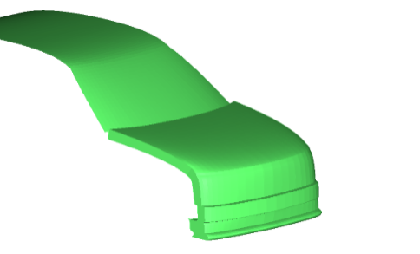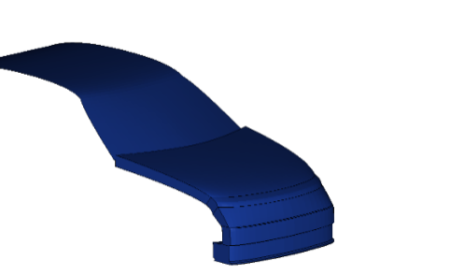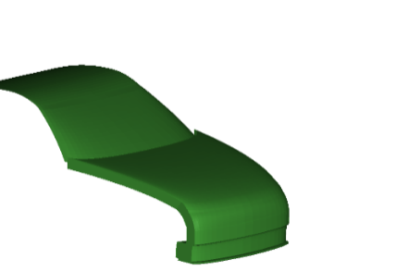
SUV
Familycar
Roadster

3.1.2.2.1.3. The generic vehicles are available in three two different unit systems and shall be used in the unit system used throughout the procedure:
- Millimetre, kilogram, milliseconds (mm_kg_ms)
- Millimetre, tons, seconds (mm_to_s)
3.4.2.2. Auxiliary files for the utilisation of the generic vehicle models are available together with the models, which are further explained in Annex 2. These files are templates only and therefore have to be adjusted by the user.

3. General design
3.1. The generic vehicle models are finite element simulation models, which were designed to represent three different shapes and stiffnesses representative for the European fleet at the time of development of the models. The geometry of the cross-section at the vehicle centreline of the three different vehicle shapes is shown below:
Figure 2
Components of the generic vehicle models to represent generic structure

Amend as follows (move figure 3 after 3.2.1 and delete it after 3.2.2):
3.2. Physical properties
3.2.1. The generic vehicle model consists of the components shown in Figure 13. The structural response is modelled through an outer shell surface, an interface layer, (for modelling the vehicles fascia), a generic foam (to model energy absorbing structures like rips), resting on the bottom layer (a rigid skeletal vehicle structure) and the compaction layer which works a hard stop.
Figure 3
Components of the generic vehicle models to represent generic structure
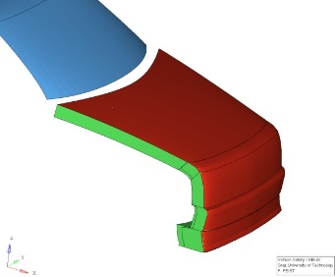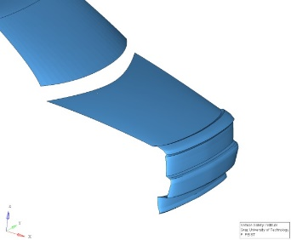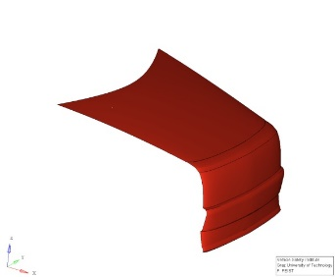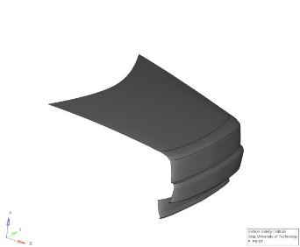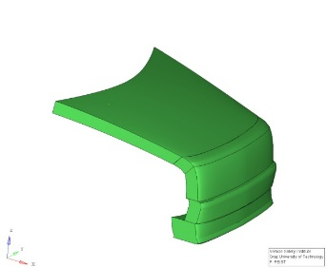
Interface Layer
Foam Layer
Compaction Layer
Foam Bottom Layer
Generic Vehicle

3.2.3.3.2.2. The generic vehicle models have only one degree of freedom, which is the x-direction in the vehicle coordinate system. An initial velocity is applied to the generic vehicle models at the start of the simulation. Further motion in x are not prescribed. The mass of the generic vehicle modes are shown in Table 1. The vehicle’s moments of inertia remain unconsidered, though.

Table 1: Mass of the generic vehicle models
Vehicle Category | Total Mass [(kg)]
SUV | 1775
Familycar | 1690
Roadster | 1462.5

4. Certification Plausibility Check
4.1. The certification of Impactor simulations on the generic vehicle models may be performed if the user has any doubt that the generic vehicle models work properly with the solver version and control cards used as plausibility check. If issues (i.e. significant the deviations to the reference curves outside of the provided corridors shown in red) are identified, the user shall switch to another solver version [and] review the control settings [and report the issue to gv.vsi@tugraz.at. GRSP through a Contracting Party].
4.2. To perform the comparison, the files specified in Annex 2 for the respective FE code, vehicle shape and impactor location shall be used. Impacts shall be performed with the rigid cylindrical impactor (density= 7.89 E‐6 kg/mm³, diameter= 120 mm, height= 400 mm and wall thickness= 5 mm) at the vehicle centreline on the spoiler (ID=1), Bumper (ID=3), Bonnet Leading Edge (ID=5) and bonnet (ID=7), as shown in the figure below.
Figure 4
Impact locations for GV certification plausibility check

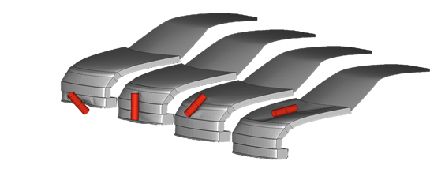
1
3
5
7
4.3. The outputs of the impactor node shall be utilised to compare the simulation results with the references shown in Table 2. The impactor acceleration has to be multiplied with 5.95kg to receive the force and the resultant displacement is used as displacement. The black and grey lines shown in the figures show the responses of the generic vehicle models in the three different FE codes and should be used as reference. The focus in the development of the generic vehicle models was consistency between the different FE codes using the shown corridors and median responses as reference.

4.4. The GV Models have been validated have been developed and tested with the following solver versions:
• RADIOSS 2019
• LS-Dyna R12
• VPS 2019, 2020, 2021, 2022
Other solver versions can be used, but users shall verify check the behaviour of the GV models by performing the impactor simulations as plausibility check as described in this chapter. The response of the models [from 5 mm] up to the maximum deflection shall be within the specified corridors utilizing the tabular values which are part of the auxiliary files shown in Table 2 (see Annex 2). If modifications of the models are required, they shall comply with the specified corridors and be documented and reported to [GRSP through a Contracting Party].

[Table 2: Reference Curves for Impactor Simulations with Generic Vehicle models. The red corridors shall be used to compare the response of the GV model [from 5 mm] up to the maximum deflection. The black lines show the responses of the GV models in the three different codes at the time of development.

LC | FCR | RDS | SUV
Corridor
LS-Dyna
Radioss
VPS
1
3
5
7
]

Annex 1
File list of generic vehicle models

Table A-1: File structure and names of the generic vehicle models. The models are provided “as is”. The users are responsible to check verify the behaviour of the models according to chapter 4.

FE Code | Unit System | Master files | File ID
LS-Dyna | mm, kg, ms | GV_FCR_R3_1_mm_kg_ms.key | D-GV-1
 |  | GV_RDS_R3_1_mm_kg_ms.key | D-GV-2
 |  | GV_SUV_R3_1_mm_kg_ms.key | D-GV-3
 | mm, to, s | GV_FCR_R3_1_mm_to_s.key | D-GV-4
 |  | GV_RDS_R3_1_mm_to_s.key | D-GV-5
 |  | GV_SUV_R3_1_mm_to_s.key | D-GV-6
RADIOSS | mm, kg, ms | GV_FCR_R3_1_mm_kg_ms.0000.rad  GV_FCR_R3_1_mm_kg_ms.0001.rad | R-GV-1  R-GV-10
 |  | GV_RDS_R3_1_mm_kg_ms.0000.rad  GV_RDS_R3_1_mm_kg_ms.0001.rad | R-GV-2  R-GV-20
 |  | GV_SUV_R3_1_mm_kg_ms.0000.rad  GV_SUB_R3_1_mm_kg_ms.0001.rad | R-GV-3  R-GV-30
 | mm, to, s | GV_FCR_R3_1_mm_to_s.0000.rad  GV_FCR_R3_1_mm_to_s.0001.rad | R-GV-4  R-GV-40
 |  | GV_RDS_R3_1_mm_to_s.0000.rad  GV_RDS_R3_1_mm_to_s.0001.rad | R-GV-5  R-GV-50
 |  | GV_SUV_R3_1_mm_to_s.0000.rad  GV_SUV_R3_1_mm_to_s.0001.rad | R-GV-6  R-GV-60
VPS | mm, kg, ms | GV_FCR_R3_1_mm_kg_ms_VPS.inc | V-GV-1
 |  | GV_RDS_R3_1_mm_kg_ms_VPS.inc | V-GV-2
 |  | GV_SUV_R3_1_mm_kg_ms_VPS.inc | V-GV-3
 | mm, to, s | GV_FCR_R3_1_mm_to_s_VPS.inc | V-GV-4
 |  | GV_RDS_R3_1_mm_to_s_VPS.inc | V-GV-5
 |  | GV_SUV_R3_1_mm_to_s_VPS.inc | V-GV-6

Annex 2
Auxiliary Files
Table A-2: Auxiliary files to facilitate the use of the generic vehicle models. All master files listed in this table have to be adjusted by the user to create the specific simulation setup to perform the impactor simulations specified in Chapter 4. They are available in both unit systems. It also includes the reference curves and corresponding corridors shown in Table 2 for each shape and loadcase.

[
LS-Dyna
Template for Impactor Simulations | \Auxiliary_files_Impactor_Sim\00__GV_Main_IMP_Template.dyn | D-I-1
referring to include files:  - Cyclindrical impactor  - Parameters for impact on FCR  - Parameters for impact on RDS  - Parameters for impact on SUV  - Exemplary control file | \IMP_FILES\11a_IMP_NodEle_Cyl.inc  \IMP_FILES\10__IMP_Parameters_FCR.inc  \IMP_FILES\10__IMP_Parameters_RDS.inc  \IMP_FILES\10__IMP_Parameters_SUV.inc  \CONTROL_EXAMPLE\00__Controls_example.inc | D-I-2  D-I-3  D-I-4  D-I-5  D-I-6
RADIOSS
Template for Impactor Simulations | \Auxiliary_files_Impactor_Sim\00__GV_Main_IMP_Template_0001.rad  \Auxiliary_files_Impactor_Sim\00__GV_Main_IMP_Template_0000.rad | R-I-1
referring to include files:  - Cyclindrical impactor  - Parameters for impact on FCR  - Parameters for impact on RDS  - Parameters for impact on SUV | \IMP_FILES\IMPACTOR.inc  \IMP_FILES\IMP_Parameters_FCR_01.inc  \IMP_FILES\IMP_Parameters_FCR_03.inc  \IMP_FILES\IMP_Parameters_FCR_05.inc  \IMP_FILES\IMP_Parameters_FCR_07.inc  \IMP_FILES\IMP_Parameters_RDS_01.inc  \IMP_FILES\IMP_Parameters_RDS_03.inc  \IMP_FILES\IMP_Parameters_RDS_05.inc  \IMP_FILES\IMP_Parameters_RDS_07.inc  \IMP_FILES\IMP_Parameters_SUV_01.inc  \IMP_FILES\IMP_Parameters_SUV_03.inc  \IMP_FILES\IMP_Parameters_SUV_05.inc  \IMP_FILES\IMP_Parameters_SUV_07.inc | R-I-2  R-I-3  R-I-4  R-I-5  R-I-6  R-I-7  R-I-8  R-I-9  R-I-10  R-I-11  R-I-12  R-I-13  R-I-14
VPS
Template for Impactor Simulations | \Auxiliary_files_Impactor_Sim\fcr-impactor-template.pc  \Auxiliary_files_Impactor_Sim\rds-impactor-template.pc  \Auxiliary_files_Impactor_Sim\suv-impactor-template.pc | V-I-1  V-I-2  V-I-3
referring to include files:  - Cyclindrical impactor | \Auxiliary_files_Impactor_Sim\impactor.inc | V-I-4
COMMON
Tabular values of curves shown in Table 2 for  - FCR Loadcase 1  - FCR Loadcase 3  - FCR Loadcase 5  - FCR Loadcase 7  - RDS Loadcase 1  - RDS Loadcase 3  - RDS Loadcase 5  - RDS Loadcase 7  - SUV Loadcase 1  - SUV Loadcase 3  - SUV Loadcase 5  - SUV Loadcase 7 | COMMON\Reference_Values_FCR_01.csv  COMMON\Reference_Values_FCR_03.csv  COMMON\Reference_Values_FCR_05.csv  COMMON\Reference_Values_FCR_07.csv  COMMON\Reference_Values_RDS_01.csv  COMMON\Reference_Values_RDS_03.csv  COMMON\Reference_Values_RDS_05.csv  COMMON\Reference_Values_RDS_07.csv  COMMON\Reference_Values_SUV_01.csv  COMMON\Reference_Values_SUV_03.csv  COMMON\Reference_Values_SUV_05.csv  COMMON\Reference_Values_SUV_07.csv | C-A-1  C-A-2  C-A-3  C-A-4  C-A-5  C-A-6  C-A-7  C-A-8  C-A-9  C-A-10  C-A-11  C-A-12

]

The reference curves shown in Table 2 are included in the file “Impactor_Simulation_Results.csv”.

[The specified files generic vehicles are available on the website of the Mutual Resolution No. 1 (M.R.1) of the 1958 and the 1998 Agreements: [www.unece.org/trans/main/wp29/wp29wgs/wp29gen/wp29resolutions.html For review, the files are available in the meantime here: https://openvt.eu/EuroNCAP/tb024/-/tree/GV-models-for-DPPS/Generic_vehicle_Models]
[The specified auxiliary files are available on the website of the Mutual Resolution No. 1 (M.R.1) of the 1958 and the 1998 Agreements: [ www.unece.org/trans/main/wp29/wp29wgs/wp29gen/wp29resolutions.html For review, the files are available in the meantime here: https://openvt.eu/EuroNCAP/tb024/-/tree/GV-models-for-DPPS/Generic_vehicle_Models]

