Proposal for Supplement 03 of the 09 series of amendments to UN Regulation No. 14 (Safety-belts anchorages)
Submitted by the expert from Spain

The text reproduced below was prepared by Spain to align UN Regulations adult and children safety.

I. Proposal
Annex 6, note a: amend to read:
"Annex 6
"…
Note a: For M2 and M3 vehicles of all classes, forward facing Seats facing Built in Child Restraint Systems shall be equipped with at least two lower anchorages and one upper anchorage which allow the installation of three point safety-belts type Ar.
“
II. Justification

- For M2 and M3 vehicle of all classes, when an adult seating in a forward-facing seat which face a built in Child Restraint system, an impact between the adult and the child shall be prevented.

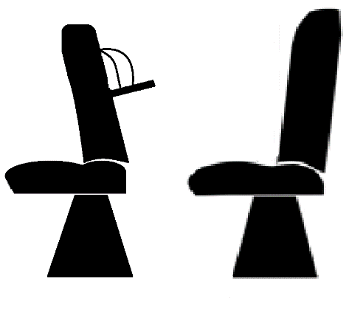
- In order to prevent the impact between the occupants a 3-point belt is requested on the adult seating position.
- The text has been proposed to be updated in the UN Regulation 16 Supplement 05 to 08 series of amendments, it seeks to harmonize requirements in both UN Regulation 14 and UN Regulation 16.

