|  |  |  |  |
| --- | --- | --- | --- |
|  | United Nations | ECE/TRANS/WP.29/GRSG/2023/10 | |
| _unlogo | **Economic and Social Council** | | Distr.: General  10 January 2023  Original: English |

**Economic Commission for Europe**

Inland Transport Committee

**World Forum for Harmonization of Vehicle Regulations**

**Working Party on General Safety Provisions**

**125th session**

Geneva, 27–31 March 2023

Item 4(e) of the provisional agenda

**Awareness of the Proximity of Vulnerable Road Users:**

**UN Regulation No. [167] (Vulnerable Road Users Direct Vision)**

Proposal for Supplement 1 to the original version of UN Regulation No. [167] (Vulnerable Road Users Direct Vision)

**Submitted by the expert of the Informal Working Group on Awareness of Vulnerable Road Users Proximity** **[[1]](#footnote-2)\***

The text was reproduced below was prepared by the experts from the VRU-Proxi Informal Working Group to amend UN Regulation No. [167] for Vulnerable Road Users Direct Vision as adopted at the 188th session of the World Forum for Harmonization of Vehicle Regulations (WP.29) by ECE/TRANS/WP.29/2022/140/Rev.1. The modifications to the adopted text (ECE/TRANS/WP.29/2022/140/Rev.1) are marked in bold for new or strikethrough for deleted characters.

I. Proposal

*Table of contents*, amend to read:

"Contents

*Page[[2]](#footnote-3)\**\*

…

Annexes

…

**8 Method for the assessment of an alternative front volume** "

*Paragraph 5.3.*, amend to read:

"5.3. If it can be demonstrated that the reason that a vehicle cannot meet the limit to the front is because of an innovative design, for example where the A-pillars are closer together than in a conventional design, then the vehicle may be deemed to comply **to the discretion of the manufacturer** if it passes all other applicable limits in addition to the following requirement**s**. ~~This shall be demonstrated by positioning five test objects with equidistant spacing between the vehicle nearside and offside planes. The test objects shall be moved in the longitudinal plane until they are positioned such that the top of the object is just visible from the point E2, through any window/glazed area. The test object shall be a 1.40 m tall pole of 30 mm diameter. A marker point representing a VRU shoulder shall be positioned 0.130 m closer to the vehicle, in the longitudinal plane, than the centre of the pole. The average distance in the longitudinal plane between the vehicle frontal plane and the shoulder marker point for each pole when it is just visible, shall be calculated. For any test object where the shoulder marker point lies to the rear of the frontal plane, a distance of 0.0 m shall be used to calculate the average. The average distance shall be equal to or less than:~~

**The alternative volume of the frontal assessment zone that is visible through any glazed area shall be calculated according to the method explained in Annex 8. If this method is used then the minimum value of front visible volume shall, for level 1 vehicles, be [6m3] and for level 2 or level 3 vehicles, be [4.5 m3].**

~~5.3.1. Level 1: 1.65m~~

~~5.3.2. Level 2:~~ ~~1.97m~~

~~5.3.3. Level 3: 1.97m~~ "

*Insert new Annex 8,* to read:

**"Annex 8**

**Method for the assessment of an alternative front volume**

**0. As an alternative the Front Visible Volume can be determined by the volume of space, contained entirely within the frontal assessment volume, that is visible via sightlines projected from one of the E-points through the direct vision opening lines associated with any glazed area of the cab.**

**1. Alternative frontal assessment volume**

**1.1. The alternative frontal assessment volume shall be defined as the volume of space between the frontal, nearside and offside plane of the vehicle and the horizontal and vertical boundaries of the frontal assessment zone as defined below and illustrated in Figure 1 of this Annex.**

**1.2. The forward boundary of the frontal assessment zone shall be formed by a plane parallel to the vehicle frontal plane and positioned 2,000 mm forward of the vehicle frontal plane.**

**1.3. The nearside boundary of the total assessment zone shall be formed by a plane parallel to the vehicle nearside plane and positioned [2,000mm / 4,500 mm] further to its nearside.**

**1.4. The offside boundary of the total assessment zone shall be formed by a plane parallel to the vehicle offside plane and positioned 2,000 mm further to its offside.**

**1.5. The rearward boundary of the total assessment zone shall be formed by the vehicle frontal plane.**

**1.6. The vertical boundaries of the assessment zone shall be formed by the ground plane and a plane parallel to the ground plane but positioned 1,602 mm above the ground.**

**Figure 1**

**Definition of the Frontal Assessment Volume, Based on a Category N3 Vehicle as an Example intended for Left-hand Traffic**

**Frontal assessment vo**

**Frontal Assessment Volume**

**Frontal Assessment Volume**

**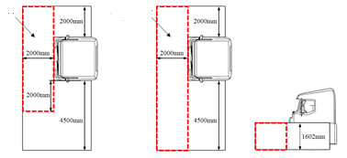**

[ or ]

**2. Numerical Test Method**

**2.1. The Numerical Test Method as defined in Annex 7 is applicable for the determination of the alternative Front Visible Volume.**

**3. Physical Test Method**

**3.1. The Physical Test Method as defined in Annex 6 is applicable for determination of the alternative Frontal Visible Volume. For determination of the alternative frontal assessment volume the front visible line length is the length of gridlines within the frontal assessment volume that are visible on the assessment plane from the point E2 and through any transparent area of the vehicle, where the view from the driver’s seat would predominantly lie forward of the frontal plane of the vehicle. Line length measured from the point E2 shall include only lines that are parallel to the median longitudinal plane of the vehicle as shown in Figure 2.**

**3.2. The front visible line length for the alternative frontal volume (mm) is converted into the alternative Front Visible Volume (mm3) as follows:**

$$[Front Visible Volume = \frac{Front visible line length}{0.0000593932}-13,715.5591368016]$$

**Figure 2  
Visible Line Lengths to Front Side Based on an Example Intended for Left-Hand Traffic**

[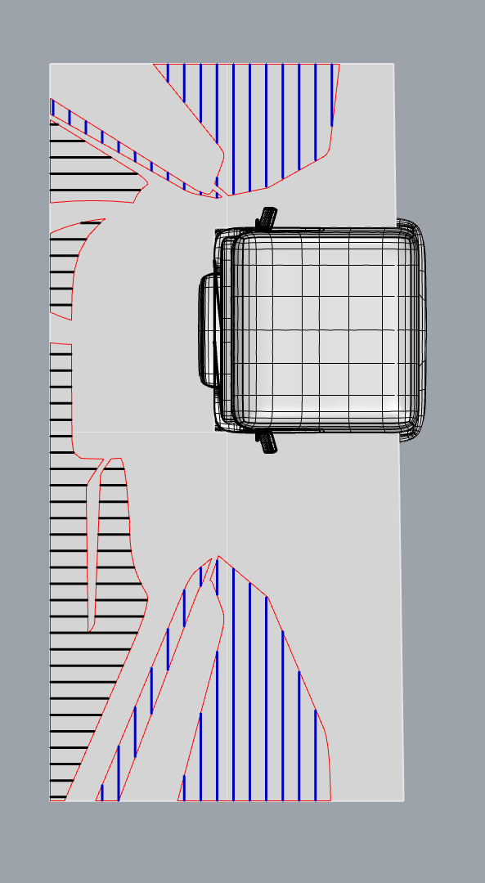]"

II. Justification

1. The current method for assessment of the frontal visible volume in UN Regulation No. 167 depends on the geometry of the cab design (position of the A-pillars). Therefore, this method may disadvantage future cab designs with A-pillars closer to each other.
2. With this amendment an alternative frontal assessment volume is proposed to the discretion of the manufacturer. This alternative assessment volume is independent of the cab design as the assessment volume is not determined by elements of the cab geometry anymore.

1. \* In accordance with the programme of work of the Inland Transport Committee for 2023 as outlined in proposed programme budget for 2023 (A/77/6 (Sect. 20), table 20.6), the World Forum will develop, harmonize and update UN Regulations in order to enhance the performance of vehicles. The present document is submitted in conformity with that mandate. [↑](#footnote-ref-2)
2. \*\* Page numbers will be added at a later stage. [↑](#footnote-ref-3)