Submitted by the experts from OICA | Informal document GRE-88-24  (88th GRE, 25-28 April 2023,  agenda item 6 (a))

Revised proposal for a new series of amendments to UN Regulation No. 48
Submitted by the International Association of the Body and Trailer Building Industry
The text reproduced below was prepared by the expert from the International Association of the Body and Trailer Building Industry (CLCCR), introducing amendments to UN Regulation No. 48 to increase the number of manoeuvring lamps on trailers according to the length of the trailer. This document is a revised version of ECE/TRANS/WP.29/GRE/2022/25/Rev.1 with improvements to the description of the installation position. The modifications to the existing text are marked in bold for new and strikethrough for deleted characters.
I. Proposal
6.26.1. Presence
Optional on motor vehicles and trailers.
Paragraph 6.26.2., amend to read:
"6.26.2. Number
One or two (one per side) on vehicles not exceeding 6 m in length.
A maximum of four (up to two per side) on vehicles above 6 m and up to and including 9 m in length.
A maximum of six (up to three per side) on vehicles exceeding 9 m in length.
However, installed lamps must be type-approved according to the 00 or subsequent series of amendments to UN Regulation No. 23, or to the 00 or subsequent series of amendments to UN Regulation No. 148 "
Paragraph 6.26.4., amend to read:
"6.26.4. Position
No special requirement.
6.26.4.1. In width: No special requirement.
6.26.4.2. In height: Above the ground, not more than 1,500 mm.
6.26.4.3. In length: In the case of the installation of more than one manoeuvring lamp, lamps shall be mounted as symmetrically as practicable along each side of the vehicle.
The distance between two adjacent manoeuvring lamps on the same side shall not be less than 0.5 m."
Paragraph 6.26.7., unamended and provided as supplementary information only:
“6.26.7. Electrical Connections
Motor vehicles: Manoeuvring lamps shall be so connected that they cannot be switched ON unless the main-beam headlamps or the dipped-beam headlamps of the motor vehicle are switched ON at the same time.
The manoeuvring lamp(s) shall be switched ON automatically for slow manoeuvres up to 15 km/h provided that one of the following conditions is fulfilled:
(a) Prior to the vehicle being set in motion for the first time after each manual activation of the propulsion system; or
(b) Reverse gear is engaged; or
(c) A camera-based system which assists parking manoeuvres is operating.
The manoeuvring lamps shall be automatically switched OFF if the forward speed of the vehicle exceeds 15 km/h and they shall remain switched OFF until the switch ON conditions are met again.
Trailers: Manoeuvring lamps shall be so connected that they cannot be activated unless the position lamps of the trailer are switched ON at the same time and shall take their input speed directly from the trailer.
The manoeuvring lamp(s) shall be switched ON automatically for slow manoeuvres up to 15 km/h provided that one of the following conditions is fulfilled:
(a) Prior to the trailer being set in motion for the first time after each manual activation of the vehicle propulsion system; or
(b) The reverse lamp is switched ON; or
(c) A camera-based system which assists parking manoeuvres is operating.
The manoeuvring lamps shall be automatically switched OFF if the forward speed of the trailer exceeds 15 km/h and they shall remain switched OFF until the switch ON conditions are met again.”
II. Justification
1. This proposal for a new series of amendments to UN Regulation No. 48 (Installation of lighting and light-signalling devices) submitted by the expert from CLCCR intends to improve the all-round visibility of trailers and vehicle combinations by increasing the number of manoeuvring lamps to be installed in relation to the length of the vehicle. This will help to mitigate the risk of low-speed manoeuvring accidents in low light conditions.
Paragraph 6.26.2.
2. Following feedback from contracting parties during the eighty-sixth session of the Working Party on Lighting and Light-Signalling (GRE) it was suggested to limit the number of manoeuvring lamps in relation to the length of the vehicle. This proposal aligns with common lengths already prescribed for direction indicators (paragraph 6.5.3.). References to 6 m can also be found in the requirements for side-markers and side retro-reflectors. The text was also updated to match that found in the proposal for device transition GRE/2023/3.
Paragraph 6.26.4.2.
- As the number of lamps has been increased to a maximum of 3 per side, the installation height has been limited to 1.5 m to avoid the risk of glare to other road users. This also aligns with the maximum height for the installation of side-marker lamps. It should be noted that the observation area of manoeuvring lamps must also meet the requirements of Annex 14 (see Figure 1 below for an illustration of the maximum, worst-case condition).
Paragraph 6.26.4.3.
- Similarly to para. 4 above (increased number of lamps), the requirements according to the length ensure symmetry of the installation and specify a minimum separation of lamps to avoid causing confusion or distraction to other road users.
- As a reminder from informal document GRE-86-05-Rev.2, paragraph 6.26.7., the trailer manoeuvring lamps shall be automatically switched off if the forward trailer speed exceeds 15 km/h and shall remain switched off until the conditions for activation are met again. To ensure vehicle combination compatibility, the lamps are required to take their speed input directly from the trailer (and not the towing vehicle).
6. Background supporting information:
6.1. Workplace transport safety: a brief guide (Health & Safety Executive (HSE), series code INDG199(rev2), United Kingdom of Great Britain and Northern Ireland) (excerpts):
(a) Every year, there are over 5000 accidents involving transport in the workplace. About 50 of these result in people being killed (www.hse.gov.uk/statistics). The main causes of injury are people falling off vehicles, or being struck or crushed by them.
(b) Lighting
Every workplace should have suitable and sufficient lighting, particularly in areas where:
• Vehicles manoeuvre, or pedestrians and vehicles circulate and cross.
• Loading and unloading takes place.
(c) Safe site (activity) - Reversing
Around a quarter of all deaths involving vehicles at work occur as a result of reversing. It also results in considerable damage to vehicles, equipment and property.
The most effective way of reducing reversing incidents is to remove the need to reverse by, for example, using one-way systems. Where this is not possible, sites should be organised so that reversing is kept to a minimum.
Where reversing is necessary, consider the following:
• Install barriers to prevent vehicles entering pedestrian zones.
• Plan and clearly mark designated reversing areas.
• Keep people away from reversing areas and operations.
• Use portable radios or similar communication systems.
• Increase drivers’ ability to see pedestrians.
• Install equipment on vehicles to help the driver
6.2. A guide to workplace transport safety (Health & Safety Executive (HSE), series code HSG136 (3rd Edition), United Kingdom of Great Britain and Northern Ireland)¹ (excerpts):
Vehicle visibility and reversing aids
• It is important that drivers are able to see clearly around their vehicle, so they can see hazards and avoid them.
• Vehicles should also be clearly visible to pedestrians and other vehicles in the workplace, so consider fitting, for example, additional lights, reflectors and flashing (or rotating) beacons (as well as horns for drivers to warn others that they are approaching).
- An increasing number of companies and freight operators across the European Union are installing manoeuvring lamps to trailers and vehicle combinations as a "post-registration" installation, to provide better all-round visibility for the driver (and other workers) when in close proximity to low-speed manoeuvring vehicles. This is particularly relevant when reversing with a long trailer. This proposal will allow installation of additional manoeuvring lamps in relation to the vehicle length at the point of type approval.
Figure 1
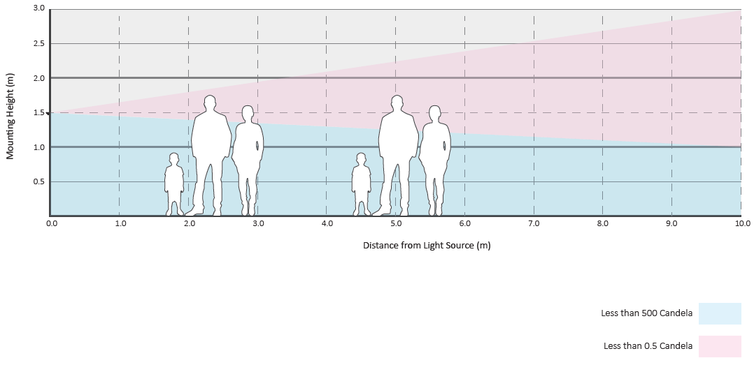
Figure source: Labcraft. No copyright is attached to this illustration.
________________

Contains public sector information published by the Health and Safety Executive and licensed under the Open Government Licence.

