Proposal for Transitional Provisions of [09] Series of Amendments to UN Regulation No. 48
This document is a revised proposal to amend Transitional Provisions to [09] series of Amendments to UN Regulation No. 48. It is based on ECE/TRANS/WP.29/GRE/2020/8/Rev.3 which is submitted to the eighty-eighth session of the Working Party on Lighting and Light-Signalling (GRE). The modifications to paragraph 12 are shown in red colour.

I. Proposal
Add a new paragraph 12.8. and related subparagraphs to read:

“12.8. Transitional provisions applicable to [09] series of amendments.
12.8.1. As from the official date of entry into force of the [09] series of amendments, no Contracting Party applying this Regulation shall refuse to grant or refuse to accept type approvals under this Regulation as amended by the [09] series of amendments.
12.8.2. For vehicles of categories M, and N₁, O₁ and O₂:
12.8.2.1. As from 1 September [20262027] Contracting Parties applying this Regulation shall not be obliged to accept type approvals to the preceding series of amendments, first issued after 1 September [20262027].
12.8.2.2. Until 1 September [20292030], Contracting Parties applying this Regulation shall accept type approvals to the preceding series of amendments, first issued before 1 September [20262027].
12.8.2.3. As from 1 September [20292030], Contracting Parties applying this Regulation shall not be obliged to accept type approvals, and extensions thereof, issued to the preceding series of amendments to this Regulation.
12.8.3. For vehicles of categories N₂, N₃, O₃ and O₄:
12.8.3.1. As from 1 September [20282029] Contracting Parties applying this Regulation shall not be obliged to accept type approvals to the preceding series of amendments, first issued after 1 September [20282029].
12.8.3.2. Until 1 September [20312032], Contracting Parties applying this Regulation shall accept type approvals to the preceding series of amendments, first issued before 1 September [20282029].
12.8.3.3. As from 1 September [20312032], Contracting Parties applying this Regulation shall not be obliged to accept type approvals, and extensions thereof, issued to the preceding series of amendments to this Regulation.
12.8.4. Notwithstanding the transitional provisions above, Contracting Parties who start to apply this Regulation after the date of entry into force of the most recent series of amendments are not obliged to accept type approvals which were granted in accordance with any of the preceding series of amendments to this Regulation.
12.8.5. Notwithstanding paragraphs 12.8.2.3. and 12.8.3.3., Contracting Parties applying this Regulation shall continue to accept type approvals to the preceding series of amendments to this Regulation, for the vehicle types which are not affected by the changes introduced by the [09] series of amendments.
12.8.6. Contracting Parties applying this Regulation may grant type approvals according to any preceding series of amendments to this Regulation.
12.8.7. Contracting Parties applying this Regulation shall continue to grant extensions of existing approvals to any preceding series of amendments to this Regulation.”

II. Justification
- Global vehicle demand is still trending well below pre-pandemic levels, and a comparison with 2019 volumes (91.2 million units) highlights how far registrations have dropped.

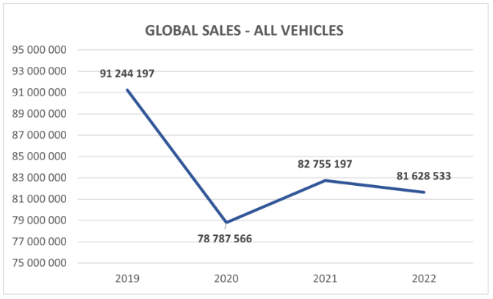

To fulfil the promise of a net zero automotive sector, industry is having to move at unprecedented speed to innovate in pursuit of improvements in range, production costs and sustainability, within an increasingly competitive environment and while facing significant supply chain challenges.

- OICA wishes to request an additional year is added to the new type date for the following reasons:
- The 09 series of amendments of UN Regulation No. 48 covers an extensive set of new requirements including inputs from the Special Interest Group (SIG), the device transition and the mandatory introduction of automatic headlamp levelling which includes revised aiming provisions. The transitional provisions were originally drafted for introduction of automatic headlamp levelling only.
- Industry needs a proportionate amount time to be able to respond to regulatory changes and whilst levelling has been discussed for several years, the final aiming diagram, the device transition and the SIG work were not foreseen. Therefore industry asks for at least 36 months from entry into force of the regulation (expected July 24) to be able to implement the necessary engineering changes.
- This additional year will also allow sufficient time for the vehicle installation approval of devices type-approved according to the original series of amendments to UN Regulations No. 148/149/150 which can be approved up until the end of August 2026. The new type date for the 01 series of amendments to the device Regulations is 1 September 2026 (WP.29/2022/92-93-94).

- OICA requests an additional 3 years are added to the acceptance of existing approvals to aid the transition to electric/hydrogen powered vehicles which are designed to have a longer product lifecycle.

- Correction to paragraph 12.8.3. As the transitional provisions above also apply to package of changes to the 09 series of amendments (levelling + SIG + device transition), then all other vehicle categories need to be included in the transitional provisions.

