Submitted by the expert from Australia | Informal document GRE-88-14  88th GRE, 25-28 April 2023,  agenda item 6 (a)

Questions regarding the interpretation of UN Regulation No. 48 – Uniform provisions concerning the approval of vehicles with regard to the installation of lighting and
light-signalling devices
Submitted by the expert from Australia:
This paper has been submitted by the expert from Australia to clarify with the GRE if/where lamps other than those defined/specified in UN Regulation No. 48, including external optical signals to indicate the operating status of a trailer system, can be fitted to vehicles in conformity with this Regulation.
I. Questions
Does UN Regulation No. 48 allow for the fitment of any lamps other than those that are listed as mandatory or optional in the Regulation, or that meet the definition of an external status indicator (for example low intensity lamps, lamps for emergency service vehicles, and/or other types of status indicators)?
If not, should UN Regulation No. 48 include requirements (or provisions to clearly allow) for devices such as in-mirror lamps for blind spot systems, special warning lamps (UN Regulation No. 65), and optical signals to indicate the operating status (or a change in the operating status) of a trailer system?
II. Background
Vehicles are currently being fitted in Australia and other markets with a range of external optical signals that may not be covered by UN Regulation No. 48, including for example:
a. In-mirror lamps for blind spot sensors;
b. Operating status lamps for cooling systems on refrigerated trailers;
c. Trailer REESS status indicators;
d. Tyre pressure indicators; and
e. Light and heavy trailer Electronic Brake System (EBS) and/or Antilock Brake System (ABS) operating status lamps.
Australia has previously submitted a proposal to amend UN Regulation No. 48 to clearly allow for the fitment of additional lamps that are designed to indicate the operating status of trailer systems to the driver of a towing vehicle (refer GRE-87-22). Helpful feedback and comments from OICA on this proposal was received and Australia is currently in the process of finalising technical requirements for these types of lamps or optical signals. Australia intends to submit a formal paper for GRE 89 following discussions with vehicle manufacturing industry.
These lamps do not meet the definition of an external status indicator, and are not specified as “mandatory” or “optional” lamps under UN Regulation No. 48. They are also not intended nor are they in use for the parked state only. Some examples are shown in the Figures below:

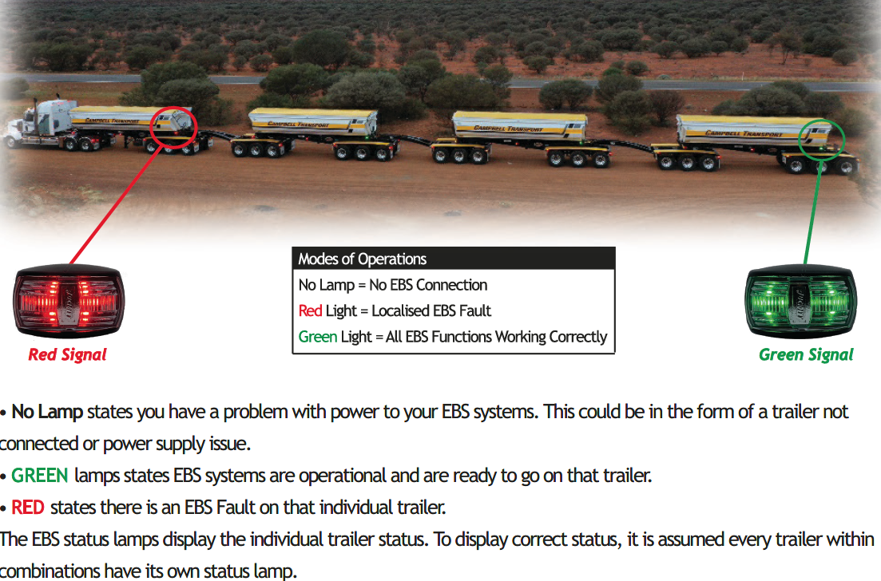
Figure 1: Operating status lamps for EBS on multiple trailers in a road train combination

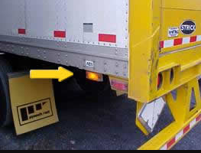
Figure 2: Operating status lamp for ABS on a trailer
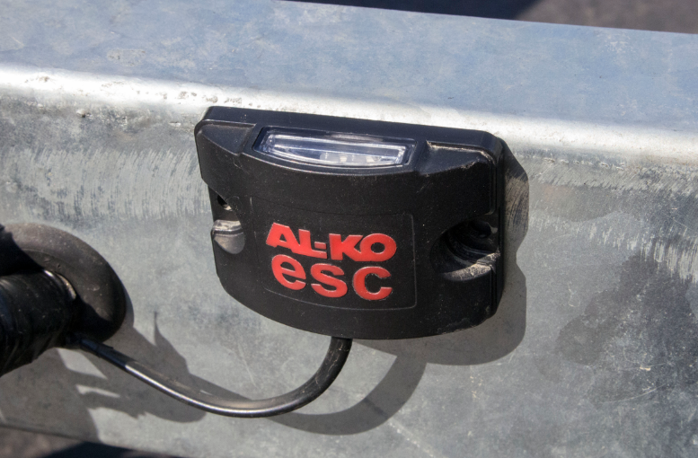
Figure 3: Operating status lamp for Electronic Stability Control (ESC) on a trailer
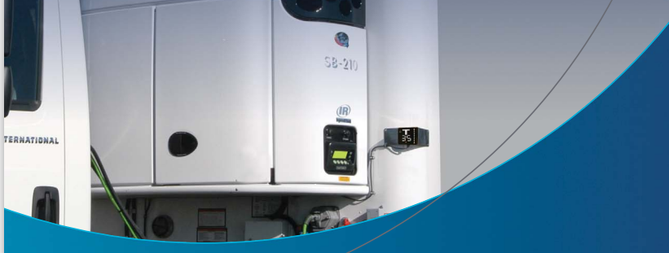
Figure 4: Operating status lamp for a cooling system on a refrigerated trailer
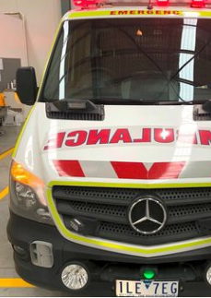
Figure 5: Green operational lamps to help traffic cameras recognise when emergency service vehicles have activated their flashing lights to respond to an emergency. The green light remains on because there’s a chance the traffic cameras will miss the rapidly flashing blue and red lights as they pass.

