Vehicle-to-Vehicle communication in the context of WP.29
The note below is based on the working paper ITS-05-02 prepared as a background note for the fifth session of the IWG on ITS, special session organized upon request by the World Forum for Harmonization of Vehicle Regulations (WP.29). The IWG received other presentations and liaison statements from standard developing organizations. The discussions were fruitful but did not allow to conclude in 3 hours about the role of WP.29 on V2V.
WP.29 discussed further steps and agreed that a dedicated Task Force is established under the IWG on ITS. WP.29 agreed to transmit this document to the task force.
I. Introduction
1. At the fourteenth GRVA session, (September 2022), the expert from China presented GRVA-14-20, proposing that GRVA address the topic of Vehicle-to-Vehicle (V2V) communication. GRVA decided to consult WP.29 on potential ways forward.
2. WP.29 decided, at its 188th session (ECE/TRANS/WP.29/1168, para. 19) in November 2022, that the Informal Working Group (IWG) on Intelligent Transport Systems (ITS) should perform preparatory activities and explore the potential role of WP.29 regarding V2V communication. This document is aimed at supporting the discussions at the IWG on ITS on this topic.
II. History and potential benefits of Vehicle-to-Vehicle communication
3. The beginning of Vehicle-to-Vehicle communication and, more generally, vehicular communications goes back to the 1970s, when first route guidance systems were developed in Japan and the United States of America.
4. Several countries initiated pre-regulatory activities to support the deployment of vehicular communications. For example, the U.S. Department of Transportation's (DOT) National Highway Traffic Safety Administration (NHTSA) released an Advance Notice of Proposed Rulemaking (ANPRM) and a supporting comprehensive research report on V2V communications technology in August 2014.
5. These activities highlighted the potential of the technology to increase road safety e.g. for an unprotected left turn scenario and an intersection crossing scenario.
6. Recent activities (e.g. the presentations during the webinar 3 on 28 February 2022) presented to the IWG on ITS highlight the potential of this technology to support automated driving systems in certain scenarios.
III. Vehicle-to-Vehicle communications and WP.29
A. Relevant activities outside of WP.29 on Vehicle-to-Vehicle communications
7. Developments in the field of vehicular communications are supported by activities performed by standardization bodies and partnerships such as IEEE, Institute of Electrical and Electronics Engineers (wireless access in vehicular environments (WAVE) - IEEE 802.11p), ETSI (ITS G5 - ETSI EN 302 571), 3GPP (the international cooperation that developed protocols for 2G/3G/4G/5G), 5GAA (connecting the telecom industry and vehicle manufacturer), ISO and the International Telecommunication Standardization Sector (ITU-T).
8. The International Telecommunication Union (ITU), through its Radiocommunication Sector (ITU-R), and its executive arm, the Radiocommunication Bureau (BR), is the global agency responsible for management of the radio-frequency spectrum.
9. Regulatory activities such as those performed by WP.29 often overlap with voluntary standards activities. Such overlaps do not necessarily represent duplicate efforts, as regulations and voluntary standards are in many cases complementary. This is for example the case for UN Regulation No. 51 (noise) and ISO 362 as well as UN Regulation No. 155 (cyber security and cyber security management system) and ISO/SAE 21343.
B. Challenges for regulators related to Vehicle-to-Vehicle communications
1. Voluntary standards and penetration rates
10. The technological development in the field of vehicular communication and the voluntary standardization efforts led to numerous trials and pre-deployment projects.
11. Some series vehicles are equipped with V2V technologies such as the Cadillac CTS (2017) and the Volkswagen Golf 8 (2020). The penetration rate of the vehicular communication remains very low.
12. Technical regulation could potentially accelerate the deployment of the technology.
2. Various standards for different and adjacent use cases
13. Several standardization activities led to the development of communication protocols for dedicated short-range communication e.g. based on Wi-Fi technology as well as the cellular based communication.
14. GRVA-14-20 provides an overview of standards in the field of V2V, as reproduced below:
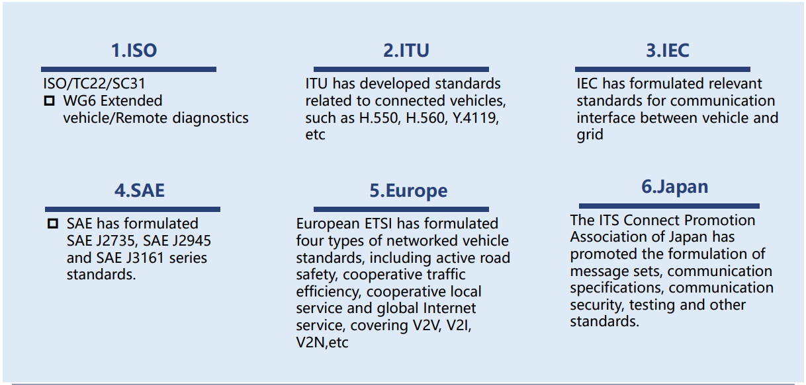
15. Harmonization of technical requirements by the Contracting Parties at WP.29 could potentially help solving the issue of coexistence. Technical discussions could lead to the identification of problems and finding solutions in order to either:
(a) Define technology neutral requirements that would solve the issue of coexistence; or
(b) Rely on a specific standard in order to ensure interoperability like the Working Party on Braking and Running Gear (GRRF) did for the connectivity between trucks/tractors and trailer, relying on ISO 11992.
3. Technology neutrality
16. The existence of various standards in the field of vehicular communication suggests that vehicle communication technology is still under development.
17. If regulations mandate, at an early stage, certain technologies, it could impede the future development potential of vehicular communication technology. One important consideration for the regulator would be to keep in mind the importance of technology neutrality, which is a key principle for the work of WP.29 (a distinguishing factor to the work done by standard developing organisations).
18. In case WP.29 would support the development of regulation in the field of vehicular communications, WP.29 might wish to advise the IWG or the GR in charge to develop a set of minimum safety requirements to ensure safety, rather than mandate a specific technology.
4. Telecommunication technologies cycles vs. vehicle lifecycles
19. Telecommunication standards used in mobile networks broadly have a lifecycle of at least one decade. The first generation of mobile networks (1G, analogue) was deployed in the 1980s. It was decommissioned and replaced by the second generation (2G, digital) in the 1990s. The third generation entered the market in the 2000s, the fourth generation in the 2010s and the fifth generation in the 2020s. Former generations are potentially decommissioned when the new generation is deployed.
20. The average age of passenger cars varies widely between different countries, ranging between 5 (Singapore) to 17 years (South America). Many cars are not decommissioned before age 30. Trucks and buses usually have a longer lifetime than passenger cars. WP.29 activities performed under the Informal Working Group (IWG) on Safer and Cleaner Used and New Vehicles (SCUNV) showed that vehicles imported into some African regions have an average age exceeding 18 years, demonstrating the longer lifecycle for road vehicles than for telecommunication products.
21. The implications of these different life cycles cannot be neglected in the field of vehicular communications. ERA GLONASS and eCall, the Russian and European automated emergency response systems, became mandatory in some jurisdictions a few years before the underlying telecommunication system was announced to be decommissioned. In fact, many countries are currently considering decommissioning 2G and 3G within the next years.
22. Such considerations could lead standardization and regulatory bodies to discuss legacy risks and envisage provisions related to backward compatibility, retrofit and decommissioning of safety functions in vehicles, in certain circumstances when the telecommunication is no longer possible.
4. Safety requirements
23. Harmonization activities could review existing provisions addressing safety and develop additional ones, if necessary, related to data transmission. It might include considerations related to coverage, interference, latency, interoperability and translate into provisions related to vehicle requirements, in terms of e.g. signal power / distance requirements etc.
24. Requirements that would not be relevant to the vehicle itself would not be addressed by the WP.29 frameworks. Activities with ITU would support consistency between vehicle requirements and infrastructure requirements.
25. Considerations related to frequency bands allocations might be necessary, but any regulatory activities would remain in the remit of ITU-R.
IV. How to introduce Vehicle-to-Vehicle in the regulatory framework?
26. Performance requirements could be developed by WP.29 and its subsidiary bodies in order to clarify on one hand technical requirements related to data transmission and on the other hand data requirements.
27. Harmonization of technical requirements could be performed under the framework of the 1958/1998 Agreements depending on the willingness of a contracting party to sponsor these activities.
28. Careful consideration should be given to regulatory subjects that are not traditionally under the remit of WP.29, such as privacy. Nevertheless, the WP.29 framework could include requirements related to these matters in order to implement principles, developed in the relevant bodies and jurisdictions, in a harmonized manner and translate them for the purpose of wheeled vehicles, their subsystems and parts. Such elements could either be included in UN GTRs and UN Regulations or in guidelines and resolutions depending on the choices made by the contracting parties.
V. How to organize the work within the subsidiary bodies of WP.29
29. This paper suggests, as a prerequisite to GRVA and other GR’s with V2X activities, that the IWG on ITS:
(a) Performs an evaluation of the work done by Standard Development Organisations (SDOs) and partnerships dealing with vehicular communications.
(b) Explores telecommunication, Information and Communication Technologies and vehicle lifecycles in order to avoid situations where safety systems would rapidly become ineffective as the technology would become obsolete.
(c) Defines potential strategies on how to address legacy risks and cross-cutting issues such as privacy and data-protection. Focus on a use case e.g. merging?
(d) Identify roles and responsibilities for stakeholders (WP.29, ITU-R, etc.) dealing with infrastructure (roads, telecommunication providers), vehicles, suppliers etc.
(e) Elaborate a summary of important studies showing how V2X, and V2V in particular, can contribute to vehicle safety, sustainability and other use cases.

NHTSA, https://www.nhtsa.gov/sites/nhtsa.gov/files/documents/v2v_pria_12-12-16_clean.pdf, accessed 14 December 2022
NHTSA, https://www.nhtsa.gov/staticfiles/rulemaking/pdf/V2V/Readiness-of-V2V-Technology-for-Application-812014.pdf, accessed 14 December 2022
https://wiki.unece.org/pages/viewpage.action?pageId=154665003

