Proposal for Supplement 11 to the 01 Series of Amendments to
UN Regulation No. 43 (Safety glazing)

The text reproduced below was prepared by the expert from the Republic of Korea, which is based on the paragraph 10. of the minutes of 124th GRSG session (ECE-TRANS-WP.29-GRSG-103). And it supersedes the working document (ECE-TRANS-WP.29-GRSG-2023-07) that has already been submitted since it needs to be corrected some errors. The modifications to the text of the working document are displayed in red. (Marked in bold for new and strikethrough for deleted characters)

- Proposal
Annex3,
Paragraph 9.1.2.2., amend to read:
"9.1.2.2. For the windscreens of M1 Vehicles ¹⁸ the test shall be carried out in Test Area B defined in Annex 21, Paragraph 2.3., excluding any opaque obscuration impinging on it.
For the windscreens of N1 Vehicles, the manufacturer may request that the same test may be carried out either in Test Area B defined in Annex 18, Paragraph 2.3, or in the Zone I defined in Paragraph 9.2.5.2.3. of this Annex, excluding any opaque obscuration impinging on it.
For windscreens of other categories of vehicles, the test shall be carried out in the Zone I defined in Paragraph 9.2.5.2.3. of this Annex, excluding any opaque obscuration impinging on it.
However, for agricultural and forestry tractors and for construction-site vehicles for which it is not possible to determine Zone I, the test shall be carried out in Zone I' as defined in Paragraph 9.2.5.3. of this Annex."
Paragraph 9.2.5.2.3, amend to read and insert a new figure 22:
"9.2.5.2.3. Zone I is the windscreen zone determined by the intersection of the windscreen with the four planes defined below:
In addition, opaque obscuration can be exempted in Zone I. It is the limited areas where it is intended that a sensing device, e.g. a rain-drop detector, rear view mirror or autonomous sensors, will be bonded to the inner side of the windscreen. The opaque obscuration where such devices may be applied is defined in paragraph 9.2.5.2.4. of this Annex.
Pl – A vertical plane passing through 0 and forming an angle of 15° to the left of the median longitudinal plane of the vehicle;
P2 – A vertical plane symmetrical to Pl about the median longitudinal plane of the vehicle.
If this is not possible (in the absence of a symmetrical median longitudinal plane, for instance) P2 shall be the plane symmetrical to Pl about the longitudinal plane of the vehicle passing through Point 0.
P3 – A plane passing through the straight Line OQ and forming an angle of 10° above the horizontal plane;
P4 – A plane passing through the straight Line OQ and forming an angle of 8° below the horizontal plane.
Figure 22
Determination of Zone I

Insert new paragraphs 9.2.5.2.4., to 9.2.5.2.4.1., amend to read and insert a new Figure 23:
"9.2.5.2.4. Determination of the opaque obscuration
P5 – a plane passing through a transverse horizontal line containing O and forming an angle of 5° above the horizontal plane
P6 – a vertical plane passing through O and inclined at 20° to the right of the X axis in the case of left-hand drive vehicles and to the left of the X axis in the case of right-hand drive vehicles.
P7 – a plane symmetrical to P6 in relation to the longitudinal median plane of the vehicles.
9.2.5.2.4.1. Any opaque obscuration bounded downwards by P5 and laterally by P6 and P7. (See figure 23)
Figure 23
Zone I (example of a left-hand steering control vehicle)
(Upper obscuration area as defined in paragraph 9.2.5.2.4.1.)
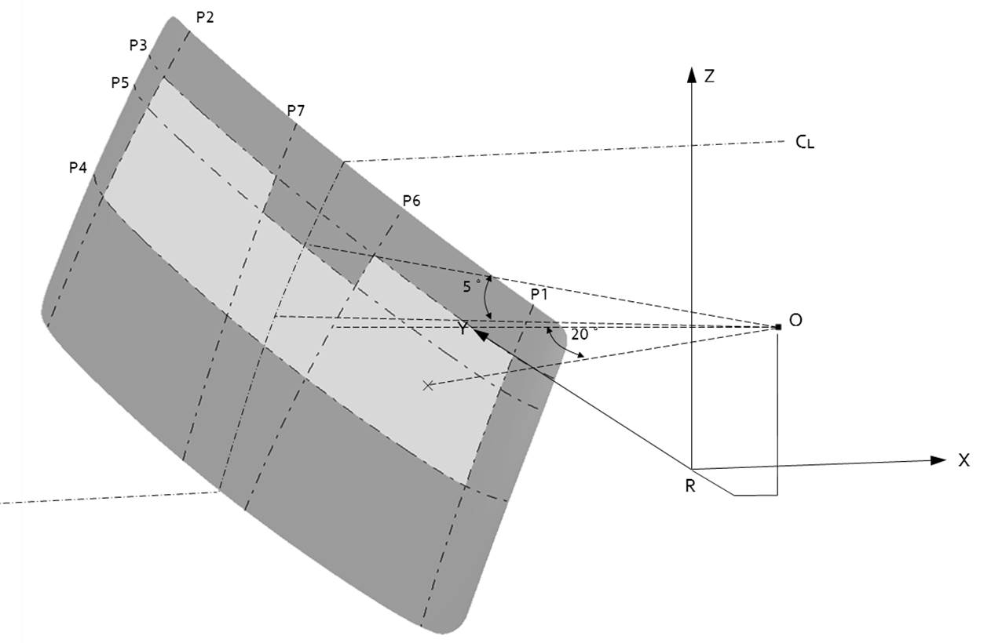

Paragraph 9.3.1.1.1., the references of Figures 22(a), 22(b) and 25, renumber as Figures 24(a), 24(b) and 27
Paragraph 9.3.1.1.3., the references of Figures 22(a) to 24 and 22(b) and Figures 22(a) to 24, renumber as Figures 24(a) and 24(b) and as Figures 24(a) to 26.
Paragraph 9.3.1.2.1., the reference of Figure 24, renumber as Figure 26
Paragraph 9.3.1.2.2., the reference of Figure 25, renumber as Figure 27
Paragraph 9.3.4., Figure 25, renumber as Figure 27
Paragraph 10.4.1., the references of Figures 26 to 28 and Figure 26, renumber as Figures 28 to 30 and as Figure 28
Paragraph 10.4.2., the references of Figures 26 to 30 26, 27, 29 and 30, renumber as Figures 28 to 32 and as Figure 28 28, 29, 31 and 32
Paragraph 10.4.3., the reference of Figures 27, renumber as Figure 29
Paragraph 10.4.5., Figures 27 to 30, renumber as Figures 29 to 32 and as Figure 28
Paragraph 10.5.1., the references of Figure 31 and Figure 31, renumber as Figures 33
Paragraph 11.2.4.1., the references of Figure 32 and Figure 32, renumber as Figure 34
Paragraph 11.2.4.3., the references of Figure 33 and Figure 33, renumber as Figure 35
Paragraph 12.4., the references of Figure 34, renumber as Figure 36
Paragraph 13.2., the reference of Figure 35 and Figures 34 and 35, renumber as Figures 37, and as Figures 36 and 37

II. Justification
1. For the optimized installation of interior rear-view mirrors and various safety and convenience features (e.g. Lane Departure Warning System and Autonomous Vehicle Sensors) of trucks with open type loading trays, it is necessary to allow an additional opaque obscuration area from the Zone I of the current text of the UN Regulation.
2. For the same purpose, the amendment to UN GTR No.6 has already been adopted at the 119th session of GRSG. The above text is proposed to align UN Regulation No. 43 to UN GTR No. 6.

18 As defined in the Consolidated Resolution on the Construction of Vehicles (R.E.3), document ECE/TRANS/WP.29/78/Rev.6, para. 2 - https://unece.org/transport/vehicle-regulations/wp29/resolutions

