Proposal for a new 02 Series of Amendments to UN Regulation No. 160 (Event Data Recorder)
The text reproduced below was prepared by the expert from the International Organization of Motor Vehicle Manufacturers (OICA) to introduce the requirements of new verification procedures with transitional provisions to allow for necessary preparation time. The text is based on chapter 6 of the proposal by the IWG on EDR/DSSAD (see documents ECE/TRANS/WP.29/GRSG/2023/11 and ECE/TRANS/WP.29/GRSG/2023/15) and is marked in blue bold for new and blue strikethrough for deleted characters.

I. Proposal
Insert new paragraph 6., to read:
"6. Verification Procedures
6.1. The accuracy of the measurement of longitudinal and lateral acceleration data element shall be verified using a component test fixture that subjects the EDR/airbag control module acceleration sensors to a sinusoidal acceleration motion in accordance with the following:
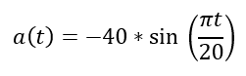 +/- 2g
6.1.1. The component test fixture shall be equipped with an acceleration sensor with a minimum range of +/- 500g and associated data acquisition system with a sampling frequency of 10kHz that is oriented to sense acceleration in the direction of the test fixture’s motion.
6.1.2. The air bag electronic control unit/EDR and applicable peripheral sensors, if needed to generate the air bag deployment signal, shall be mounted on the component test fixture as oriented in the vehicle. If the above does not generate a deployment signal, the manufacturer shall recommend the most appropriate way to generate the deployment signal.
6.1.3. The air bag deployment signal shall be recorded along with the component test fixture’s acceleration.
6.1.4. Following the activation of the component test fixture, the acceleration traces recorded by the component test fixture shall be passed through a 150 Hz two pole Butterworth filter. The equation for the 150 Hz Butterworth filter is shown below:
a_ref_150Hzfilt(n) = 0.00208057 * a_ref_raw(n)
+0.00416113 * a_ref_raw(n-1)
+0.00208057 * a_ref_raw(n-2)
+1.86689228 * a_ref_150Hzfilt(n-1)
-0.87521455 * a_ref_150Hzfilt(n-2)
The filtered component test fixture acceleration traces shall be compared to the acceleration traces recorded in the EDR unit by aligning the traces using the air bag deployment signal time.
6.1.5. The EDR recorded acceleration trace shall be fully contained in a corridor that is +/- 10 per cent of the full-scale range of the accelerometer used by the controller containing the EDR applied to the component test fixture’s filtered acceleration trace. The comparison of acceleration sensor traces shall only be made on the axis the component test was conducted.
For example, if the accelerometer in the controller containing the EDR function has a +/- 100 g range, then +/- 10 g would be applied to the component test fixture’s filtered acceleration trace. The EDR recorded acceleration trace shall be fully contained within that corridor (see the Figure).

Corridor +/- 10 Per Cent of the Full-Scale Range of the Accelerometer
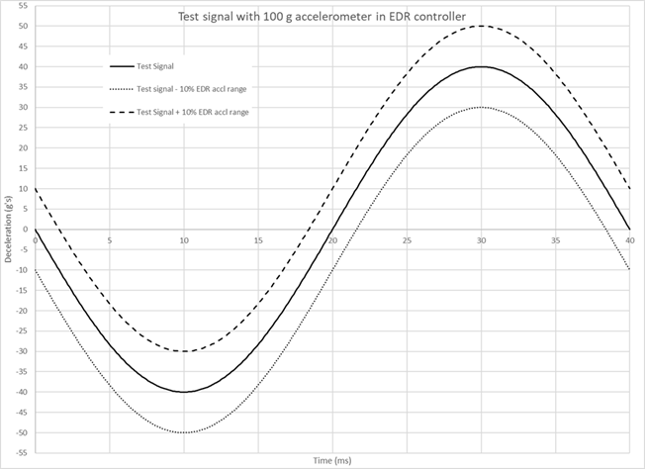
6.1.6. The EDR acceleration trace in paragraph 6.1.5. can be time shifted up to +/- 2ms based on the inverse of the 500 Hz sample rate to further align the data. The minimum step of the time shift may be the inverse of the sample rate of the EDR.
6.1.7. The acceleration data elements satisfy the tolerance condition if the EDR recorded acceleration trace is fully contained within the corridor established in paragraph 6.1.5., with or without following the above time shift in paragraph 6.1.6.
6.1.8. If the recommended waveform cannot realize algorithm wakeup due to the reason of manufacturer’s algorithm strategy, the manufacture may select a waveform, or amplify the suggested waveform. The waveform used for the EDR acceleration data accuracy shall be provided for review, if it is different than the waveform defined in the verification process."

Paragraphs 6. to 11.4, renumber as paragraphs 7. to 12.4

Paragraph 11.5.(former), renumber as paragraph 12.5, and amend to read:

"12.5. Notwithstanding paragraph 12.4., Contracting..."

Insert paragraphs 12.6. to 12.9, to read

12.6. As from the official date of entry into force of the 02 series of amendments, no Contracting Party applying this Regulation shall refuse to grant or refuse to accept type approvals under this Regulation as amended by the 02 series of amendments.
12.7. As from 1 September 2024, Contracting Parties applying this Regulation shall not be obliged to accept type approvals to the 01 series of amendments to this Regulation, first issued after 1 September 2024.
12.8. Until 1 September 2026, Contracting Parties applying this Regulation shall accept type approvals to the 01 series of amendments to this Regulation, first issued before 1 September 2024.
12.9. As from 1 September 2026, Contracting Parties applying this Regulation shall not be obliged to accept type approvals issued to the 01 series of amendments to this Regulation.

12.10. Notwithstanding paragraph 12.9., Contracting Parties applying this Regulation shall continue to accept type approvals issued according to the 01 series of amendments of this Regulation, for vehicles which are not affected by the changes introduced by the 02 Series of amendments.

Paragraph 11.6 (former), renumber as 12.11.

Annex 4, Table 1, footnote 10, amend to read:
_____________________________
10 +/- 10 per cent of the full range of the accelerometer used in the Electronic Control Unit (ECU) containing the EDR function as specified in paragraph 6.1.5.

II. Justification
- Since it is difficult to verify the acceleration sensor accuracy in crash tests, the IWG EDR/DSSAD agreed to adopt a component test. A time shifting algorithm was also specified to address the differences in sampling rates that may exist between the EDR and the test bench.
- For more clarity an annex is added that includes an illustration of the lateral and longitudinal acceleration data element acceptant corridor.
- This supplementary verification procedure needs to be implemented with transitional provisions since it implies new measuring material for both the technical services and the manufacturers. A period of two years seems reasonable in this case.

