|  |  |  |  |
| --- | --- | --- | --- |
|  | United Nations | ECE/TRANS/WP.29/GRSP/2023/9 | |
| _unlogo | **Economic and Social Council** | | Distr.: General  1 March 2023  Original: English |

**Economic Commission for Europe**

Inland Transport Committee

**World Forum for Harmonization of Vehicle Regulations**

**Working Party on Passive Safety**

**Seventy-third session**

Geneva, 15–19 May 2023

Item 6 of the provisional agenda

**UN Regulation No. 16 (Safety-belts)**

Proposal for the 09 Series of Amendments to UN Regulation No. 16 (Safety-belts) [[1]](#footnote-2)\*

Submitted by the expert from the Netherlands

The text reproduced below was prepared by the Ad Hoc Group on Child Restraint Systems to introduce definitions, requirements and a test procedure for lower tether anchorages. The modifications to the current text of the UN Regulation are marked in bold for new or strikethrough for deleted characters.

**I. Proposal**

*Insert new paragraphs 2.48. to 2.54.,* to read:

**"2.48. *"Lower tether anchorage (LTA)"*: anchorage on the vehicle seat track or on or close to the vehicle floor to which a Lower tether bracket can be attached or is integrated. The Lower tether bracket may or may not be part of the vehicle approval.**

**2.49. *"Lower tether"*: type of anti-rotational device intended to restrict the rearward rotation of a rearward-facing ECRS.**

**2.50. *"Lower tether strap"*: a webbing strap (or equivalent) which extends from the back of an Enhanced Specific Vehicle Child Restraint System to the lower tether anchorage in the vehicle and which is equipped with an adjustment device, a tensioning-relieving device, and a lower tether connector.**

**2.51. *"Lower tether connector"* means a device intended to be attached to a lower tether bracket.**

**2.52. *"Lower tether hook"* means a connector typically used to attach a lower tether strap to a lower tether bracket and which is the same and has the same dimensions as the ISOFIX top tether hook as defined in figure 3 of Annex 4 of UN Regulation No. 129.**

**2.53. *"Lower tether bracket"* means the bracket that is attached to or integrated with the lower tether anchorage.**

**2.54. *"Generic lower tether bracket"* means the generic bracket provided by the ECRS manufacturer together with the ECRS, to be attached to the LTA as indicated by the vehicle manufacturer."**

*Paragraph 15.5.7*., shall be deleted

*Insert new paragraphs 15.6. to 15.6.4.,* to read:

**"15.6. As from the official date of entry into force of the 09 series of amendments, no Contracting Party applying this Regulation shall refuse to grant or refuse to accept type approvals under this Regulation as amended by the 09 series of amendments.**

**15.6.1. As from [1 September 2025], Contracting Parties applying this Regulation shall not be obliged to accept type approvals to the preceding series of amendments that were first issued on or after [1 September 2025].**

**15.6.2. Notwithstanding paragraph 15.6.1., Contracting Parties applying this Regulation shall continue to accept type approvals of safety-belts and restraint systems to the preceding series of amendments to the UN Regulation.**

**15.6.3. Notwithstanding paragraph 15.6.1., Contracting Parties applying this Regulation shall continue to accept type approvals to the preceding series of amendments to this Regulation, for vehicles which are not affected by the changes introduced by the 09 series of amendments.**

**15.6.4. Contracting Parties applying this Regulation shall not refuse to grant type approvals according to any preceding series of amendments to this Regulation or extensions thereof."**

*Annex 2*, amend to read:

"Annex 2

…

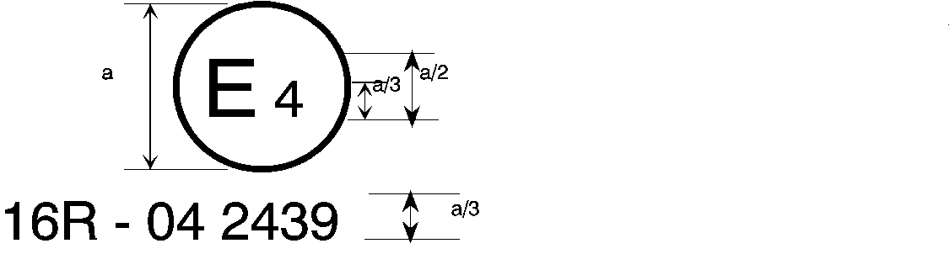

**09** 2439

The above … amended by the **09** series of amendments.

…

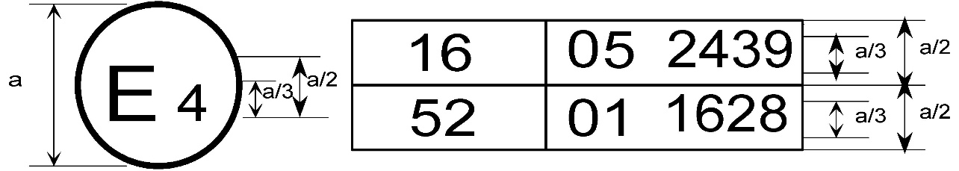

**09** 2439

The above … included the **09** series of amendments and Regulation No. 52 the 01 series of amendments.

…

2. Arrangements of the safety-belt approval marks (see paragraph 5.3.5. of this Regulation)



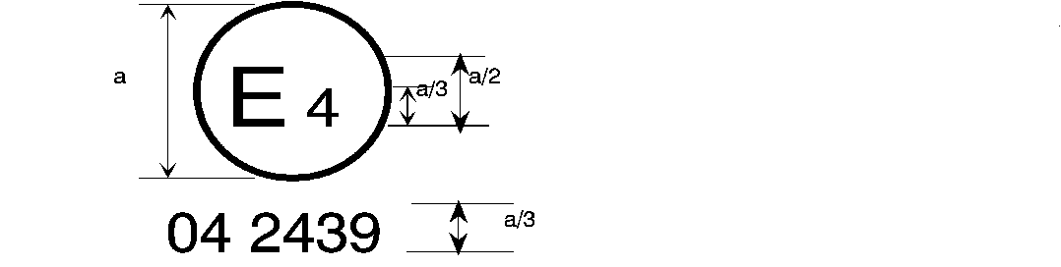

**09** 2439

a = 8 mm min.

The belt … the 06, 07**,** ~~or~~ 08 **or 09** series of amendments at the time of approval.

###### B → 4 m



**09** 2489

The belt … 06, 07**,** ~~or~~ 08 **or 09** series of amendments at the time of approval.

…

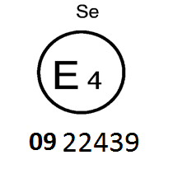

The belt bearing … the 06, 07**,** ~~or~~ 08 **or 09** series of amendments at the time of approval.

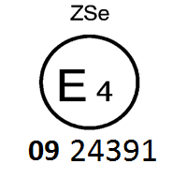

The belt … the 06, 07**,** ~~or~~ 08 **or 09** series of amendments at the time of approval.



**09** 2439

a ≥ 8 mm

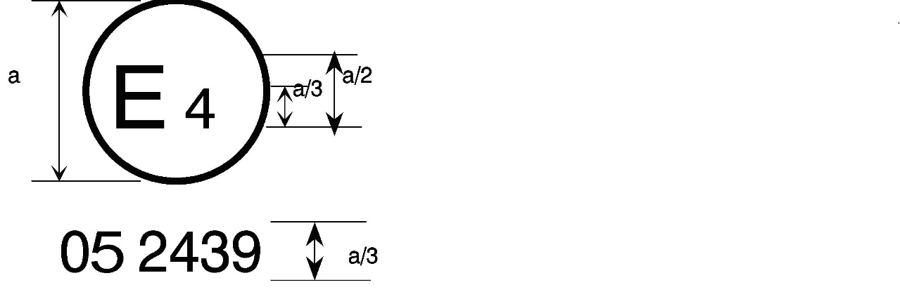

a = 8 mm min.



The belt … the 06, 07**,** ~~or~~ 08 **or 09** series of amendments at the time of approval. This belt shall not be fitted to vehicles of category M1.

Aer4m

**E4**

AIRBAG

**09**2439

The … 06, 07**,** ~~or~~ 08 **or 09** series of amendments at the time of the approval. This safety-belt has to be fitted to a vehicle equipped with an airbag in the given seating position."

*Annex 17,* amend to read:

"Annex 17

Requirements for the Installation of Safety-Belts and Restraint Systems for Adult Occupants of Power-Driven Vehicles on Forward Facing Seats, for the Installation of Child Restraint Systems

1. Compatibility with child restraint systems

1.1. The vehicle manufacturer shall include in the vehicle handbook, simple advice to the vehicle user on the suitability of each passenger seating position for the fitting of child restraint systems. This information shall be given by pictograms or in the national language, or at least one of the national languages, of the country in which the vehicle is offered for sale.

For each forward-facing passenger seating position, and for each specified ISOFIX position, the vehicle manufacturer shall indicate:

(a) If the seating position is suitable for child restraints of the "universal" category (see paragraph 1.2. below); and/or

(b) If the seating position is suitable for i-size child restraint systems (see paragraph 1.4. below); and/or

**(c) If the seating position is suitable for child restraint systems equipped with lower tether anchorages; and/or**

(~~c~~**d**) If the seating position is suitable for child restraint systems other than those specified above (e.g. see paragraph 1.3. below).

…"

*Annex 17 – Appendix 3,* amend to read:

"Annex 17 – Appendix 3

Example of detailed information e.g. for child restraint system manufacturers

# Table 1

**Technical Information Specifically for e.g. Child Restraint System Manufacturers  
(and as such, translation into national languages is not required)**

|  | *Seating position* | | | | | | | | |
| --- | --- | --- | --- | --- | --- | --- | --- | --- | --- |
| Seat position number | 1 | 2 | 3 | 4 | 5 | 6 | 7 | 8 | 9 |
| Seating position suitable for universal belted (yes/ no) |  |  |  |  |  |  |  |  |  |
| i-Size seating position (yes/ no) |  |  |  |  |  |  |  |  |  |
| Seating position suitable for lateral fixture (L1/ L2) |  |  |  |  |  |  |  |  |  |
| Largest suitable rearward facing fixture (R1/ R2X/ R2/ R3) |  |  |  |  |  |  |  |  |  |
| Largest suitable forward facing fixture (F2X /F2/ F3) |  |  |  |  |  |  |  |  |  |
| Largest suitable booster fixture (B2/B3) |  |  |  |  |  |  |  |  |  |

1. Add information for each non i-size seating position compatible with a support leg, as described in this regulation.

2. Add information for each seating position equipped with lower ISOFIX anchorages but without ~~T~~**t**op ~~T~~**t**ether, according to this regulation.

3. Add information if the adult safety belt buckles are located laterally in between both ISOFIX lower anchorages.

**4. Add information where any seating position is provided with lower tether anchorages and/or lower tether brackets and/or in case the top tether anchorage of the front seat (if available) may be used as LTA.**

II. Justification

1. This proposal, together with simultaneous proposals updating UN Regulation No. 129 and UN Regulation No. 145 aims at:

(a) Introducing definitions and requirements for lower tether anchorages;

(b) Only facilitating attachment by means of the ISOFIX top tether connector;

(c) Facilitating four options: anchorage provided in the vehicle, anchorage and bracket provided in the vehicle (including integral solution whereby the connector can be directly hooked to the seat rail) and top tether anchorage of the front seat used as LTA, at the discretion of the vehicle manufacturer;

(d) not allowing other constructions whereby straps around vehicle seats, straps around seat rails, etc. are used.

2. See GRSP-71-19, distributed at the seventy-first session of the Working Party on Passive Safety (GRSP) for background information.

3. This proposal does not mandate the use of LTAs; but if LTAs are used as anti-rotation device, the requirements shall be unambiguous, and the user shall be informed sufficiently.

4. The use of rearward-facing child restraints of age groups >1.5 is recommended by the medical society (age groups 0, 1 and 1.5 is already covered by i-Size). The most common and dangerous car accidents are frontal collisions. They represent the accidents where the highest speeds and the greatest forces are at play. When a child is forward-facing and a frontal collision occurs, the child is flung forward in the seat, being caught by the harness. This puts stress on the neck, the spine and the internal organs. Rearward facing seats counteract this forward movement, the child would be thrown back into the car seat. This distributes the force more evenly across their backs and causes far less stress on "bendy" parts of the body. To prevent rotation during the rebound phase, LTAs have become a common means of "anti-rotation device".

5. Since there are vehicles on the market already equipped with LTAs not meeting the requirements of the UN Regulation or approved as such, there is a need to introduce transitional provisions and therefore a new series of amendments.

1. \* In accordance with the programme of work of the Inland Transport Committee for 2023 as outlined in proposed programme budget for 2023 (A/77/6 (Sect. 20), table 20.6), the World Forum will develop, harmonize and update UN Regulations in order to enhance the performance of vehicles. The present document is submitted in conformity with that mandate. [↑](#footnote-ref-2)