Informal document No. 2
Distr.: General
19 January 2023

English only
Economic Commission for Europe
Inland Transport Committee
Eighty-fifth session
Geneva, 21–24 February 2023
Item 7 (e) (i) of the provisional agenda
Strategic Questions of a Horizontal and Cross-Sectoral
Policy or Regulatory Nature:
Environment, Climate Change and Transport:
Inland Transport Committee follow-up to the 2030 Agenda
Update on monitoring of implementation of transport-related Sustainable Development Goals
Note by the secretariat
Summary
This document provides information about the main developments in monitoring the implementation of the 2030 Agenda for Sustainable Development and the Sustainable Development Goals, and the contribution of the Inland Transport Committee (ITC) and its subsidiary bodies. It was originally issued as ECE/TRANS/2020/5 and ECE/TRANS/2022/Inf.1 1, and contains some updates since last year. In particular, it discusses briefly the impact of the COVID-19 pandemic on the transport-related Sustainable Development Goal indicators relating to passenger and freight modal split and public transport use.
In light of the ongoing efforts to reposition the United Nations Development System and gear it toward effectively implementing the Sustainable Development Goals, the role of ITC in addressing global transport issues, among others, through its regulatory, analytical, capacity-building and policy-relevant work becomes even more important. The Committee may wish to reflect on ways to strengthen its role and contribution in implementing the transport-related targets of the 2030 Agenda.

I. The 2030 Agenda and the Role of the Committee in tracking progress in the achievement of transport-related Sustainable Development Goals
1. In 2015, global leaders adopted a set of 17 Sustainable Development Goals and 169 targets for 2030 that aspire to help humanity revert to a virtuous path of sustainability. Sustainable transport and mobility are key elements in achieving the Sustainable Development Goals, as the mapping of The Inland Transport Committee (ITC) of the United Nations Economic Commission for Europe (ECE) activities against the Goals has shown.
2. ITC contributes directly to the monitoring of implementation of transport-related targets and indicators of three Sustainable Development Goals. The importance of tracking progress and setting performance targets for the achievement of the Sustainable Development Goal targets was highlighted in United Nations General Assembly resolution A/70/260, adopted in April 2016.
3. This document provides detailed information on ITC contribution in tracking progress in the implementation of the Sustainable Development Goals and the current state of affairs.
II. Transport-related Sustainable Development Goals, targets and indicators
4. In March 2016, 230 indicators were chosen to measure the achievement of the Sustainable Development Goals. Subsequently, the indicators were categorized by the availability of source data into three categories:
- Tier I: Indicator conceptually clear, established methodology and standards available and data regularly produced by countries
- Tier II: Indicator conceptually clear, established methodology and standards available but data are not regularly produced by countries
- Tier III: Indicator for which there are no established methodology and standards or methodology/standards are being developed/tested
5. ECE, through the work of the Committee and its subsidiary bodies, especially the Working Party on Transport Statistics (WP.6), participates as Partner Agency to the monitoring of implementation of the following targets and indicators (see Annex for more detailed information):
- Target 3.6 “By 2020, halve the number of global deaths and injuries from road traffic accidents”, in particular Indicator 3.6.1 (Tier I): “Death rate due to road traffic injuries”.
- Target 9.1 “Develop quality, reliable, sustainable and resilient infrastructure, including regional and transborder infrastructure, to support economic development and human well-being, with a focus on affordable and equitable access for all”, in particular Indicator 9.1.1 (Tier III): “Proportion of the rural population who live within 2 km of an all-season road” and Indicator 9.1.2 (Tier I): “Passenger and freight volumes, by mode of transport”.
- Target 11.2 “By 2030, provide access to safe, affordable, accessible and sustainable transport systems for all, improving road safety, notably by expanding public transport, with special attention to the needs of those in vulnerable situations, women, children, persons with disabilities and older persons”, in particular Indicator 11.2.1 (Tier II): “Proportion of population that has convenient access to public transport, by sex, age and persons with disabilities”.
III. Updates on indicator-based progress assessment in the achievement of transport-related Sustainable Development Goals
A. Status of Target 3.6, Indicator 3.6.1 (road safety)
1. Status
6. In 2010, the United Nations General Assembly (resolution 64/255) proclaimed a Decade of Action for Road Safety 2011-2020. Target 3.6 of the 2030 Agenda for Sustainable Development aims to halve the overall number of road deaths by 2020 compared to 2010. Through United Nations General Assembly (resolution 74/299), a second Decade of Action for Road Safety 2021-2030 has been declared with the explicit target to reduce road deaths and injuries by at least fifty per cent during this period. According to the latest available figures reported in the 2018 WHO Global status report on road safety, the number of annual road traffic deaths has reached 1.35 million, with road traffic injuries now the leading killer of people aged 5–29 years. Evidence shows that the global community is not meeting Target 3.6.
7. Regional data collected by ECE demonstrate the continuing decrease of road accident fatalities in the ECE region from nearly 154,000 in 2000 to less than 99,000 in 2019, with a 3.7 per cent drop since 2018 (Figure 1). For 2019 data, Iceland and Norway are the safest countries, with 17 and 20 road deaths per million inhabitants, respectively. Over the first decade of action so far, there was a 15 per cent reduction from 2010 to 2019. In this period many countries have reduced their number of deaths by 50 per cent or more (Belarus, Malta and Turkmenistan), yet other countries have stagnated or even increased their number of deaths.
Figure 1
Road fatalities, ECE and sub-regions, 2000–2019

Source: Economic Commission for Europe statistics database
2. Role of ITC
8. Evidence shows that countries with higher numbers of accessions to conventions and agreements have better road safety performance records, supported by the legally binding nature of these legal instruments and best practices that drive their development, which, in turn, trigger favourable changes nationally. When aggregated, individual accessions create a more harmonized legal and regulatory framework nationally and internationally, which supports the development of sustainable inland transport systems.
9. ITC collects and disseminates significant amounts of statistics on road safety for ECE member States, such as in the online statistical database, and statistics publications like: “Statistics of Road Traffic Accidents in Europe and North America” and “Transport Statistics Infocards”. Data specifically related to fatalities as set out in this indicator have been measured and collected by ECE for decades. This year the secretariat has tried to increase the value of these data through data stories (see ECE/TRANS/2023/32).
B. Status of Target 9.1, Indicator 9.1.2 (Passenger and freight volumes, by mode of transport)
1. Status
10. The inland modal split of goods in the ECE region varies significantly across countries, with some countries close to 100 per cent of freight travelling by road, yet ten other countries having 50 per cent plus of inland freight travelling by inland waterways or rail (pipeline data are excluded from this calculation due to inconsistent data coverage).
11. During the COVID-19 pandemic, a majority (21) of countries with available data saw their share of road freight increase as a proportion of total inland freight, with seven countries seeing their share of rail/inland water transport increase. (It is important to note that while rail and inland water data here are recorded on the territorial principle, road freight data relate to the residency principle, and the pandemic will have affected the amount of cabotage performed by the vehicle fleets of many countries).
Figure 2
Change in non-road inland freight as a share of freight inland modal split, 2019 to 2020 (percentage points)

Source: Economic Commission for Europe statistics database
12. For passenger transport, modal split across the ECE region is difficult to calculate given differing data availabilities, but has remained broadly stable as a split between rail and total road over recent years, with rail being approximately 5–7 per cent of passenger-km. This may be an underestimate of the road sector’s share, as some countries report total road passenger-km without private passenger car usage. During the pandemic, understandably a strong shift away from public transport occurred in many countries. Rail passenger numbers in particular were heavily hit (see Figure 3), with drops of 30-50% year-on-year common.
Figure 3
Rail passenger numbers, 2019 and 2020

Source: Economic Commission for Europe statistics database
2. Role of ITC
13. ITC through its work in WP.6 gathers significant transport-related statistics with particular reference to passenger and freight volumes for ECE member States as set out in the online statistical database, and the number of statistics publications that are prepared include, but are not limited to: “Bulletin of Transport Statistics for Europe and North America” and “Transport Statistics Infocards”. Data specifically related to passenger and freight volumes as set out in this indicator have been measured and gathered by ECE for decades.
14. This Sustainable Development Goal indicator is currently lacking in any standards or guidance at the international level, despite being a Tier 1 indicator. WP.6 agreed at its session in 2019 to improve guidance on this at both the international and national levels, and a guidance framework was developed in 2020 (ECE/TRANS/WP.6/2020/2). The secretariat has already prepared a wiki page detailing national approaches to monitoring this indicator so countries can also see the examples of their peers in tracking modal split.
15. Furthermore, ITC through the work of the Working Party on Transport Trends and Economics (WP.5) on climate change adaptation, prepared policy-oriented recommendations that aim to improve the long-term sustainability of international transport systems and set best examples of national policies, addressing the issues of transport networks vulnerability among member Governments, including developing and landlocked countries, as well as small island States.
C. Status of Target 11.2, Indicator 11.2.1 (Convenient Public Transport Access)
16. Sustainable Development Goal indicator 11.2.1 measures the proportion of the urban population with convenient access to public transport. While the data collection of WP.6 does not cover access, the passenger usage statistics provide strong insights into this. Since 2019 the secretariat has published passenger numbers on tram and metro networks, for over 145 ECE cities and regions. The data can be explored at https://unece.org/tram-and-metro-data. These data can also show the impact of COVID-19 (and the boom in teleworking) on passenger numbers, with most systems still seeing daily passenger numbers less than pre-pandemic.
D. Additional Indicators and Activities that Support Measurement of Transport-Related Sustainable Development Goals
17. WP.6 is expanding its work on measuring transport within the Sustainable Development Goals on a holistic basis; not just monitoring the global indicators but exploring what data are available and relevant for measuring transport trends in the ECE region. The trend towards electric vehicles is obviously very relevant in order to reduce greenhouse gas emissions and improve local air quality, therefore relevant to goals 13 and 11 among others. Figure 4 shows recent changes in new passenger car CO₂ per km figures against average vehicle weight. Increases of the latter have possibly cancelled out some or all CO₂ benefits from increasing electrification in recent years.
Figure 4
Comparison of average new passenger car weight against CO2 per km, selected Eurostat countries 2015 and 2019. Source: Eurostat road_eq_unlweig and sdg_12_30 tables
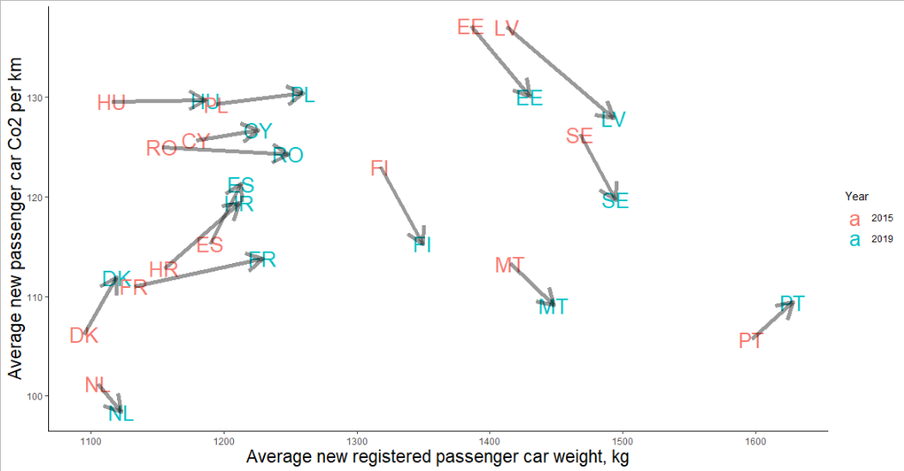
18. These additional indicators, together with country indicators chosen for their specific circumstances, will hopefully be presented in a new WP.6 micro-site in 2023.
19. The Working party on Pollution and Energy (WP.29/GRPE) is including vehicle Life Cycle Assessment into its list of priorities in the 2022/2023 timeframe (ECE/TRANS/WP.29/GRPE/84, paras. 24 to 28). If adopted and when finalized, the regulatory procedure is expected to provide a way to quantify the environmental footprint of individual vehicles through their manufacturing, use and dismantling phases, thus relevant to Goal 12 on sustainable production and consumption.
IV. Conclusion: Enhancing the role of the Committee in achieving the transport-related Sustainable Development Goals
20. The Committee is directly involved in the major global efforts to track progress in implementing the transport-related Sustainable Development Goals. One of the objectives of the ITC Strategy until 2030 which was adopted in 2019 is to contribute to the achievement of the Sustainable Development Goals. Overall, the work of ITC and its subsidiary bodies relates directly to 14 of the 17 Sustainable Development Goals. Yet serious gaps of capacity and implementation remain to be able to ensure that sustainable transport and mobility play their full role in the global efforts towards sustainability.
21. The Committee may wish to invite member States to support a stronger role for ITC and its subsidiary bodies, especially WP.6 in monitoring the Goals and request the secretariat to further enhance its contribution in the ongoing Sustainable Development Goal tracking framework.

Annex
Transport-related Sustainable Development Goals, targets and indicators
In March 2016, 230 indicators were created to measure the achievement of the Sustainable Development Goals. Subsequently, the indicators were categorized by the availability of source data into three categories:
- Tier I: Indicator conceptually clear, established methodology and standards available and data regularly produced by countries
- Tier II: Indicator conceptually clear, established methodology and standards available but data are not regularly produced by countries
- Tier III: Indicator for which there are no established methodology and standards, or methodology/standards are being developed/tested
Transport-related goals
Goal 3. Ensure healthy lives and promote well-being for all at all ages
3.6 By 2020, halve the number of global deaths and injuries from road traffic accidents.
Indicator 3.6.1: Death rate due to road traffic injuries
Possible Custodian Agency: WHO
Partner Agencies: ECE
Tier I
Goal 9. Build resilient infrastructure, promote inclusive and sustainable industrialization and foster innovation
9.1 Develop quality, reliable, sustainable and resilient infrastructure, including regional and transborder infrastructure, to support economic development and human well-being, with a focus on affordable and equitable access for all
Indicator 9.1.1: Proportion of the rural population who live within 2 km of an all-season road
Possible Custodian Agency: World Bank
Partner Agencies: ECE, UNEP
Tier: III
Indicator 9.1.2: Passenger and freight volumes
Possible Custodian Agency: ICAO, International Transport Forum-OECD
Partner Agencies: ECE, UNEP, UPU
Tier: I
Goal 11. Make cities and human settlements inclusive, safe, resilient and sustainable
11.2 By 2030, provide access to safe, affordable, accessible and sustainable transport systems for all, improving road safety, notably by expanding public transport, with special attention to the needs of those in vulnerable situations, women, children, persons with disabilities and older persons.
Indicator 11.2.1: Proportion of population that has convenient access to public transport, by sex, age and persons with disabilities
Possible Custodian Agency: UN-Habitat
Partner Agencies: ECE, UNEP
Tier: II

The Committee’s work relates directly to fourteen of the seventeen Sustainable Development Goals, mainly through the United Nations legal instruments and regulations of global and regional geographical coverage under its purview, relevant analytical and capacity-building activities, as well as policy dialogue

