|  |  |
| --- | --- |
| Submitted by the expert  from the Russian Federation | Informal document **GRSP-73-02**  (73rd GRSP session, 15-19 May 2023,  agenda item 10) |

Proposal for the 03 series of amendments to UN Regulation No. 100

The text reproduced below was prepared by the expert from the Russian Federation in order to identify electric vehicles. The changes to the current text of UN Regulation No.100 are given in bold (new provisions) or crossed out (deleted elements).

1. Proposals

Add to:

5.1.1.5 Identification

5.1.1.5.1. Identification of the vehicles with the electric power train which includes a Rechargeable Electrical Energy Storage System (REESS).

5.1.1.5.1.1 The Type A sticker specified in Annex 10 shall be placed on the vehicles of categories М, N equipped with the electric power train which includes a REESS.

5.1.1.5.1.2 The Type B sticker specified in Annex 10 shall be placed on the vehicles of categories М, N equipped with the internal combustion engine running on a fuel of the 1st liquid group (diesel fuel, biodiesel fuel...) besides the electric power train which includes a REESS.

5.1.1.5.1.3 The Type B or Type C sticker specified in Annex 10 shall be placed on the vehicles of categories М, N equipped with the internal combustion engine besides the electric power train which includes a REESS.

5.1.1.5.2 These stickers on the vehicles of categories M, N shall be applied according to Annex 11.

Annex 10

Provision concerning the identification mark of the vehicles of categories М, N equipped with the electric power train which includes a REESS.

(paragraph 5.1.1.5.1.1, 5.1.1.5.1.2, 5.1.1.5.1.3 of this Regulation)

The mark is a sticker, which shall be resistant to changing weather conditions.



Type A

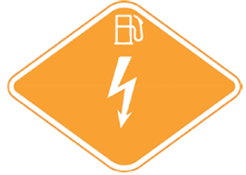

Type B Type C

The colour and dimensions of this sticker shall meet the following requirements.

The colours of the background and pictograms of the identification sticker shall be used in accordance with the data in Table 1.

Table 1 – Identification sticker colours

|  |  |
| --- | --- |
| Colour | RGB code |
| Background and edging | |
| Orange | 255,165,0 |
| Pictograms | |
| White | 255, 255, 255 |
| Bordering | |
| White | 255, 255, 255 |

The proportions of the identification sticker shall correspond to Table 2. The H (height) value shall be 50 mm for the vehicles of categories M1 and N1, or 120-150 mm for the vehicles of categories M2 and M3, as well as N2 and N3.

Table 2 – Identification sticker elements dimensions

|  |  |  |
| --- | --- | --- |
| Element | Size, mm | |
| Sticker height (H) | to be placed on the glazing | to be placed on the body elements |
| 50 | 120-150 |
| Sticker width | 1.4 H | |
| Edging width | 0.025 H min | |
| Bordering width | 0.06 H | |

Annex 11

Provision concerning the arrangement or placement of the identification mark of the vehicles of categories M and N equipped with the electric power train which includes a REESS.

The identification sticker on the vehicles of categories M1 and N1 shall be placed on four sides (Figure 11.1, 11.3):

- at the front: upper corner of the windscreen from the passenger side;

- on the right and on the left: in the lower corner of the side window near the B-pillar of the body;

- at the rear: upper corner of the rear window from the driver side. In case of absence of the rear window, on the rear part of the body from the driver side.

The identification sticker on the vehicles of categories M2 and M3 shall be placed on four sides and optionally on the roof (Figure 11.2):

- at the front: from the side of passenger compartment doors on the windscreen or the body (the sticker shall contrast with the background);

- at the rear: from the driver side on the rear window or the body (the sticker shall contrast with the background);

- on the right and on the left: on the outside of the doors on the right side (in case of the vehicles intended for left-hand traffic) or on the left side (in case of the vehicles intended for right-hand traffic) as well as on the opposite side at the emergency exits

- at the top: on the roof next to the emergency exit

The identification sticker on the N2 category vehicles shall be placed on four sides and optionally on the roof (Figure 11.4):

- at the front: upper corner of the windscreen from the passenger side;

- on the right and on the left: in the lower corner of the side window near the B-pillar of the body;

- at the rear: upper corner of the rear window from the driver side. In case of absence of the rear window, on the rear part of the body from the driver side.

The identification sticker on the N3 category vehicles shall be placed on four sides and optionally on the roof (Figure 11.5):

- at the front: from the passenger side on the windscreen or the body (the sticker shall contrast with the background);

- on the right and on the left: on the outside of the doors

- at the rear: upper corner of the rear window from the driver side. In case of absence of the rear window, on the rear part of the body from the driver side.

- at the top next to the emergency exit.

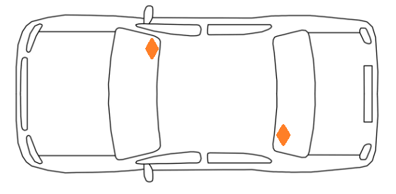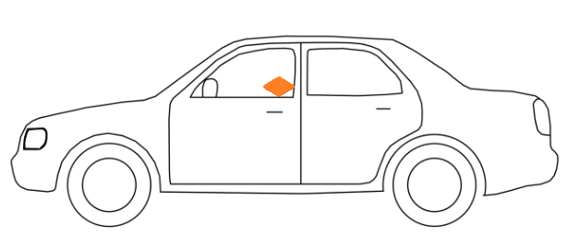

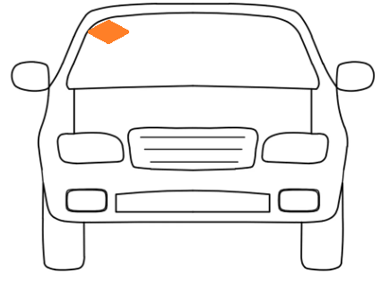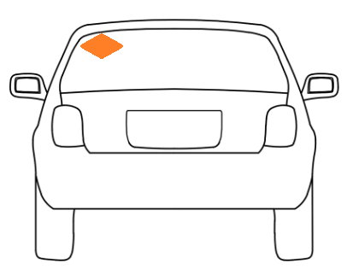

Figure 11.1 - Placement on a vehicle of category М1

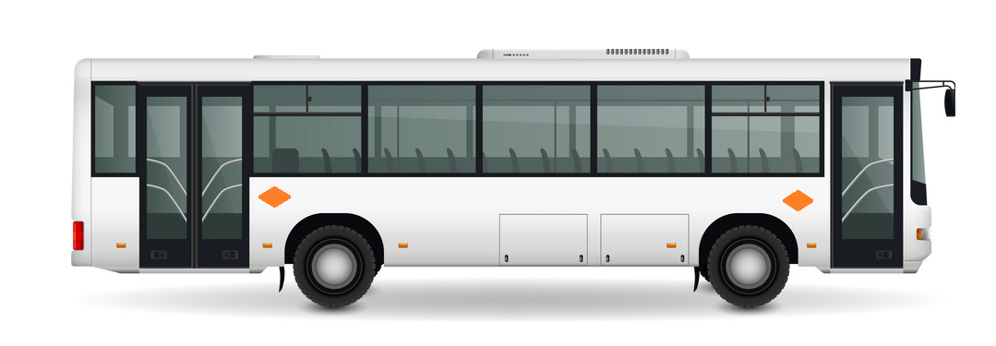

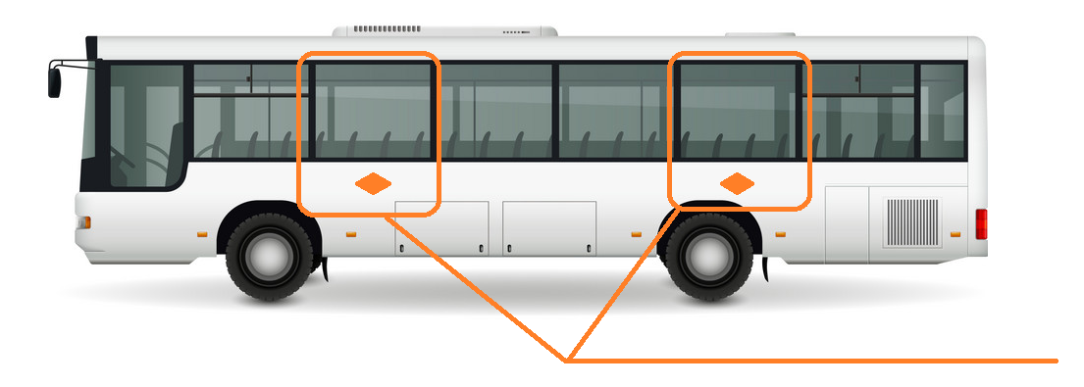

Emergency exit

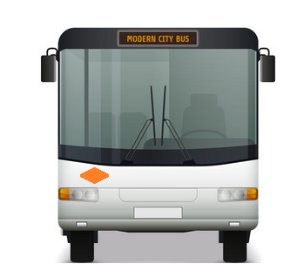 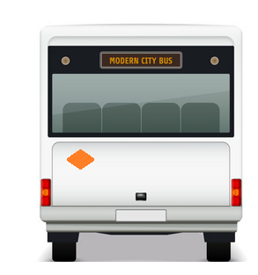

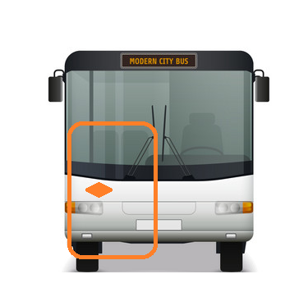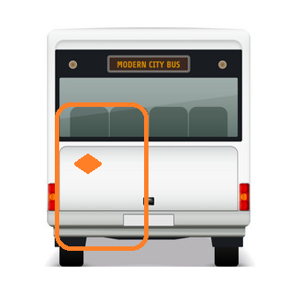

Figure 11.2 - Placement on a vehicle of categories М2 and M3

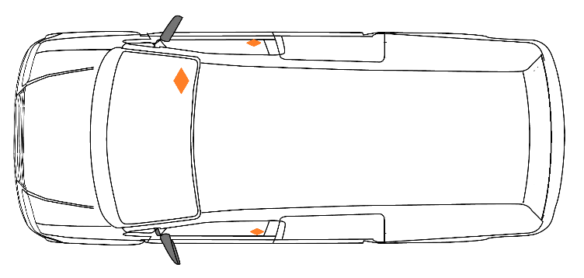

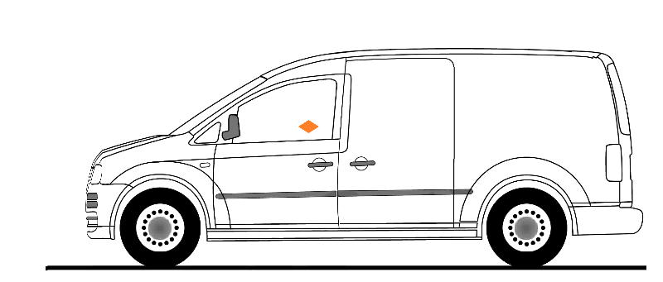

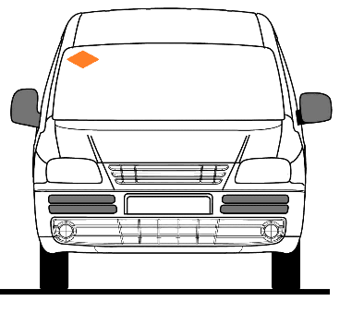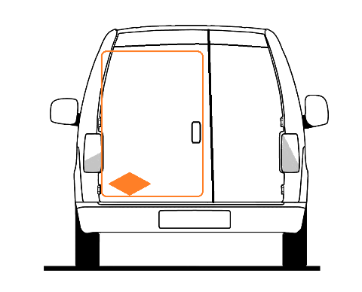

Figure 11.3 Placement on a vehicle of category N1

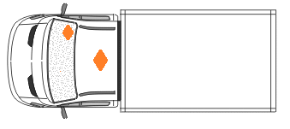

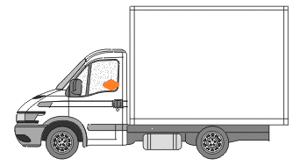

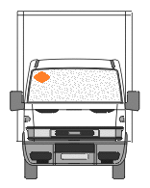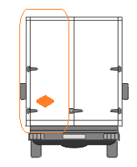

Figure 11.4 Placement on a vehicle of category N2

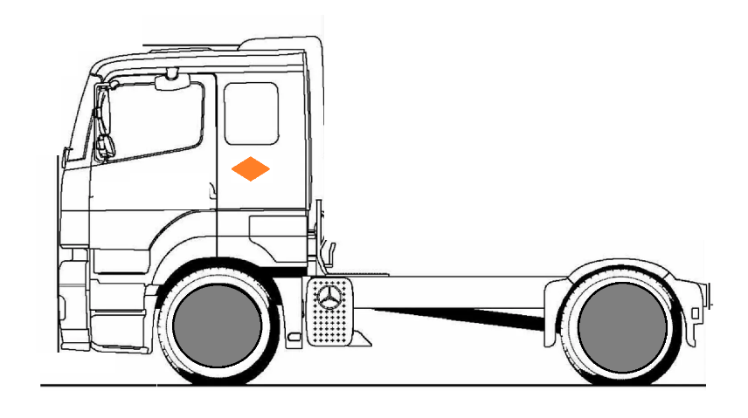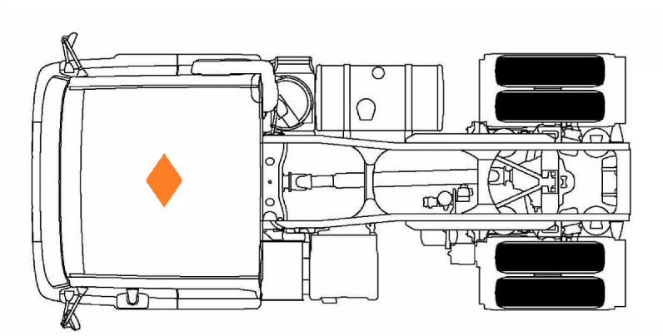

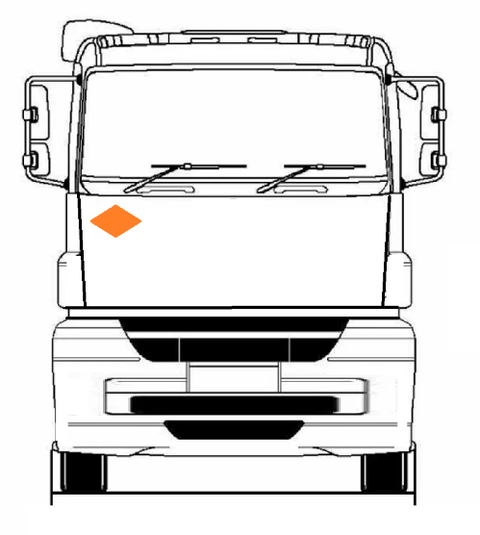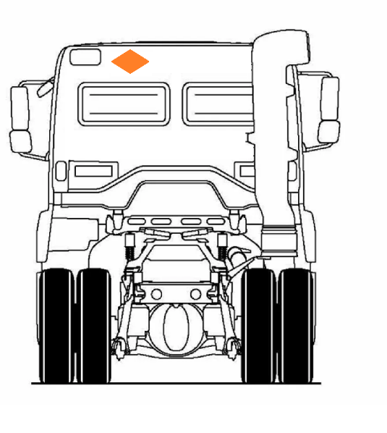

Figure 11.5 Placement on a vehicle of category N3