Proposal for the 13 series of amendments to UN Regulation No. 13 (Heavy vehicle braking)
Submitted by the expert from France
The text reproduced below is based on ECE/TRANS/WP.29/GRVA/2023/2, adopted by GRVA during the week of this session (15th session). It includes, in blue, amendments to the approval number and marking provisions, refering to the series of amendment. It is submitted to GRVA for final adoption in view of submission to WP.29 and AC.1 for consideration in June 2023.
I. Proposal
Paragraph 4.2., amend to read:
“4.2. An approval number shall be assigned to each type approved, its first two digits (at present 13) shall indicate the series of amendments incorporating the most recent major technical amendments made to the Regulation at the time of issue of the approval. The same Contracting Party shall not assign the same number to the same vehicle type equipped with another type of braking system, or to another vehicle type.”
Paragraph 5.2.1.32., amend to read:
“5.2.1.32. Subject to the provisions of paragraph 12.3. of this Regulation, all vehicles of the following categories shall be equipped with a vehicle stability function:
(a) M₂, M₃, N₂ ¹²;
(b) N₃ ¹² having no more than 3 axles;
(c) N₃ ¹² with 4 axles, with a maximum mass not exceeding 25t and a maximum wheel diameter code not exceeding 19.5;
(d) N₃ ¹² with 4 axles, with two power-driven axles in the rear axle group and only non-driven axles in the other axle group(s), including off-road vehicles (regardless of footnote 12).
The vehicle stability function shall include roll-over control and directional control and meet the technical requirements of Annex 21 to this Regulation.”
Insert new paragraphs 12.8., 12.8.1., 12.8.2., 12.8.3., 12.8.4., 12.8.5., 12.8.6., 12.8.7., to read:
“12.8. Transitional provisions applicable to the 13 series of amendments
12.8.1. As from the official date of entry into force of the 13 series of amendments, no Contracting Party applying this Regulation shall refuse to grant or refuse to accept type approvals under this Regulation as amended by the 13 series of amendments.
12.8.2. As from 1 September 2026, Contracting Parties applying this Regulation shall not be obliged to accept type approvals to the 12 series of amendments, first issued after 1 September 2026.
12.8.3. Until 1 September 2028, Contracting Parties applying this Regulation shall accept type approvals to the 12 series of amendments, first issued before 1 September 2026.
12.8.4. As from 1 September 2028, Contracting Parties applying this Regulation shall not be obliged to accept type approvals issued to the 12 series of amendments to this Regulation.
12.8.5. Notwithstanding paragraph 12.8.4., Contracting Parties applying this Regulation shall continue to accept type approvals issued according to the 12 series of amendments to this Regulation, for the vehicles that are not affected by the changes introduced by the 13 series of amendments.
12.8.6. Contracting Parties applying this Regulation may grant type approvals according to any preceding series of amendments to this Regulation.
12.8.7. Contracting Parties applying this Regulation shall continue to grant extensions of existing approvals to any preceding series of amendments to this Regulation.”
Annex 3, amend to read:
“Annex 3
Arrangements of approval marks

Model A
(See paragraph 4.4. of this Regulation)

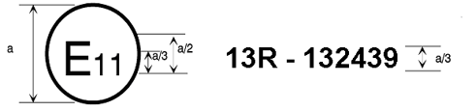
a = 8 mm min.

The above approval mark affixed to a vehicle shows that the vehicle type concerned has, with regard to braking, been approved in the United Kingdom (E 11) pursuant to Regulation No. 13 under approval number 132439. This number indicates that the approval was given in accordance with the requirements of Regulation No. 13 with the 13 series of amendments incorporated. For vehicles of categories M₂ and M₃, this mark means that that type of vehicle has undergone the Type-II test.

Model B
(See paragraph 4.5. of this Regulation)

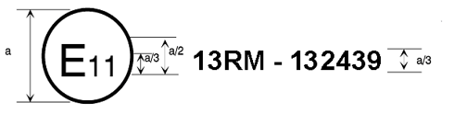
a = 8 mm min.

The above approval mark affixed to a vehicle shows that the vehicle type concerned has, with regard to braking, been approved in the United Kingdom (E 11) pursuant to Regulation No. 13. For vehicles of categories M₂ and M₃, this mark means that the type of vehicle has undergone the Type-IIA test.

Model C
(See paragraph 4.6. of this Regulation)

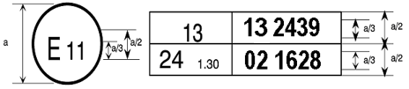
a = 8mm min.

The above approval mark affixed to a vehicle shows that the vehicle type concerned has been approved in the United Kingdom (E 11) pursuant to Regulations Nos. 13 and 24. (In the case of the latter Regulation the corrected absorption coefficient is 1.30 m⁻¹.)”

This number is given merely as an example.

