Proposal for Supplement 1 to the 04 Series of Amendments to UN Regulation No. 127 (Pedestrian safety)
Submitted by the experts from France, Germany, Netherlands, Japan, and the International Organization of Motor Vehicle Manufacturers *
The text reproduced below was prepared by the experts from France, Germany and the International Organization of Motor Vehicle Manufacturers (OICA). The proposed test makes a few minor adaptations and clarifications to the existing requirements. The modifications to the current text of the UN Regulation No. 127 (including ECE/TRANS/WP.29/2022/70, ECE/TRANS/WP.29/2022/129 and ECE/TRANS/WP.29/2022/130) are marked in bold for new or strikethrough for deleted characters.

I. Proposal
Paragraph 2.1., amend to read:
"2.1. "Adult headform bonnet top test area" is an area on the outer surfaces of the front structure. The area is bound:
(a) In the front, by a wrap around distance (WAD) of 1,700 or a line 82.5 mm rearward of the bonnet leading edge reference line, whichever is most rearward at a given lateral position;
(b) At the rear, by a WAD 2,500 or a line 82.5 mm forward of the bonnet rear reference line, whichever is most forward at a given lateral position, and
(c) At each side, by a line 82.5 mm inside the side reference line.
The distance of 82.5 mm is to be set with a flexible tape held tautly along the outer surface of the vehicle."
Paragraph 2.8., amend to read:
"2.8. "Bonnet rear reference line" (BRRL) means the geometric trace of the most rearward points of contact between a 165 mm diameter sphere and the front structure of the vehicle when the sphere is traversed across the front structure of the vehicle while maintaining contact with the windscreen (see Figure 2). The wiper blades and arms are removed during this process.
…"
Paragraph 2.44., amend to read and insert Figures 12 and 13:
"2.44. "Windscreen test area" is an area on the outer surface of the windscreen. It is bound (see figure 12):
(a) In the front, by a line 100 mm rearward to the opaque obscuration of the windscreen. In case of absence of the opaque obscuration, the line is measured from the front visible edge of the windscreen material.
(b) In the rear, by a WAD 2,500 or a line 130 mm forward to the rear visible edge of the windscreen material, whichever is more forward at a given lateral position.
(c) At each side, by a line 100 mm inside the opaque obscuration of the windscreen. In case of absence of the opaque obscuration, the line is measured from the side visible edge of the windscreen material.
For (a) and (c): the distances of 100 mm are to be measured with a flexible tape held tautly along the outer surface of the vehicle at an angle of 90° to the tangent line to the opaque obscuration limit or in case of absence of the opaque obscuration, from the visible edge respectively.
For (b): the distances of 130 mm is to be measured with a flexible tape held tautly along the outer surface of the vehicle at an angle of 90 ° to the tangent line to the rear visible edge of the windscreen.
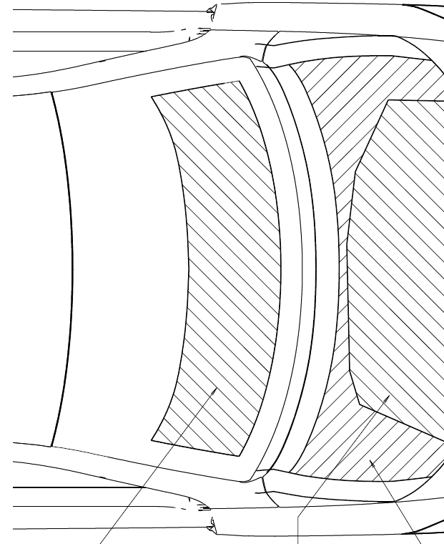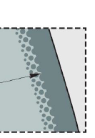
100
100
Visible edge of windscreen -130mm or
WAD 2500, whichever is more forward.
130
Opaque obscuration (e.g. black print) or, in absence of obscuration, visible edge of windscreen material.
Opaque obscuration e.g. black print (solid strip)
Measure perpendicular
Figure 12
Windscreen test area
Windscreen test area
Depending on the geometry, in case there is no intersection between (b) and (c), resulting in an open test area, then the marking shall be modified using the shortest distance to close the open test area (see figure 13).
Figure 13
Upper corner definition with "shortest distance"

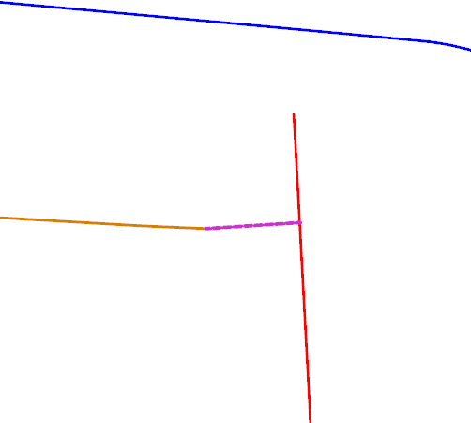
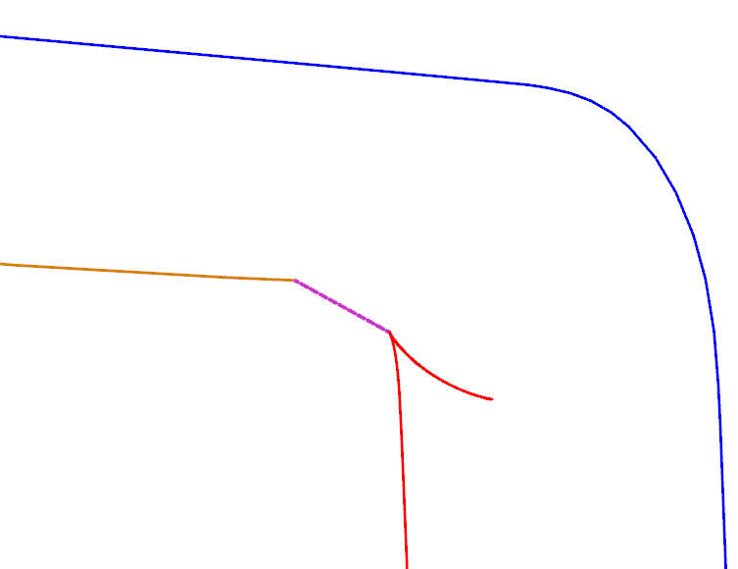
Side offset is forward of rear offset
Connecting curve
R
S
Rear offset is inboard of side offset
Connecting curve
R
S
Both side offset and rear offset are short of intersection
Connecting curve
R
S

Tests assigned to any measuring points located in the windscreen area forward of and including WAD 1,700 are performed with the child headform impactor. Tests assigned to any measuring points located in the windscreen area rearward of WAD 1,700 are performed with the adult headform impactor."
Paragraph 2.45., insert Figures 14 and 15 and amend to read:
"2.45. "Cowl monitoring area" is generally located near the rear of the bonnet test area and the front of the windscreen test area.
For the adult head tests, if any, this area is bound:
(a) In the front, by the forward most boundary of the adult headform bonnet top test area as defined in paragraph 2.1. or a line 82.5 mm forward of the bonnet rear reference line, whichever is most rearward at a given lateral position; and
(b) At the rear, by a WAD 2,500 or the front of the windscreen test area, whichever is most forward at a given lateral position.
For the child head tests, this area is bound:
(a) In the front, by the forward most boundary of the child headform bonnet top test area as defined in paragraph 2.16. or a line 82.5 mm forward of the bonnet rear reference line, whichever is most rearward at a given lateral position; and
(b) At the rear, by a WAD 1,700 or the front of the windscreen test area, whichever is most forward at a given lateral position.
At each side, the cowl monitoring area is bound by the TP line (see figure 14), where:
(a) the "T point" is the rear corner of the bonnet top test area; and
(b) the "P corner point" is the lower corner of the windscreen test area; using a flexible tape held tautly from point T to P.

Figure 14  Lateral limits of the cowl monitoring area  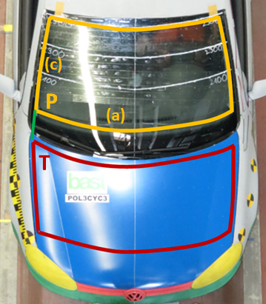  P  (c)  (a)  T | Figure 15  Particular case, if no unique "P point" corner  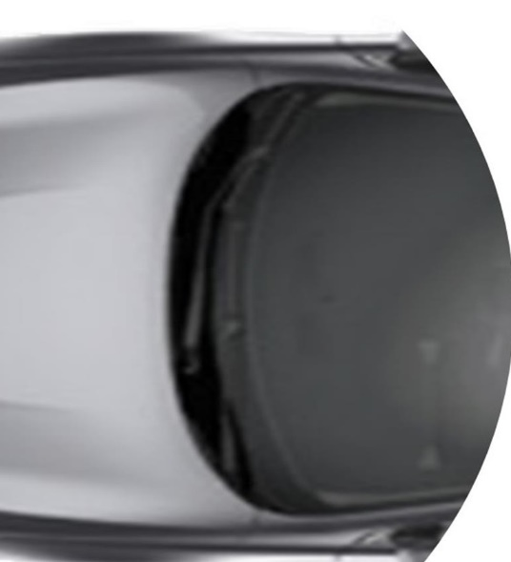  45°  +x  (a)  P  (c)

If there is no unique "P point" where the lines defined in 2.44 (a) and (c) intersect, then the "P point" is defined by the first contact of a vertical plane intersecting the vertical longitudinal vehicle center-plane at an angle of 45° with the (a)-(c) transition of the windscreen test area boundary, as shown in Figure 15.
Tests assigned to any monitoring point located in the cowl monitoring area forward of and including WAD 1,700 are performed with the child headform impactor. Tests assigned to any monitoring point located in the cowl monitoring area rearward of WAD 1,700 are performed with the adult headform impactor."
Paragraph 2.48., insert Figure 16 and amend to read:
"2.48. "Atypical windscreen fracture behaviour" is where the headform to windscreen impact results in at least one of the following cases:
(a) The absolute value of the minimum value of the derivation of the headform acceleration versus time is below less than 180 g/ms for within the first 4 ms after the initial contact of the headform to the windscreen, as shown in Figure 16; or
Figure 16
Jerk criterion graph and formula
│min ($\frac{da}{dt}$) │< 180g/ms, for 0 < t < 4ms
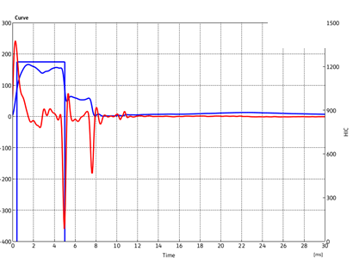
Acceleration Curve a(t)
Derivation (Jerk curve) $\frac{da}{dt}$
Minimum: jerk peak
Time [ms]
Acceleration [g]
Derivation = Jerk Curve [g/ms]
4 ms

(b) The minimum value of the acceleration below 300 m/s2 between the initial peak and 10 milliseconds is reached later than 4 ms in the time/acceleration plot, or glass breaking which expands to whole windshield is not visibly observed."

Insert new paragraph 2.49., to read:
"2.49. "Third of the windscreen test area" means the geometric trace of the area between the lateral boundaries of the windscreen test area as defined in paragraph 2.44.(c), measured with a flexible tape following the outer contour of the windscreen on any transverse section, divided in three equal parts."

Paragraph 4.2., amend to read:
"4.2. An approval number shall be assigned to each type approved in accordance with Schedule 4 of the Agreement (E/ECE/TRANS/505/Rev.3). The section 2 of the approval number shall be supplemented with a slash and one of the following characters as applicable:
(a) the letter "T" for vehicles approved using the specific provisions related to WAD 2,100 boundary in accordance with paragraph 11.19.; or
(b) the letter "E" for vehicles approved with the extended WAD 2,500 boundary.
Example:
Example of the first extension to the 2439th type approval issued by the United Kingdom of Great Britain and Northern Ireland for a vehicle approval according to UN Regulation No. 127, third series of amendments and its supplement 1, using the specific provisions related to WAD 2,100 boundary;
E11*127R03/01/T*2439*01.

(c) the letter "F" for vehicles approved using the specific provisions related to BRRL in accordance with paragraphs 11.22. and 11.23.

Example:
Example of the first extension to the 2439th type approval issued by the United Kingdom of Great Britain and Northern Ireland for a vehicle approval according to UN Regulation No. 127, fourth series of amendments and its supplement 1, using the specific provisions related to BRRL boundary;
E11*127R04/01/F*2439*01.

Paragraphs 11.14. to 11.19. (former), renumber as paragraphs 11.16. and 11.21.

Insert new paragraphs 11.22. and 11.23., to read:
"11.22. Notwithstanding paragraph 11.19., until the 1 September 2030, contracting parties applying this Regulation shall continue to grant type approvals using the specific provisions related to BRRL (see footnote 2 in paragraph 2.1).
11.23. Notwithstanding paragraphs 11.20. and 11.21., until the 1 September 2031, contracting parties applying this UN Regulation shall continue to accept type approvals issued using the specific provisions related to BRRL (see footnote 2 in paragraph 2.1.)."
Paragraphs 11.20. to 11.21. (former), renumber as paragraphs 11.24. to 11.25.
Annex 5,
Paragraph 4.2., amend to read:
"4.2. A minimum of nine tests shall be carried out with the child headform impactor over the areas prescribed by the child bonnet top test area and the child windscreen test area together, with three tests each to the middle and the outer thirds of the child/small adult test areas, at positions judged to be the most likely to cause injury. Where possible, at least one of these nine tests shall be carried out on the windscreen test area. Furthermore, and at the discretion of the technical service, one of these nine tests may be conducted (in any third) in the cowl monitoring area.
For each test on the windscreen an undamaged and untested windscreen shall be used.
Tests shall be to different types of structure, where these vary throughout the area to be assessed and at positions judged to be the most likely to cause injury. Taking into account any symmetry of the windscreen and relevant structures, the number of tests on the windscreen test area may be reduced at the discretion of the Technical Service."
Paragraph 5.2., amend to read:
"5.2. A minimum of nine tests shall be carried out with the adult headform impactor, over the adult areas prescribed by the adult bonnet top test area and the adult windscreen test area together, with three tests each to the middle and the outer thirds of the adult test areas, at positions judged to be the most likely to cause injury. Where possible, at least one of these nine tests shall be carried out on the windscreen test area. Furthermore, and at the discretion of the technical service, one of these nine tests may be conducted (in any third) in the cowl monitoring area.
For each test on the windscreen an undamaged and untested windscreen shall be used.
Tests shall be to different types of structure, where these vary throughout the area to be assessed and at positions judged to be the most likely to cause injury.
Taking into account any symmetry of the windscreen and relevant structures, the number of tests on the windscreen test area may be reduced at the discretion of the Technical Service."
II. Justification
1. The proposal adapts and clarifies the existing provisions.
2. Clarification of the definition of the cowl monitoring area:
(a) Regarding the impactor to be used, the same WAD 1700 limit as in paragraph 2.44 "Windscreen test area" definition applies between the child and adult cowl monitoring areas;
(b) Editorial deletion of "any third" in annex 5;
(c) Addition of side limits (TP).
3. Clarification of the definition of the windscreen test area:
(a) Determination of the upper corners in some special cases, where the curves do not intersect; and
(b) Definition of the third of the area.
4. Clarification of the jerk criterion: addition of the formula and example of the graph of an atypical test.
5. Extension of the transitional provisions, in some special cases where BRRL minus offset is not on the bonnet.
6. In the 04 series of amendment to UN Regulation No. 127, two levels of stringency in terms of the BRRL boundary of the bonnet top test area will be approved and that may be identified only by the notice of approval in accordance with Annex 1, part 2.
7. With the transitional provision in paragraphs 11.22. to 11.23., a type approval may be issued using the specific provisions related to BRRL boundary while another type approval may be granted with the real physical edge of the bonnet used as BRRL.
8. For typical procedure of vehicle type approval, such as IWVTA or EU WVTA, the UN type approval numbers are generally used to identify the level of the stringency of each system approval, and therefore, it is desired to allow identification of the stringency level only by the approval numbers.
9. In general, Schedule 4 of the Agreement (E/ECE/TRANS/505/Rev.3) should be referred to for the assignment of the approval numbers, where according to paragraph 3. of Schedule 4, section 2 of an approval number may include one or two character(s) indicating the implementation stages.
10. With the Revision 3 of the Agreement, the approvals to any preceding series of amendments may be issued while, with current paragraph 4.2., the number indicating the latest series of amendments will be assigned regardless of the series approved. This issue should be resolved by referring to the Schedule 4 of the Agreement.

________________

* In accordance with the programme of work of the Inland Transport Committee for 2022 as outlined in the proposed programme budget for 2022 (A/76/6, part V, sect. 20, para. 20.76), the World Forum will develop, harmonize and update UN Regulations in order to enhance the performance of vehicles. The present document is submitted in conformity with that mandate.
or WAD 2,100 in accordance with paragraphs 11.19. to 11.21.
In the case where the BRRL is not on the bonnet and the line 82.5 mm forward of the BRRL is rearward of WAD 2100, then the rear physical edge of the bonnet shall be used as BRRL, in accordance with paragraphs 11.22. and 11.23.
from WAD 2,100 boundary, if applicable, in accordance with paragraphs 11.19. to 11.21.

