|  |  |  |  |
| --- | --- | --- | --- |
|  | United Nations | ECE/TRANS/2023/23 | |
| _unlogo | **Economic and Social Council** | | Distr.: General  12 December 2022  Original: English |

**Economic Commission for Europe**

Inland Transport Committee

**Eighty-fifth session**

Geneva, 21-24 February 2023

Item 7 (g) of the provisional agenda

**Strategic Questions of a Horizontal and   
Cross-Sectoral Policy or Regulatory Nature:**

**Analytical work on transport**

Taking stock of new trends towards electric vehicle charging infrastructure

Note by the secretariat

I. Mandate

1. The Inland Transport Committee (ITC) at its eighty-fourth annual session in February 2022 requested the Working Party on Transport Trends and Economics (WP.5) “to take into consideration the new trend towards electric charging infrastructure and, in coordination with the chairs of the relevant working parties, to prepare a first assessment of issues that need addressing in the realm of the Committee to be presented at its eighty-fifth session”.

2. The present document provides a preliminary starting point for such an analysis. Given its inter-disciplinary scope, this document has been prepared jointly by the ECE Sustainable Transport[[1]](#footnote-2) and Sustainable Energy Divisions and has been submitted as ECE/TRANS/WP.5/2022/2 to WP.5 for consideration at its thirty-fifth annual session (September 2022). The document has also been presented to the Working Party on Road Transport (SC.1), the Working Party on Intermodal Transport and Logistics (WP.24) and the Informal ECE Working Group on Electric Vehicles and Environment (EVE/ WP.29) as well as to the ITC Bureau at its session in November 2022. Feedback received has been included in the present version of the document. The Committee at its eighty-fifth annual session is invited to consider this document and provide specific guidance on how it wishes to further pursue this new area of work.

II. Trends of importance to determine future transport demand

A. Introduction

3. Any discussion on what the future impact of increased electrification of the vehicle fleet on availability of charging infrastructure for electric vehicles (EV) including light-duty electric vehicles (LDVs) will be, should not take place without gaining an understanding as to how demand for transport is expected to develop in the future. Many factors influence transport demand and they do so in different ways. ECE has developed and uses the For Future Inland Transport Systems (ForFITS) tool to provide insights into forward-looking transport demand evolution and associated energy and greenhouse gases (GHG) emissions.[[2]](#footnote-3) As many stakeholders in the field of clean transport, it uses the “Avoid/Shift/Improve” paradigm to analyse the GHG mitigation potential of sustainable mobility.[[3]](#footnote-4)

4. Some policies lead to increased demand for mobility and transport; while others are aimed at reducing this demand (Avoid); yet others assist in shifting demand across modes (Shift).[[4]](#footnote-5) Technological progress, coupled with demographic, socio-economic and environmental developments and changing societal habits, result in high uncertainty for projecting future mobility patterns. Changes in working (i.e., tele-work) and shopping (i.e., e-commerce and on-demand delivery), new technologies (Improve)– such as automation, vehicle electrification and behaviours such as the sharing economy – are already present today and have an impact on the functioning of transport systems. An overview of such ongoing and upcoming innovations is provided below.

B. Trends in passenger road transport

5. Road vehicle demand in the Organisation for Economic Co-operation and Development (OECD) countries has stabilized over the past two decades (Stapleton et al., 2017). The International Transport Forum (ITF) compared the growth in car and van use in national statistics for six developed countries and noted signs of a levelling off and possibly even a decline. One explanation is that domestically, younger generations are travelling less, a trend that is likely to continue throughout their lives. This is for reasons that are mostly external to transport (living and socio-economic situations, city versus countryside etc.). It can also be attributed to other factors such as the age at which a person graduates from university or a family is started and changes in social interactions (in-person versus digital encounters).[[5]](#footnote-6) Yet, results from the International Transport Forum’s new global urban passenger transport model show that in the baseline scenario total motorized mobility and related CO2 emissions in cities will grow by 94 per cent per cent and 27 per cent in 2050 compared with 2015 and according to this same study, the share of private cars will continue to increase in developing regions while slightly decreasing in developed economies.

6. On the positive side, several innovative mobility solutions are becoming increasingly popular and will likely continue expanding in the future. Car sharing and carpooling are two of the most visible and rapidly evolving areas in the shift towards a more sustainable mobility as they contribute to more efficient use of available resources, generally reducing the number of cars in cities and traffic congestion, thereby reducing the potential for road crashes, and cutting air pollution. Another promising mobility concept is Mobility as a Service (MaaS) which will likely further spread as well. One of its key features is the potential to deliver integrated mobility to enable end-to-end trips by offering services combining different transport modes provided by different transport service providers under a single platform and a single service provider for trip planning, scheduling, ticketing, and payment.[[6]](#footnote-7)

7. And finally, there is an increasing role of digitalization with Shared Electric Mobility Services (SEMS) which, in line with principles of circular economy, are offering instead of ownership, sharing economy services bringing users and providers together on a purely need-basis, on a digital platform. SEMS feature several business models ranging from membership or peer-to-peer based systems to for-hire systems (for e.g. e-bike, e-car, e-ride sharing etc.).

8. Another trend is automatization of vehicles with expectation that fully autonomous vehicles become available. In such case, purchase of vehicles for personal use may sharply decline while people may continue buying cars as capital investment to turn these cars into robotaxi to earn money for their owners.

9. These various trends may have an important impact on the shift to electrification in road transport. Depending on how people would want to travel may determine where charging sources for EVs should be made available.

C. Trends in road freight transport

10. In 2020, road freight transport accounted for 77.4 per cent per cent of the total inland freight transport in the European Union followed by rail and inland waterways transport (16.8 per cent and 5.8 per cent respectively),[[7]](#footnote-8) in some countries in the ECE region such as the UK, it is almost 90 per cent[[8]](#footnote-9) while in others such as the Russian Federation, road vehicles are carrying 70 per cent[[9]](#footnote-10) of containerised freight transport.

11. While in some countries, rail may be cheaper than road, for the long-haul movement of bulk goods, road freight continues to offer a level of accessibility and flexibility that rail cannot match easily. Domestic road freight constitutes the ‘lifeblood’ of supply chains, ensuring that goods move from manufacture and assembly to retailers and consumers and in that sense serves three broad distribution functions: long-haul freight, regional distribution, and as part of combined transport for the first and last mile distribution.[[10]](#footnote-11)

12. Needless to emphasize that road freight transport will remain a crucial driver of supply chains and like passenger transport will be subject to enhanced digitalization and technological innovations. Self-driving trucks for instance are increasingly a real option for transport logistics companies helping them to overcome staff shortages and process ever increasing volumes of freight. Increased digitalization of vehicles can generate other wins such as optimized driving and, via information exchange with other vehicles and road infrastructure, an improved flow of traffic.[[11]](#footnote-12) Also in terms of environmental sustainability of the road freight sector, progress is to be expected by increased introduction of electric trucks and e-LDVs or through increased introducing of other forms of propulsion and fuels such as those using hydrogen, synthetic fuels, or liquefied gas.

D. What is hampering a full-fledged electrical freight and passenger mobility?

13. While EVs are becoming increasingly popular, several factors remain which discourage, at least certain consumer groups, the purchase of an EV. These include the often still limited accessibility to public charging equipment; the remaining high purchase cost of an EV compared to a petrol or diesel vehicle; and the limited driving range per charge compared to a fuel tank.

14. Even though driving an EV can be less expensive in terms of costs of charging versus costs of petrol or diesel vehicle when using private home chargers, this price difference may however not be so competitive for users without possibilities to charge at home or for users who need to drive long distances daily and as such are required to charge at public charging points. A combination of limited accessibility to chargers which at the same time sell expensive electricity would not help EV adoption. Moreover, the supplier managed charging network price, which during winter season can be a disincentive for extended periods of time, may also not attract customers to EVs, again, those without home charging possibility or driving daily long distances.

15. Differently to passenger vehicles, the availability of electric LDVs or heavy-duty vehicles (HDVs) is still limited in some regions, but rapidly growing. The drawback remains the existing battery capabilities – as they do not offer the required range and charging times for long haul applications. Also, the public charging for such vehicles is only in its infancy or testing phase. Hence, the shift to electrification remains currently limited to urban/ sub-urban deliveries, which represent a significant portion of heavy duty trips.

16. On the other hand, a mix of Government introduced fiscal and policy incentives towards consumers (drivers) combined with investment readiness in EV charging infrastructure and ongoing developments in the field of EV technology (in particular batteries) already produce fruitful results and will likely take away remaining reservations in the foreseeable future.

III. Electrification outlook for motor-vehicles and impact on demand for charging infrastructure

A. Steady increase of demand for electric vehicles and charging infrastructure

17. With the introduction of millions, to hundreds of millions, of electric vehicles in need of charging in the next two decades, the impact on the electricity sector and charging infrastructure will be substantial. The growth in electric vehicles fleet is expected to tenfold between 2021 and 2030 under the stated policies scenario and up to fourteen times under the announced pledges scenario.

18. According to a 2022 study conducted by Eurelectric,[[12]](#footnote-13) this is what the future electric vehicle fleet will look like:

* By 2030, 65 million EVs on the road;
* By 2035, 130 million EVs on the road;
* Within 4-6 years: EVs expected to be cheaper than an ICE equivalent vehicle.

19. On the other hand, the following is a snapshot of the existing state of the current e-charging infrastructure landscape and its expected development up to 2035[[13]](#footnote-14) :

* Today: 374,000 public charge points in Europe;
* 13 million chargers by 2025;
* 32 million chargers by 2030 (for 60 million EVs):
* Of which 29 million residential and 3 million of public chargers, i.e. one public charging point for 20 vehicles
* 65 million chargers by 2035 (for 130 million EVs):
* 9 million public;
* 56 million residential 85 per cent residential, 6 per cent workplace, 4 per cent public highway corridors, 5 per cent destinations (semi-public).

# Figure I **Global EV sales by scenario**

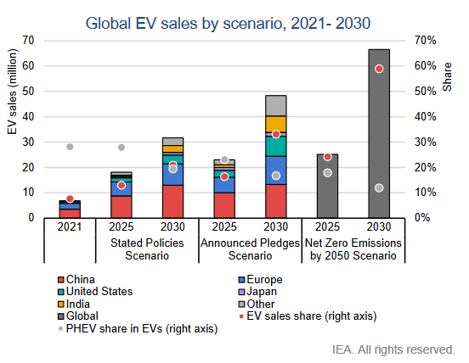

*Source:* IEA (2022)[[14]](#footnote-15)

B. Expected impact on the electricity grid

20. The electricity grid will prove to be either a key enabler or a limiting factor on EV expansion depending on how the transition is managed. EV charging is a unique interface between the transportation and energy sectors of the future, and as such will require a new level of coordination, planning, and cooperation across historically siloed stakeholders. Unmanaged charging of huge numbers of EVs can result in adverse effects on the electrical grid, such as voltage fluctuations, voltage drops, and even power losses. These all result in a less reliable and resilient grid, which, when paired with the parallel pushes to electrify building heat and cooling and industrial sector processes, is a key concern. Fortunately, through the integration of smart charging and other management processes, EVs can be turned from a grid challenge into a grid service asset.[[15]](#footnote-16)

21. Forecasting the increasing pressure on the grid with the increasing electric vehicle fleet is not as straight forward since different grids have varying abilities to adapt to change in demand (aging grids will have a harder time). It is safe to say though that investment in grid upgrades will be needed, both for EV and for renewable energy integration and that funding will need to be made available for this purpose. On the other hand, it should be noted that the expected impact of EV on electricity demand; will not be that high, even by 2030. Based on the IEA Mobility Model it was calculated, that in 2020, the global EV fleet consumed over 80 TWh[[16]](#footnote-17) of electricity which represents around 1 per cent of global electricity demand. Based on the same model it is forecasted that by 2030 global consumption of electric vehicles is to increase to 525 TWh in the Stated Policies Scenario (SPS)[[17]](#footnote-18) and to 860 TWh in the Sustainable Development Scenario (SDS). This would bring the portion of EV electricity consumption to 2 per cent of global overall consumption.[[18]](#footnote-19) While this is only a limited increase in electricity consumption by EVs, smart charging solutions will need to be put in place to ensure that the EV electricity demand increase is not limited by grid capacity, and does not occur during electricity peak demand times. The working party on transport statistics (WP.6) of the sustainable transport division has also started to look at the linkage between EV recharge and CO2 emissions, when considering real time electricity mix and EV charging behaviour, which could be an important lever to minimize GHG emissions by adapting the EV recharging time to the time of lower carbon intensity of electricity generation (ECE/TRANS/WP.6/2022/6).

# Figure II **Recent trends in electric vehicle sales**

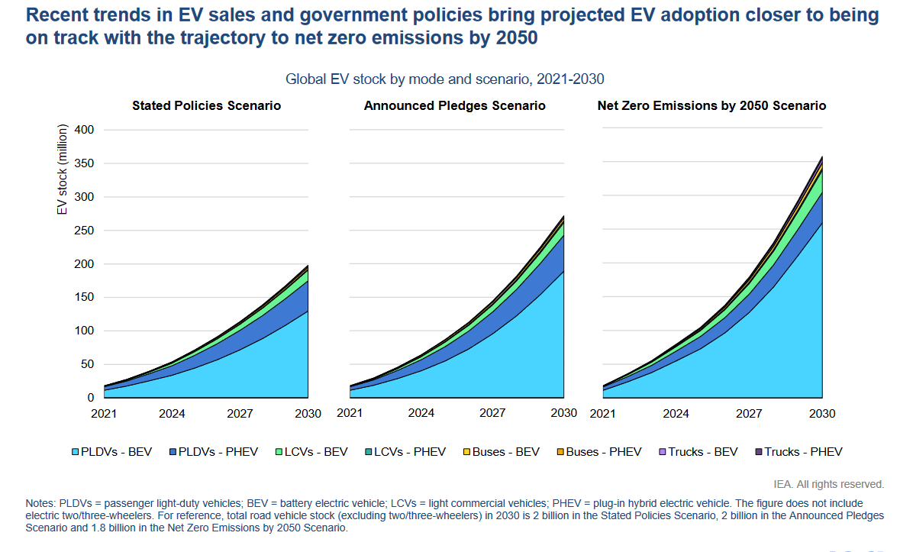

*Source:*ECE Sustainable Energy Division and IEA (2022)

C. Steady increase of demand for electric vehicle charging infrastructure

22. The EV adaptation growth requires a parallel growth in charging infrastructure. Using a rule of one EVSE (EV supply equipment/i.e. charging point) for ten to fifteen EV a fleet of 200 million EVs would require deployment of 13 to 20 million EVSE until 2030 (stated policies scenario) and 18 to 27 million EVSE under the announced pledges scenario. With the need of installation of many millions EVSE, the impact on the electricity sector and infrastructure will be substantial. The EV fleet is expected to become increasingly significant for power systems under both stated policies scenario and announced pledges scenario, possibly driving increments in peak power generation and transmission capacity.

23. The latter may require integrating the EV charging process into the broader electricity network, using cars as mobile electricity storage units which could take the form of Vehicle-To-Grid (V2G), Vehicle-To-Home (V2H), Vehicle-To-Building (V2B) or even Vehicle-to-Everything (V2X) approaches.

24. Through these different technologies, EV charging will take place across several diverse segments and charger types. Such as, for example:

* Slow charging (Level I) in homes, workplaces, and overnight stay locations;
* Medium and fast charging (Level II) at workplaces and fleet hubs; and
* Ultra-fast/hyper charging (Level III DC Fast Charging) along highway corridors or terminals.

25. Each of these brings different challenges and opportunities for grid integration. While unmanaged and unpredictable charging, particularly during peak load times in the later afternoon/early evenings, threatens to overstress the grid, smart charging can account for price signals, available grid capacity, grid operator signals, and end user preferences to turn the vehicle into an energy asset. There are real opportunities, for example, to use aggregated, connected EVs to help flatten load curves, provide ancillary services such as frequency balancing for transmissions grid operators, manage grid congestion over large geographies, and avoid renewables curtailment by shifting EV charging times throughout the day. Vehicle-to-grid (V2G) is an emerging technology that allows power to flow both to and from the EV, which can even further support these grid services, provide as a storage asset of renewable (often low carbon) electricity for domestic prosumers,[[19]](#footnote-20) or supply a source of resilient energy for homes in the case of a grid outage.

26. Lastly, reference should be made to security aspects of EV charging infrastructure, which may relate both to its vulnerability to cyber security breaches as well as to the overall security context of Electric Vehicle Charging Stations (EVCS), whereby similarly to guarded/ fenced off parkings for truck drivers during their rest times also EVCS will require a secured environment for EV drivers wanting to recharge their vehicles.

IV. Smart charging solutions – key to a successful deployment of a global EV car fleet

A. Setting the scene

27. To achieve the above explained benefits, new sets of standardized technical and communication requirements will need to be developed fast and by cross-sector collaboration. New data management protocols will also need to be defined and deployed to facilitate the exchange, privacy, and security of large, sensitive datasets.[[20]](#footnote-21)

28. On the front-end, the transition will also require a shift in consumer behaviour. Drivers can be encouraged, through price signals and charger availability, to charge at work during the day (when solar generation is maximized) and at home late at night (when rates are lower) rather than in the evenings when they arrive home. A shift in thinking may also be required to get people comfortable with not always having EV batteries at full charge every time they drive (in fact, keeping a battery at 100 per cent charge may be more detrimental to battery health than sustaining middle charge levels).[[21]](#footnote-22)

29. To maximize benefits, EV owners will also need to be encouraged to give up some autonomy on how charging is conducted. While individual consumers should always have the choice to supersede the services mentioned above on specific occasions, EV drivers in general will need to hand over some control to grid operators and smart charging controllers to enable this managed charging in aggregate. The latter implies that fully user managed charging stations enabling users to control and decide the charging parameters fully autonomously (time, power, duration, carbon intensity) may not always be possible/ nor desirable. Instead, supplier-managed charging stations where providers automatically adjust the charging parameters and/ or prices according to real-time energy production, local energy consumption and electrical infrastructure capabilities which allow to optimize energy consumption, flatten electricity usage in peak hours, or minimize emissions during time of low emissions electricity generation, will become more widely introduced.

30. Such measures will be essential in preventing grid overload and enabling the electricity to be used by other users (industry, homes, etc.). Intelligent charging management systems could be coupled with hourly forecasts, market signals, and consumer preference data. The idea should be that one can charge at any time, though if the demand will be high/too high then the price will go up to discourage charging yet charging cannot be cut off as the latter would negatively affect seamless mobility.

B. Innovative EV charging station solutions

31. Due to the importance of harmonizing the EV/grid integration, it is paramount that smart charging-enabled systems are installed from the beginning. A wide-spread deployment of non-smart chargers would be detrimental to meeting the long-term demands of EV adoption and result in costly and time-consuming retrofits as the scale of the problem is realized. Adoption of EVs across ECE member states is set to be potentially very quick, so making smart charging a priority and addressing the cooperation between stakeholders in the near-term is an important part of a successful transition.

|  |
| --- |
| *Box 1* |
|  |
| Curbside Charging examples |
| One key challenge for the EV transition is how to provide accessible charging infrastructure to the large number of people who live in multi-family dwellings with no off-street parking. For these individuals residential charging is not an option, which forces EV owners to spend time traveling to and from centralized chargers and creates a major barrier to adoption. One popular solution that is gaining traction globally is curbside charging. |
| Curbside chargers are publicly accessible charging points located on streets, typically in denser urban areas. They can either be deployed as slow chargers that allow an EV to charge overnight in much the same way as a residential charger, or as medium or fast chargers that provide a charge point for shorter stays. Curbside charging has gained traction with deployments in several cities across ECE member States:   * London, UK: Through London’s Go Ultra Low Cities funding plan, the city has converted 1,300 lamp posts for curbside EV charging in partnership with Siemens and Ubitricity, backed by Shell (CleanTechnica). The city is also putting millions of pounds of investment toward piloting hundreds of installations of other curbside technologies, including Trojan Energy’s hidden sub-grade chargers (FleetNews) and Connected Kerb’s installations in the Boroguh of Lambeth (Connected Kerb). London’s longer-term strategy includes the deployment of 1,500 on-street charge points by 2023 up to more than 10,000 in the next decade (TfL). * New York City, US: NYC’s Department of Transportation and Mayor’s Office of Sustainability, in partnership with EV charger provider Flo, is piloting 120 Level 2 curbside chargers across all five boroughs. The city’s goal is to install 1,000 curbside chargers by 2025 and 10,000 by 2030 (NYC.gov) to promote equal access to charging. * Amsterdam, The Netherlands: Amsterdam is installing thousands of public chargers across the city, with the projection that as many as 23,000 charging points will be needed by 2025 (World Economic Forum).   In relation to this, the Informal ECE Working Group on Electric Vehicles and Environment (EVE/ WP.29) points out that charging with outdoor curbside chargers in extremely cold conditions may affect charge times as battery heating may apply. Charging in extremely cold weather without battery heating may affect and possibly permanently damage the battery in the vehicle depending on protection mechanisms of the battery management system. |

# Figure III **Proportion of public chargers of total stock**

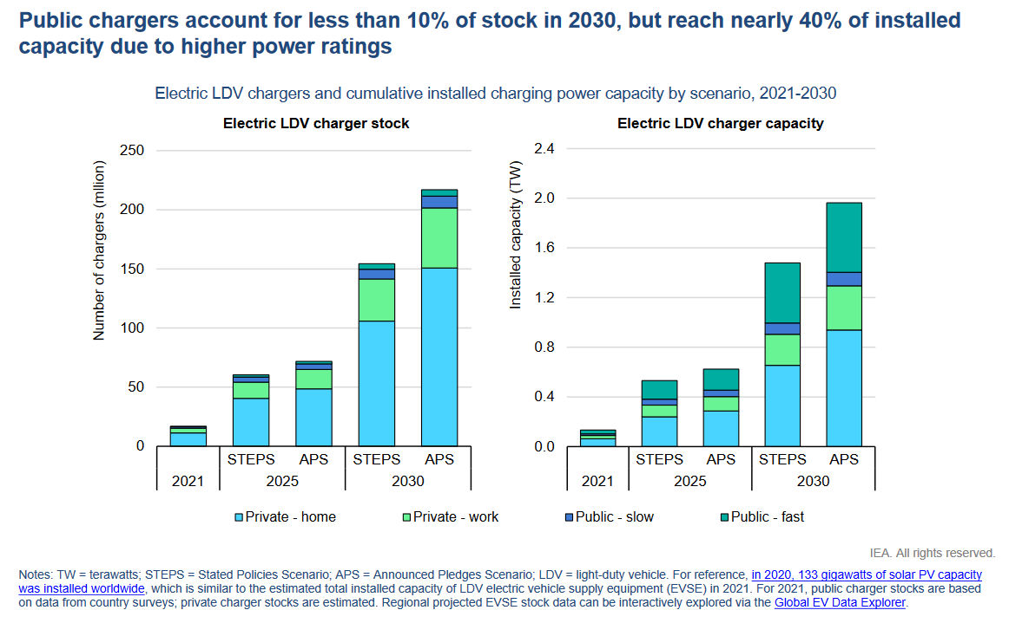

*Source:* IEA (2022)

32. Innovative charging solutions,[[22]](#footnote-23) many of which still in pilot phases, include:

* Wireless electric vehicle charging which is based on the principle of inductive charging whereby a magnetic coil in the charger hidden beneath the road surface transfers electricity through an air gap to a second magnetic coil which is fitted underneath the vehicle. It suffices the vehicle is parked in the immediate proximity of a charging point.
* Pop-Up Pavement Chargers: which retract into the ground when not in use and can be activated through an online application have been piloted in the UK (Oxford) offering fast charging measuring up to seven kilowatts (KW), as of 2021 expansion was planned.
* Roadside Street EV Car Charging Cabinets: Deutsche Telekom announced plans to turn 12,000 street cabinets[[23]](#footnote-24) into charging stations. Each device will supply per hour two vehicles with enough power to reach a range between 50-75 km. Pilot projects have been implemented in the cities of Bonn and Darmstadt with the aim to build a nationwide network by upgrading parts of its existing telecommunications infrastructure to become charging stations.
* While many electric vehicle charging innovations necessitate cars being parked, a pilot project in Sweden has explored the possibility of charging “on the go” using electrified roads. Electric rails have been installed in the tarmac of a 1.25-mile road network near Stockholm. A vehicle’s moveable arm senses the electric rail’s position in the road and charges it automatically when driving above it. Operates similarly to trams, but instead of being operated by an overhead line, it is powered by conductive feeds from the road below.

C. Innovations in battery development

33. Turning batteries more efficient, faster chargeable, less sensitive to temperature variations and putting in place measures that contribute to better heat management are equally important as such measures reduce the overall electricity requirements for EVs per number of km driven. Also, the batteries longevity and upholding its initial capacity and charging rates are important. In this context it should be noted that in April 2022, under the auspices of the ECE World Forum for Harmonization of Vehicle Regulations (WP.29), a United Nations Global Technical Regulation on In-vehicle Battery Durability for Electrified Vehicles UN GTR No.22 has been adopted. This UN GTR ensures minimum performance requirements for batteries inside cars and vans, to make sure batteries last for at least 160,000 km and eight years without losing more than 30 per cent of its original capacity, regardless of the conditions of use (excluding extreme usage behaviour).

D. Applicability of e-mobility for the road freight transport sector

34. Finding an economically viable solution for the electrification of HDVs remains a cumbersome path with many major obstacles to overcome. The key challenge remains the limited driving range with heavier vehicles requiring more power especially when they are loaded. As such the kWh requirement per Km for heavy duty trucks and buses is around 1.1-1.3 kWh/Km depending on the type of vehicle, and for medium duty vehicles 1.0 kWh/Km or less. Compared to 0.2 kWh/km and less for passenger cars and light duty vehicles. For heavy duty this equates to a battery size of around 800-1,000 kWh to deliver 800 km of range this comes at a huge cost for the vehicle.[[24]](#footnote-25) Moreover the battery weight to achieve this range would be in the region of 5,000-6,000 kg, equivalent to a payload loss of ca. 5-10 per cent compared to a diesel fuelled truck.[[25]](#footnote-26) In addition, charging times would be quite long (in the range of hours) even when using the latest generation of batteries and charging technology. Trucks operating over shorter distances, 150-300 km (requiring batteries around 100-200 kWh) primarily those servicing urban centres and ‘last mile’ deliveries are better placed to go electric.

35. Another bottleneck may be the lacking HDV electric charging infrastructure along major road itineraries which in the case of increased electrification of truck fleets could lead to long waiting times and insufficient capacities near major charging centres. In this regard, it should be noted though that in recent years an increasing "terminalization" of supply chains is unfolding, whereby inland terminals are taking up a more active role in supply chains. Derived (buffer) terminalization is relevant to refer to in this context whereby the function of warehousing shifts to the terminal and the terminal becomes a buffer, a de facto storage centre. This offers the supply chain a higher degree of flexibility as it not only lowers warehousing costs but also helps them to adapt to unforeseen events such as demand surges or delays. An increasing number of inland terminals across a country will also shorten the distances between the storage units and the distributors and final customers which makes it more likely for these transports to be undertaken by electric HDVs who will be able to fast charge while waiting to be loaded at the inland terminals.

E. Applicability of e-mobility for the public transport sector

36. The transition of bus fleets from combustion engine to electric drive is in full swing. According to recent estimates, in Europe, by 2030 there could be over 60,000 electric buses (or one third of the current public transport inventory) on the road. Like private passenger EVs, the transition to electric buses will pose new challenges for urban infrastructure and transport business processes and will require intelligent charging solutions. Even more than for electric passenger cars, putting in place the right charging and energy management system are of utmost importance given the major impact this will have on how flexible, efficient, and affordable future operating processes will be.

V. Smart EV charging requires standardized and harmonized protocols and standards with national, regional, global applicability

A. Overview of most widely used charging protocols and standards are described below:[[26]](#footnote-27)

1. Open Charge Point Protocol/ IEC 63110 - Between the charging station and the charging station management system

37. Open Charge Point Protocol (OCPP) has been developed to make it possible to connect different types/brands of charging stations to a single Charging Station Management System (CSMS) and vice versa, i.e. to connect a single type/brand of charging station to a range of charging station management systems. OCPP supports the management of charging stations and the handling of charging transactions, including the identification and authorisation of the EV driver. In addition, the protocol can be used to control charging stations for smart charging. OCPP is used by the Charging Station Operator (CSO) to communicate with the charging stations it manages through its CSMS.[[27]](#footnote-28) OCPP has been developed into the international ‘de facto’ standard for managing charging stations and is used by many CPOs. OCPP is managed by the Open Charge Alliance.[[28]](#footnote-29)

2. Open Charge Point Interface/ IEC 63119 – Between the charging station operator and the mobility service provider

38. Open Charge Point Interface (OCPI) protocol is used to exchange information between the CSO and the mobility service provider (MSP), but also with other market operators which require EV information. The OCPI protocol is used to set up a direct connection between two parties and supports the exchange of information on locations, tariffs, authorisations and charging transactions. It also supports smart charging through the management of charging profiles.

3. ISO 15118 / CHAdeMO – Between the car and the charging station

39. ISO[[29]](#footnote-30) 15118 was developed with two important goals: providing a user-friendly mechanism for authentication, authorisation, and payment at the charging station without further user interaction, known as Plug and Charge (PnC) and for Integration of the EV into the Smart Grid to enable flexible energy transfer (V2G) and thereby deliver added value for the grid without compromising the EV or its driver.

4. Open Smart Charging Protocol – Between the charging station operating environment and the grid operator

40. Open Smart Charging Protocol **(**OSCP) is used between the Charging Station Operator (CPO) and the grid operator (DSO or distribution system operator). This protocol provides many opportunities to make optimal use of the availability of flexible power. It enables interactive communication between operators to ensure optimal alignment of power needs and availability.

# Figure IV **Overview of the standards, where they apply, and where there is duplication**

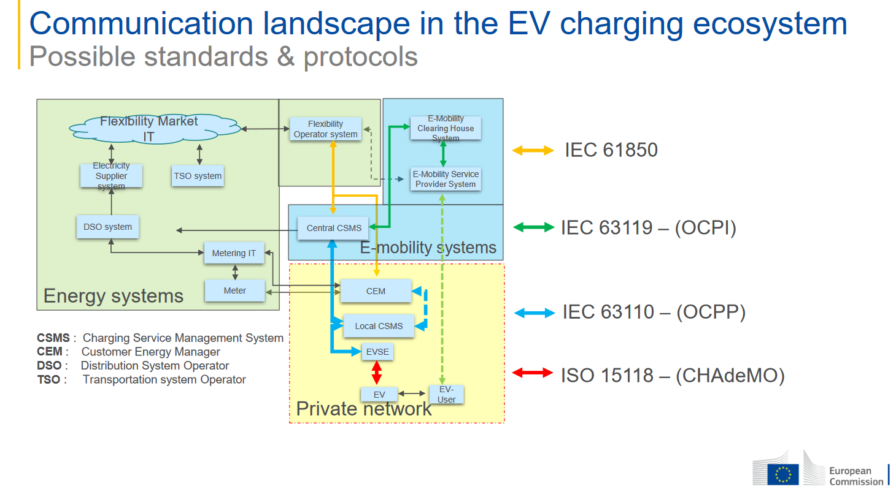

*Source:* EC, DG Move, 2022

B. Way forward

41. In the EV charging protocols market, the following developments are observed:

(a) The market is becoming more international and while new operators are still entering the market, consolidation is also taking place, with parties merging or being acquired;

(b) New regulations and guidance documents are being issued by regional organizations at supranational level with increasing impact on new legislation at national levels.

VI. Status of preparedness for increased electrification of the vehicle fleet and next steps

* Open-source protocols have been helping the emerging EV charging industry since its inception more than a decade ago. These protocols (of which OCPP and OCPI are the most well-known), have developed over the years following the needs of the industry and legislators. These open-source protocols are (royalty) free to use and anybody is invited to contribute to its development. Legislators in United Nations member States that lead in EV adoption (Republic of Korea, California, Netherlands) are mandating OCPP to get access to government funding. The European Commission recommends OCPP. And the US Government announced in June 2022 to mandate both OCPP and OCPI. Since open-source protocols are freely and easily accessible, they are used all over the world. As an example, the OCPP protocol has been downloaded to over 72,000 individual IP addresses in 154 countries globally. This means that all the knowledge and experience incorporated in those standards are directly and freely shared with anyone.
* Things are developing rapidly, and standards need to be agile enough to deliver to the industry and legislators. De jure[[30]](#footnote-31) standard setting organizations cannot manoeuvre that fast and are often dominated by one sector, de facto standard setters tend to be more agile. As an example, as a solution to the slow development speed at de jure SDOs, the Industry Association CharIn has set out to standardize the new MegaWatt Charging Standard (MCS). Ratification of this new industry standard will be done afterwards by ISO.
* Concentration in one sector entails the danger that innovations from other sectors (energy, grid management) do not have enough room for further development. In addition, too prominent a position entails the danger that new players, whether in developed countries or in upcoming markets cannot gain access to the market (vendor lock-out), or that consumers will be forced to stay with a provider (consumer lock-in). Global policy must be designed in such a way that a level playing field is guaranteed for everyone.
* The informal Working Group on EVE emphasized the need to carefully consider any additional data needs to be stored on-board vehicles as vehicle Original Equipment Manufacturers (OEMs) are looking at ways where data collection can be minimized.

VII. Guidance to the Committee by its Working Parties and the Bureau

42. The following Working Parties have already considered the present document and decided on specific actions:

A. Working Party on Transport Trends and Economics (WP.5)

43. WP.5 at its thirty-fifth session in September 2022 decided to introduce a steady workflow on general trends and developments surrounding passenger electric vehicles (EVs) and its charging infrastructure. In this regard, the Working Party will biennially take stock of latest developments in this field and in passenger road transport in general, considering the trends discussed in chapter II above. As appropriate, it plans to organize targeted workshops and/ or prepare assessment reports and issue recommendations on these topics. As an immediate first step, it decided to prepare its Transport Trends and Economics 2022–2023 publication to explore this theme further.

44. A standing WP.5 agenda item on passenger EVs and its charging infrastructure will be placed under its cluster of work on review and monitoring of emerging issues and sustainable development goals. As part of this same cluster, WP.5 also plans to investigate the development of more user-centric policies (including harmonization of payment systems for public charging) and/or frameworks considering accessible and affordable charging at public Electric Vehicle Supply Equipment (EVSE) and its integration in the electricity grid.

45. Finally, WP.5 decided to organize, as part of its cluster of work on transport security a designated workshop on security aspects of EVCS, both in terms of cyber security threats, as well as in terms of physical security of users during the charging process. Such a workshop will be held at its next session in 2023, possibly in cooperation with the Working Party on Road Transport (SC.1) or the Informal Working Group on Intelligent Transport Systems under the World Forum for Harmonization of Vehicle Regulations (WP.29).

B. Working Party on Intermodal Transport and Logistics (WP.24)

46. WP.24 at its sixty-fifth session decided to consider as part of its work scope the developments for commercial EV fleets including eLDVs and eHDVs and their charging infrastructure in the context of intermodal transport. It thus agreed to look at what could be a role played by intermodal terminals in providing charging infrastructure to eLDVs used for last mile deliveries, i.e. from the intermodal terminal to the customer.

C. Working Party on Transport Statistics (WP.6)

47. WP.6 at its seventy-third session introduced a discussion around certain aspects of vehicle statistics, including emissions from electric vehicles depending on the time that they are charged (and the policy implications this has), the number and capacity of vehicle charging stations, as well as statistics on the trade in used vehicles. WP.6 stands ready to consider data collection on EVs and EV supply equipment (EVSE) by developing, where required, data definitions and by setting up a specific data collection mechanism on public charging infrastructure points.

VIII. Guidance by the Committee

48. The Committee may wish to take note of the consideration given by WP.5, WP.24 and WP.6 to this document and its recommendations and may wish to welcome the proposed actions.

49. The Committee may wish to invite WP.29 to make proposals on possible future activities on regulatory tools for harmonized communication between vehicles and Electrical Vehicle Supply Equipment (EVSE), taking into consideration already existing related standards and/ or protocols.

50. The Committee may also wish to invite SC.1 to consider and make proposals on road transport developments in view of the electrification of LDVs and HDVs and how to best arrange the development of charging infrastructure. SC.1 is further invited to closely collaborate with WP.24 to find solutions serving best the transport haulage in general as well as the last mile deliveries.

51. Given the cross-sectoral nature of the topic at hand, the Committee may wish to consider engaging more closely with its sister ECE Committee on Sustainable Energy on these matters, and if deemed appropriate, take a decision on what form such cooperation could take.

52. Given that addressing the various aspects of electrical mobility requires close cooperation among several of its subsidiary bodies, the Committee may wish to request WP.5 to continue playing a coordinating role and report back to ITC at its next session.

1. Staff of the Transport Facilitation and Economics, Vehicle Regulations, Road Traffic Safety and Transport Innovations and Intermodal Transport and Logistics sections. [↑](#footnote-ref-2)
2. ECE ForFITS (2022), available at: https://unece.org/forfits-model-assessing-future-co2-emissions (last accessed 27 June 2022) [↑](#footnote-ref-3)
3. Fore example, ForFITS application in Uzbekistan in 2020, available at: https://unece.org/DAM/env/epr/epr\_studies/ECE.CEP.188/ECE.CEP.188.ENG.05.Annexes.pdf [↑](#footnote-ref-4)
4. Source: UK Department for Science (2019), “The Future of Mobility”, available at: https://assets.publishing.service.gov.uk/government/uploads/system/uploads/attachment\_data/file/780868/future\_of\_mobility\_final.pdf (last accessed: 24 June 2022) [↑](#footnote-ref-5)
5. Source: Chatterjee, K., Goodwin, P., Schwanen, T., Clark, B., Jain, J., Melia, S., Middleton, J., Plyushteva, A., Ricci, M., Santos, G. and Stokes, G. (2018). Young People’s Travel – What’s Changed and Why? Review and Analysis. Report to Department for Transport, Bristol. Retrieved from www.gov.uk/government/uploads/system/uploads/attachment\_ data/file/673176/young-peoples-travel-whats-changed.pdf [↑](#footnote-ref-6)
6. Source: UNECE (Geneva, 2020), “Transport Trends and Economics 2018-2019 – Mobility as a Service”, available at: https://unece.org/DAM/trans/main/wp5/publications/Mobility\_as\_a\_Service\_Transport\_Trends\_and\_Economics\_2018-2019.pdf (last accessed 25 June 2022) [↑](#footnote-ref-7)
7. Source: Eurostat 2020 [↑](#footnote-ref-8)
8. Source: UK Department of Science (2019), “The Future of Mobility”, cfr. supra [↑](#footnote-ref-9)
9. Source: TransRussia (2019), available at: https://transrussia.ru/Articles/an-updated-look-at-road-transport-in-russia (last accessed: 24 June 2022) [↑](#footnote-ref-10)
10. UK Department of Science (2019), “The Future of Mobility”, cfr. supra [↑](#footnote-ref-11)
11. DHL (February 2022), “Road Freight 101 – The importance and future of road transport”, available at: https://dhl-freight-connections.com/en/business/road-freight-101-the-importance-and-future-of-road-transport/ (last accessed 25 June 2022) [↑](#footnote-ref-12)
12. Source: E&Y and Eurelectric Study (2022), “Power Sector Accelerating E-mobility”, available at: power-sector-accelerating-e-mobility-2022-ey-and-eurelectric-report.pdf (last accessed, 24 June 2022) [↑](#footnote-ref-13)
13. Idem [↑](#footnote-ref-14)
14. Source: IEA Global EV Outlook (2022), Available at: https://www.iea.org/reports/global-ev-outlook-2022 (last accessed 26 June 2022) [↑](#footnote-ref-15)
15. Idem [↑](#footnote-ref-16)
16. TWh (a unit of electrical energy) means 1,000 gigawatts per hour or one million megawatts per hour. [↑](#footnote-ref-17)
17. The IEA Stated Policies Scenario (STEPS) represents a path based on the energy and climate measures governments have put in place to date, and specific policy initiatives under development. [↑](#footnote-ref-18)
18. In the IEA Sustainable Development Scenario (SDS), all current net zero pledges are achieved in full and there are extensive efforts to realise near-term emissions reductions. [↑](#footnote-ref-19)
19. Definition: Prosumers both produce and consume energy – a shift made possible, in part, due to the rise of new connected technologies and the steady increase of more renewable power like solar and wind onto the electric grid (US Department of Energy, 2022) [↑](#footnote-ref-20)
20. Data here can include “vehicle use patterns, battery state of charge, infrastructure and vehicle power capabilities, grid tariffs and energy prices, T&D grid situation, and renewables production (forecast and real-time)” (Source: ENTSO-E-Position Paper, available at: ENTSO-E Position Paper on Electric Vehicle Integration into Power Grids (entsoe.eu) (last accessed 25 June 2022) [↑](#footnote-ref-21)
21. Ernst & Young (EY), “2022 Eurelectric Report”, available at: https://assets.ey.com/content/dam/ey-sites/ey-com/en\_gl/topics/power-and-utilities/power-and-utilities-pdf/power-sector-accelerating-e-mobility-2022-ey-and-eurelectric-report.pdf (last accessed 25 June 2022) [↑](#footnote-ref-22)
22. Source: Einfochips.com (2021) [↑](#footnote-ref-23)
23. Explanation: Weatherproof/ environmentally controlled streetside cabinets housing transmission and telecommunication equipment. [↑](#footnote-ref-24)
24. Source: Benchmark Mineral Intelligence (2019), quoted from “Energy density and the challenges of electrification for heavy duty vehicles”, available at: https://www.benchmarkminerals.com/energy-density-and-the-challenges-of-electrification-for-heavy-duty-vehicles/ (last accessed 25 June 2022) [↑](#footnote-ref-25)
25. Idem [↑](#footnote-ref-26)
26. Overview of protocols, Source: in part reproduced from: “Position Paper on Open Markets & Open Protocols” (June, 2021), NAL Working Group Open Market & Open Protocols, Netherlands [↑](#footnote-ref-27)
27. Source: Open Charge Point Protocol 2.0.1, Open Charge Alliance, [Online]. Available at: OCPP 2.0.1, Protocols, Home - Open Charge Alliance [↑](#footnote-ref-28)
28. Explanation: Open Charge Alliance is a global consortium of public and private electric vehicle infrastructure leaders that have come together to promote open standards through the adoption of the OCPP and the OSCP. Website: https://www.openchargealliance.org/ [↑](#footnote-ref-29)
29. ISO stands for International Organization for Standardization [↑](#footnote-ref-30)
30. Definitions: De jure standards, or standards according to law, are endorsed by a formal standard setting entity. The entity ratifies each standard through its official procedures and gives the standard its stamp of approval. De facto standards, or standards in actuality, are adopted widely by an industry and its customers. [↑](#footnote-ref-31)