UN/SCETDG/61/INF.38

Committee of Experts on the Transport of Dangerous Goods
and on the Globally Harmonized System of Classification
and Labelling of Chemicals 22 November 2022
Sub-Committee of Experts on the Transport of Dangerous Goods
Sixty-first session
Geneva, 28 November - 6 December 2022
Item 4 (c) of the provisional agenda
Electric storage systems: transport provisions
Amendments to labelling requirements of packages in the UN Model Regulations
Transmitted by the expert from China
Introduction
- In recent years, the lithium ion battery industry has developed more and more quickly. According to research, the global output of lithium ion cells in 2021 reached 562.4 GWh, with a significant year-on-year growth of 91.0 %. At the same time, the size of lithium ion batteries or equipment containing lithium ion batteries, such as portable medical instruments and commercial robots, also grows rapidly. Sometimes, the capacity of packages of such goods exceeds 0.45 m³ or even 3 m³ during transport.
Discussion
- In 2020, at its 57th session, the Sub-Committee adopted the clarification that the packagings authorized in P903 (2), (4) and (5) may exceed a net mass of 400 kg, which was written into the 22nd revised edition of the UN Model Regulations. This is the basis for using P903 to transport packages of more than 0.45 m³ in capacity which contain lithium ion batteries or equipment powered by lithium ion batteries. At present, the label model No. 9A shall be affixed to the products with the minimum dimensions of 100 mm100 mm according to 5.2.2.2 and special provision SP384 of the UN Model Regulations. In accordance with transport experience in recent years, most shippers will only affix labels with the size of 100 mm100 mm due to the limited size of labels provided by label suppliers. However, compared to the huge size of the package, the label with the size of 100 mm100 mm is not visible enough to be noticed, which is contrary to the risk identification of the dangerous goods during transport.
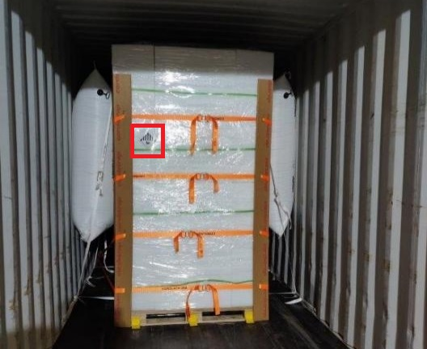
Figure 1. Package containing lithium ion batteries affixed the label model No. 9A (100 mm100 mm) in a container
- In terms of the labelling requirements for packages of large capacity, the UN Model Regulations already has some good examples to ensure labels visible enough. For example, for intermediate bulk containers of more than 450 L capacity and large packagings, it shall be labelled on two opposing sides. Moreover, for internal combustion engines applying UN 3528 or UN 3530, when the capacity exceeds 0.45 m³ or even 3 m³, SP363 provides stricter requirements on the labelling provision and size, which plays an important role to ensure the safe transport of such goods.
- For the transport of dangerous goods under UN 3480 and UN 3481, the label model No. 9A is crucial to transfer risk information of the package. China proposes to amend the UN Model Regulations to include similar labelling requirements to ensure the visibility of labels during transport.
Proposals
- China provides two possible options to amend the UN Model Regulations:
Option 1: amend special provision SP384 to read as follows:
“SP 384 The label to be used is Model No. 9A, see 5.2.2.2.2. However, for placarding of cargo transport units, the placard shall correspond to Model No 9.
Where the package has a capacity of more than 0.45 m³ but not more than 3 m³, it shall be labelled with Model No. 9A on two opposing sides.
Where the package has a capacity of more than 3 m³, it shall be labelled with Model No. 9A on two opposing sides and the minimum dimensions of the label shall be 250mm250mm.”
Option 2: amend 5.2.2.1.7 to read as the follows:
“5.2.2.1.7 Intermediate bulk containers Packages of more than 450 litres 0.45 m³ but not more than 3 m³ capacity and large packagings shall be labelled on two opposing sides. Packages of more than 3 m³ capacity shall be labelled on two opposing sides and the minimum dimensions of the label shall be 250mm250mm.”

