UN/SCETDG/61/INF.37

Committee of Experts on the Transport of Dangerous Goods
and on the Globally Harmonized System of Classification
and Labelling of Chemicals 22 November 2022
Sub-Committee of Experts on the Transport of Dangerous Goods
Sixty-first session
Geneva, 28 November - 6 December 2022
Item 4 (c) of the provisional agenda
Electric storage systems: transport provisions
Transport provisions for composite batteries consisting of both lithium ion cells and sodium ion cells
Transmitted by the expert from China
Introduction
1. With the rapid development of industries like electric vehicle and electrochemical energy storage systems in recent years, the use of lithium ion batteries and sodium ion batteries has become more and more widely. In the current 22nd revised edition of the Model Regulations, UN entries for lithium ion batteries are:
UN 3480 LITHIUM ION BATTERIES (including lithium ion polymer batteries);
UN 3481 LITHIUM ION BATTERIES CONTAINED IN EQUIPMENT or LITHIUM ION BATTERIES PACKED WITH EQUIPMENT (including lithium ion polymer batteries).
2. According to amendments adopted by the Sub-Committee at its fifty-ninth session in December 2021, the following two entries will be included in the twenty-third revised edition of the Model Regulations to address sodium-ion batteries:
UN 3551 SODIUM ION BATTERIES with organic electrolyte；
UN 3552 SODIUM ION BATTERIES with organic electrolyte CONTAINED IN EQUIPMENT or SODIUM ION BATTERIES with organic electrolyte PACKED WITH EQUIPMENT”
3. To comprehensively utilize the advantage of lithium-ion batteries such as high energy density and that of sodium ion batteries such as good low-temperature performance, it has emerged in the industry a new composite battery product consisting of both lithium ion cells and sodium ion cells, as shown in the figure 1 below:
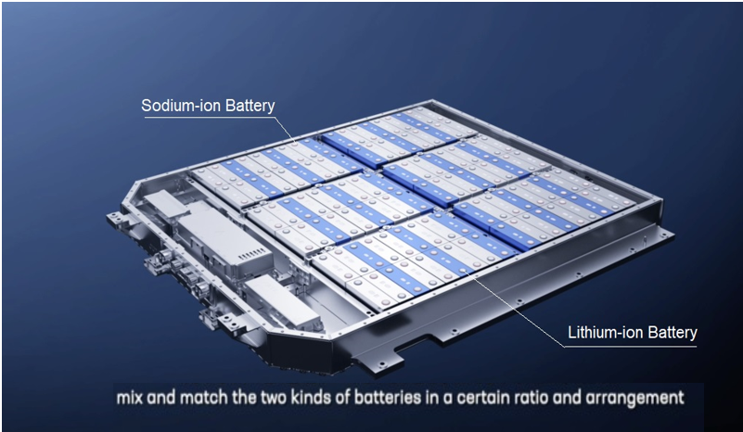
Figure 1: Composite battery consisting of both lithium ion cells and sodium ion cells
Current Problems
4. However, when it comes to the transport of such composite battery product, some compliance issues have been realized. Clarifications should be made in the Model Regulations on:
a. Classification and assignment of UN entries. Section 2.9.4 in the Model Regulations states “Cells and batteries, cells and batteries contained in equipment, or cells and batteries packed with equipment, containing lithium in any form shall be assigned to UN Nos. 3090, 3091, 3480 or 3481 as appropriate.” And, it has been adopted in 2.9.5 of the forthcoming 23rd edition of the Model Regulations that “Cells and batteries, cells and batteries contained in equipment, or cells and batteries packed with equipment containing sodium ion, which are a rechargeable electrochemical system where the positive and negative electrode are both intercalation or insertion compounds, constructed with no metallic sodium (or sodium alloy) in either electrode and with an organic non aqueous compound as electrolyte, shall be assigned to UN Nos. 3551 or 3552 as appropriate.” Then, which UN entries should this kind of composite batteries be assigned to?
b. UN38.3 test. Lithium-ion and sodium ion cells that make up these batteries have been proved to meet the requirements of relevant tests in the Manual of Tests and Criteria, Part III, sub-section 38.3 respectively. But, what procedures should the battery as a whole to follow in UN38.3 test? Should the procedures for lithium batteries be applied?
c. Marking and documentation. Should lithium ion batteries and sodium ion batteries be marked and indicated at the same time, referring to the current requirements in SP390?
Proposal
5. To address the above problems, the experts from China suggest clarifying in either 2.9.4 and 2.9.5 or a new special provision in Chapter 3.3 of the Model Regulations that transport provisions for this kind of composite battery products should be in accordance with those for lithium ion batteries. Experts of the TDG Sub-Committee and other relevant professionals in this area are invited to discuss the issue together with us.
________________

