UN/SCEGHS/43/INF.14
Committee of Experts on the Transport of Dangerous Goods
and on the Globally Harmonized System of Classification
and Labelling of Chemicals
Sub-Committee of Experts on the Globally Harmonized
System of Classification and Labelling of Chemicals 11 November 2022

Forty-third session
Geneva, 7-9 December 2022
Item 7 of the provisional agenda
Programme of work for the biennium 2023-2024
Review of the use of human data for the classification of skin sensitisers in Chapter 3.4 of the GHS
Transmitted by the expert from Germany
Background
1. The German experts noted that with respect to the use of human data, the current chapter 3.4 of the GHS on skin sensitization has several deficiencies, including classification criteria which are not precisely defined, and criteria which in some cases potentially underestimate the potency of skin sensitizers when classifying them based on certain types of human data.
2. In 2021, the Organisation for Economic Co-operation and Development (OECD) published Guideline 497 on Defined Approaches (DAs) for Skin Sensitization. The main purpose of this project was to validate the DAs under examination for use in classification and labelling of skin sensitizers under the GHS. In this context, the human data sub-group (HDSG) of the OECD project, composed of experts from the United States of America (National Toxicology Program Interagency Center for the Evaluation of Alternative Toxicological Methods/NICEATM, US Food & Drug Administration/FDA, US Consumer Product Safety Commission/CPSC) and Germany (German Federal Institute for Risk Assessment/BfR) curated a large set of human reference data from Human Predictive Patch Tests (HPPT, including the Human Maximization Test, HMT, and the Human Repeated Insult Patch Test, HRIPT).
3. In the GHS, positive HPPT results (≥ 1 sensitised test subject) currently lead to classification of the tested substance as at least skin sensitizer 1B. If the positive result is obtained at a dose per skin area (DSA) ≤ 500 µg/cm², the substance is classified as skin sensitizer 1A. The current GHS rules, however, do not consider the number of sensitized individuals, thereby potentially ignoring significant differences in potency. For example, a substance positively tested at a DSA of 501 µg/cm² would be classified as skin sensitizer 1B, even if 100% of the test panel were sensitized, while a substance positively tested at 499 µg/cm² would be sub-categorized as skin sensitizer 1A, even if only 1 % of the test panel tested positive. Moreover, due to the fixed 1A/1B cut-off of 500 µg/cm², the current GHS criteria do not take into account the uncertainty associated with HPPT results obtained at borderline DSA values close to said cut-off.
4. In order to better reflect potency, while remaining as much as possible in line with the current GHS classification rules, the HDSG introduced the “DSA1+”, i.e. the hypothetical DSA that sensitizes exactly one test subject. The DSA1+ is estimated from the number of sensitized individuals observed in the test, i.e. DSA1+ = DSA/(number of sensitized). It can be used for GHS classification in the same way as the DSA, i.e. using the 500 µg/cm² cut-off. This is depicted in figure 1:
Figure 1

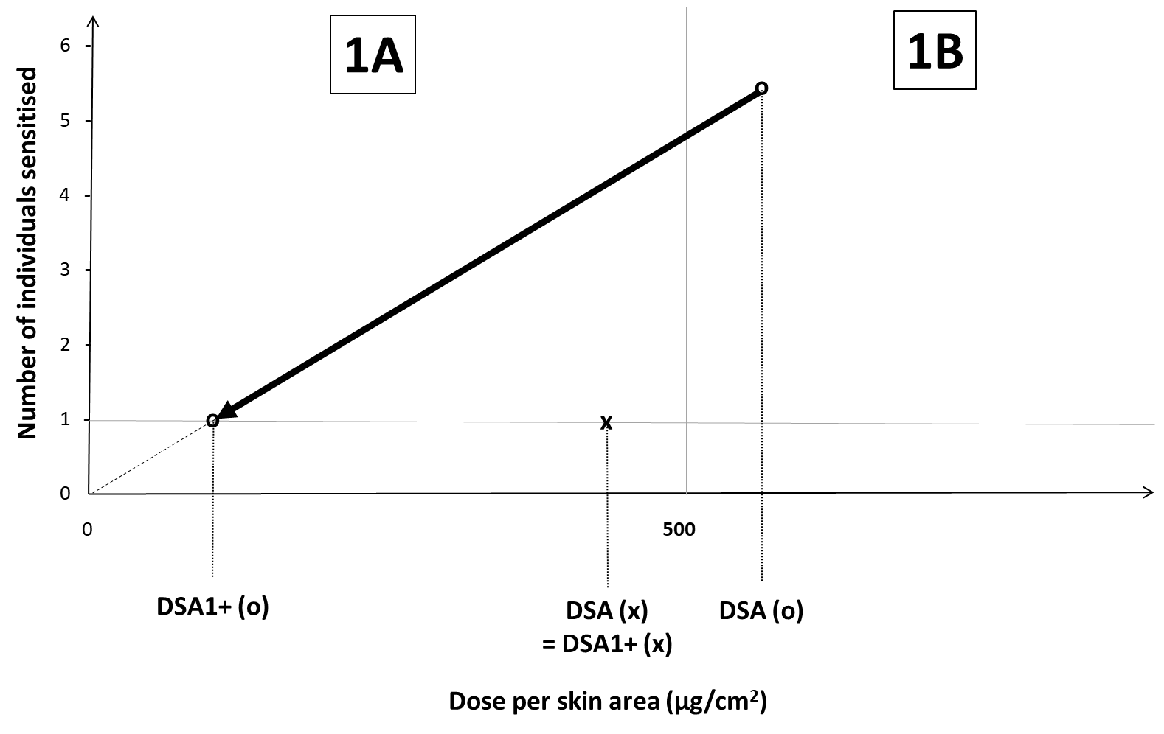
5. Figure 1 shows two substances, one (x) causing exactly one sensitized individual at a DSA (which already is the DSA1+) slightly below the 500 µg/cm² cut-off that would be sub-categorized as skin sensitizer 1A. The other substance (o) was tested at a slightly higher DSA above 500 µg/cm² and would be sub-categorized as skin sensitizer 1B regardless of the fact that a much higher number of individuals (six) was sensitized. In order to compare the potency of both substances, the DSA for the second substance is converted to the DSA1+ by extrapolation. It is shown that the DSA1+ for this substance now clearly falls into the 1A range.
6. Of note, by applying linear extrapolation the HDSG did not imply that the dose-response relationship for skin sensitization in humans was in fact linear (it is reasonable to assume that it is not). Using linear extrapolation only reflects the fact that the published HPPTs analyzed by the group were almost exclusively performed using only one dose group and that, hence, there was no way of knowing (or modelling, for that matter) the real dose-response relationship. Obviously, this simple extrapolation is associated with some uncertainty, which has to be taken into account when determining the overall classification decision.
7. As an alternative to the DSA1+, the "DSA05", i.e. the DSA resulting in 5% sensitization incidence, can be used, which can be obtained in an analogous fashion, i.e. DSA05 = [DSA/(positive incidence in %)] x 5 %.
8. Current work by the HDSG (Herzler et al. (2022), submission under preparation) shows for a total of 605 positive HPPT test results that, as expected, the current GHS rule based on the DSA leads to a significantly lower number of 1A sub-categorizations compared to using DSA1+ or DSA05 (the latter two are fairly comparable, with the DSA1+ resulting in a slightly higher number of 1A results), thereby partially underrepresenting the potency of the tested substances as shown in figure 2:
Figure 2
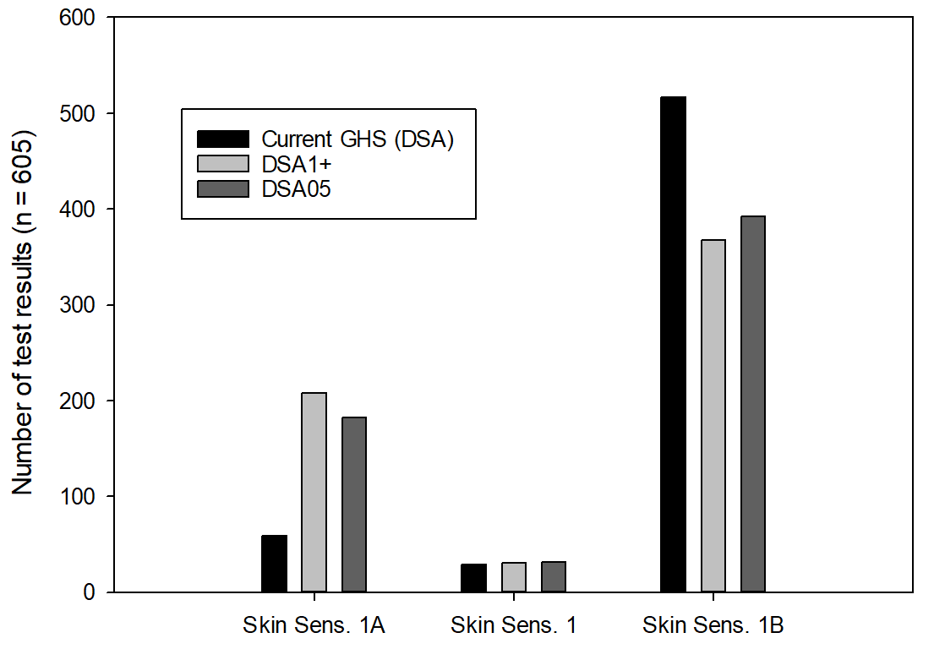
9. Furthermore, the HDSG developed concepts for establishing the reliability of HPPT results, for identifying and handling borderline HPPT results and for performing, in a consistent way, a weight-of-evidence (WoE) analysis of multiple HPPT results for the same test substance, if these were not fully concordant with respect to the classification outcome. A detailed report of this work can be found in Annex 4 to the supporting document to OECD Guideline Document 497, which was published as No. 336 in the OECD Series on Testing and Assessment.
10. While studying the current GHS system for classifying skin sensitizers based on HPPT data, it also became apparent that the current GHS text may need to be revised in that it claims that these tests could determine an “induction threshold”. However, in HPPTs usually only one dose/DSA is tested and the result is either positive or negative (i.e. either above or below a hypothetical induction threshold), but does not provide the threshold itself, which could be much higher or lower, depending on the result obtained (i.e. a negative result at a low DSA cannot rule out the possibility of a positive result at a higher DSA, nor can a positive result at a high DSA corresponding to 1B rule out a positive result at a lower DSA in the 1A range). Moreover, it has also been shown that the outcome of an HPPT may vary depending on the procedure used for challenging the test subjects to elicit an allergic reaction (provided the substance/mixture tested has sensitising properties).
11. Finally, during the work of the Informal Working Group on Non-Animal Test Methods (IWG NATM) in the 2021/2022 biennium, it became obvious that, with respect to the use of human data for the classification of skin sensitizers, the current GHS text in a number of places uses terminology, such as “relatively high/low and substantial incidence” or “relatively high” exposure, to distinguish between skin sensitisers of sub-categories 1A and 1B, without providing operational definitions. This may lead to divergent interpretations by different competent authorities (e.g. for the European Union, such interpretation has been provided in the “Guidance on the Application of the CLP Criteria” as issued by the European Chemicals Agency, ECHA), potentially hampering the overall goal of classification harmonised on a global scale.
Proposal
12. Germany invites the Sub-Committee to consider the above issues and the inclusion of their discussion into the programme of work of a suitable existing informal working group, e.g. the informal working group on practical classification issues (PCI), for the biennium 2023/2024.
13. The aim of discussing the issues outlined above would be to obtain consensus on potential corrections or clarifications in the respective parts of Chapter 3.4. The discussion should include the findings from the OECD project on DAs for skin sensitisation.
14. As a result of these discussions appropriate amendments of the current GHS text and guidance may be proposed for consideration by the Sub-Committee.

https://www.oecd.org/officialdocuments/publicdisplaydocumentpdf/?cote=ENV-CBC-MONO(2021)11/ann4%20&doclanguage=en (last accessed 2022-10-23)
https://echa.europa.eu/documents/10162/2324906/clp_en.pdf (last accessed 2022-10-23)

