UN/CE/TDG-GHS/11/INF.1
Committee of Experts on the Transport of Dangerous Goods
and on the Globally Harmonized System of Classification
and Labelling of Chemicals
Eleventh session 16 November 2022
Geneva, 9 December 2022
Item 1 of the provisional agenda
Adoption of the agenda
Working arrangements for the eleventh session and registration procedures
Note by the secretariat
Introduction
1. This document contains information about the working arrangements and registration procedures for the eleventh session of the Committee of Experts.
2. For information about the organisation of the sixty-first session of the TDG Sub-Committee please refer to informal document INF.22 and for the forty-third session of the GHS Sub-Committee to informal document INF.11.
Working arrangements
3. The Committee’s session will be held on:
Friday 9 December, from 14:30 to 16:30 (Geneva time)
as a hybrid session with interpretation. This modality will allow participation in-person as well as remote connection for those who will be unable to travel to Geneva.
4. The session will be conducted with the platform Zoom (accessible with a web browser). Details on how to login and use Zoom will be circulated a few days before the session. Only delegates duly accredited as members of a delegation entitled to participate in the work of the Committee can attend the session. For information on how to register refer to paragraphs 8 and 9 below.
5. The Committee will consider all items on the agenda for the session (see ST/SG/AC.10/49) available on the website.
6. Documents submitted for consideration during the session will be made available and circulated as informal documents on the website.
7. The Committee of Experts is expected to adopt the report on the basis of a draft prepared by the secretariat that will be made available to all participants in the session.
Registration procedures for the session
8. The secretariat wishes to recall that only delegates duly accredited as representatives of a country or organisation (IGO, NGO, …) entitled to participate in the work of the Committee can participate in the session, irrespective of the participation modality (i.e. in person or online). Heads of delegation are invited to communicate to the secretariat well in advance of the start of the session the composition of their delegation.
9. Delegations which have not yet officially designated a head of delegation are invited to do so as soon as possible. For details on how to proceed, please refer to informal document INF.32 (TDG 56th session) – INF.14 (GHS 38th session).
10. Only delegates included in the list provided by the head of delegation will be considered duly accredited to attend the session (either in person or remotely) and will be given the credentials enabling them to participate. The list of registered participants will be circulated one week before the session to the Permanent Missions in Geneva for their information and follow-up, if needed.
All participants (i.e.: those wishing to attend in-person and those wishing to connect remotely)
11. All participants shall register online through INDICO before the session irrespective of the participation modality (online or in-person).
Participants wishing to attend in-person (including those holding a long-duration badge)
12. Those wishing to attend in-person (in Room XXVI) are kindly requested to indicate so in the online registration form and shall note the following information on the relocation of the Pass and ID badging services.
13. Following the renovation works, the Pregny Pavilion will be closed to pedestrians until end of May 2023. Pedestrian access and exit via the external turnstiles to the front of the Pregny Pavilion, as well as vehicle access and exit via the Pregny gate will remain operational (see maps in Annex).
14. During the renovation works, conference participants, media, NGOs and members of Permanent Missions are invited to collect their badges at the Villa Les Feuillantines (Avenue de la Paix 13) open from Monday to Friday from 8:00 to 16:45.
15. Following issuance of a badge, access to the Palais des Nations will be through the Peace Gate “bis”, a new temporary access screening point, as shown in the annex to this document. For additional details refer to: https://www.ungeneva.org/en/pregny-gate-closure.

Annex
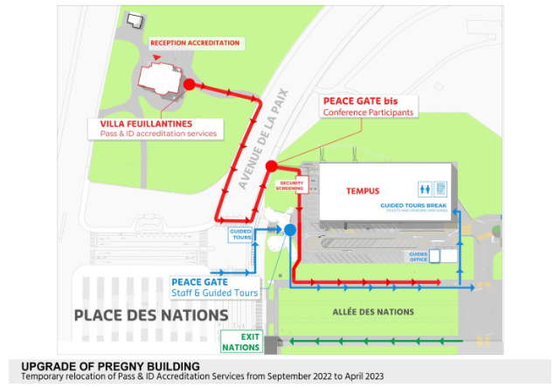

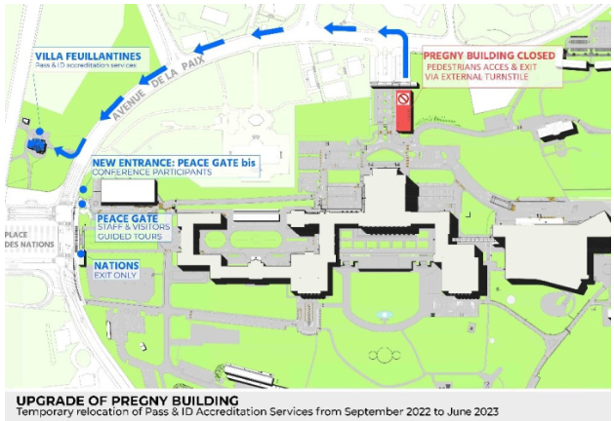

https://unece.org/sites/default/files/2022-11/UN-SCETDG-61-INF22e_0.pdf
https://unece.org/sites/default/files/2022-11/UN-SCEGHS-43-INF11e.pdf
https://unece.org/sites/default/files/2022-09/ST-SG-AC.10-49.e.pdf
https://unece.org/info/Transport/Dangerous-Goods/events/369883
https://unece.org/DAM/trans/doc/2019/dgac10c3/UN-SCETDG-56-INF32e-UN-SCEGHS-38-INF14e.pdf
https://indico.un.org/event/1000389/

