United Nations ECE/EB.AIR/GE.1/2022/21₋ECE/EB.AIR/WG.1/2022/14

Economic and Social Council

Distr.: General

July
1

2022

Original: English
Informal document with amendments to the Technical Guidance for Emissions Inventory Adjustments under the Amended Gothenburg Protocol
Prepared by the Task Force on Emission Inventories and Projections

Economic Commission for Europe

Executive Body for the Convention on Long-range Transboundary Air Pollution

Steering Body to the Cooperative Programme for Monitoring and Evaluation of the Long-range Transmission of Air Pollutants in Europe Working Group on Effects
Eighth joint session
Geneva, 12–16 September 2022
Item 10 (a) of the provisional agenda
Progress in activities of the Cooperative Programme for Monitoring and Evaluation of the Long-range Transmission of Air Pollutants in Europe in 2022 and future work: improvement and reporting of emission data and adjustments under the Protocol to Abate Acidification, Eutrophication and Ground-level Ozone
Technical Guidance for Emissions Inventory Adjustments under the Amended Gothenburg Protocol
Inventory adjustments in the context of emission reduction commitments

Prepared by the Task Force on Emission Inventories and Projections
Summary
Conscious of the uncertainties inherent in estimating and projecting emission levels and the need for continuous scientific and methodological improvements, and determined that the emergence of new methodologies should not put any Party at a disadvantage in terms of its emission reduction commitments, at its thirtieth session (Geneva, 30 April–4 May 2012), the Executive Body to the Convention on Long-range Transboundary Air Pollution adopted decisions 2012/3 and 2012/4 to allow
Parties to make adjustments under the Protocol to Abate Acidification, Eutrophication and Ground-level Ozone to emission reduction commitments or to inventories for the purposes of comparing total national emissions with them. At its thirty-first session (Geneva, 11–13 December 2012), the Executive Body adopted decision 2012/12 on guidance for such adjustments. Further technical guidance was then included as decision 2014/1, as adopted by the Executive Body at its thirty-third session (Geneva, 8–11 December 2014).
Recognizing that the existing technical guidance to support adjustment applications referred to emission ceilings, the Executive Body to the Convention on Long-range Transboundary Air Pollution requested
GE.22-10479(E)
that additional technical guidance be drafted to support Parties wishing to apply for adjustments within an emission reduction commitment framework.
The present document contains that technical guidance, as drafted by the Task Force on Emission Inventories and Projections, and trialed in 2022. It outlines both best practice in quantifying adjustments within an emissions reduction commitment framework and the information that should be reported to support the technical review of the application.

Contents
Paragraphs Page
- Introduction ............................................................................................................. 1-8 4
- Inventory adjustments in the context of emission reduction commitments ............. 9-12 5 III. Principles for quantification of inventory adjustments under emission reduction
commitments ........................................................................................................... 13-19 8
IV. Good practice in calculating and reporting inventory adjustments under
emission reduction commitments ............................................................................ 20-29 10 V. Applying for an inventory adjustment under emission reduction commitments ..... 30 11
VI. Review of inventory adjustments under emission reduction commitments ............ 31 11 VII. Reporting a previously approved inventory adjustment under emission reduction
commitments ........................................................................................................... 32 11
VIII. Source-specific observations relating to inventory adjustments under emission reduction commitments ............................................................................ 33-35 12

I. Introduction

A. Purpose of the present technical guidance
- Within the Convention on Long-range Transboundary Air Pollution (Convention), there are Executive Body decisions explaining the concept of several flexibility mechanisms that can be used for demonstrating compliance with emission targets. One such mechanism is the use of adjustments that can be made to emissions inventories. Under specific circumstances, such adjustments allow Parties to report national emission estimates for compliance purposes that differ from their best science national emission estimates.
- The document Technical Guidance for Parties Making Adjustment Applications and for the Expert Review of Adjustment Applications (ECE/EB.AIR/130) explains, among other things:
  - How a Party should apply for a new adjustment (including the information that must be provided);
  - How the validity and quantification of the new inventory adjustment are reviewed;
  - The steps in determining whether a new inventory adjustment application is approved or rejected;
  - How previously approved inventory adjustments should be reported and reviewed.
- Document ECE/EB.AIR/130 also includes case studies and worked examples to support Parties considering their options regarding making a new inventory adjustment application.
- However, the existing technical guidance and adjustment reporting templates support Parties who wish to use the option of inventory adjustments to demonstrate compliance with emission ceilings specified in the Protocol to Abate Acidification, Eutrophication and Ground-level Ozone (Gothenburg Protocol). The Gothenburg Protocol, as amended in 2012, requires Parties to demonstrate compliance with emission reduction commitments (ERCs) for 2020 onwards. Inventory adjustments that are applicable to ERCs (rather than ceilings) require different considerations and the submission of additional supporting information.
- The present technical guidance has been prepared in response to a request from the Executive Body to the Steering Body to the Cooperative Programme for Monitoring and Evaluation of the Long-range Transmission of Air Pollutants in Europe (EMEP) to draft technical guidance to support Parties wishing to use adjustments to demonstrate compliance specifically with the ERCs in the amended Gothenburg Protocol.
- Parties signatories to the Gothenburg Protocol but not to the amended Gothenburg Protocol are required to demonstrate continued compliance with emission ceilings. It is necessary to retain the original technical guidance and associated processes that pertain to demonstrating compliance with the ceilings of the Gothenburg Protocol for these Parties. This document therefore presents technical guidance that is additional technical guidance, or guidance specifically relating to the amended Gothenburg Protocol. This guidance does not replace the existing technical guidance that refers to inventory adjustments in the context of emission ceilings set under the Gothenburg Protocol.

B. Previously approved adjustments for the Gothenburg Protocol ceilings will not be valid for the amended Gothenburg Protocol emission reduction commitments
7. Parties wishing to use adjustments to demonstrate compliance with the ERCs specified in the amended Gothenburg Protocol will not be able to use existing inventory adjustments accepted for compliance with the Gothenburg Protocol ceilings. They will, in effect, need to “start again” in assessing which recalculations in their inventory are eligible as adjustments. This is primarily for two reasons:
- The reference version of the EMEP/European Environment Agency (EEA) air pollutant emission inventory guidebook (EMEP/EEA Guidebook) (that is used to determine the scientific knowledge and understanding when the commitments were set) is the 2009 version for the commitments specified in the amended Gothenburg Protocol, i.e. different to that used for adjustments under the Gothenburg Protocol. As a result, it is likely that the validity and quantification of most adjustments will have changed;
- The calculations required for an adjustment under the amended Gothenburg Protocol will require consideration, and reporting, of information relating to emissions in 2005, as well as 2020 onwards. Previously accepted adjustments under the Gothenburg Protocol do not provide this information.

C. European Union National Emission reduction Commitments Directive
8. Whilst this technical guidance is for use within the Convention, it is also recognized that the European Union National Emission reduction Commitments Directive (NECD) refers to Convention guidance documents. To facilitate cooperation between the Convention and NECD, reference is made to NECD in this guidance where there are relevant and material differences between the two instruments.
II. Inventory adjustments in the context of emission reduction commitments
- It is necessary to clearly differentiate between inventory adjustments that apply in the context of a compliance regime based on emission ceilings (Gothenburg Protocol) and those that apply in the context of ERCs (amended Gothenburg Protocol) – henceforth referred to in this guidance as, respectively, “adjustments under ceilings” and “adjustments under ERCs”.
- Adjustments under ERCs are inherently more complicated than adjustments under ceilings. This is because demonstrating compliance with ERCs requires emissions data from the compliance year in question (in this case, 2020 onwards) and 2005. For example, a “new source” adjustment (as defined in Executive Body decision 2012/12) under a ceiling compliance check always provides a beneficial revision to the compliance total. However, this is not the case when determining compliance with ERCs – a new source adjustment may aid or hinder compliance with an ERC, depending on the time trend of the new source (see para. 12 below for illustrative examples).
- A valid adjustment under ERCs might involve either revising down the emissions in the compliance year in question, or revising up the emissions in 2005 to change noncompliance into compliance. However, in many cases, it is likely that both years would need to be revised to capture relevant changes that have an impact across the entire time series; the magnitude and direction of the revisions will determine whether the net effect would bring a Party into compliance and is therefore considered eligible for an adjustment application.

Illustrative examples of adjustments under emission reduction commitments
12. Given the relative complexity of adjustments under ERCs compared to adjustments under ceilings (both in terms of conceptualizing them, and also providing sufficient supporting information), it is helpful to consider some illustrative examples (see figure below). These examples demonstrate some of the many possible combinations that might be considered for an adjustment under ERCs application and explain which are theoretically valid and which are not.
Illustrative examples of adjustments that have an impact on 2005 and 2020 emissions in different ways
Example base case
Emissions fall from 100 in 2005 to 80 in 2020.
The reduction achieved is 20 per cent, insufficient to meet the ERC of 25 per cent. Therefore, an adjustment can be applied for.
120
0
20
40
60
80
100
2005
2006
2007
2008
2009
2010
2011
2012
2013
2014
2015
2016
2017
2018
2019
2020
Example adjustment A: A new growing source  The impact of the adjustment reduces emissions in later years by more than the earlier years. This could be from, for example, a new source that grows with time.  It is an appropriate case for an adjustment application. In this case, the percentage reduction changes from 20 per cent to 40 per cent. |  | Example adjustment B: A new constant source  This is an example of an adjustment that relates to a new source that is constant with time.  Even though the adjustment value is the same for each year of the time series, it acts to increase the percentage  reduction between the first and last years in the time series  – in this case, from 20 per cent to 25 per cent. It is therefore a valid case for an application.
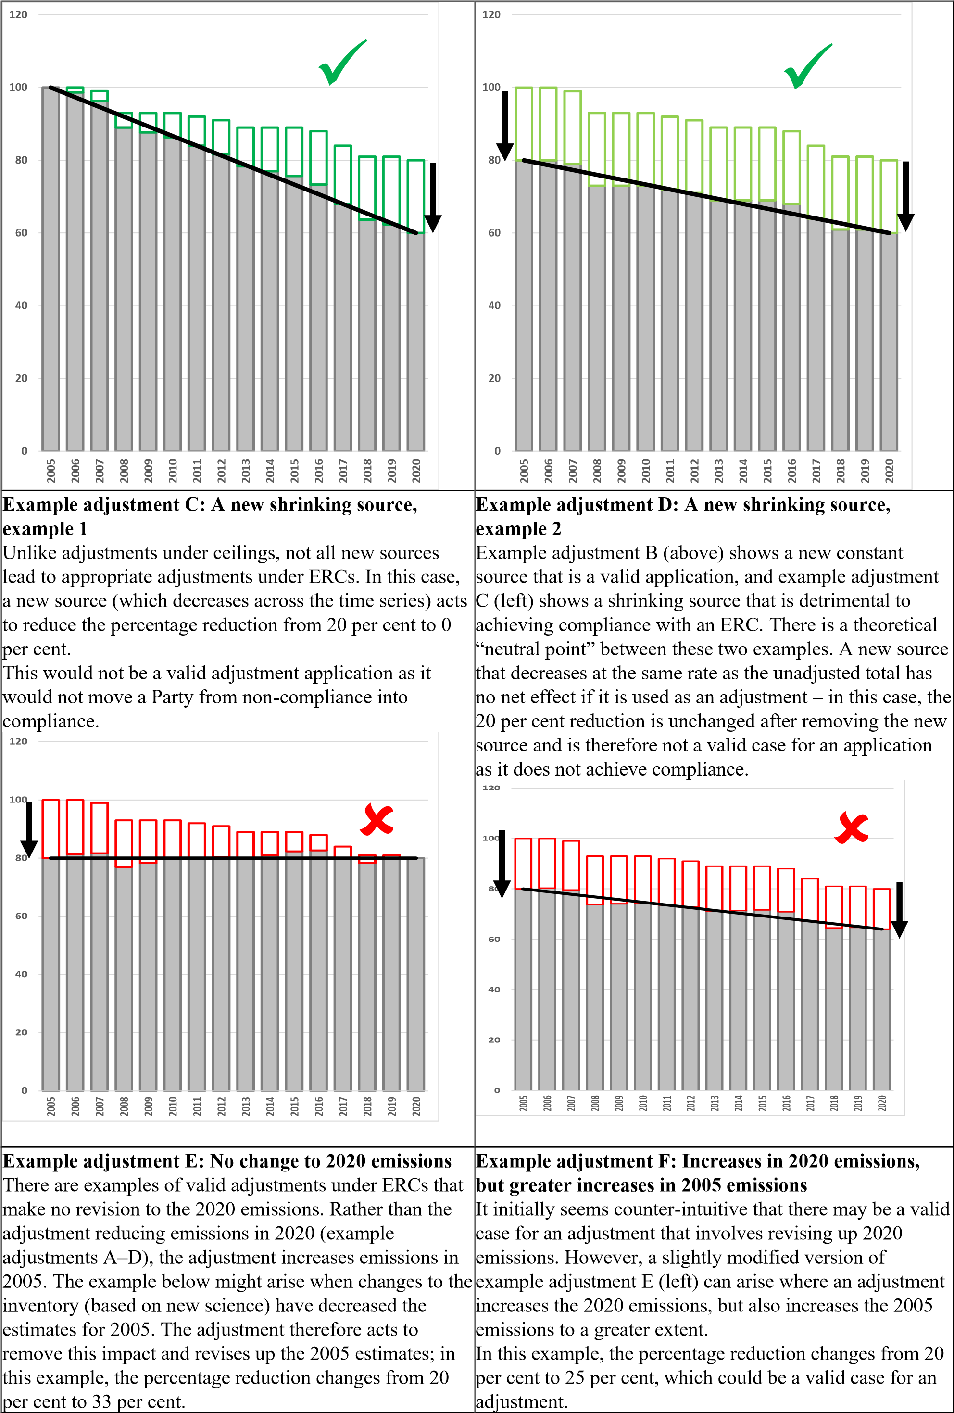
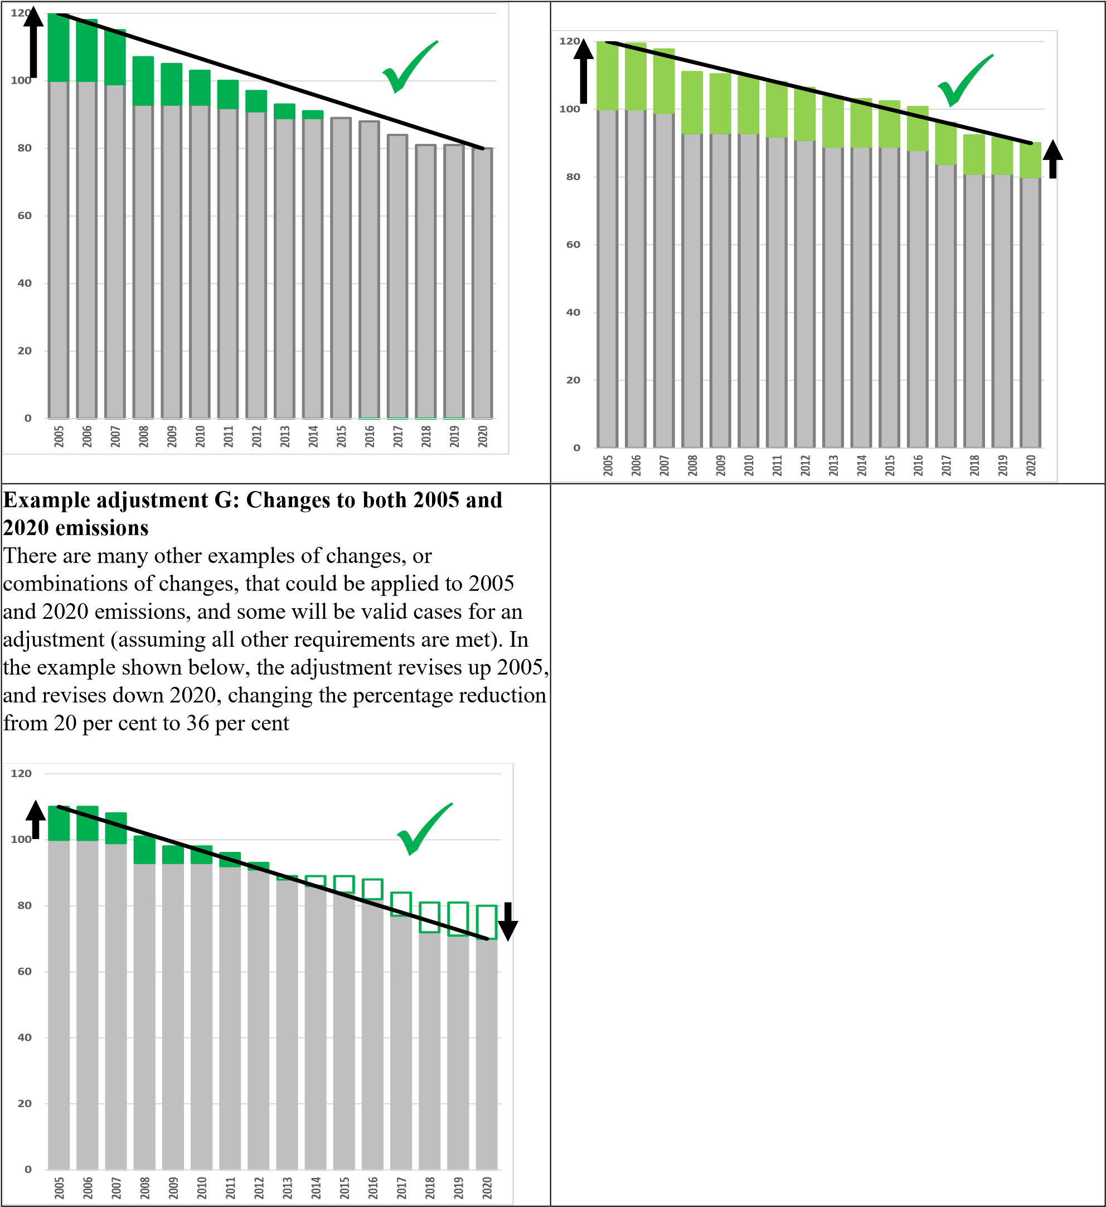
III. Principles for quantification of inventory adjustments under emission reduction commitments

A. Reference version of the EMEP/EEA Guidebook
13. The 2009 version of the EMEP/EEA Air Pollutant Emission Inventory Guidebook is to be used as the reference version for the purpose of calculating adjustments for the amended Gothenburg Protocol.

B. Information that needs to be reported
14. An inventory adjustment under ERCs makes revisions to the emission estimates for one or more source categories in 2005 and/or relevant years from 2020 onwards:
- Reporting of data: The revisions need to be reported in the adjustments under the ERC template provided – entitled “Annex IIa to ECE-EB Air130 adjustment Application”. The adjustment needs to change the status of compliance with the ERC from non-compliant to compliant. This is not simple to interpret from reported data, so the template includes calculations to check that the impact of the adjustment increases the percentage emissions reduction from 2005;
- Accompanying methodology and results text: Sufficiently detailed supporting information also needs to be provided, in either the informative inventory report or a separate adjustments report. This is explained in the existing technical guidance for adjustments.

C. Quantification of the adjustment under emission reduction commitments
- Irrespective of whether the inventory adjustment is based on a new source, or recalculations caused by changes to methodologies or emission factors, the underlying calculations used to quantify the adjustment under ERCs will be the same.
- The emission reduction (prior to any adjustments) is expressed as:
ER_{Y} (%) = 100 x (E₂₀₀₅ - E_{Y})/E₂₀₀₅ (1)
Where:
ERY is the emission reduction (prior to adjustment) in the year Y compared to emissions in 2005, expressed as a percentage
E2005 is the national emission total in the year 2005
EY is the national emission total in the year Y
When making an adjustment under ERCs application, Parties will need to demonstrate that ERY is lower than the corresponding ERC set for a Party for the given pollutant, i.e. the Party is in non-compliance.
- The emission reduction after an adjustment has been applied is expressed as:
AER_{Y} (%) = 100 x (AE₂₀₀₅ - AE_{Y})/AE₂₀₀₅ (2)
Where:
AER_{Y} is the adjusted emission reduction in the year Y compared to the emissions in 2005, expressed as a percentage
AE₂₀₀₅ is the adjusted national emission total in the year 2005 (in some cases, AE₂₀₀₅ = E₂₀₀₅)
AE_{Y} is the adjusted national emission total in the year Y (in some cases, AE_{Y} = E_{Y}, i.e. the emission in year Y is not adjusted)
- When making an adjustment under an ERC application, Parties should demonstrate that the impact of all adjustments results in AER_{Y} being greater than the corresponding ERC, i.e. the net impact of the adjustments moves the Party from non-compliance to compliance:
AE₂₀₀₅ and AE_{Y} and are defined as:
AE₂₀₀₅ = E₂₀₀₅ +A₂₀₀₅ and AE_{Y} = E_{Y} +A_{Y} (3)
Where:

A_{Y} and A₂₀₀₅ are the adjustments made (in absolute terms) to the national emissions totals in years Y and 2005 respectively. These are calculated using the same principles outlined in the existing technical guidance, which explains how changes applied to emission factors and methodologies are used in the quantification of the adjustment. In the case of adjustment under ERCs, it may be that one of A_{Y} and A₂₀₀₅ is zero.
- The following worked example shows the calculations that relate to example adjustment G (see figure above), where the adjustment under ERCs application increases the emission in 2005 from 100 to 110 and decreases the emission in 2020 from 80 to 70:
Equation (1) gives:
Emission reduction ER_{Y} (%) = 100 x (100 - 80)/100 = 20% Equation (2) gives:
Adjustment emission reduction AER_{Y} (%) = 100 x (110 - 70)/110 = 36%
As a reduction of 36 per cent is greater than the ERC of 20 per cent, this would move the Party from non-compliance into compliance, and is therefore a valid case for an adjustment under ERCs application.
IV. Good practice in calculating and reporting inventory adjustments under emission reduction commitments
20. The review of adjustments under ceilings has highlighted several points that benefit from some clarification. They are included here in relation to adjustments under ERCs, but Parties should note that this is best practice that can be applied to all adjustments.

A.Ongoing commitment to report adjustments under ceilings
- Parties signatories to the amended Gothenburg Protocol are required to demonstrate compliance with relevant ERCs. They are no longer requested to submit adjustments that demonstrate compliance with emissions ceilings, and any such adjustments under ceilings that are submitted will not be reviewed.
- Parties signatories to the Gothenburg Protocol, but not to the amended Gothenburg Protocol, are required to demonstrate compliance with relevant ceilings. Their potential use of adjustments remains unchanged, and they may apply for a new adjustment under ceilings and/or continue to report previously approved adjustments.

B.Level of detail of the source categories to which an adjustment applies
- Existing technical guidance on adjustments does not provide much information on the extent to which recalculations across several Nomenclature For Reporting (NFR) sources could, or should, be aggregated and reported as one adjustment application, or reported as many individual adjustment applications.
- It is considered good practice to report an adjustment for each individual source category (as defined in the NFR reporting structure), and not at a finer resolution. However, the sectoral resolution to which an adjustment is applied should be guided by the underlying reason for the methodology change, so that all resulting recalculations can be captured in a single adjustment. This is particularly the case where there are links or impacts across different sources. For example, in manure management, if an underlying parameter is changed that has an impact on ammonia emissions from all livestock classes, then it is sensible to aggregate the resulting recalculations and report the total impact as a single adjustment, labelled as being for the source sector “3.B Manure management” even if it is a sum of recalculations made to several sources.

- This approach avoids the need for Parties to include an excessive amount of data in the reporting templates, and also allows the expert reviewers to work more efficiently. However, it may not always be simple to present the adjustment in this way if there are impacts across numerous or diverse NFR sources.
- In the example given above, it would be particularly important for the Party to provide sufficiently detailed supporting information as part of the adjustment application, so that all the changes within 3.B Manure management emission calculations are transparent and can be reviewed by an expert review team.

C.Scope of an individual adjustment
- The adjustment process allows Parties to create a version of their national emission estimates for compliance assessment that changes non-compliance into compliance for those pollutants for which an adjustment application is requested or has, in the past, been approved. This is done by removing the impact of selected past improvements that have been made to the inventory that are detrimental to achieving compliance with given ceilings or ERCs. This process does not require the removal of inventory recalculations that have been beneficial to achieving compliance.
- However, when considering recalculations that have been applied to an individual source (an “individual source” being defined by the NFR reporting structure), many national inventory compilers have considered it appropriate to include all recalculations in their adjustment application (both beneficial and detrimental) and report a net impact of recalculations. The expert review teams have considered this to be best practice but note that this approach is not required by the Executive Body decisions relating to adjustments.
- In some cases, selecting only the recalculations that would be beneficial to attaining compliance would be very complex. For example, quantifying an adjustment under ERCs for passenger cars by accounting for recalculations caused by changes to emission factors is expected to be complex. It is even more involved for a national inventory compiler to selectively include only the changes to specific types of passenger cars or driving conditions that would be beneficial for compliance with an ERC.
- Applying for an inventory adjustment under emission reduction commitments
  - Applying for an adjustment under ERCs uses the same process as for adjustments under ceilings, with the exception that the ERC version of the adjustment application template should be used. The template entitled “Annex IIa to the ECE-EB Air130 adjustment Application” accompanies this technical guidance and is specifically for applying for adjustments under ERCs. The template is similar in format to the template that is used for adjustments under ceilings. Instructions are included in a “Read me” sheet in the template.
- Review of inventory adjustments under emission reduction commitments
  - The review of inventory adjustments under ERCs uses the same process as for adjustments under ceilings and is detailed in existing technical guidance.
- Reporting a previously approved inventory adjustment under emission reduction commitments
  - From 2023 onward, reporting of previously approved inventory adjustments under ERCs uses the same process as for inventory adjustments under ceilings, with the exception that the ERC version of the annex VII adjustments summary template (to be developed and made available at CEIP’s website) should be used.
- Source-specific observations relating to inventory adjustments under emission reduction commitments
  - As illustrated in section II above, there is a complex relationship between recalculations applied to the inventory and valid examples of adjustments under ERCs. Some sector-specific comments are made in the sections below.
  - Road transport: There have been numerous changes made to emission factors for different classes of road vehicles; hence, there are likely to have been some substantial recalculations applied to the corresponding emission estimates. However, as previously noted, Parties will need to undertake detailed analysis of the recalculations and the trends with time to understand whether the recalculations are a valid basis for an adjustment under ERCs.
  - Anaerobic digestion: An adjustment under ERCs that relates to anaerobic digestion needs to split the digestate into that which comes from animal manure, and that which is other organic material:
    - “Other organic material”: As the 2009 version of the EMEP/EEA Guidebook does not include a methodology for “Other organic material”, this can be considered a new source. Therefore, the adjustment process would act to remove it from the current estimates. This is expected to be beneficial for achieving compliance for most Parties, because it is likely to be a source that has grown with time (see figure above, example adjustment A);
    - “Animal manure”: Given that there was no specific methodology included in the 2009 version of the EMEP/EEA Guidebook, it is reasonable to assume that ammonia emissions from anaerobic digestion and digestate application to soils would be calculated in the same way as applying the manure directly to soils. Hence, the adjustment would require the following to be quantified:
Current emission estimates (from anaerobic digestion and digestate application to land, caused by animal manure only –  irrespective of whether these are reported in agriculture or waste) | Minus | Emission calculated from “normal” manure application (using emission factors from the 2009 version of the EMEP/EEA Guidebook)

For 2005 and all relevant compliance years. This may or may not be beneficial for compliance, depending on the trends with time, and the differences in emission factors. Parties will need to undertake their own assessment.
  - Nitrogen oxides (NO_{x}) and non-methane volatile organic compound (NMVOC) emissions from 3.B Manure management and 3.D Agricultural soils – For some Parties to the Convention (such as the European Union member States), NO_{x} emissions from 3.D Agricultural soils are included in reporting requirements but are excluded when calculating ERCs. NO_{x} adjustment applications under ERCs for this source category are therefore not valid in the Convention. In NECD, emissions of both NO_{x} and NMVOC from both 3.B Manure management and 3.D Agricultural soils are reported but are excluded when calculating ERCs. Adjustment applications under ERCs are therefore not valid for NO_{x} and NMVOC from these source categories in NECD.
  - Sources moved into/out of the national total – There may be examples of sources being reported in “6.B Other (not included in national total)”, and then moved to another NFR source that is included in the national total, or vice versa. These are often small sources but may be valid cases for adjustments under ERCs. Parties will need to assess whether the changes in allocating sources to NFR categories and the emission trends with time would mean that an adjustment under ERCs based on these changes would be beneficial in achieving compliance and would therefore be a valid basis for an adjustment application.

Executive Body decisions 2012/3, 2012/4 and 2014/1 (all Executive Body decisions referred to in the present document are available at https://unece.org/decisions).
Annex II to ECE/EB.AIR/130 is used for applying for an adjustment. Annex VII to the Guidelines for Reporting Emissions and Projections Data under the Convention on Long-range Transboundary Air Pollution (ECE/EB.AIR/125) is used for reporting previously approved adjustments.
See https://unece.org/environment-policy/air/protocol-abate-acidification-eutrophication-and-groundlevel-ozone.
ECE/EB.AIR/148, para. 13 (b), forthcoming.
See www.eea.europa.eu/publications/emep-eea-guidebook-2019.
Directive (EU) 2016/2284 of the European Parliament and of the Council of 14 December 2016 on the reduction of national emissions of certain atmospheric pollutants, amending Directive 2003/35/EC and repealing Directive 2001/81/EC, Official Journal of the European Union, L 344 (2016), p. 1–31.
Available at www.eea.europa.eu/publications/emep-eea-emission-inventory-guidebook-2009.
Available at: https://www.ceip.at/fileadmin/inhalte/ceip/00_pdf_other/2022/annex_iia_to_ece eb.air130_adjustment_application_v2021.xlsx
ECE/EB.AIR/130, paras. 11 and 41.
The value of 36 per cent is quoted here to zero decimal places for convenience. All calculations relating to compliance assessments are undertaken using full precision.

