Proposal for Supplement 9 to the 03 series of amendments to UN Regulation No. 129 (Enhanced Child Restraint Systems)
Submitted by the expert from the Spain
The text reproduced below was prepared by the expert from the Spain on behalf of the TSG group aims to clarify the approach in the production qualification testing phase. The modifications to the current text of the UN Regulation are marked in bold for new or strikethrough for deleted characters.

I. Proposal
Paragraph 9.2., amend to read:
9.2. Qualifying the production of Enhanced Child Restraint Systems
The production of each new approved type of Enhanced Child Restraint System shall be subjected to production qualification tests. Where the type approval consists of different modules, product qualification tests will be conducted with each module of the ECRS.
Additional qualifications of production may be prescribed following paragraph 11.4.
For this purpose, a random sample of 5 Enhanced Child Restraint Systems will be taken from the first production batch. The first production batch is considered to be the production of the first block containing a minimum of 50 Enhanced Child Restraint Systems and a maximum of 5,000 Enhanced Child Restraint Systems.

II. Justification

- The proposal is meant to clarify how to assess the production qualification testing phase and consider the ECRS in its overall design, including each module and configuration.
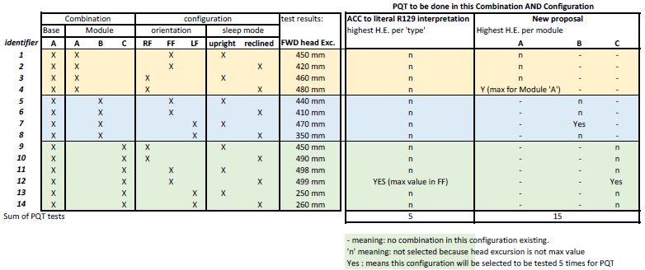

- TSG has the knowledge that the approach to identify the highest head excursion per module and perform a set of PQ tests per module is already used by some Technical Services and accepted by some Manufactures and some Approval Authorities

