Proposal for amendments to UN Regulation No. 46 (Devices for indirect vision)

The text reproduced below was prepared by the expert from the International Organization of Motor Vehicle Manufacturers (OICA) to introduce provisions adapted to centre-steered vehicles of category M₂, M₃, N₂, N₃. The modifications to the current text of the regulation are marked in bold for new and strikethrough for deleted characters.

I. Proposal
Insert a new paragraph 12.7., to read:
“12.7. “Center steer vehicle” means a vehicle that is steered from a central driving position.”
Insert a new paragraph 12.8., to read:
“12.8. “Central driving position” is defined when Y co-ordinate of the “R” point¹ is in Y₀ position within ±60 mm.”
Insert a new paragraph 12.9., to read:
“12.9. “Side steer vehicle” means a vehicle which is not a center steer vehicle.”

Paragraph 15.2.1.1.1., amend to read:
“15.2.1.1.1. The fields of vision prescribed in paragraph 15.2.4. below shall be obtained from the minimum number of mandatory mirrors or camera-monitor devices set out in the following table.
A minimum number of camera-monitor systems is undefined, but they shall provide the same field of vision as given in the table below and the provision on the minimum mounting height does not apply.
In the case of camera-monitor systems, the maximum number of monitors shall not exceed the corresponding number of mirrors.

Vehicle category | Rear-view Class I | Main rear-view Class II | Main rear-view Class III | Wide-angle view Class IV | Close-proximity view Class V | Front-view Class VI
M₁ | Compulsory  Unless the vehicle is fitted with anything other than safety glazing material in the field of vision prescribed in paragraph 15.2.4.1. | Optional | Compulsory  1 on the driver's side and  1 on the passenger's side Class II mirrors may be fitted as an alternative. | Optional  1 on the driver's side  and/or  1 on the passenger's side | Optional  1 on the driver's side  and  1 on the passenger's side  (both shall be fitted at least 2 m above the ground) | Optional  (shall be fitted at least 2 m above the ground)
M₂ | Optional  (no requirements for the field of view) | Compulsory  1 on the driver's side and  1 on the passenger's side | Not permitted | Optional  1 on the driver's side  and/or  1 on the passenger's side | Optional  1 on the driver's side and  1 on the passenger's side  (both shall be fitted at least 2 m above the ground) | Optional  (shall be fitted at least 2 m above the ground)
M₃ | Optional  (no requirements  for the field of view) | Compulsory  1 on the driver's side and  1 on the passenger's side | Not permitted | Optional  1 on the driver's side  and/or  1 on the passenger's side | Optional  1 on the driver's side  and  1 on the passenger's side  (both shall be fitted at least 2 m above the ground) | Optional  (shall be fitted at least 2 m above the ground)
N₁ | Compulsory  Unless the vehicle is fitted with anything other than safety glazing material in the field of vision prescribed in paragraph 15.2.4.1. | Optional | Compulsory  1 on the driver's side and  1 on the passenger's side  Class II mirrors may be fitted as an alternative. | Optional  1 on the driver's side  and/or  1 on the passenger's side | Optional  1 on the driver's side  and  1 on the passenger's side  (both shall be fitted at least 2 m above the ground) | Optional  (shall be fitted at least 2 m above the ground)
N₂  ≤ 7.5 t | Optional  (no requirements for the field of view) | Compulsory  1 on the driver's side  and  1 on the passenger's side | Not permitted | Compulsory  For both sides if a Class V mirror can be fitted  Optional  For both sides together if not  In addition according to paragraphs 15.2.4.5.6. to 15.2.4.5.11. for vehicles with a mounting height of the Class V mirror of not less than 2.4 m (see paragraph 15.2.4.5.12.): the required field of vision (paragraphs 15.2.4.5.6. to 15.2.4.5.9.) may be viewed using a combination of direct view and indirect vision devices (of Classes IV, V, VI). | Compulsory  (see paragraphs 15.2.2.7. and 15.2.4.5.5.)  1 on the passenger's side  For center steer vehicles  (see paragraph 15.2.2.7. and 15.2.4.5.5) on both sides  Optional  1 on the driver's side  (both shall be fitted at least 2 m above the ground).  A tolerance of +10 cm may be applied  In addition according to paragraphs 15.2.4.5.6. to 15.2.4.5.11. for vehicles with a mounting height of the Class V mirror of not less than 2.4 m (see paragraph 15.2.4.5.12.): the required field of vision (paragraphs 15.2.4.5.6. to 15.2.4.5.9.) may be viewed using a combination of direct view and indirect vision devices (of Classes IV, V, VI). | Optional  1 front mirror  (shall be fitted at least 2 m above the ground)  In addition according to paragraphs 15.2.4.5.6. to 15.2.4.5.11. for vehicles with a mounting height of the Class V mirror of not less than 2.4 m (see paragraph 15.2.4.5.12.): the required field of vision (paragraphs 15.2.4.5.6. to 15.2.4.5.9.) may be viewed using a combination of direct view and indirect vision devices (of Classes IV, V, VI).
N₂  > 7.5 t | Optional  (no requirements  for the field of view) | Compulsory  1 on the driver's side and  1 on the passenger's side | Not permitted | Compulsory  1 on the driver's side and  1 on the passenger's side  In addition according to paragraphs 15.2.4.5.6. to 15.2.4.5.11. for vehicles with a mounting height of the Class V mirror of not less than 2.4 m (see paragraph 15.2.4.5.12.): the required field of vision (paragraphs 15.2.4.5.6. to 15.2.4.5.9.) may be viewed using a combination of direct view and indirect vision devices (of Classes IV, V, VI). | Compulsory  (see paragraph 15.2.2.7. and 15.2.4.5.5)  1 on the passenger's side  For center steer vehicles  (see paragraph 15.2.2.7. and 15.2.4.5.5) on both sides  Optional  1 on Driver's side  (both shall be fitted at least 2 m above the ground)  In addition according to paragraphs 15.2.4.5.6. to 15.2.4.5.11. for vehicles with a mounting height of the Class V mirror of not less than 2.4 m (see paragraph 15.2.4.5.12.): the required field of vision (paragraphs 15.2.4.5.6. to 15.2.4.5.9.) may be viewed using a combination of direct view and indirect vision devices (of Classes IV, V, VI). | Compulsory  (see paragraph 15.2.1.1.2  1 front mirror (shall be fitted at least 2 m above the ground)  In addition according to paragraphs 15.2.4.5.6. to 15.2.4.5.11. for vehicles with a mounting height of the Class V mirror of not less than 2.4 m (see paragraph 15.2.4.5.12.): the required field of vision (paragraphs 15.2.4.5.6. to 15.2.4.5.9.) may be viewed using a combination of direct view and indirect vision devices (of Classes IV, V, VI).
N₃ | Optional  (no requirements  for the field of view) | Compulsory  1 on the driver's side and 1 on the passenger's side | Not permitted | Compulsory  1 on the driver's side and  1 on the passenger's side  In addition according to paragraphs 15.2.4.5.6. to 15.2.4.5.11. for vehicles with a mounting height of the Class V mirror of not less than 2.4 m (see paragraph 15.2.4.5.12.): the required field of vision (paragraphs 15.2.4.5.6. to 15.2.4.5.9.) may be viewed using a combination of direct view and indirect vision devices (of Classes IV, V, VI). | Compulsory  (see paragraph 15.2.2.7. and 15.2.4.5.5)  1 on the passenger's side  For center steer vehicles  (see paragraph 15.2.2.7. and 15.2.4.5.5) on both sides  Optional  1 on driver's side  (both shall be fitted at least 2 m above the ground)  In addition according to paragraphs 15.2.4.5.6. to 15.2.4.5.11. for vehicles with a mounting height of the Class V mirror of not less than 2.4 m (see paragraph 15.2.4.5.12.): the required field of vision (paragraphs 15.2.4.5.6. to 15.2.4.5.9.) may be viewed using a combination of direct view and indirect vision devices (of Classes IV, V, VI). | Compulsory  (see paragraph 15.2.1.1.2  1 front mirror  (shall be fitted at least 2 m above the ground)  In addition according to paragraphs 15.2.4.5.6. to 15.2.4.5.11. for vehicles with a mounting height of the Class V mirror of not less than 2.4 m (see paragraph 15.2.4.5.12.): the required field of vision (paragraphs 15.2.4.5.6. to 15.2.4.5.9.) may be viewed using a combination of direct view and indirect vision devices (of Classes IV, V, VI).

Paragraph 15.2.4.6.1., amend to read:
15.2.4.6.1. The field of vision shall be such that the driver can see at least a flat horizontal portion of the road, which is for side steer vehicles bounded by:
(a) A transverse vertical plane through the outermost point of the front of the vehicle;
(b) A transverse vertical plane 2,000 mm in front of the plane defined in (a);
(c) A longitudinal vertical plane parallel to the longitudinal vertical median plane going through the outermost side of the vehicle at the driver's side; and
(d) A longitudinal vertical plane parallel to the longitudinal vertical median plane 2,000 mm outside the outermost side of the vehicle opposite to the driver's side.; and
(e) The the front of this field of vision opposite to the driver's side may be rounded off with a radius of 2,000 mm (see Figure 9 9.1).

The field of vision shall be such that the driver can see at least a flat horizontal portion of the road, which is for center steer vehicles bounded by:
(f) A transverse vertical plane through the outermost point of the front of the vehicle;
(g) A transverse vertical plane 2,000 mm in front of the plane defined in (a);
(h) A longitudinal vertical plane parallel to the longitudinal vertical median plane 2,000 mm outside the outermost side of both sides of the vehicle; and
(i) the front of this field of vision on both sides may be rounded off with a radius of 2,000 mm (see Figure 9.2).

For the defined field of vision, see also paragraph 15.2.4.9.2. below.
The provisions for Class VI front-view devices are compulsory for forward controlled (as defined in paragraph 12.5. of this Regulation) vehicles of categories N₂ > 7.5 t and N₃.
If vehicles of these categories cannot fulfil the requirements by using a front-view device, a vision support system shall be used. In the case of a vision support system this device shall be able to detect an object of 50 cm height and with a diameter of 30 cm within the field defined in Figure 9 9.1 and Figure 9.2..

Figure 9.1., amend to read:

Figure 9

Figure 9.1

Class VI field of vision for side steer vehicle
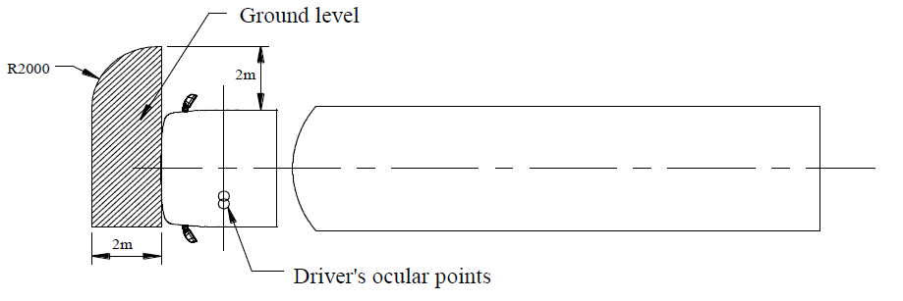

Insert a new figure 9.2, to read:
Figure 9.2

Class VI field of vision for center steer vehicle
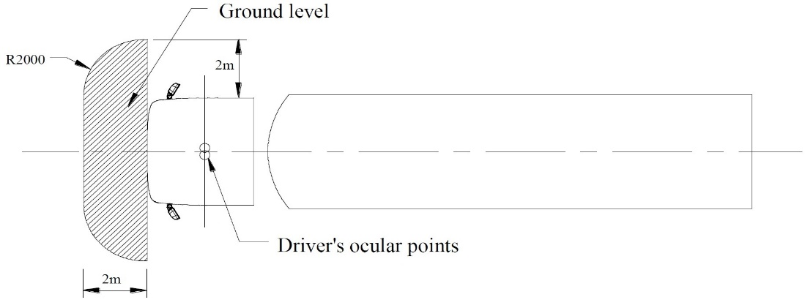

Paragraph 15.2.4.6.2., amend to read:

“15.2.4.6.2. However, if the driver can see, taking into account the obstructions by the A-pillars, a straight line 300 mm in front of the vehicle at a height of 1,200 mm above the road surface and which is situated between a longitudinal vertical plane parallel to the longitudinal vertical median plane going through the outermost side of the vehicle at the driver's side and a longitudinal vertical plane parallel to the longitudinal vertical median plane 900 mm outside the outermost side of the vehicle opposite to the driver's side for side steer vehicles or on both sides for centre steer vehicles, a Class VI device for indirect vision is not mandatory.”

Paragraph 16.1.3.1. (current), amend to read:

“16.1.3.1. Magnification factor
The minimum and the average magnification factors of the CMS, in both
horizontal and vertical directions shall not be lower than the minimum average
magnification factor indicated below.
The minimum magnification factor shall not be less than:
(a) for Class I: 0.31;
(b) for Class II (driver's side): 0.26;
(c) for Class III (driver's side): 0.29;
(d) for Class IV (driver's side): 0.054;
(e) for Class II (passenger's side): 0.13;
(f) for Class III (passenger's side): 0.19;
(g) for Class IV (passenger's side): 0.016.
The average magnification factor shall not be less than:
(h) for Class I: 0.33;
(i) for Class II (driver's side): 0.31;
(j) for Class III (driver's side): 0.31;
(k) for Class IV (driver's side): 0.091;
(l) for Class II (passenger's side): 0.16;
(m) for Class III (passenger's side): 0.20;
(n) for Class IV (passenger's side): 0.046.”

Insert a new paragraph 16.1.3.1.1., to read:

“16.1.3.1.1. Magnification factor for side steer vehicles
The minimum and the average magnification factors of the CMS, in both
horizontal and vertical directions shall not be lower than the minimum average
magnification factor indicated below.
The minimum magnification factor shall not be less than:
(a) for Class I: 0.31;
(b) for Class II (driver's side): 0.26;
(c) for Class III (driver's side): 0.29;
(d) for Class IV (driver's side): 0.054;
(e) for Class II (passenger's side): 0.13;
(f) for Class III (passenger's side): 0.19;
(g) for Class IV (passenger's side): 0.016.
The average magnification factor shall not be less than:
(h) for Class I: 0.33;
(i) for Class II (driver's side): 0.31;
(j) for Class III (driver's side): 0.31;
(k) for Class IV (driver's side): 0.091;
(l) for Class II (passenger's side): 0.16;
(m) for Class III (passenger's side): 0.20;
(n) for Class IV (passenger's side): 0.046.”

Insert a new paragraph 16.1.3.1.2., to read:

“16.1.3.1.2. Magnification factor for center steer vehicles of categories M₂, M₃, N₂, N₃
The minimum and the average magnification factors of the CMS, in both
horizontal and vertical directions shall not be lower than the minimum average
magnification factor indicated below.
The minimum magnification factor shall not be less than:
(a) for Class II (driver center): 0.22;
(b) for Class IV (driver center): 0.043.
The average magnification factor shall not be less than:
(c) for Class II (driver center): 0.23;
(d) for Class IV (driver center): 0.068.”

II. Justification
Paragraphs 12.7 to 12.9.
Creation of a new definition for centre steer vehicles, which is based on UN Regulation No. 43 paragraph 2.38.:
“"Central driving position" is defined when Y co-ordinate of the R point is in Y₀ position within ±60 mm.”
For differentiation in the rest of the text, the proposal inserts as well a new definition for side steer vehicles.
Paragraph 15.2.1.1.1.
Since the driver is sitting on the longitudinal axis of the vehicle, further away from the side window (compared to the driver’s side of a side steer vehicle), the direct vision next to the vehicle is more obstructed. The driver cannot see straight down to the road on either side on center steer vehicles. Therefore, the indirect vision requirement class V is necessary on both sides of the vehicle to provide adequate vision.

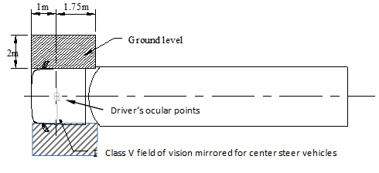

Paragraph 15.2.4.6.1.
Since the driver is sitting the middle of the vehicle, the same fields of view on both sides of the vehicle are needed for usage in left-hand- and right-hand traffic. Therefore, the class VI field of view has been mirrored over the center of the vehicle for center steer vehicles.

Paragraph 15.2.4.6.2.
Since the driver is sitting the middle of the vehicle, the same fields of view on both sides of the vehicle are needed for usage in left hand- and right-hand traffic. Therefore, the direct visibility requirement (straight line) has been mirrored over the center of the vehicle.

Paragraph 16.1.3.1.
This paragraph serves now only as the headline for two new paragraphs.

Paragraph 16.1.3.1.1.
The content of this paragraph was transferred from the former paragraph 16.1.3.1.. “Side steer vehicles” was added to the paragraph title. Since the current wording applies to side steer vehicles only, no change has been made.

Paragraph 16.1.3.1.2.
This paragraph was added for center steer vehicles of categories M₂, M₃, N₂, N₃.
Values for vehicles of category M₁ and N₁ should be considered for evaluation when center steer vehicles of these categories will be established.
UN R46 uses the values calculated by the ISO 16505 (A.3.3) for side steer vehicles, with the exception of two values (minimum magnification factors class II, driver and passenger side) due to feasibly reasons. Chapter B.7 of ISO 16505 indicates that the performance of CMS, for center steer vehicles with a central driving position, should be adapted to the different geometrical properties of such vehicles.

Excerpt from ISO 16505:2019:
“”B.7 Maximum mirror distance for a new vehicle with a different layout than existing vehicle types
In the case of a completely new vehicle with a layout that to a great extent differs from the common layouts of existing vehicles within the markets, the performance of the CMS should be adapted to the different geometrical properties of the new layouts. Examples can be vehicles with a central driving position or vehicles where the driver is positioned particularly high or low above the ground. In order to do this, it should be beneficial to study the different coordinate components of the distance a mirror between driver ocular reference point and mirror centre. These component values in the x, y, and z coordinate directions can then be studied and compared against typical values for vehicles that already exist within the market(s) that the vehicle is intended for.”
The new magnification factors for center steer vehicles are calculated using the ISO 16505:2019 standard formulas described in B.3.2 and based on the following input:
- The driver is located in “cross-car” direction in the center of the vehicle.
- The vehicle has a maximum load width of 2600mm.
- The maximum “head rotation angle” sideways, away from straight forward, is 55°.
- This is a ECE-R46 requirement documented in Chapter 15.2.2.4.
- The Mirror cannot extend more than 250mm outboard from the maximum vehicle width.
- This is a ECE-R46 requirement documented in Chapter 15.2.2.6.
- For simplification it is assumed that the center of the mirror is located at halve the allowed additional width. So the mirror center is calculated at 125mm additional width per side.
- The viewing distances a_{centerdriver} are calculated by trigonometric projection using the rules above.
- The relevant viewing angles β_{centerdriver/min} and β_{centerdriver/max} are calculated by trigonometric projection performed in a simplified horizontal plane where the required FOV provides the front most aim points as described in the ISO 16505:2019 Standard ANNEX B.3.1 Figure B.18
- The results of these projections shown in the Tables below (see Figures 1 and 2), and the minimum allowed curvature radii of r=1200mm for CLASS II and r=300mm for CLASS IV, are the input values used to calculate the Center-Steer magnification factors.
An Excel spreadsheet, that is referenced in the Standard can be accessed online as an calculation aid (see: http://standards.iso.org/iso/16505/).

Figure 1 - Viewing angles and distances for UN/ECE-R46 class II:
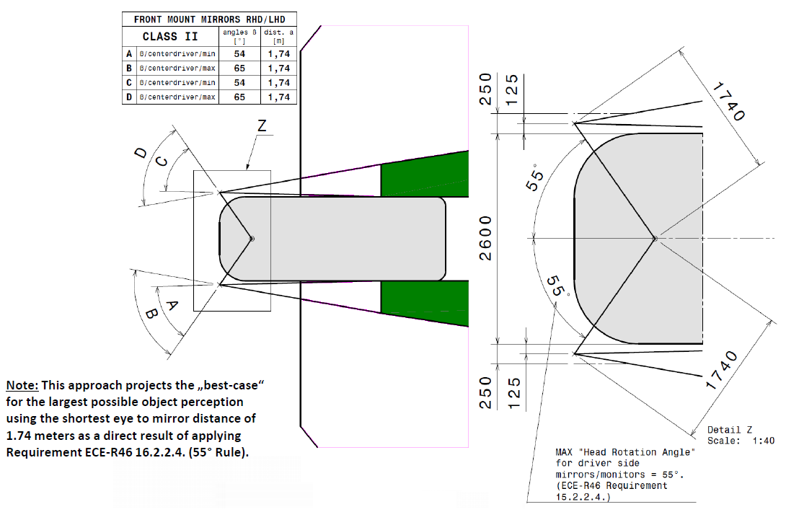

Figure 2 - Viewing angles and distances for UN/ECE-R46 class IV:
