Proposal for Supplements to UN Regulation No. 48
This document is a revised proposal to permit the use of very small logos on signalling lamps. It is based on ECE/TRANS/WP.29/GRE/2020/5/Rev.2 and GRE informal document GRE-85-26 which were submitted to the eighty-fifth session of the Working Party on Lighting and Light-Signalling (GRE). The modifications to are shown in bold.

I. Proposal
A. Proposal for a Supplement to the 06, 07 and 08 series of amendments to UN Regulation No. 48
Amend paragraph 2.1.7. to read:
"2.1.7. “Manufacturer logo” means a graphic mark, emblem, word, or a combination of those elements with an area greater than 5cm², used to aid and promote public identification and recognition of a vehicle manufacturer's brand name.
Amend paragraph 5.5.5. to read:
"5.5.5. In case of lamps incorporating a manufacturer logo, only two lateral logos (one on each side) or one central logo can be fitted on the rear of the vehicle and only two lateral logos (one on each side) or one central logo can be fitted on the front of the vehicle. All logos with an area greater than 5cm² that are not vehicle manufacturer or body manufacturer logos are prohibited."

II. Justification
- Some functions may, already today, contain design parts / text / graphics, that are neither logos/trademarks nor connected to the vehicle manufacturer but fulfill other purposes.

- As the current text of UN-R148 01 series and associated amendments to UN R48 only allow official logos/trademarks such inscriptions or graphics will be forbidden in future. This proposal intends to allow those graphics in a very limited way in addition to the official manufacturer logos.

- The definition of “manufacturer logo” excludes trademarks of lamp or vehicle manufacturers that are present on the apparent surface of lamps for decades without any complaints to traffic safety. The introduction of the requirements on logos as a supplement to existing regulations, means, that component manufacturers are enforced to remove the trademarks/logos from their designs as soon as amendments to their approvals become necessary, or as soon as they apply for approvals to UN Regulation 148 for lamps approved to the previous regulations e.g. UN R7. This introduces costs for the modification of production tools without any benefit to traffic safety.

- The evaluation introduced in GRE-85-16 implies that small structures cannot be identified by the human eye in relevant distances if their size does not exceed 100 cm² and their structures are composed of elements of less than 10 mm size. We believe that an exemption for extremely small trademarks is possible because they cannot be identified as logos and therefore cannot have a negative influence on traffic safety.

- Our approach is to exclude logos of less than 5 cm² from the requirements. This size is so small that the trademarks cannot act as representative signs because even within close vicinity to the vehicle they are not visible.

Here below some examples:
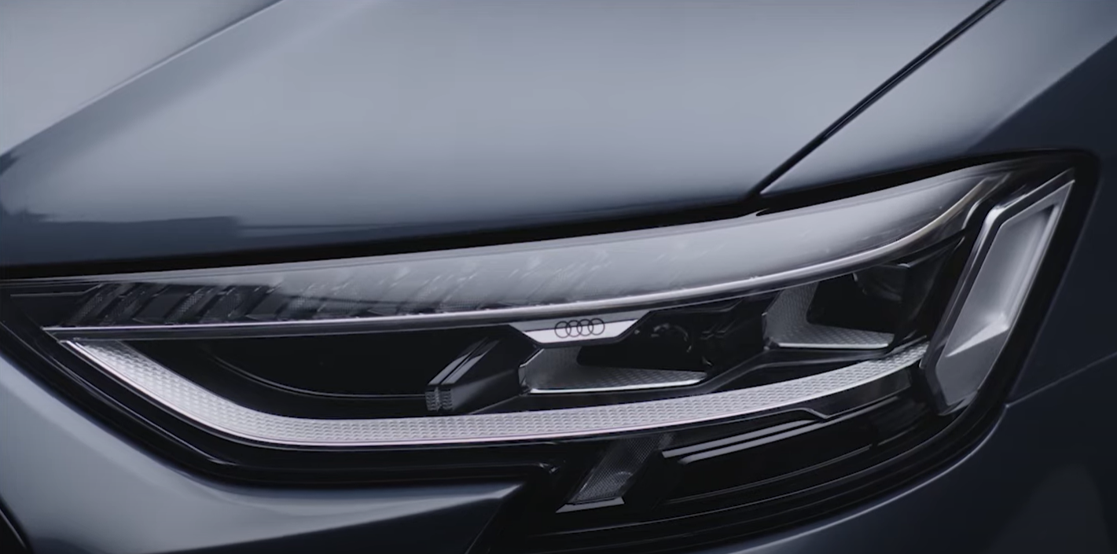
Image from YouTube: https://www.youtube.com/watch?app=desktop&v=6vHo5WWqfwI&feature=youtu.be
Video source: Audi

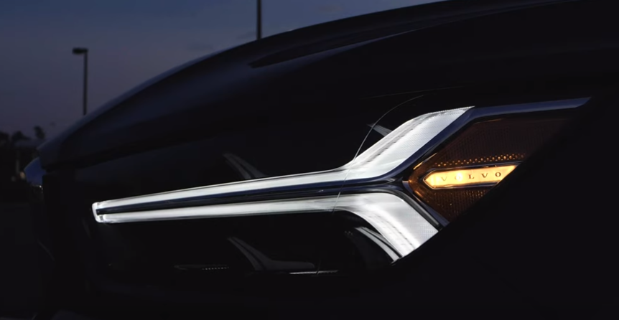
Picture source: Paul Henri-Matha/Volvo Cars

