E/ECE/324/Rev.2/Add.128/Rev.1/Amend.9−E/ECE/TRANS/505/Rev.2/Add.128/Rev.1/Amend.9
19 September 2022
Agreement
Concerning the Adoption of Harmonized Technical United Nations Regulations for Wheeled Vehicles, Equipment and Parts which can be Fitted and/or be Used on Wheeled Vehicles and the Conditions for Reciprocal Recognition of Approvals Granted on the Basis of these United Nations Regulations*
(Revision 3, including the amendments which entered into force on 14 September 2017)
_________
Addendum 128 – UN Regulation No. 129
Revision 1 - Amendment 9
Supplement 8 to the 01 series of amendments – Date of entry into force: 22 June 2022
Uniform provisions concerning the approval of Enhanced Child Restraint Systems used on board of motor vehicles (ECRS)
This document is meant purely as documentation tool. The authentic and legal binding text is: ECE/TRANS/WP.29/2021/120
_________
UNITED NATIONS
Paragraph 7.1.3., amend to read:
"7.1.3. Dynamic Testing for Frontal, Rear and Lateral Impact:
(a) Frontal impact test shall be performed on all Enhanced Child Restraint Systems within the scope of this Regulation.
(b) Lateral impact tests shall be performed on all enhanced child restraint systems within the scope of this Regulation, except for built in Enhanced Child Restraint Systems.
(c) Rear impact tests shall be performed on all rearward and lateral facing Enhanced Child Restraint Systems within the scope of this Regulation.
(d) The frontal and rear impacts shall be performed on the test bench (trolley plus standard seat) or in the vehicle bodyshell, according to paragraph 6.6.4.1. table 4, or in a complete vehicle according to paragraph 7.1.3.3. The lateral impact tests shall be performed on the test bench only, according to paragraph 6.6.4.1. Table 4.
(e) For lateral impacts tests the Enhanced Child Restraint Systems shall be tested in its most upright used position. If this upright position falls outside the Vehicle Seat Fixture, this position shall still be chosen.
For Enhanced Child Restraint Systems that fit into any of the vehicle seat fixtures where the lateral shock absorbers can be adjusted outside the Vehicle Seat Fixture, the width position of the lateral shock absorbers that still fit in the Vehicle Seat Fixture shall be chosen;
For Enhanced Child Restraint Systems that do not fit into any of the vehicle seat fixtures, a lateral test shall be performed for each listed vehicle.
For each test, the initial position of the side impact door panel relative to the bench shall be adjusted according to the minimum distance between the vehicle's door panel and the centre of the seating position as shown in Figure 3.
Figure 3
Minimum distance for lateral impact
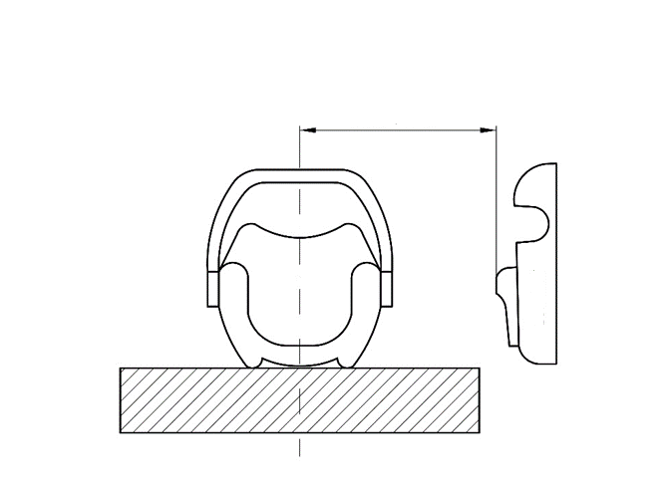
Door Panel
Minimum distance
(f) For frontal and rear impacts, the tests shall be performed with the Enhanced Child Restraint System adjusted to the size of the dummy(ies) selected to cover the entire size range, in the child seating position representing the most upright position and the most reclined position for each dummy and impact orientation.
If not yet covered by the previous configurations, the Technical Service may test the Enhanced Child Restraint Systems in a position defined by the Technical Service that it fits in the Vehicle Seat Fixture.
(g) For frontal, rear and lateral tests an anti rebound device acting on the vehicle seatback shall stay inside the seat fixture in one position, but may protrude beyond the Vehicle Seat Fixture in its adjusted position according to the user manual."
Paragraph 7.2.8., amend to read:
"7.2.8. The complete seat, or the component fitted with ISOFIX attachments (e.g. ISOFIX base) if it has a release button, is attached rigidly to a test rig in such a way that ISOFIX connectors are vertically aligned as shown in Figure 4. A 6 mm diameter bar, 350 mm long, shall be attached to the ISOFIX connectors. A mass of 5 kg shall be attached to the extremities of the bar."
Paragraph 7.2.8.5., Figure 3 (former), renumber as Figure 4.

* Former titles of the Agreement: Agreement concerning the Adoption of Uniform Conditions of Approval and Reciprocal Recognition of Approval for Motor Vehicle Equipment and Parts, done at Geneva on 20 March 1958 (original version); Agreement concerning the Adoption of Uniform Technical Prescriptions for Wheeled Vehicles, Equipment and Parts which can be Fitted and/or be Used on Wheeled Vehicles and the Conditions for Reciprocal Recognition of Approvals Granted on the Basis of these Prescriptions, done at Geneva on 5 October 1995 (Revision 2).

