Economic Commission for Europe
Inland Transport Committee
Working Party on the Transport of Dangerous Goods
Joint Meeting of the RID Committee of Experts and the
Working Party on the Transport of Dangerous Goods 9 September 2022
Geneva, 12-16 September 2022
Item 7 of the provisional agenda
Reports of informal working groups
Minutes from the fifth meeting of the Informal Working Group on the Transport of Hazardous Waste
(held on Wednesday, 15 June 2022, 10h00-16h00 and on Thursday, 16 June 2022, 9h15-12h00 as a hybrid meeting in The Hague and hosted online via Webex)
Transmitted by European Federation of Waste Management and Environmental Services (FEAD)
Participants
Name | Country/Organisation | Participation
François Pondant | Belgium | In person
Claude Pfauvadel | France | In person
Jean-Michel Piquion | France | In person
Gudula Schwan | Germany | In person
John Bethke | Germany | In person
Soedesh Mahesh | The Netherlands | In person
Hennie C. van der Stokker | The Netherlands | In person
Maurits van den Adel | The Netherlands | In person on the 15th
Majken Strange | Denmark | Remote
David Boland | Ireland | Remote
Iliass Zerktouni | Luxembourg | Remote
Silvia García Wolfrum | Spain | Remote on the 15th
Camilla Oscarsson | Sweden | Remote on the 15th
Malin Jonsson | Sweden | Remote
Wonett Hall | UK | Remote
Dario Pinna | Cefic | In person
Rikarnto Bountis | EuRiC | Remote
Jan Goedhart | FEAD | In person
Roland Schüler | FEAD | In person
Willy Van Praet | FEAD | In person
Baudouin Ska | FEAD | In person
Damian Rambault | FEAD | In person
Aizea Astor Hoschen | FEAD | In person
Aline Fussien | FEAD | Remote*
Olivier Deweerdt | FEAD | Remote
Frederik Van Braekel | FEAD | Remote on the 16th
* Not present due to connection issues.

1. Introduction of the first session (15 June 2022)
A short welcome and tour de table by FEAD (Baudouin Ska) was followed by the presentation of the proposed agenda. On the agenda item on asbestos, Claude Pfauvadel (FR) updated the Informal Working Group (IWG) on the current situation. Wonett Hall (UK) proposes to organise a dedicated meeting on this issue as it is complex and important. This proposal will be taken into consideration on the second day when the point asbestos will be handled.
Two issues were raised during the AOB: the alleged toxicity of cigarette butts according to recent analysis carried out in France, and monkeypox virus medical waste falling under category A.
- Cigarette butts’ toxicity (raised by France (Claude Pfauvadel)). Recent analysis carried out in France have shown cigarette butts to be toxic by contact, meaning that packaging classification under UN2811, class 6.1, packing group III rules would have to be applied. As such toxic properties only resulted from 1 out of 3 samples taken, Mr Pfauvadel suggested the need of more extended sampling and pointed out that such classification under ADR would be a huge burden. Otherwise, a derogation would need to be applied in case classification under UN2811 is confirmed by an extended sampling.
- Monkeypox virus medical waste falling under category A (raised by FEAD (Willy Van Praet) and Germany (Gudula Schwan)). Mr Van Praet introduced the issue by describing the current medical situation in Belgium, where there are currently only 17 patients, who are treated at home, being it thus not feasible to collect their waste as category A. Due category A collection of the waste would only be possible for patients treated in hospitals. Ms Schwan had already worked on a proposal to handle monkeypox virus waste from patients as category B and limit category A for cultures as done for other viruses.
The introduction and discussion of the AOB was followed by a historical overview of the IWG and a summary of the fourth Informal Working Group meeting held online on 19 November 2020.
2. Issue 5.2: presence of hazardous household waste in the (selective) collection of non-hazardous waste (e.g. empty packaging)
The issue was introduced by Chair Baudouin Ska (FEAD) and illustrated with pictures of aerosol containers used in households with CLP pictograms (e.g. flammable/corrosive, with equivalence in ADR), which are disposed of in the household waste selective collection system with other (non-dangerous) empty packaging. The separate collection of such waste in the plastic/aluminium/packaging households waste collection cannot be controlled, meaning that the transport to the first sorting plant is theoretically ADR incompliant (1.1.3.6 requires e.g. corresponding transport documents). Fire incidents occurred in Belgium in this context with waste transported in pressed trucks. The issue has also a financial perspective considering the different treatment and financial burden between hazardous/non-hazardous waste. The sorting facilities receiving the empty packaging are also only licensed for the treatment and storage of non-hazardous waste.
This practice at national level was corroborated by the participants, although some national representatives (United Kingdom, France) pointed out that they didn’t see a practical issue because this is not checked in any controls. Derogations from ADR exist in The Netherlands (the derogation does not apply to certain aspects, such as the training of the drivers), and Denmark (exemption covers collection of hazardous household waste with red boxes). France suggested to extend the exemption of 1.1.3.1a. Germany proposed a similar approach as to batteries (from collection to first sorting plant) although there is a major difference due to the specific system already in place for batteries, which does not exist for aerosol containers. Also, the treatment facilities for waste batteries are licensed for the treatment and storage of hazardous waste.
The IWG agreed that FEAD should make a proposal to fit the current situation in the ADR with due consideration to the scope which should be sufficiently and properly limited to household waste when hazardous waste (empty packaging) could be mixed with other waste, to avoid a loophole e.g. for chemical waste, or separately collected hazardous household waste.
3. Issue 2.2 on “transport of packaged waste, inner packaging packed together” and issue 2.5 on “chemical compatibility for single plastic packaging”
The issue was introduced by Chair Baudouin Ska (FEAD) and illustrated with pictures of the reality for the waste management sector as well a decision tree prepared by FEAD, which visualizes how the ADR compliant possibilities are “blocked” in the different situations:
- for single packaging, in the case of plastic packaging, rules for chemical compatibility (under 4.1.1.21 of ADR) are not feasible for waste. As the mixture is not always known and often varies from day to day, rules for collective entries have to be applied, which lead to “further testing required”, which means e.g. “storage at ambient temperature for 6 months”. Considering that the waste can have a different composition each time, it is impossible to test the chemical compatibility at that frequency.
- for mixed packaging, combined packaging must be tested in the same configuration (inner packaging - outer packaging) as the one used during the transport. For waste, this configuration can change in each transport as inner packaging can be different in size, shape, and material.
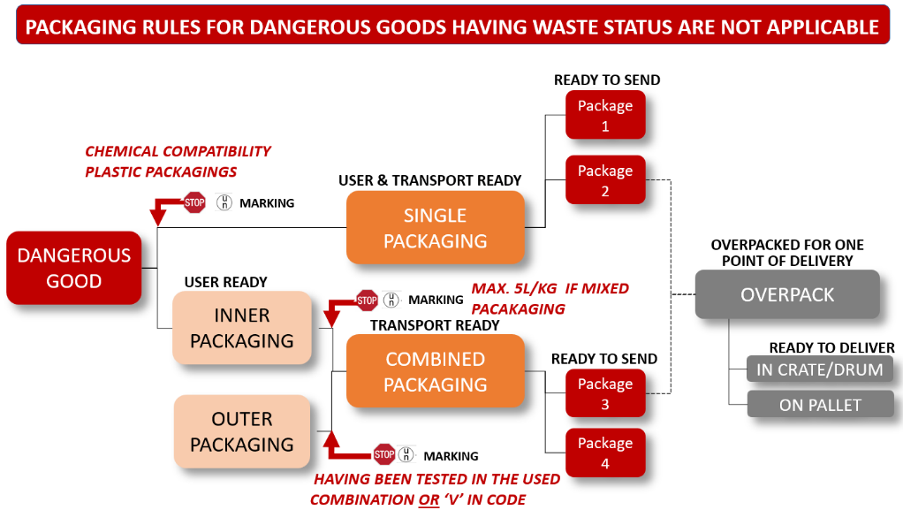
FEAD prepared and shared an overview and comparative table with national derogations, which were used as basis for a proposal of a common solution to be introduced in the ADR.
Contrary to FEAD’s view, France considered the need to differentiate between municipal waste and industrial and commercial waste as well mobile and not mobile collection within the municipal waste. The issue should be approached from “easy” to “difficult”, easy meaning household waste and small businesses not producing dangerous goods as main activity, and where an extensive derogation could apply, and difficult meaning large companies, such as chemical companies, with the corresponding knowledge and expertise. The grey zone in between both categories would also need to be tackled appropriately.
The IWG agreed on a due separation of both issues, i.e. single and combined packaging. FEAD’s approach on single packaging was accepted by the group, who agreed on having a concrete proposal to be submitted by FEAD the following day.
On combined packaging, FEAD presented its proposed common solution based on the existing national derogations. The following points were discussed in the group:
- Responsibility should not require a specific (approved) certification. It could be considered that the expert holds specific training under 1.3 on classification of waste. Responsibilities should be as per 1.4.
- Scope to be added and limited as per ADR 2.1.3.5.3.
- Absorbent material should be added.
- No deviation of ADR rules in relation to age of the outer packaging.
- Applicability (household waste/industrial and commercial waste): after a tour de table of the national derogations it was agreed that there should be no specification in FEAD’s proposal, leaving it up to the national authorities.
- Classification as per ADR.
- Systematic approach (place in the ADR). Considering that the Joint Meeting has not accepted a dedicated chapter on waste so far, it should be integrated according to the current systematic of the ADR (under the rules on combined packaging and/or chemical compatibility as applicable).
- Marking and labelling. N.O.S. should only apply where it is truly not possible to classify according to the ADR (see 2.1.3.5.5).
- Other ADR provisions remain applicable, e.g.
  - Same chemical characteristics to pack in the same outer packaging
  - No opening of packaging during transport.
The IWG agreed on the approach taken by FEAD, and a more concrete and updated proposal presented to the IWG the following day.
4. AOB: monkeypox virus
According to the introduction made earlier, Germany shared with the group the draft multilateral agreement to treat monkeypox virus waste from patients as category B and restrict category A for cultures.
Germany will also submit a proposal to the UN SCTDG in June to update the UN Model Regulations accordingly and proposes the multilateral agreement with immediate application to cover the period until 2025. The draft multilateral agreement was presented to the IWG and the draft proposal for the SCTDG will be shared with the IWG by FEAD Secretariat for information and feedback.
FEAD fully supported Germany whereas other national representatives raised concerns in relation to the future evolution of the virus and will follow the recommendations from their competent national health authorities.
5. Introduction of the second session (16 June 2022)
The second session of the meeting was introduced by the Chair – Baudouin Ska (FEAD) with a summary of the discussion and decisions taken the day before. Concerns were raised by Denmark with regards to the proposal to be made by FEAD on issue 5.2, the presence of hazardous household waste in the (selective) collection of non-hazardous waste (e.g. empty packaging), as it should not interfere with their current national system and derogation. FEAD (Baudouin Ska) clarified again that such a proposal will be done with sufficient scope limitations so as not to cover these and other situations as discussed the day before.
6. Transport of fixed asbestos and manufactured articles containing asbestos // Working document 57: transport of asbestos in bulk (France)
The issue was introduced by Chair Baudouin Ska (FEAD) with an overview of the current situation and a historical overview of Special Provision 168, with concrete questions on its interpretation.
France (Claude Pfauvadel) presented the current situation with regards to the French proposal, pointing out some difficulties to continue their work due to the lack of concrete feedback from the Joint Meeting as to why such proposal does not fit the different national situations. Therefore, France suggests that the proposal is submitted to the Joint Meeting by FEAD in name of the IWG after some fine-tuning of the document by France and further discussion within the IWG during the dedicated meeting proposed the day before.
After the discussion, the IWG agreed that there are divergencies in the interpretation of SP 168, especially linked to the fact that it was not originally meant for waste. The IWG also agreed to follow the French approach with a new proposal to fit asbestos waste transports in the ADR instead of waiting for the UN Subcommittee to clarify SP 168, and potentially consider a broad and flexible interpretation of the current SP to cover waste asbestos issues (unlikely as agreed by the IWG).
- Interpretative divergencies were intensively discussed:
  - France has a strict interpretation of the wording of SP 168 according to which broken items can no longer be considered as manufactured articles. In addition, once an item that is made from, or contains, asbestos is broken it always generates free respirable fibres, i.e., it is not possible to ensure a zero risk and consequently impossible to comply with any of the two options contained in SP 168 to waste.
  - The Netherlands has a more flexible interpretation of SP 168 which also covers waste and under which bulk transport is possible provided that no hazardous quantities of respirable asbestos fibres escape. To ensure this, national provisions require bags with double liners.
  - Germany concludes that there are different national interpretations but recognises the problem for international carriages and sees the issue in relation to the fact that SP 168 is not made to cover waste.
  - UK considered the need to address quantification, especially of what is considered a hazardous quantity.
  - Denmark pointed out that they also have a flexible interpretation of SP 168 because they strictly comply with the applicable occupational health and safety regulations, which should also be considered in the drafting of the French proposal.
- The UN Subcommittee (rather than the Joint Meeting) was considered by the IWG to be the competent body to clarify SP 168. However, in view of the diverging positions of some UN-members, it was considered quite impossible to reach an agreement to modify/clarify SP 168 at that level.
- France proposes to introduce the transport of asbestos waste in the ADR (i.e., declared transport with transport documents) rather than extending/clarifying Special Provision 168. Limitations contained in the French proposal are linked to the nature of the operation. As these are not completely objective parameters, the circumstances of the case together with the unloading procedure should be further discussed and clarified within the IWG once the draft proposal is fine-tuned.
- France will fine-tune the draft proposal, which should be finalised by December to be submitted to the JM in the March 2023 session. The IWG will have a dedicated meeting to discuss the proposal in November.
7. Finalising of decision taking
Based on the discussions of the previous day, FEAD presented its proposals on issue 2.2, “transport of packaged waste, inner packaging packed together” and issue 2.5, “chemical compatibility for single plastic packaging”. After discussion in the IWG, the proposals are as follows:
- FEAD proposal on issue 2.5: chemical compatibility for single plastic packaging
Under 4.1.1.22 add the following paragraph:
“In the case of liquid waste classified under 2.1.3.5.5 the use of plastic packaging tested with all the five standard liquids is allowed. The packaging shall follow the testing procedure for packing group I (X-code)”
  - List of liquids to be included
- FEAD proposal on issue 2.2: combined packaging
Under 4.1.1.5.3
In the case of waste classified under 2.1.3.5.5, mixed inner packaging in one outer packaging shall comply with the following provisions:
  - An outer packaging tested for solids is also allowed to be used for combined packaging (reference to 6.1.3.1d)
  - The outer packaging shall be tested for packaging group I
  - In derogation from 4.1.1.5.1 inner packaging of different sizes, shapes and materials are allowed provided that the outer packaging can be properly closed
  - Sufficient cushioning and absorbent material are used to take up void spaces and leakages, and to prevent significant movement of the inner packaging’s
  - In case of plastic outer packaging, the type of construction material (plastic) used for the packaging tested for solids must be the same as the one used for packaging tested for liquids and chemically compatible with all the five standard liquids
  - 4.1.10.4 is not applicable
FEAD will fine-tune the proposal and prepare two INF documents to be submitted to the Joint Meeting in the September session. Official proposals will follow according to the feedback of the JM. The INF documents will be previously submitted to the IWG for feedback.
8. Conclusions and next meeting
- FEAD will make a proposal to fit issue 5.2 (presence of hazardous household waste in the (selective) collection of non-hazardous waste (e.g. empty packaging)) in the ADR with due consideration to the scope, which should be sufficiently limited to avoid a loophole (e.g., for chemical waste, or separately collected hazardous household waste).
- FEAD will fine-tune the proposal on issue 2.5 (chemical compatibility for single plastic packaging) and issue 2.2 (combined packaging) and prepare two INF documents to be submitted to the IWG for feedback. The INF documents will be submitted to the Joint Meeting in the September session. Official proposals will follow according to the feedback of the JM.
- Germany will submit a proposal to the UN SCTDG to classify monkeypox waste from patients as category B (instead of A) in the UN Model Regulations and propose a multilateral agreement with immediate application to cover the period until 2025. The draft proposal for the SCTDG will be shared with the IWG by the FEAD Secretariat for information and feedback.
- France will fine-tune the draft proposal on the transport of asbestos in bulk, which should be finalised by December to be submitted to the JM in the March 2023 session. The IWG will have a dedicated meeting to discuss the French proposal in November, possibly the 16th or 17th in the afternoon (2 p.m. to 5 p.m.). FEAD Secretariat will circulate a doodle to set the date.
FEAD thanks the Dutch administration for the perfect hosting of the meeting and the participants (present and online) for their involvement and contribution.
__________________

After the meeting Multilateral Agreement M347 was signed solving the issue.

