|  |  |  |  |
| --- | --- | --- | --- |
|  | United Nations | ECE/TRANS/WP.29/GRSG/2022/30 | |
| _unlogo | **Economic and Social Council** | | Distr.: General  22 July 2022  Original: English |

**Economic Commission for Europe**

Inland Transport Committee

**World Forum for Harmonization of Vehicle Regulations**

**Working Party on General Safety Provisions**

**124th session**

Geneva, 11–14 October 2022

Item 4 (d) of the provisional agenda  
**Awareness of the Proximity of Vulnerable Road Users:**

**UN Regulation No. XXX (Vulnerable Road Users Direct Vision)**

Proposal for an Amendment to the New UN Regulation No. [XXX] (Vulnerable Road Users Direct Vision)

Submitted by the expert from the Informal Working Group on Awareness of Vulnerable Road Users Proximity [[1]](#footnote-2)\*

The text was reproduced below was prepared by the experts from the VRU-Proxi Informal Working Group (VRU-Proxi) to amend the new UN Regulation No. [XXX] for Direct Vision of Heavy Vehicles as adopted at the 123rd session of the Working Party on General Safety Provisions (GRSG)(see ECE/TRANS/WP.29/GRSG/102, paragraph 28). The modifications to the adopted text (ECE/TRANS/WP.29/GRSG/2022/7 as amended by annex VII of ECE/TRANS/WP.29/GRSG/102) are marked in bold for new or strikethrough for deleted characters.

I. Proposal

*Paragraph 2.2.*, amend to read:

"2.2. "Vehicle type with regard to its Direct Vision" means vehicles which do not differ in such essential respects as:

(a) The manufacturer's trade name or mark;

(b) The dimensions and shapes of the components of the vehicle structure situated in front of a vertical plane positioned 1000mm behind the driver’s eye point (E2) and perpendicular to the longitudinal plane of the vehicle;

(c) The distance in the X axis between the ~~centre of the front axle of the vehicle~~ **Accelerator Heel Point** and the foremost point of the vehicle;

(d) The number, size, shape or location of transparent areas of the vehicle situated in front of a vertical plane positioned 1,000 mm behind the driver’s eye point (E2) and perpendicular to the longitudinal plane of the vehicle;

(e) The direct vision level, as defined by the table in Annex 5, that the vehicle will fall into."

II. Justification

The testing procedure has been seen to be independent of the distance between the front axle and the foremost point of the vehicle. The reference point is the Accelerator Heel Point. Further explanations are given in figures 1 to 3 below.

Figure 1

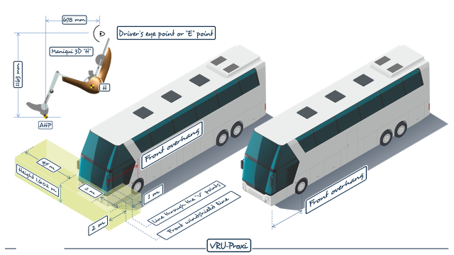

Figure 2

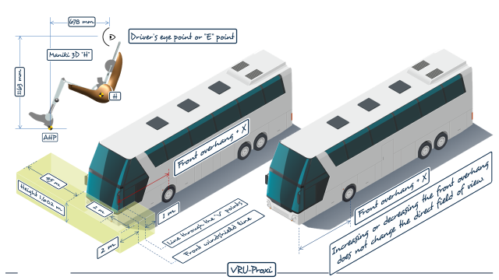

Figure 3

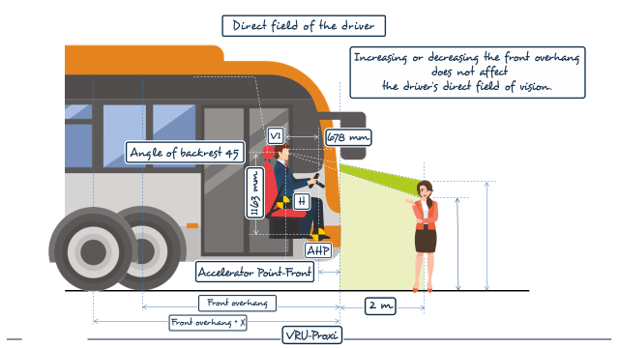

\_\_\_\_\_\_\_\_\_\_\_\_\_\_\_\_

1. \* In accordance with the programme of work of the Inland Transport Committee for 2022 as outlined in the proposed programme budget for 2022 (A/76/6, part V, sect. 20, para. 20.76), the World Forum will develop, harmonize and update UN Regulations in order to enhance the performance of vehicles. The present document is submitted in conformity with that mandate. [↑](#footnote-ref-2)