UN/SCETDG/60/INF.42

Committee of Experts on the Transport of Dangerous Goods
and on the Globally Harmonized System of Classification
and Labelling of Chemicals 30 June 2022
Sub-Committee of Experts on the Transport of Dangerous Goods
Sixtieth session
Geneva, 27 June-6 July 2022
Item 14 of the provisional agenda
Other business
Validation of Test Series 8: Applicability of Test Series 8 (d)
Submitted by the Responsible Packaging Management Association of Southern Africa (RPMASA)
Introduction
1. At the fifty-seventh, fifty-eighth and the sixtieth session of the Sub-Committee of Experts on the Transport of Dangerous Goods, the Institute of Makers of Explosives (IME) have submitted various papers (UN/SCETDG/58/INF.8, UN/SCETDG/57/INF.13, and ST/SG/AC.10/C.3/2022/18) regarding the suitability of the 8(d) Vented Pipe test for use with ANEs. These papers proposed ammonium nitrate emulsions (ANEs) that satisfy the acceptance criteria of the 8(e) CanmetCERL Minimum Burning Pressure test, should not be subjected to the 8(d) Vented Pipe test.
2. The current situation is that if ANEs are to be transported in bulk in portable tanks, they must also be subjected to the 8(d) test to determine suitability for containment in portable tanks as an oxidizing substance. This paper provides additional experimental data to support the continued use of the 8(d) test to predict the bulk behaviour of ANEs when subjected to a large fire under confined, vented conditions.
3. All figures referred to in this document may be found in the annex hereto.
Background
4. The inclusion of the use of the 8(e) CanmetCERL Minimum Burning Pressure test for ANEs that give false positives during the 8(c) test has been accepted into the Manual of Test and Criteria, provided that the reaction time in test 8(c) is longer than 60 s and the water content of the ANE in question is greater than 14%.
5. In paper ST/SG/AC.10/C.3/2022/18, IME has proposed that the 8(e) also be used as a replacement for the 8(d) test for ANEs. This is based on the results obtained from the numerical modelling, which was used to determine the behaviour of ANEs, under the following conditions:
- Transient heat flux of 24 kW/m²
- Ullage of 90% and 10%
The modelling was performed using a set volume and specific energy input. ANE kinetics and AN crust formation were input parameters. It was concluded that Ullage had little effect on the heat transfer penetration. This is mainly ascribed to the thermal diffusivity that is small and the high viscosity of the ANE inhibiting convection within the ANE. The simulation also showed minimal temperature change in the emulsion. Modelled results also indicate similar reaction behaviour of ANEs irrespective of Aluminium or Stainless steel as tanker material. In the paper, it is stated that this behaviour is because tankers are not pressure vessels and will rupture at pressures well below the MBP of the ANE. The conclusion was that there is a very low probability of ignition as the fire would die out once the fuel has been consumed.
6. Originally, it was believed that small scale test results, such as those generated by an Accelerating Rate Calorimeter (ARC), 8(c) and 8(e), could be used to predict the outcome of large scale tests, such as the 8(d). However, results from all of these tests showed that this was not the case and that the nature of the event of a large scale test cannot be predicted using small scale testing. As such, additional large scale testing work was undertaken to better understand the thermal behaviour of ANEs under extreme thermal conditions.
Discussion
7. ANEs have been transported in bulk since the 1980s. There have been several fires during transport and to date none of these fires have led to an explosion involving the ANE. The properties of the ANE, especially emulsions – high water content, low thermal diffusivity, as well as appropriate tank design are contributing factors to the failure of the ANEs to explode under these circumstances.
8. Various small scale tests have been developed to understand the thermal behaviour of emulsions when exposed to high temperatures. For this study, the focus was placed on the 8(c), 8(e) and accelerating rate calorimetry (ARC). At this stage, there is little understanding as to whether the results of small scale tests correlate with the effects of large scale applications.
9. A suitable large scale test method for quantities greater than 60 kg is currently not available for testing ANEs. It was decided to apply the NATO standard Fast Heating Munition test procedures AOP-4240 in order to assess the reaction of the ANEs to heat fluxes that take place when the ANE is subjected to a large liquid hydrocarbon fuel pool fire. This test method is used to test insensitive munitions and thus the standard test method was modified to accommodate the use of ANEs. This is known as the fast cook-off test. A 2, 5 and 10 m steel pipe (270mm in diameter and pipe wall thickness of 5mm) was positioned on a table with a steel grid. The pipe was filled with the ANE sample. The steel trough was filled with 4200 litres of paraffin up to a level of 300mm below the base of the pipe. Thermocouples were placed at various levels inside the pipe. See annex for test setup diagram. The samples tested are present in Table 1.
Table 1: Composition of ANE Samples
Sample | Oxidiser Composition | Fuel Phase
ANE 1 | Dual salt | Recycled oil + Paraffinic oil + Surfactant
ANE 2 | Single salt | Paraffinic oil + Surfactant
ANE 3 | Multiple salt | Paraffinic oil + Surfactant
ANE 4 | Single salt | Recycled oil + Paraffinic oil + Surfactant

Table 2: Summary of ANE test results compared to Fast cook-off test
Sample | 8(c) | 8(e) (MPa) | ARC Onset temperature (°C) | Fast cook-off
 |  |  |  | Configuration
 |  |  |  | 2m (± 150 kg ANE) | 5m (± 380 kg ANE) | 10m (± 760 kg ANE)
ANE 1 | - | - (>7 ) | 195 | Vented | Detonation* | Not tested
ANE 2 | - | - (>7 ) | 200 | Vented | Vented | Vented*
ANE 3 | - | - (>7 ) | 240 | Vented | Vented | Not tested
ANE 4 | - | - (>7 ) | 200 | Not tested | Detonation | Not tested
* These tests were repeated 3 times to confirm repeatability of the test
10. All of the ANE samples gave a negative result for both the 8(c) and the 8(e) tests. ARC tests were conducted on the samples. The 1g sample was introduced into the sample container (or 'bomb'), which was then mounted in the calorimeter and the temperature and pressure sensors were attached. Experiments were started at ambient air pressure, and the standard ARC procedure of “heat-wait-search” was used. During this procedure, the temperature of the vessel was raised from an initial temperature of 80 °C in increments (heat period) of 5 °C. The vessel was maintained adiabatic during both the wait period (which enables the thermal transients to dissipate) and the search period. During the search period, the ARC system searches for exothermic behaviour in the vessel. The system records an exotherm whenever the self-heating rate of the sample exceeds a chosen threshold value of 0.02 °C/min. The temperature at which the self-heating rate first exceeded 0.02 °C/min was recorded as the onset temperature. The initial temperature for each “heat-wait-search” experiment was 80 °C, and the final temperature was 350 °C.
11. The onset temperatures, where the emulsion starts to react exothermically, were found to be well below the 331 °C reported by Oxley, et. al. (1989). In this study, these temperatures were found to be around 200 °C. The onset temperature in this study did not appear to be affected by the formulation of the sample and could not be used to predict the large scale behaviour of the ANE in the fast cook-off test. None of the small scale test results correlate to the nature of the event seen in the large scale fast cook-off test.
12. The large scale fast cook-off test has demonstrated that the type of event is affected by both the oxidiser and the fuel phase composition. The inclusion of recycled oil in the fuel phase always resulted in a detonation reaction in a 5 m pipe. Both single salt as well as multiple salt formulations were able to vent in a 5 m pipe.
13. In paper ST/SG/AC.10/C.3/2022/18, it was noted that the low thermal diffusivity, as well as the highly viscous nature of ANE’s, inhibits convection in the emulsion phase. In the large scale tests three temperature thermocouples were placed within the emulsion column, at the bottom, middle and top of the pipe. From the thermal data given in Figure 6 - Figure 9, it is evident that in a relatively short period of time (7-10 minutes from when the first temperature thermocouple starts to show an increase in temperature) that all of the temperature thermocouples display similar temperature readings. With the low thermal conductivity of ANEs, this is only possible if there is significant convection of the ANE within the pipe.
14. No correlation between any of the small scale tests and the nature of the event seen during the vented pipe test could be found, as given in Table 3.
Table 3: Summary of small scale ANE test results compared to 8(d)
Sample | 8(c) | 8(e) (MPa) | ARC Onset temperature (°C) | Vented pipe test 8(d)
ANE 1 | - | - (>7 ) | 195 | +
ANE 2 | - | - (>7 ) | 200 | -
ANE 3 | - | - (>7 ) | 240 | -
ANE 4 | - | - (>7 ) | 200 | Not tested
15. When comparing the nature of the event seen in the fast cook-off tests there seems to be a correlation to the nature of the event seen in the 8(d) test, as presented in Table 4. It was decided to monitor the internal temperature of the ANE during the most recent 8(d) tests. The data in Figure 10 shows a similar convection behaviour of the ANE to that of the fast cook-off test.
Table 4: Comparison of Large Scale ANE test results
Sample | Fast cook-off |  |  | Vented pipe test 8(d)
 | Configuration
 | 2m | 5m | 10m
ANE 1 | Vented | Detonation | Not tested | +
ANE 2 | Vented | Vented | Vented* | -*
ANE 3 | Vented | Vented | Not tested | -
ANE 4 | Not tested | Detonation | Not tested | Not tested
* These tests were repeated 3 times to confirm repeatability of the test
16. These thermocouples were inserted ± 5 cm from the bottom of the pot and the second thermocouple was inserted half way up the pot. From Figure 10, a similar temperature profile can be seen where the ANE’s temperature increases over time. The bottom temperature thermocouple records a higher initial temperature. After ± 7 minutes, both thermocouples reach a similar temperature as the test continues.
17. During the simulation conducted in ST/SG/AC.10/C.3/2022/18, only the heat exposure of ANE over a fairly small surface area was considered. The paper suggests that there is a very low probability of ignition as the emulsion should not reach the required temperatures. In the tanker incident provided in the paper, it was noted that the tanker would rupture, resulting an open system. During the 8(d) test and the fast cook-off test, the heat distribution is over a large surface area hence exposing the ANE to a greater amount of heat energy. During both the 8(d) and the fast cook-off tests, it was noted that ANE temperature increases rapidly to a point where the ANE will undergo either rapid venting of the entire contents, deflagration, or detonation.
18. The test methodologies that were used in paper ST/SG/AC.10/C.3/2022/18 and this paper do not correlate. The simulation was performed under very specific conditions and these conditions can change in terms of tanker design, in input energy (rate and magnitude), and environmental conditions. ANE behaviour can thus not be generalised as being consistent when subjected to stimuli outside of the parameters used in the model.
Proposal
19. At this stage, the proposal is for the continued use of the 8(d) test. Based on the argument presented herein, it is proposed that the 8(d) test remains in use, as this test shows the characteristic of ANE when subjected to extreme thermal conditions. Knowing the characteristic behaviour of ANE in undefined conditions will be advantageous in identifying plausible consequences as a result of unforeseen thermal events during transportation.
20. Further to the above, it is proposed that additional work be scheduled for ANE samples to be tested, using both the fast cook-off test and the 8(d), in order to further verify the correlation between the two tests.

Annex
Fast Cook-off Test Setup Diagram

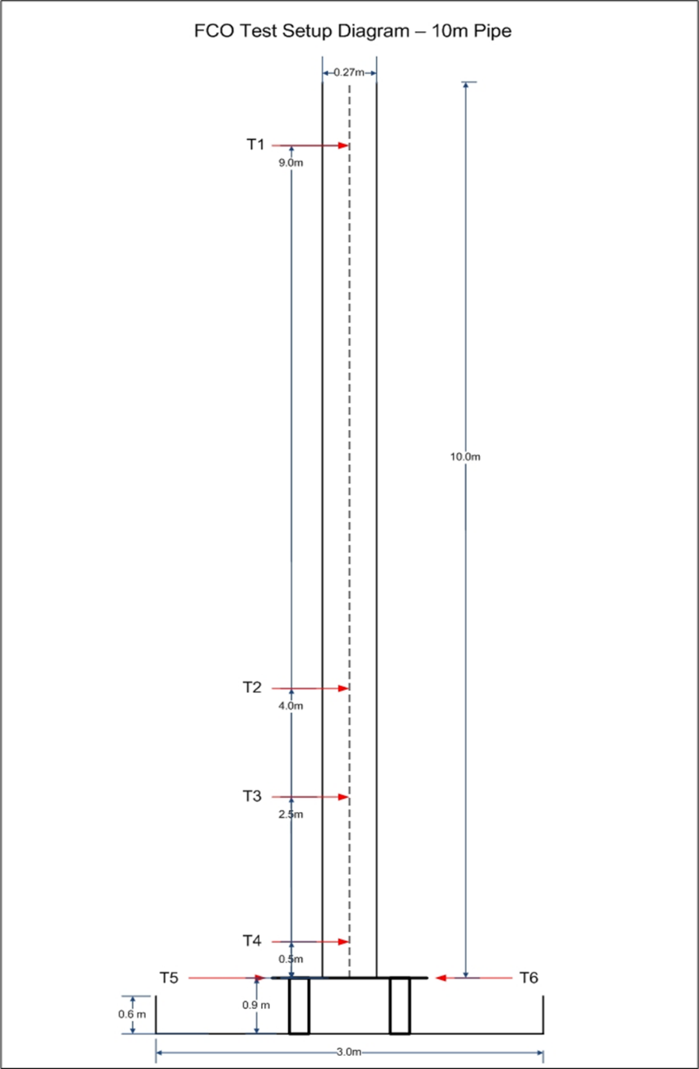
Figure 1: Fast Cook-off test set-up
ARC Thermal Decomposition Traces

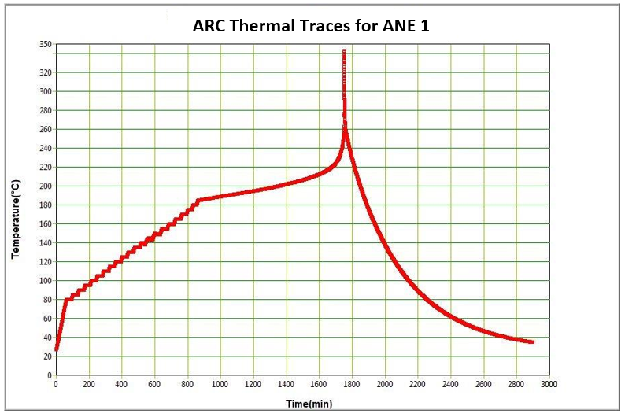
Figure 2: ARC Data for ANE 1

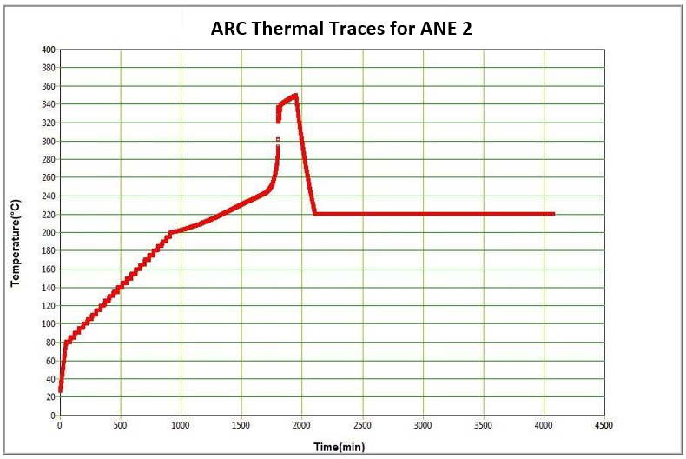
Figure 3: ARC Data for ANE 2
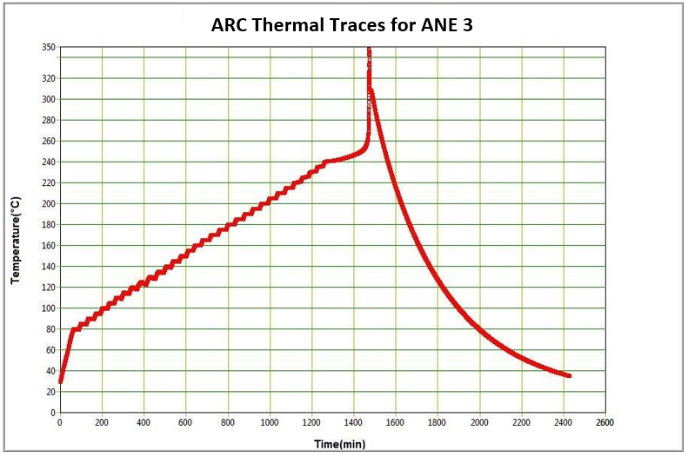
Figure 4: ARC Data for ANE 3

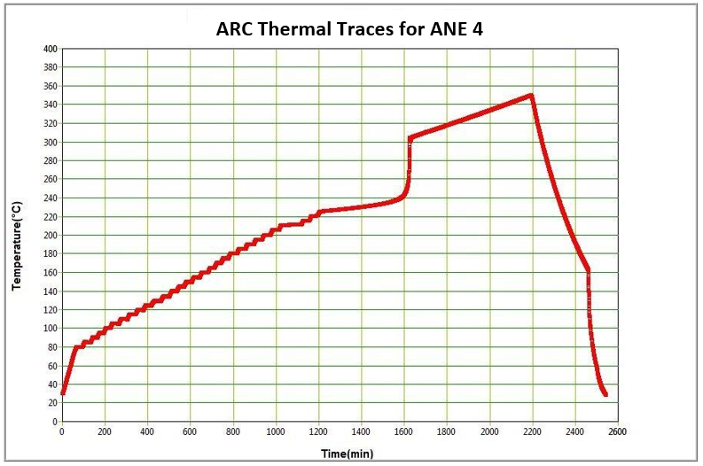
Figure 5: ARC Data for ANE 4

Fast Cook-Off test Thermal Traces
8
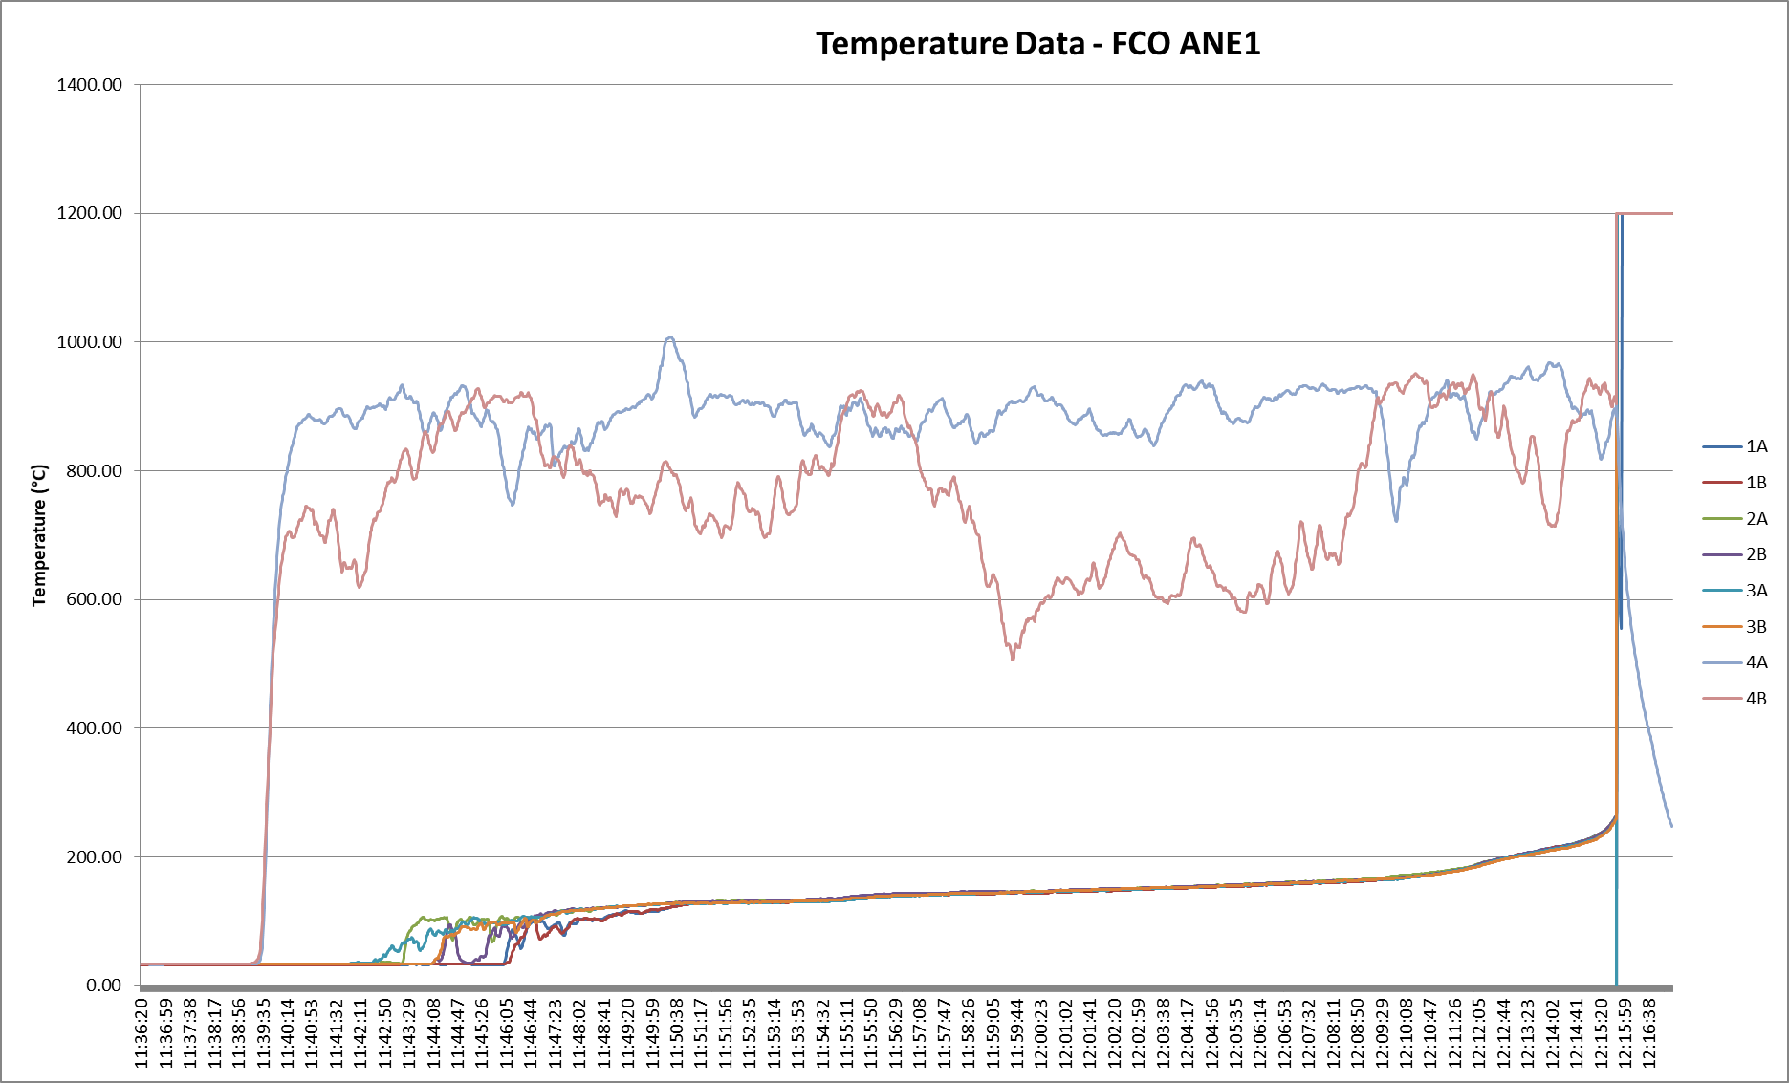
Figure 6: Fast Cook-off Temperature Data for ANE 1
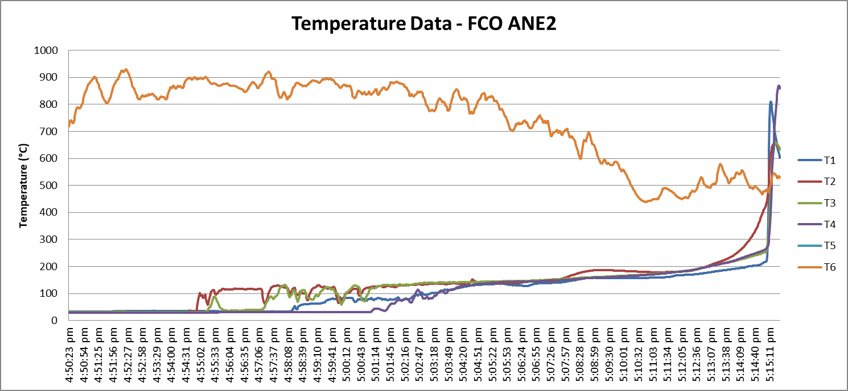
Figure 7: Fast Cook-off Temperature Data for ANE 2
9
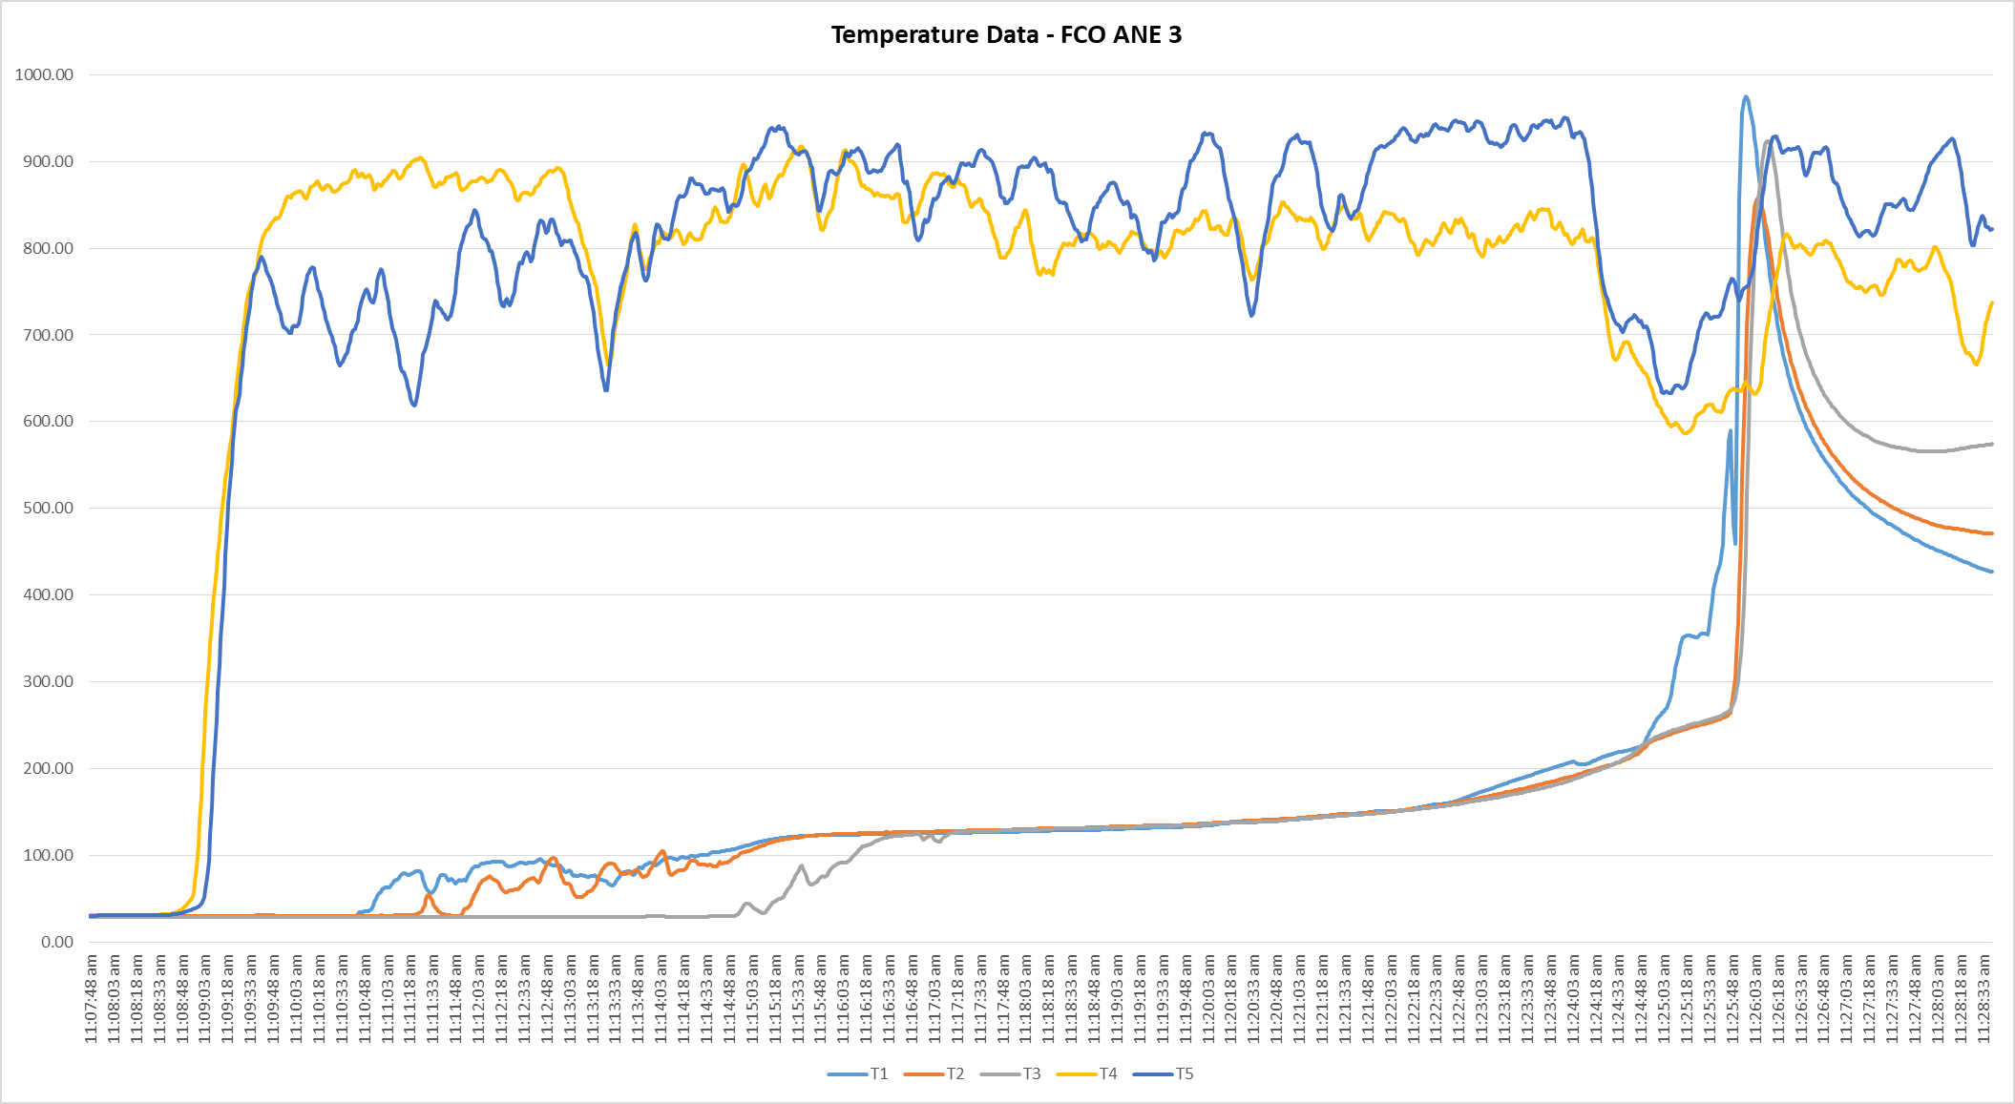
10
Figure 8: Fast Cook-off Temperature Data for ANE 3

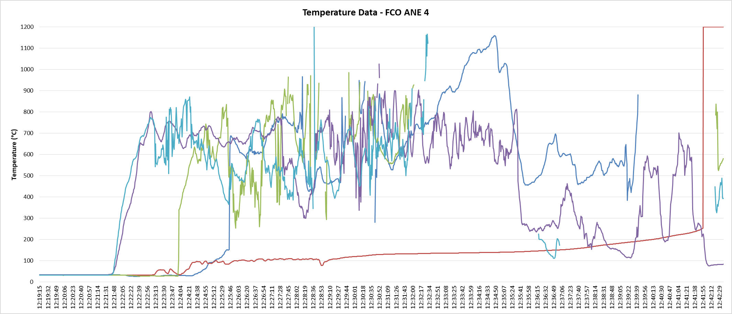
Figure 9: Fast Cook-off Temperature Data for ANE 4

11
8(d) test Thermal Trace
12

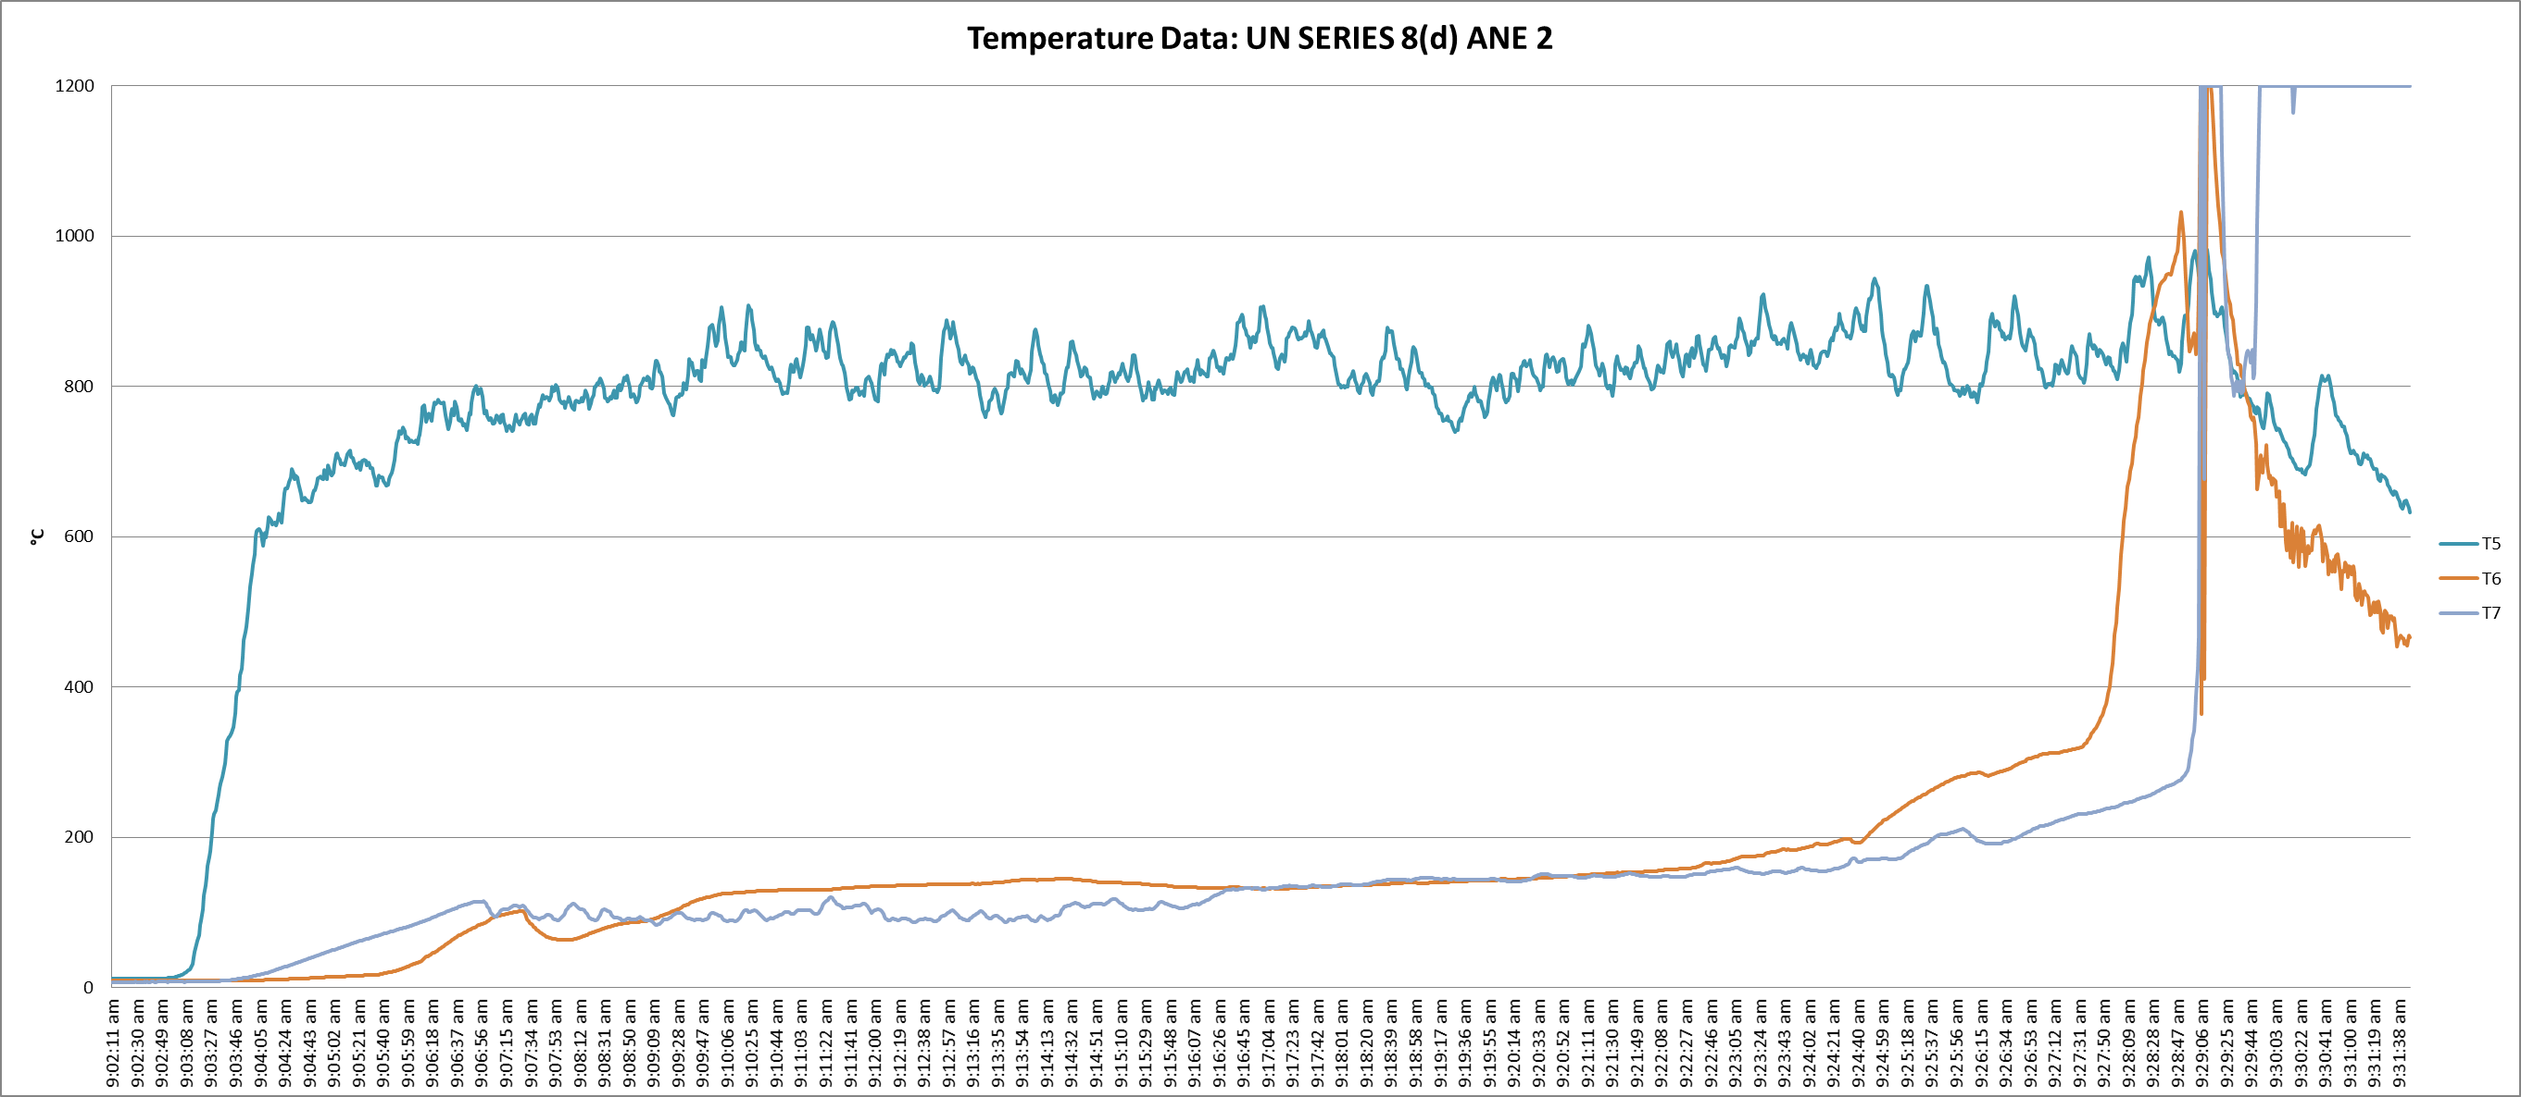
Figure 10: Temperature Data for 8(d) of ANE 2

Comparison of Tests

ST/SG/AC.10/C.3/2022/18 | UN/SCETDG/60/INF.XXXX
Aim
Determination of the thermal behaviour of emulsions in a tanker  (transportation) | Thermal characterization of ANE as in based on small scale and large scale testing
Methodology
modelling | Small scale and large scale testing
Set-up
Sectioned tanker with 10% and 90% ullage | ARC, 8(c), 8(d), 8(e), and fast cook-off test
Results
Almost no temperature increase | Gradual temperature increase throughout the system over a short period (10 -15 min) in large scale testing
No pressure event from ANE | Pressure event (venting) or detonation event
ANE not burning away and will remain after the fire has died down | No ANE remains observed after the large scale test
No correlation between small scale test results and the nature of the event in large scale testing

Table 5: Comparison of tests

Oxley, J. C., Kaushik, S. M. & Gilson, N. S., 1989. Thermal Decomposition of Ammonium Nitrate-Based Composites. Thermochimica Acta, Issue 153, pp. 269-286.

