UN/SCETDG/60/INF.38

Committee of Experts on the Transport of Dangerous Goods
and on the Globally Harmonized System of Classification
and Labelling of Chemicals 27 June 2022
Sub-Committee of Experts on the Transport of Dangerous Goods
Sixtieth session
Geneva, 27 June-6 July 2022
Item 2 (b) of the provisional agenda
Explosives and related matters: improvement of test series 8

Recommendations on Test Series 8: Applicability of Test Series 8 (d)
Transmitted by the Institute of Makers of Explosives (IME)
Introduction
- IME submitted working paper ST/SG/AC.10/C.3/2022/18 proposing that ANEs that go through the 8(e) test should not be subjected to the 8(d) test. Examples of transport incidents were presented and modeling that supported these observations was also provided in the paper.
- This INF paper provides two additional transport events that have taken place in the USA, one of which is an ANE while the other is a sensitized emulsion, which is transported as a Division 1.5 substance, and behaves as an ANE in conditions of fire, but is not a substance to which the proposal in document ST/SG/AC.10/C.3/2022/18 applies.
- All figures referred to in this document may be found in the Annex hereto.
Background
- In ST/SG/AC.10/C.3/2022/18 the modelling work provides insight into the behaviour of ANEs when exposed to a fire. This is an unprecedented study, which will be submitted to a peer reviewed journal later this year.
Discussion
- In the first event a transporter was carrying 44,000 lbs. of 5.1 emulsion, an ANE, on a highway in Arkansas when, for unknown reason(s), there was a fire in the axle area (Figures 1 to 3). The event occurred on 25 October 2016. Fire suppression was attempted unsuccessfully and eventually all 8 tires were engulfed in flames. Emergency Response procedures were activated, and the area was evacuated to a ½ mile radius. The fire was allowed to burn out. There were no injuries. All wheels burned on the tanker, and the aluminium fenders also melted. The double-walled stainless steel tank did not fail. The ANE, without any signs of heat damage, was recovered.
- The second event took place on 21 December 2014. An employee was en route to deliver a load of sensitized emulsion product to a mine site when he noticed sparks coming from underneath the rear axles of the triple-axle tanker he was pulling. He brought the tractor / trailer unit to a stop along the side of the road and as he walked back to the rear of the trailer to investigate, flames were visible on a tire. The employee attempted to extinguish the tire fire using both fire extinguishers installed on the trailer as well as the extinguisher in the cab of the tractor. The firefighting efforts were unsuccessful, and the employee then disconnected the tractor from the trailer and began diverting traffic away from the scene. Traffic was stopped and the out-of-control fire was allowed to burn itself out with all personnel cleared for a one-mile area. The fire consumed all six tires on the passenger side of the trailer, the air hoses, lights and wiring, and melted the aluminum rims. Once the fire had burned out the emulsion was pumped out of the tank. (Figures 4 to 6).
Conclusion
7. These two events showed a behaviour consistent with the model’s prediction and validate use of the modeling to support the proposal given in ST/SG/AC.10/C.3/2022/18.

Annex
Figures Referred to in this document
Figure 1. The tanker after the fire had died down

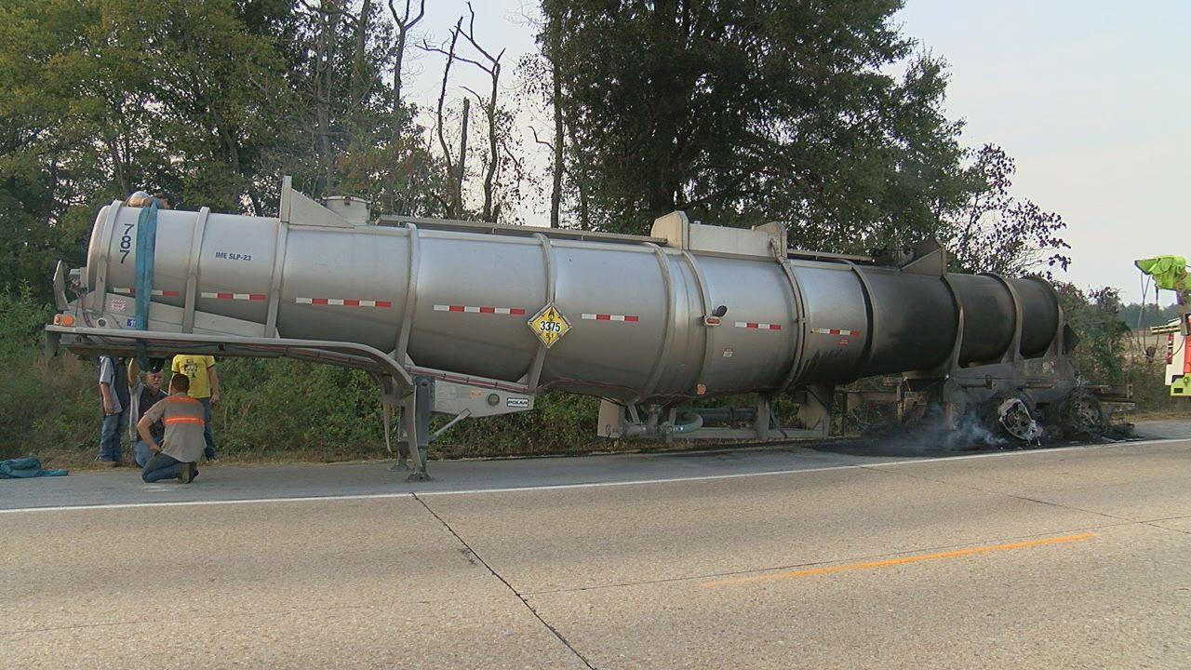

Figure 2. Closeup on the burnt tire area

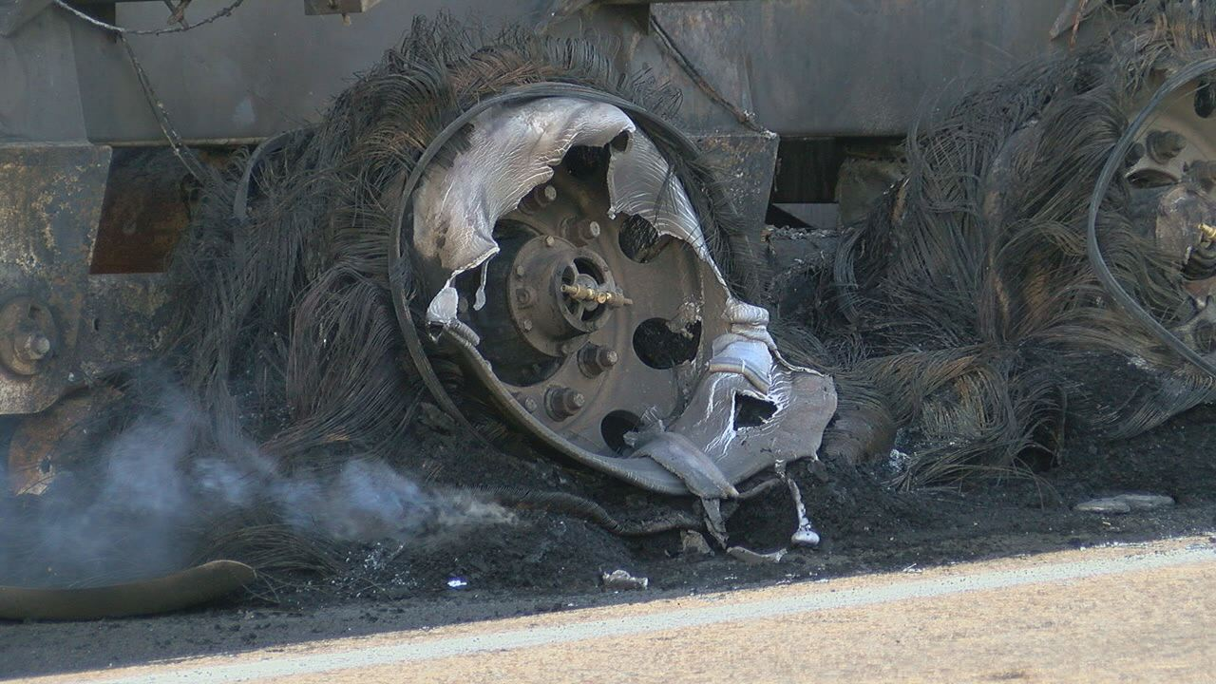

Figure 3. The tanker image captured while the fire was raging.

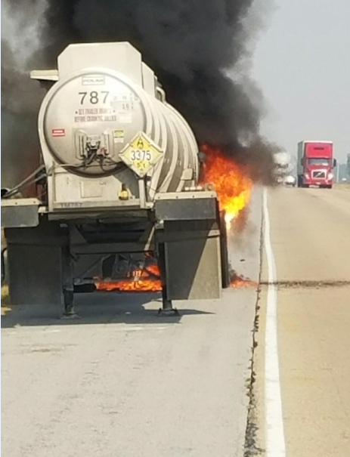

Figure 4: Crust (on top) and residual sensitised emulsion in the heated area after almost all the product was pumped out of the tank

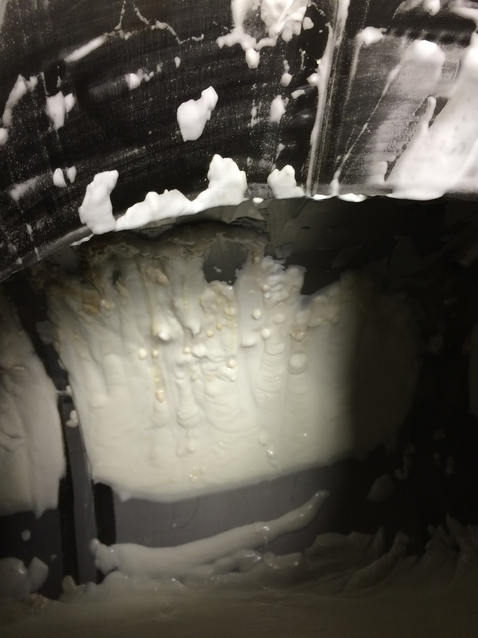

Figure 5: Tanker in the workshop showing heated-affected areas

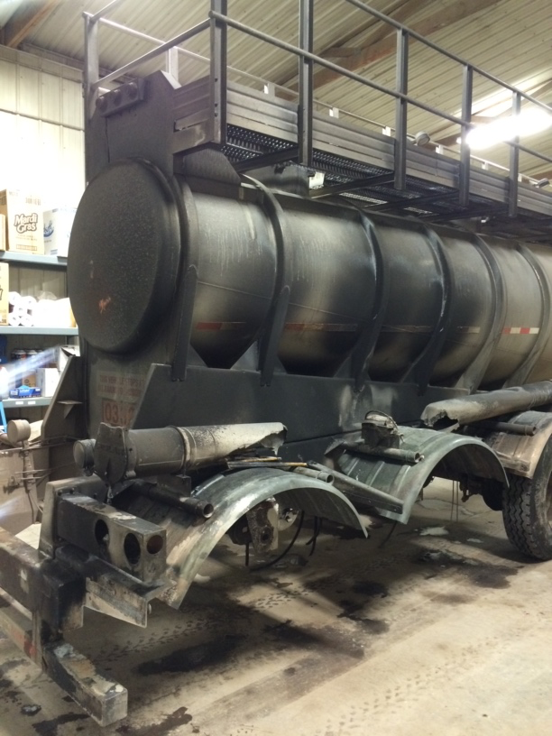

Figure 6: Burnt and melted tire area

