|  |
| --- |
| **UN/SCETDG/60/INF.27** |
| **Committee of Experts on the Transport of Dangerous Goods and on the Globally Harmonized System of Classification and Labelling of Chemicals**  **Sub-Committee of Experts on the Transport of Dangerous Goods 20 June 2022**  **Sixtieth session**  Geneva, 27 June-6 July 2022  Item 4 (c) of the provisional agenda  **Electric storage systems: transport provisions** |

Lithium ion batteries testing, short circuit test issue

Submitted by RECHARGE the Advanced Rechargeable & Lithium Batteries Association

Introduction

1. Based on the principle underlying the UN Manual of Tests and Criteria, section 38.3, the product testing for cells and batteries should be simple: “the product should be tested as designed”.

2. More and more battery powered products are using wireless (inductive) charging systems. It is usual for small items (earbuds, hearing aids, cell phones), but it is also anticipated for other product types in the future.

The reasoning is that consumers appreciate the simplicity and ease of use: see picture below: the device to be charged is simply placed on a pad, and there is no requirement to connect a cable to recharge.



In this case, when the battery is not removable from within the equipment, it is sometimes not possible to apply an external short circuit test in accordance with paragraph 38.3.2.1, specifying in the last sentence: “*A cell or battery that is an integral part of the equipment it is intended to power, that is transported only when installed in the equipment, may be tested in accordance with the applicable tests when installed in the equipment*.”

3. As wireless charging equipment has no accessible connections or contacts, therefore an external short circuit cannot be applied, unless the equipment and battery are dismantled.

See example on picture below

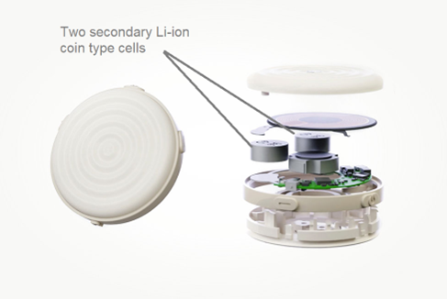

Hereafter the link to the webpage of the manufacturer of this device <https://www.duearity.com/>.

4. Another example is high voltage batteries, and parts of batteries that require protection due to a high potential voltage risk. The design applied in this case will sometimes require that there be no accessible live contacts or terminals.

Below is an example of a high voltage battery, where components are also high voltage for a short circuit test.

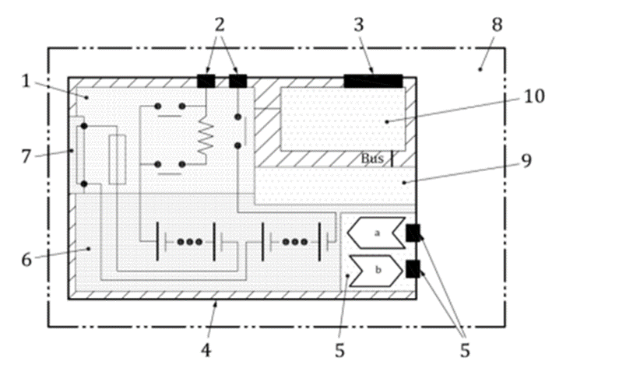

Of course, cells can always be tested and verified for the short circuit test. However, their assembly as a battery, or as a component-battery, may preclude the possibility of applying a short circuit, without dismantling components that are part of the design.

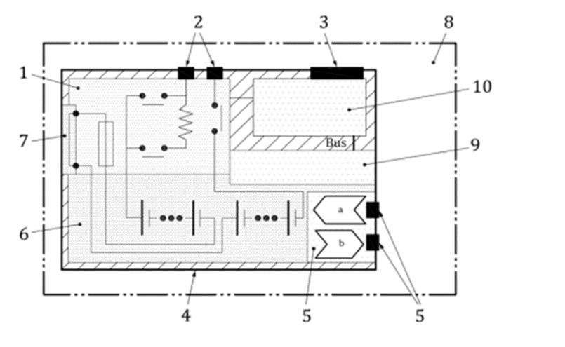

5. The safety system that is part of high voltage batteries is designed to protect against an external short-circuit. As a result, test is passed without current flow, because the protective components, (red shaded box in illustration 6) are preventing it, via a fast reaction-rate open-circuit disconnect. This is the best technical way to prevent the risks related to the application of an external short circuit.

The component-battery can be of a high voltage but is of course not equipped with these protective parts. Nevertheless, it needs to be transported for manufacturing or maintenance purposes. These component-batteries can be designed in a way that no short-circuit set-up is possible, with protective parts that are part of the design preventing possible application of a short-circuit. In this case, is the requirement to make the test possible going against the technical approach of safety?

6. In addition, in the case of small hear buds, it certainly can be argued that the testing laboratories could open the system for testing purpose. However, this cannot be required for high voltage batteries, as this may end up in a configuration where the open component-battery will present an electrical risk. For example, when removing a casing part, high voltage systems may be exposed in open air, and/or present arcing risks because of lack of insulation, and require special protections or special equipment to handle in a safe way.

7. Finally, the principle requiring the test laboratory to open the equipment, or the component-battery batteries and remove parts that are part of the design, is also against the principle of the test, which is supposed to test the battery as transported, to define the tested type.

Conclusion

8. Some batteries are constructed in a way that prevents the application of a short circuit by design (wireless charging, protected component-batteries) and cannot be tested without removing parts included in the design. This situation in principle prevents the possibility of demonstrating that batteries are of a tested type, because components that are part of the design must be removed for the test.

The advice of the Sub-Committee is requested to better understand how this new situation can be managed regarding the requirement of short circuit testing. Based in this feedback, RECHARGE and PRBA would be happy to propose clarification text for a future meeting.