|  |  |  |
| --- | --- | --- |
|  |  | **UN/SCETDG/60/INF.16** |

|  |  |
| --- | --- |
| **Committee of Experts on the Transport of Dangerous Goods and on the Globally Harmonized System of Classification and Labelling of Chemicals 13 June 2022** | |
| **Sub-Committee of Experts on the Transport of Dangerous Goods** |  |
| **Sixtieth session**  Geneva, 27 June-6 July 2022  Item 2 (i) of the provisional agenda  Explosives and related matters: miscellaneous |  |

Classification of nitrocellulose membrane filters for diagnostic and other life science applications

Submitted by the European Chemical Industry Council (Cefic) on behalf of the World Nitrocellulose Producers Association (WONIPA)

Introduction

1. Nitrocellulose membrane filters are used for diagnostic and other life science applications since several decades. Applications of these nitrocellulose membrane filters are rapid test devices for COVID-19 infections, pregnancy tests, infectious diseases like influenza, hepatitis and also Malaria, Borreliose and other diseases. In addition NC membranes are used as substrates for bioanalytical test platforms for analysis of proteins and biomarkers and microorganisms: bacterial load of water, food and beverages, medical diagnostics for identification and separation of target proteins in human blood serum (HIV, BSE etc.) via electrophoresis.

2. Nitrocellulose membrane filters UN 3270 with not more than 12.6 % nitrogen by dry mass, are classified in the division 4.1 of the UN Model Regulations for the Transport of dangerous goods. For getting this classification, special provision 237 requests, that the Nitrocellulose membrane filters, including paper separators, coatings or backing materials etc., that are present in transport, shall not be liable to propagate a detonation as tested by one of the tests described in the *Manual of Tests and Criteria* Part I, test series 1(a). In addition, the competent authority may determine on the basis of the results of suitable burning rate tests taking account of the standard tests in the *Manual of Tests and Criteria* Part III, subsection 33.2 that Nitrocellulose membrane filters in the form in which they are to be transported are not subject to the provisions of these Regulations applicable to flammable solids in division 4.1.

3. Cefic, on behalf of the Worldwide Nitrocellulose Producers Association (WONIPA), which represents in this case a group of manufacturers of NC membrane filters, which accounts for 80% of the worldwide production of NC membrane filters for diagnostic and life science applications, presents in this informal document the complete test results for a group of NC membrane filters, which show that this group of NC-membrane filters can be excluded from division 4.1 of the Model Regulations by using the provisions of special provision 237.

4. Due to the COVID-19 pandemic not all tests could be finalized before the deadline for working papers for the summer 2022 UN TDG session. Cefic now provides the comprehensive test results in this additional INF-paper to the working paper ST/SG ST/SG/AC.10/C.3/2022/10 and makes a proposal on the basis of those comprehensive tests to create a new special provision for this group of clearly defined NC membrane filters, which excludes this group from division 4.1 in this INF-paper. This will save a lot of work for the competent authorities worldwide, as they do not have to create competent authority decisions for each NC membrane filter type and will additionally improve the availability of the NC-membrane filters (incl. rapid test devices for COVID-19 infections) worldwide, as the transport of these filters is facilitated. A detailed description of the NC membrane filter packaging configurations, a compilation of the test results now available and the detailed test descriptions and results can be found in annexes I through III.

Test description and Test results

5. All tests were performed by the German competent Authority BAM according to the methods specified in the Manual of Tests and Criteria, seventh revised edition, 2019.

6. NC membrane filters are delivered in different product packaging configurations. Please find an overview of the NC membrane filter packaging configurations in annex I. They are produced from a master roll of NC membrane filter, from which the different forms (round filters, sheets and small rolls) are achieved by cutting the master roll into round filters, sheets and rolls.

7. Special provision 237 requests, that the Nitrocellulose membrane filters, including paper separators, coatings or backing materials etc., that are present in transport, shall not be liable to propagate a detonation as tested by one of the tests described in the *Manual of Tests and Criteria* Part I, test series 1(a). All test samples, NC-membrane filters with PET film backing, NC membrane filters without PET film backing, NC-membranes on rolls, NC-membrane in Sheet form, NC membrane filters as round filters and NC-membrane filters in Leporello form were tested in round cut outs with 38 mm diameter in their packaging configuration for transport with the UN 1(a) test in order to determine if those NC membrane filters are liable to propagate a detonation or not. All NC-membrane products contained paper separators with a weight of 80 g/m² or more. Please find a compilation of the product configurations and the test results of the samples 1 to 8 in annex II.

8. All NC membrane filters are packed for transport in a primary packaging, e.g. plastic bags or cardboard boxes or in aluminium pouches. The NC-membrane filters are wrapped for transport in this primary packaging (cardboard or plastic film or aluminium pouch). It is important, that the sequence of NC-membrane filters and paper separators is fixed and that it is ensured that the layers lie closely upon the other. This is achieved by tightly wrapping the NC-membrane filters and the paper separators with the primary packaging.

Test results

9. Section 1 in annex III shows the detailed result of the UN 1(a) test for sample 1 = NC membrane filter UniSart® backed with PET film. The test result was “negative”. The tests with the samples with a NC-grammage of 37 to 53 g NC/m² (samples Nos. 1, 2, 3, 4, 8) showed all a “negative” test result: the steel tube was not fragmented completely and no hole has been punched in the witness plate. The witness plate was only domed. The test with sample No 6 could be done only after the deadline for the working paper and after the complete N.1 tests due to COVID-19 infections of the BAM lab personnel. The test with sample No 6 with a NC-grammage of 60 g NC/m² showed a positive result: the steel tube was not fragmented completely, but a hole was punched in the witness plate. The evaluation of BAM for all tested NC membrane filters was that only the NC-membrane filters with a grammage of 37 to 53 g NC/m² are not liable to propagate a detonation, because neither the steel tube has been fragmented completely nor a hole has been punched in the witness plate in all tests. The test with a NC-membrane filter with a grammage of 60 g/m² is liable to propagate a detonation. This leads to the conclusion that only NC-membrane filters with a grammage of max. 55 g NC/m² can be considered for the group which could be excluded from the transport division 4.1.

10. In addition, the competent authority may determine on the basis of the results of suitable burning rate tests taking account of the standard tests in the *Manual of Tests and Criteria* Part III, subsection 33.2 that Nitrocellulose membrane filters in the form in which they are to be transported are not subject to the provisions of these Regulations applicable to flammable solids in division 4.1. BAM has chosen the UN Test N.1 to determine the burning rate of the NC-membrane filters.

11. As the NC membrane filters are delivered in different configurations, these configurations were taken into account for the tests. Burning rate tests were performed using stampings for round filters, stripes for NC-membrane sheets and rolls as they were delivered.

12. In section 2 in annex III the detailed test description and test results for the test with “NC-membrane filter UniSart® CN140 backed (19501) in the round filter configuration are given. The BAM evaluation for all 7 samples of NC-membrane round filters described in the table in annex II is that they all pass this UN N.1 and that the samples 1 to 4 are no flammable solids of class 4.1.

13. In section 3 in annex III the detailed test description for the test with “NC-membrane filter UniSart® CN140 backed (19501) in the sheet configuration is given. NC-membrane filters in sheet form are packed for transport closely together in cardboard boxes or plastic film with a paper separator between each sheet. In order to ensure that the UN N.1 test corresponds as closely as possible to this transport configuration, stripes of 250 mm length (including paper separators between each NC membrane filter strip) were packed together as in the transport packaging. The burning times were determined for this configuration packed in cardboard or plastic film. For the NC-membrane filter Type 114H6Z, the UN N.1 test was not performed with strips, as these are only transported in Leporello packaging. The BAM evaluation of tests with all 7 samples was that they pass this UN N.1 test because the combustion did not propagate along the 200 mm measuring distance when packed in PET film as well as in cardboard or in aluminium pouches. The results show that the samples 1 to 4 are no flammable solids as they had also a negative UN N.1 test.

14. In section 4 in annex III the detailed description for the tests with NC-membrane filter rolls is given. The BAM evaluation of a test with an NC membrane roll backed with a PET FILM with paper separators (UniSart® CN 140 backed (19501)) and a test with an NC membrane roll unbacked (UniSart® CN 140 unbacked (11301)) with paper separators is that both NC-membranes on rolls are not flammable solids because the combustion did not propagate along the measuring distance and the burning rate is less than 2.2 mm/s. Also the tests with samples 5 to 7 in roll form passed this N.1 test.

15. The complete set of test results presented in this informal document show, that it is possible to exclude a clearly defined group of NC membrane filters from the division 4.1 flammable solids. The UN 1(a) test results showed, that only NC-membrane filters with a NC-content of up to 53 g/m² are not liable to propagate a detonation in the test. The UN N.1 tests showed that a group of NC membrane filters with up to 80 g NC/m² passed all N.1 tests. As both conditions (UN 1(a) and UN N.1 test) have to be fulfilled for an exclusion from the transport division 4.1, only the group of NC-membrane filters with a NC-content of up to 53 g/m² can be excluded from transport division 4.1.

Proposal

16. CEFIC proposes to add the following special provision to the UN Model Regulations, based on the complete set of test results and a proposal for a special provision for a clearly defined group of NC membrane filters, which can be excluded from the division 4.1 flammable solids.

17. Add the following special provision to the chapter 3.3.1 of the UN Model Regulations:

SPXXX Nitrocellulose (NC) membrane filters covered by this entry with NC content not exceeding 55 g/m² and a NC net weight not exceeding 300 g per primary packaging, are not subject to the requirements of this regulation if they meet the following conditions:

(a) They are packed with separators between each layer made of paper with grammage of min. 80 g/m²

(b) They are packed tightly in any of the following configurations in order to avoid a fan out of the NC-membrane filter layers in case of a fire:

(i) Rolls packed in plastic foil with a grammage of min. 80 g/m² or aluminium pouches with an oxygen permeability of equal or less than 0.1 % according to ISO 15505.

(ii) Sheets packed in cardboard with a grammage of min. 250 g/m² or aluminium pouches with an oxygen permeability of equal or less than 0.1 % according to ISO 15505.

(iii) Round filters packed in disc holders or cardboard packaging with a grammage of min. 250 g/m² or single packed in pouches of paper and plastic material with a total grammage of min. 100 g/m².

18. Please add SPXXX to the DANGEROUS GOODS LIST in chapter 3.2 of the UN Model Regulations in Column 6 of the UN No. 3270 NITROCELLULOSE MEMBRANE FILTERS , with not more than 12.6 % Nitrogen, by dry mass.

19. If there are any questions concerning this INF paper, please contact Werner Lange at: [dr.werner.lange@icloud.com](mailto:dr.werner.lange@icloud.com). Cefic would highly appreciate, if we could have an email discussion of the INF paper before the UN TDG summer 2022 session, so that as many questions as possible can be clarified before the UN TDG session.

Justification

20. Billions of COVID-19 rapid test devices are needed worldwide to control the spread of the COVID-19 pandemic. For the billions of COVID-19 rapid test devices, billions of NC membrane filters are needed as substrate. Cefic, respectively WONIPA presents a packaging concept of the manufacturers of NC membrane filters which will simplify the transport of NC membrane filters. The simplification of the transport of NC membrane filters will improve the availability of the NC membrane filter COVID-19 rapid test devices worldwide and by this improve the control of the COVID-19 pandemic. Cefic plans to present a complete set of test results for NC membrane filters timely before the next UN TDG meeting in summer 2022 in an additional INF-paper. In this INF paper a proposal for a special provision is made for a defined group of NC membrane filters, that can be excluded from the transport division 4.1 flammable solids, which will simplify the transport of these NC membrane filters.

Annex I

Overview of NC membrane filter product packaging configurations

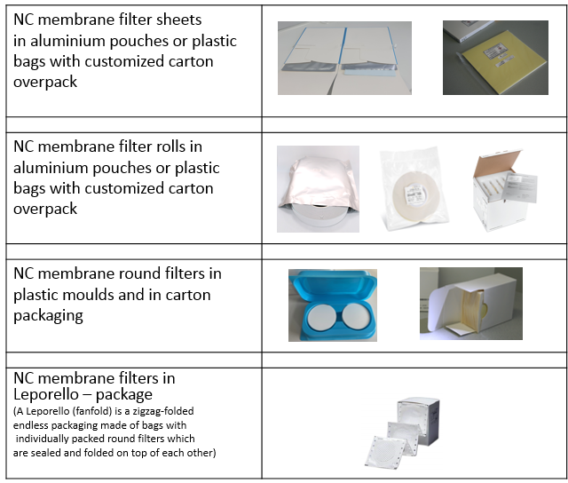

Annex II

Compilation of product configurations and test results



Annex III

Detailed Test results

Section 1 UN 1(a) test description and test results

The following figure shows the result of the UN 1(a) test for sample 1 = NC membrane filter UniSart® with a grammage of 40 g NC / m², backed with PET film.   
  
 1. Trial 2.Trial  
  
Mass of the sample: 377.1 g 374.6 g  
Remained part of the steel tube: 16 cm 17 cm  
Fragmented part of the steel tube: 24 cm 23 cm  
Residue of the sample: 0* 0*  
Witness plate: Domed Domed

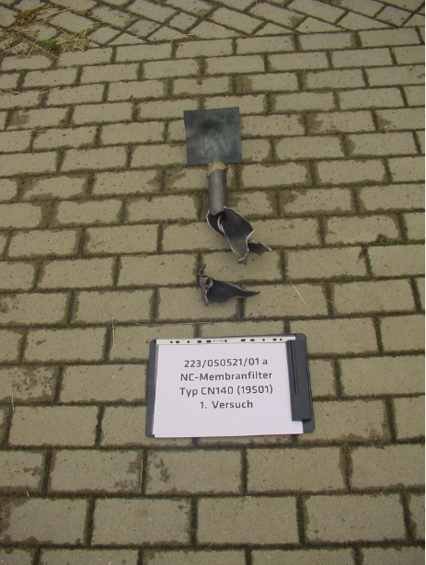 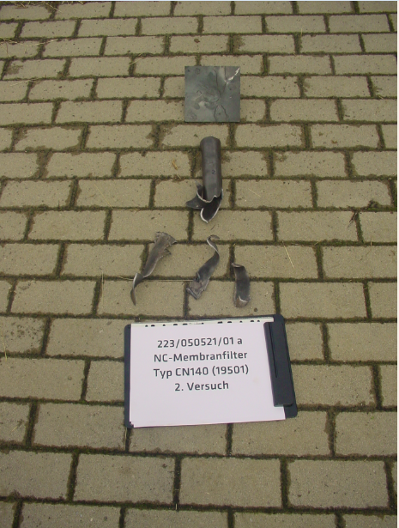

* Spread out in the test chamber  
  
Evaluation of UN Test 1(a) by BAM: The sample “NC membrane filter type UniSart® CN 140 backed (19501)   
 is considered not be able to propagate a detonation, because neither the steel tube   
 has been fragmented completely nor a hole has been punched in the witness plate.  
  
BAM evaluation of UN-Test 1(a) The samples 2, 3, 4and 8 with a grammage of 37 to 53 g / m² are considered not   
 be able to propagate a detonation because neither the steel tube has been   
 fragmented completely nor a hole has been punched in the witness   
 plate in all tests (two tests per sample were performed).  
  
The following figure shows the result of the UN 1(a) test for sample 6 = NC membrane filter with a grammage

of 60 g NC / m², backed with PET film.

3. Trial   
  
Mass of the sample: 340.7 g   
Remained part of the steel tube: 14.5 cm   
Fragmented part of the steel tube: 25.5 cm   
Residue of the sample: 0*   
Witness plate: hole punched

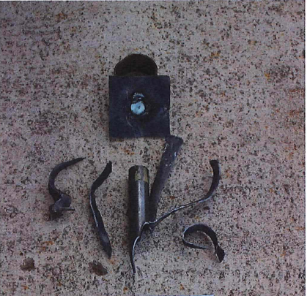 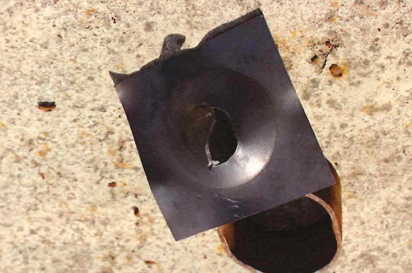

* Spread out in the test chamber

For this sample three tests were done: In two tests a hole was punched in the witness plate, in one test no hole was punched in the witness plate. Evaluation of UN Test 1(a) by BAM: sample 6 with a grammage of 60 g NC/m² is considered to be able to propagate a detonation, because a hole has been punched in the witness plate in two of three tests for this sample. So the test result for sample 6 is positive "+".  
  
**Section 2 UN N.1 Tests with NC-membrane filter in round filter test configuration; test description and test results**In order to collect as much information as possible about the burning behavior of NC membrane filters in the N.1 burning tests, also NC-membrane filter material, which is not produced for the market in round filter form, was tested in cut outs of 38 mm diameter from the respective master roll in the round filter test configuration.   
 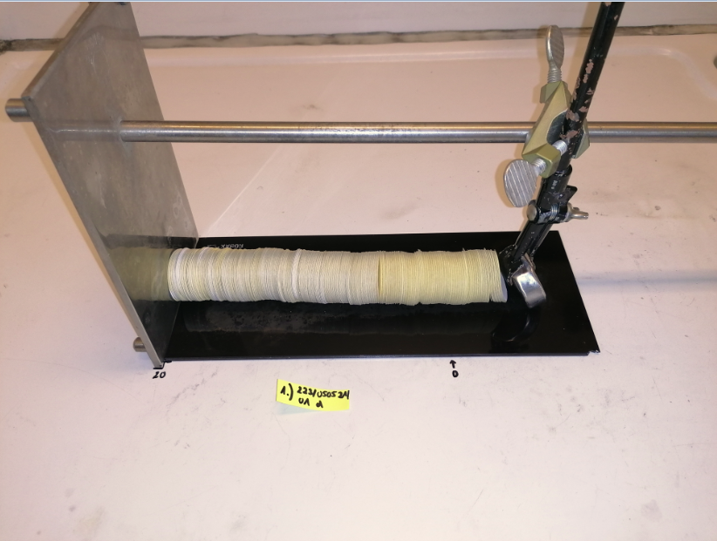 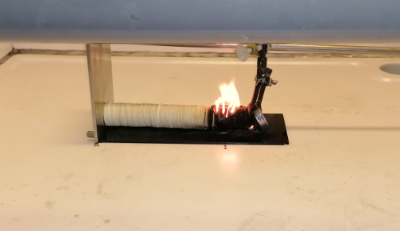

The NC membrane round filters were fixed with their paper separators, as they are configured for transport in a holding device in order to get a measuring distance of 250 mm. They were ignited and the burning speed was measured.   
  
Test results for “NC-membrane filter UniSart® CN140 backed (19501).   
  
In the preliminary test the round filters could be ignited after 43 seconds, but the flame went out after 42 minutes without propagating the combustion along the necessary measuring distance of 200 mm. Due to the clear result, the main test could be waived.   
  
BAM evaluation of this UN-Test N.1: The sample “NC-membrane filter type UniSart® CN140 backed (19501) is not a   
 flammable solid because the combustion did not propagate along the 200 mm   
 measuring distance.   
  
BAM evaluation for all NC membrane filters in the test configuration with round filters with a grammage of 37 to 80 g NC / m² packed in plastic foil or carton or aluminium pouch: These NC membrane filters pass this N.1 test because the combustion did not propagate along the 200 mm measuring distance. The samples 1 to 4 with a grammage of 37 to 53 g NC/m² are not flammable solids of the transport division 4.1, as their UN 1(a) tests showed a negative result.

**Section 3 UN N.1 NC membrane filters in test configuration with stripes for sheet form**   
  
In order to collect as much information as possible about the burning behavior of NC membrane filters in the N.1 burning tests, also NC-membrane filter material, which is not produced for the market in sheet form, was tested in stripes with 20 mm width, which were produced from especially produced from rolls with 20 mm width from the respective master roll.  
  
NC membrane filters are also transported in sheets, which are packed closely together in cardboard or plastic film or aluminium pouch, with an interleaf layer between each sheet.   
  
In order to ensure that the UN Test N.1 corresponds as closely as possible to this configuration, stripes of 250 mm length (including interleaf papers between each NC membrane filter strip) were packed together as in the transport packaging. The burning times were determined for this configuration packed in cardboard or plastic film.  
  
The UN Test N.1 was not performed with stripes of the NC-membrane filter type 114HZ because these are transported only in Leporello packaging.

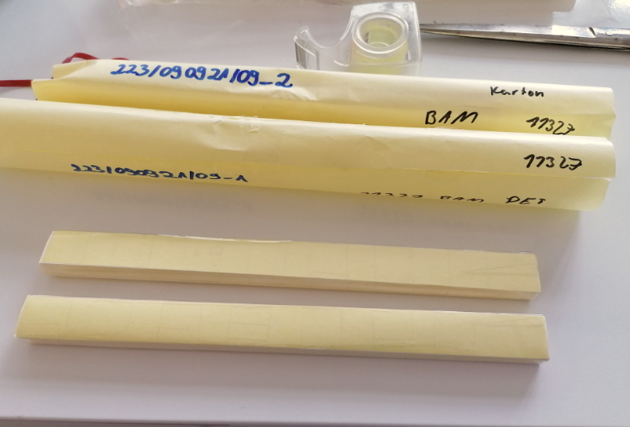 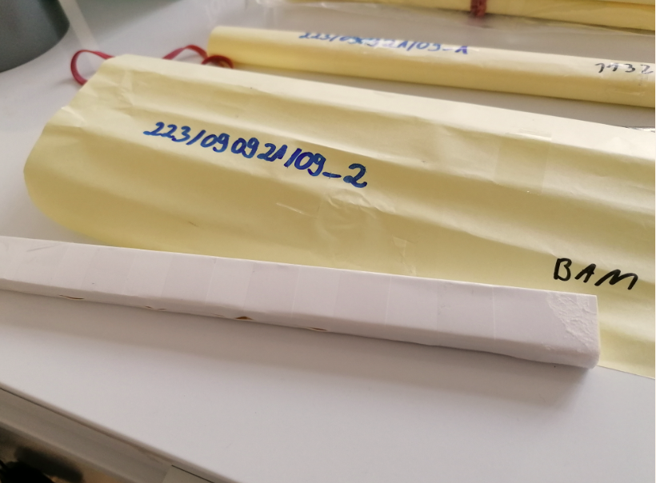   
  
Stripes packed in PET-Film Stripes packed in cardboard  
  
**Test result for “NC-membrane filter type UniSart® CN 140 backed (19501) (223/090921/07)**  
The NC membrane filters packed in PET film (with interleaf paper) could be ignited in the preliminary screening test, but the flame went out after 2 minutes without propagating the combustion along the measuring distance of 200 mm.  
  
The NC-membrane filters packed in cardboard (with interleaf paper) could be ignited in the preliminary screening test, but the flame went out after 30 seconds without propagating the combustion along the measuring distance of 200 mm.  
  
As the result was quite clear, the main test could be waived for both configurations.  
  
BAM evaluation of UN Test N.1: The sample “NC membrane filter type UniSart® CN140 backed (19501) is not a   
 flammable solid because the combustion did not propagate along the 200 mm   
 measuring distance when packed in PET film as well as packed in cardboard.   
  
BAM evaluation of UN-tests N.1 The samples 2 to 4 are not flammable solids because the combustion did not   
with sample 2 to 4: propagate along the 200 mm measuring distance when packed in PET film as well   
 as packed in cardboard and their UN 1(a) test result was negative.

**Test result for “NC-membrane filter type Protran BA 83 in aluminium pouch (sample 7)  
  
Sample 7 was chosen as example as it has the highest NC-grammage per m² with 80 g NC/m².**The tests were done in two ways:   
  
Test scenario 1  
  
The aluminium pouch was cut at both shorter sides and the NC-membrane filter stripes were ignited on one side:   
  
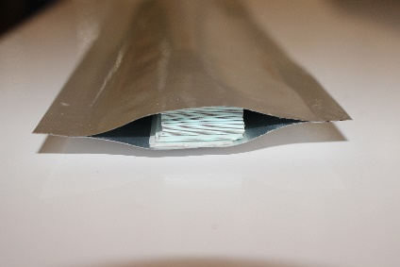 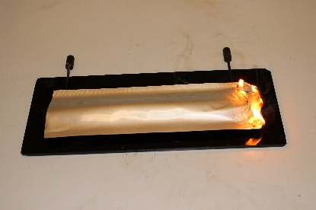   
   
  
Test scenario 2:  
  
The aluminium pouch was cut at both shorter sides and at one long side. Then the aluminium foil was tightly wrapped around the NC-membrane stripes and fixed with an adhesive tape. The NC-membrane filter stripes were ignited on one side:   
  
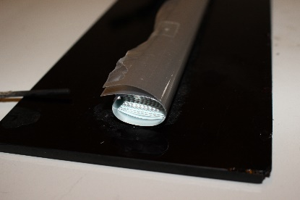 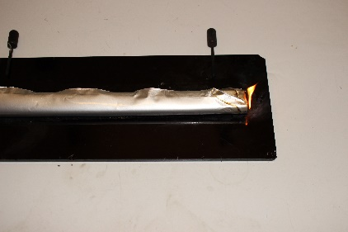

The flame went out after a short burning period and did not propagate along the 200 mm measuring distance for both test scenarios.

BAM evaluation of UN Test N.1: The sample “NC membrane filter type Protran BA 83 passes this N.1 test   
 because the combustion did not propagate along the 200 mm measuring distance  
 when packed in an aluminium pouch.   
  
BAM evaluation of UN Test N.1: The sample 5 ME 25 and sample 6 FF HP Plus pass this N.1 test   
 because the combustion did not propagate along the 200 mm measuring distance  
 when packed an aluminium pouch.   
  
BAM evaluation for all NC membrane filters in the test configuration with stripes with a grammage of 37 to 80 g NC / m² packed in plastic foil or carton or aluminium pouch: These NC membrane filters pass this N.1 test because the combustion did not propagate along the 200 mm measuring distance when packed in PET film as well as packed in cardboard or aluminium pouch. The samples 1 to 4 with a grammage of 37 to 53 g NC/m² are not flammable solids of the transport division 4.1, as their UN 1(a) tests showed a negative result.  
  
**Section 4 UN N.1 Test with NC- membrane filters on rolls in roll form test configuration**NC -membranefilters are also shipped in big quantities in rolls with paper separators between each layer of NC membrane filter, for example for Covid 19 rapid test devices. For this reason the UN N.1 test was also performed with NC membrane filters in roll form.  
  
**Test with “NC membrane filter type UniSart® backed (19501)**   
  
For this NC-membrane sample (No 1) a preliminary test was performed with strips, by cutting strips of 250 mm length from a roll of the same NC membrane material with a width of 20 mm. These strips were than stacked together with paper separators between each NC-membrane strip until a height of 10 mm was reached. Then they were tightly wrapped in PET film or cardboard.

In this preliminary screening test, it was not possible to maintain a measuring distance of 200 mm with NC-membrane filters from the rolls.

Trial 1  
  
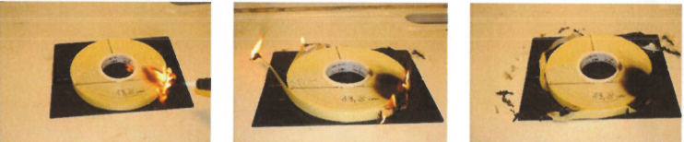

The NC-membrane roll was ignited on one side with a gas flame (measuring distance 198 mm), after 54 seconds the flame went out, over a measuring distance of 52 mm the NC-membrane filter was carbonized. The burning time for the measuring distance of 52 mm was 126 seconds, resulting in a burning rate of 0.41 mm/s.   
  
Trial 2

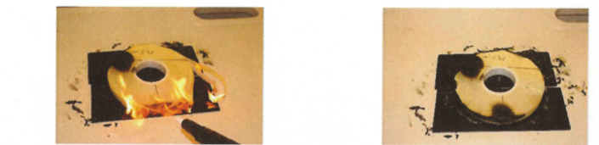

The roll was ignited on one side with a gas flame (measuring distance 65 mm. corresponds to the radius of the roll), after 28 seconds the flame went out, over a measuring distance of 52 mm the NC membrane filter was carbonized. The burning time for the measuring distance of 52 mm was 189 seconds, resulting in a burning rate of 0.28 mm/s.  
  
BAM evaluation of UN Test N.1: The sample “NC membrane filter UniSart® CN 140 backed (19501) on rolls is not a   
for sample 1 flammable solid because the combustion did not propagate along the 198 mm or   
 65 mm measuring distance, respectively, the burning rate is less than 2.2 mm/s.   
   
For the sample 2 “NC membrane filter UniSart® CN 140 unbacked (11301) on rolls” also an UN N.1 test with an ignition with a gas flame from one side was performed.  
  
  
BAM evaluation of UN Test N.1 The sample “NC membrane filter UniSart® CN 140 unbacked (11301) on rolls is   
for sample 2 not a flammable solid because the combustion did not propagate along the 160 mm or   
 165 mm measuring distance, respectively, the burning rate is less than 2.2 mm/s.   
  
BAM evaluation of all N.1 tests with NC-membranes with a grammage of 37 to 80 g NC/m²: all these samples pass this N.1 test as all tests showed either that the combustion did not propagate along the measuring distance or the burning rate was less than 2.2 mm/s. The samples 1 and 2 in the range of grammage of 37 to 53 g NC/m² are not flammable solids of the transport division 4.1, as their UN 1(a) tests showed a negative result.

_______________