UN/SCETDG/60/INF.15

Committee of Experts on the Transport of Dangerous Goods
and on the Globally Harmonized System of Classification
and Labelling of Chemicals 8 June 2022
Sub-Committee of Experts on the Transport of Dangerous Goods
Sixtieth session
Geneva, 27 June-6 July 2022
Item 2 (c) of the provisional agenda
Explosives and related matters:
Review of tests in parts I, II and III of the Manual of Tests and Criteria
Parameters for specification of Koenen test apparatus
Transmitted by the experts from the United Kingdom and the United States of America
Background
- The Koenen test is in four (4) UN Test Series (1b, 2b, 8c, and E.1). These tests involve placing the substance in Koenen tubes that are sealed with a cap assembly that can have various diameter vent holes. The tube and substance are then heated to assess the explosivity of substances and mixtures to assign classifications:
UN Test Series 1b is used to determine if a substance has explosive properties,
UN Test Series 2b is used to determine if a substance is too insensitive for acceptance into the class of explosives,
UN Test Series 8c is used to determine the sensitiveness of a candidate for ammonium nitrate emulsion, suspension, or gel, intermediate for blasting explosives, and
UN Test Series E.1 is used to determine the effect of heating a self-reactive substance or organic peroxide under defined confinement.
- The Koenen test is also used supplementally to the Model Regulations for research and safety testing.
- Whether the Koenen tube bursts during these tests, and how it bursts, are carefully evaluated. The assessment criteria are derived from the burst characteristics to aid in determining the classification of substances and mixtures.
- ST/SG/AC.10/C.3/2015/4 informed the Sub-Committee that “it was not possible for the manufacturer (Reichel) to get the former specification of sheet steel,” used to make Koenen tubes. Test results compiled by the IGUS EOS Working Group were reported comparing the new tubes to old tubes using standard substances. Based on those test results, it was recommended that the specified Koenen bursting pressure of 30 ± 3 MPa be changed to 28 ± 4 MPa while maintaining all other specifications of this test (i.e., tube dimensions and mass).
- ST/SG/AC.10/C.3/2016/6 and informal document INF.27 (49th session) document additional testing of ammonium nitrate emulsions with the same types of Koenen tubes used for the IGUS EOS testing above and again requests that the specified Koenen bursting pressure of 30 ± 3 MPa be changed to 28 ± 4 MPa.
- Informal document INF.66 (49th session), Report of the Working Group (EWG) on Explosives, agenda item 2(c) outlines that the EWG modified the proposed Koenen bursting pressure from 28 ± 4 MPa to 29 ± 4 MPa “so that it included the criteria currently found in the Manual as well as the new test results”. Revision 7 of the UN Manual of Tests and Criteria (MTC), which was published in the summer of 2019, includes this new specification for bursting pressure.
- Safety Management Services, Inc. (SMS), a U.S. Department of Transportation approved test laboratory, identified readily available steel ASTM A1008 that could be used to fabricate Koenen tubes which consistently meet the static incompressible burst pressure specified in Revision 6 and earlier revisions of 30 ± 3 MPa. This work was conducted between July 2018 and September 2019 since the manufacture (Reichel) could not produce Koenen tubes that met the MTC Revision 6 specification for static bursting pressure. Very minimal increases were required in tube wall thickness (+0.1 mm) and tube mass (+1.6 grams) to make the ASTM A1008 steel match the incompressible burst pressure specification in the MTC Revision 6. These newly manufactured tubes are identified below as “SMS tubes”.
- Paragraphs 9 and 10 include test results from a SMS presentation on this topic given at the IGUS EPP meeting held on 25 and 26 April in Huntsville, Alabama, USA. EPP participants expressed interest in revisiting the Koenen tube specifications based on the additional test data and information provided.
SMS Test Results
- SMS performed static incompressible bursting pressure tests on SMS tubes, Reichel tubes purchased in 2021, and Reichel tubes fabricated prior to 2017 which yielded the following average bursting pressures:
SMS tubes fabricated in 2019 | 29.0 MPa
Reichel tubes purchased in 2021 | 26.0 MPa
Reichel tubes fabricated prior to 2017 | 23.8 MPa
- SMS then performed Koenen testing on Luperox-P (tert-Butyl peroxybenzoate) using 8 tubes of each of the above referenced Koenen tubes, all tested with a vent diameter of 3 mm, which yielded the following results:
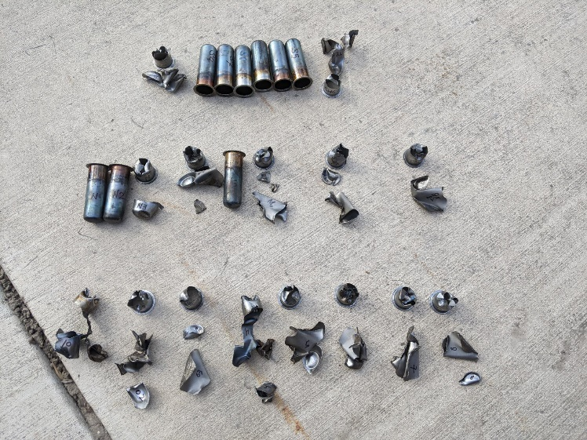
SMS: 29.0 MPa
‘21 Reichel: 26.0 MPa
‘17 Reichel: 23.8 MPa
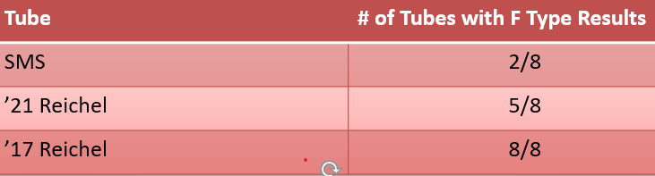
11. The above results clearly indicate that Koenen tubes with a lower static bursting pressure also yield an increased likelihood of an explosive effect for a given vent diameter. In other words, a lower static bursting pressure is likely to result in more substances being classified as Class 1 verses other dangerous goods or for Test E.1, a more severe transport packaging requirement.
Conclusions
- The current MTC Revision 7 criteria of 29 ± 4 MPa may result in more substances exhibiting an explosive effect in Test Series 1b, 2b, 8c, and E.1 than would have using tubes that complied with MTC Revision 6, possibly changing the classification and packaging specifications of such substances.
- The test data in paragraph 10 above, for the tested substance, shows that a difference of 3 MPa in tube bursting pressure will likely yield different limiting vent diameters.
- Koenen tube static bursting pressure is a key parameter for Koenen test results to align with historical test data. Tubes that meet the static bursting pressure specification may require minor variations from the tube thickness and mass specifications listed. Such minor variation to these specifications appears to have negligible effect on tube bursting and fragmentation characteristics.
- It may be possible to accommodate both the Reichel and ASTM A1008 steel specifications. The tube burst pressure is the key parameter, as opposed to the thickness or weight. The thickness and mass specifications became obsolete when the original steel specification became unavailable.
Proposal
- The submitters of this document request a discussion in the Explosives Working Group of the matters described above. Due to the unavailability of the sheet steel that meets the original static burst pressure specifications, which rendered the original thickness and mass specifications obsolete, we would like to consider a solution which would allow for very minimal variations in tube thickness and mass to accommodate available sheet steel that meets static bursting pressure of 30 ± 3 MPa in MTC Revision 6.
____________

