|  |  |  |  |
| --- | --- | --- | --- |
|  | United Nations | ECE/TRANS/WP.29/2022/82 | |
| _unlogo | **Economic and Social Council** | | Distr.: General  11 April 2022  Original: English |

**Economic Commission for Europe**

Inland Transport Committee

**World Forum for Harmonization of Vehicle Regulations**

**187th session**

Geneva, 21-24 June 2022

Item 4.8.8 of the provisional agenda

**1958 Agreement:  
Consideration of draft amendments to existing   
UN Regulations submitted by GRVA**

Proposal for a Supplement 9 to the 02 series of amendments to UN Regulation No. 90 (Replacement braking parts)

Submitted by the Working Party on Automated/Autonomous and Connected Vehicles[[1]](#footnote-2)\*

The text reproduced below was adopted by the Working Party on Automated/Autonomous and Connected Vehicles (GRVA) at its twelfth session (see ECE/TRANS/WP.29/GRVA/12, para. 90). It is based on ECE/TRANS/WP.29/  
GRVA/2021/29, as amended by GRVA-12-16. It is submitted to the World Forum for Harmonization of Vehicle Regulations (WP.29) and to the Administrative Committee (AC.1) for consideration at their June 2022 sessions.

*Paragraph 1. in Annex 7a*, amend to read:

“1. Grouping criteria

The grouping is made according to the following approach:

(a) According to the individual friction material of the brake lining;

(b) Depending on the area of the friction material area of the brake lining assembly operated by the piston/pistons of only one side of the brake calliper or, in case of drum brakes, of only one brake shoe.

Friction material area means all the area enclosed within the perimeter of the brake lining (see the red cross-hatched area, Figure 1**,** Figure 2), thus excluding the presence of any grooves and/or chamfers:

**Figure 1**

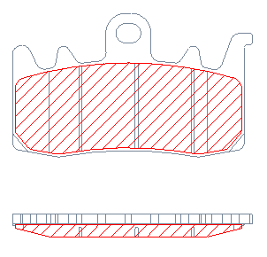

**Figure 2**

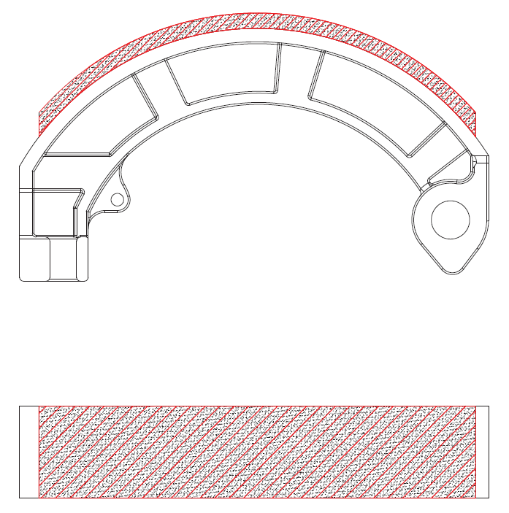

3 area groups are foreseen, as in Table 1 (for brake pads) and in Table 2 (for brake shoes):

…

**Table 2**

|  |  |
| --- | --- |
| *Group* | *Brake lining area [cm2]* |
| A | ≤21 |
| B | > 21 ≤ 54 |
| C | > 54 |

“

1. \* In accordance with the programme of work of the Inland Transport Committee for 2022 as outlined in proposed programme budget for 2022 (A/76/6 (part V sect. 20) para 20.76), the World Forum will develop, harmonize and update UN Regulations in order to enhance the performance of vehicles. The present document is submitted in conformity with that mandate. [↑](#footnote-ref-2)