Economic Commission for Europe
Committee on Environmental Policy
Special session
Geneva, 9–12 May 2022
Item 3 (b) of the provisional agenda
The Ninth Environment for Europe Ministerial Conference:
Substantive thematic documents

Information paper No.3
5 May 2022

Applying principles of circular economy to sustainable tourism
Background thematic document
Note by the secretariat
Summary
The ECE Committee on Environmental Policy at its twenty-fifth session (Geneva, 13–15 November 2019) agreed on the following two themes for the Ninth Environment for Europe Ministerial Conference (Nicosia, 5-7 October 2022):
(i) Greening the economy in the pan-European region: working towards sustainable infrastructure.
(ii) Applying principles of circular economy to sustainable tourism.
At its twenty-seventh session (Geneva and online, 3-5 November 2021), the Committee considered the drafts of two background thematic documents on the themes for the Ninth Environment for Europe Ministerial Conference and asked:
• The Committee to make concrete suggestions and proposals on the first drafts of the two background thematic documents on the themes for the Ninth Environment for Europe Ministerial Conference and to send them to the secretariat, preferably by the end of November but no later than 31 December 2021.
• The Bureau, with support from the secretariat and in cooperation with relevant stakeholders, to further develop the two drafts and submit them to the special session of the Committee in May 2022.
Comments on the first draft of the background thematic document “Applying principles of circular economy to sustainable tourism” were received from three countries (Czechia, Hungary and Sweden) and four organizations (European Investment Bank (EIB), OECD, UNEP, and UNWTO).
A consultant was contracted by the UNECE to assist the secretariat to revise and further develop the first draft of the background thematic document.
The Committee will be invited to consider the paper, as appropriate, and guide the secretariat to finalize it and process as an official document of the Ninth Environment for Europe Ministerial Conference (5-7 October, Nicosia, Cyprus).

Table of content

1 Context: Why we need to apply circular economy principles to sustainable tourism 1
1.1 The tourism industry represents an important social foundation for our society 1
1.2 The tourism industry causes significant negative externalities overshooting the ecological ceiling 2
1.3 Applying circular economy principles ensures that tourism remains in the safe and just space for all 4
1.4 Recovery from COVID-19 represents an opportunity to rebuild the tourism industry better 5
2 Opportunity: How applying circular economy principles can lead to a more sustainable tourism 7
2.1 Nine circular economy principles need to be considered for a more sustainable tourism 7
2.2 Applying circular economy principles to tourism from a demand-side perspective 9
2.3 Applying circular economy principles to tourism from a supply-side perspective 11
2.4 External drivers solving the demand-supply chicken-egg-problem 13
3 Current solutions: What has been done so far to move towards a circular tourism model 14
3.1 Six current solutions on a macro level 15
3.2 Six current solutions on a micro level 16
3.3 Six current solutions on an organizational level 17
3.4 Indicators to measure the progress towards circular tourism 18
4 Challenges: Which challenges need to be addressed to move towards a circular economy in tourism 19
4.1 The 12 most urgent and important challenges on a macro level 19
4.2 The seven most urgent and important challenges on a micro level 21
4.3 The 15 most urgent and important challenges on an organizational level 22
5 Conclusion and recommendations: How to promote a more circular economic model in tourism 23
5.1 Building a network of role-model circular tourism destinations 23
5.2 Establishing a shared circular tourism indicator framework 24
5.3 Investing beyond digitalization in data- & AI-driven innovation 25

1 Context: Why we need to apply circular economy principles to sustainable tourism

The tourism industry represents an important social foundation for our society

- The tourism industry is an important economic sector in many advanced and developing economies. In 2019, prior to the coronavirus pandemic, tourism contributed to 10.4% of the global GDP (USD 9.2 trillion), accounted for 1 in every 4 new jobs created around the world and to 10.6% of all jobs (334 million). Tourism was until 2019 the third world largest export category (USD 1.7 trillion) after fuels and chemicals. Between 2009 and 2019, the number of global international tourist arrivals continued to increase an average of 5% per year reaching record 1.5 billion arrivals in 2019 and global expenditures on travel more than doubled between 2000 and 2019, rising from USD 495 billion to USD 1.4 trillion.² The direct contribution of tourism to the European Union’s GDP was 3.9% in 2018. Furthermore, Europe was in 2019 the leader of world’s international arrivals with 51% followed by Asia and the Pacific with 25%, as well as the leader in international tourism receipts with 39% followed again by Asia and the Pacific with 30%. Despite the drastic impact of COVID-19 on tourism (discussed in section 1.4), the tourism industry is expected to continue growing an exceed the 1.8 billion thresholds in global arrivals by 2030.

- The tourism industry has also an important indirect impact on other sectors due to its multiplier effect. The strong interconnectedness of tourism with other sectors which support it (such as agriculture, transportation, finance…) leads to tourism revenues spreading across them. Therefore, tourism is acknowledged as cross-cutting economic sector considered in numerous policies and international initiatives such as: UNWTO 2030 agenda; key policies and instruments regulating Coastal and Maritime activities related to sustainable tourism, including the Barcelona Convention and its Protocols, as well as the MSSD and the Regional Action Plan on SCP, the EU MSP Directive, the ecosystem-based management principles, the EU Blue Growth Strategy, the BlueMed Initiative, the Bologna Charter Initiative, and the integrated regional development policies on sustainable tourism.

- While the tourism sector represents a major part of the GDP for many economies around the world, it is even more important for certain regions which benefit from certain types of tourism due to their geographical and cultural characteristics. For example, in Spain tourism contributed to 12% of the GDP in 2019, while for the Canary Islands region in Spain, it accounted for 33% of their GDP.

The tourism industry causes significant negative externalities overshooting the ecological ceiling

- The current linear economic tourism model is contributing to many negative externalities overshooting the ecological ceiling due to its increasing energy demand, high amount of waste generation, high amounts of water consumption and uncontrolled wastewater discharges, and increasing global greenhouse gas (GHG) emissions. According to a study published in 2015, future tourism resource consumption of water, food, land, energy and emissions will double within the next 25 to 45 years. Many environmental impacts of the tourism sector are linked to the construction and management of infrastructure such as roads, ports and airports, and tourism facilities, as well as to transportation. In the following tourism’s impact on greenhouse gas emissions, energy consumption, solid waste generation, and water consumption/pollution.

- From a greenhouse gas emissions perspective, tourism is responsible for 8% of global GHG emissions. In a ‘business-as-usual’ scenario, tourism GHG emissions will increase by 131% until 2050. Within tourism related GHG emissions, transportation accounts for 75%, accommodation for 21% and activities for 4%. This has resulted in increasing levels of air pollution becoming a major environmental health risk to the pan-European population, with disproportionate effects on children, elderly, and the poor.

- From an energy consumption perspective, in a ‘business-as-usual’ scenario, tourism will see an increase of 154% in energy consumption by 2050.⁸ The tourism sector consumes significant levels of energy which comes mostly from fossil fuels. The high energy consumption is due to both transport-related activities, such as travel to, from and at the destination, and destination-related aspects, such as accommodation, food and tourist activities. The rapid growth in both international and domestic travel, the increasing trend to travel further distances over shorter periods of time, and the preference for energy-intensive transportation modes have increased the demand of fossil fuels for energy consumption and its energy dependency.

- From a solid waste generation perspective, especially single-use consumer goods and food waste in hotels and restaurants account for 60% and 40% respectively of all solid waste generation in tourism. UNEP has estimated that European tourists generate approximately 1kg/person/day of solid waste when touring in Europe. This figure can vary between 1 and 12kg/tourist/day depending on the tourist attributes, season of the year and the environmental legislations in the destination. The high amounts of solid waste generated put a lot of pressure in popular touristic regions with a low population density, as well as in touristic regions lacking waste management programs, no or rudimentary environmental protection legislation and lack of proper infrastructure. All of this is aggravated during the peak seasons. Tourism facilities generate large volumes of solid waste, which if not properly managed, can result among others in surface water and groundwater contamination, soil contamination, biodiversity loss, and emissions of air pollutants which in turn contribute to decrease the value of the tourist destination.

- From a water consumption/pollution perspective, the tourism industry generally overuses water resources for hotels, swimming pools, golf courses and personal use of water by tourists. This can result in water shortages and degradation of water supplies, as well as generating a greater volume of wastewater. Coastal and beach tourism (makes up to 80% of all tourism) is one of the top three land-based sources of marine litter together with sewage effluents and general household in the North, Mediterranean and Baltic seas. Some regions, especially in Central Asia, are more vulnerable than others to water pollution due to for example, uncontrolled irrigation, existing low volumes of groundwater supplies and their over-extraction, inadequate wastewater treatment infrastructure and seasonality. The UNEP/ UNWTO Green Economy report states that in a ‘business-as-usual’ scenario water consumption will increase by 152% by 2050. Furthermore, according to WWF’s “Out of the Plastic Trap” report, in the Mediterranean region alone, tourism is responsible during the peak season for up to 40% increase of the surge of marine litter that enters the Mediterranean Sea.

- Moreover, the negative externalities/impacts caused by tourism are worsened when it is concentrated in one season only, like winter or summer. For example, seasonal pressures cause stress into waste management systems, as the generated solid waste’s mass and volume flow are totally season dependent. Resource availability to local communities (e.g., water or energy) is also affected by tourism concentration in peak seasons, including generating impacts to their wellbeing and livelihoods.

- Tourism has therefore led to the overshooting of several planetary boundaries with its current linear model by contributing to climate change, pollution, and biodiversity loss, as well as impacting land and marine ecosystems, and now the counter-effects are negatively affecting and will continue to affect the sector if no action is taken. There is a high probability that there will be a shift in the preferences of destinations towards higher latitudes and altitudes due to more attractive climatic conditions, creating both ‘losers and winners’ in terms of visitor flows. Impacts such as decreasing natural snow reliability, increasing water shortages, beach erosion and flooding will affect many destinations around the world. For instance, climate change has made flooding in Venice more common. This could drastically reduce tourism incomes which Venice is so dependent on due to change in tourists flows towards other destinations less at risk from such events. Furthermore, according to WWF’s “Stop the flood of plastic” report, the tourism sector in the Mediterranean region loses up to €641 million each year from marine plastic pollution.

Applying circular economy principles ensures that tourism remains in the safe and just space for all

- Applying circular economy principles to sustainable tourism can help the tourism industry move from a linear to a circular economic model, by ensuring it remains an economic driver for the social foundations (outlined in 1.1), while not overshooting the environmental ceiling (outlined in 1.2) in which it depends. Doing so requires adopting one of the two perspectives outlined below.

- On the one hand, the skeptical perspective to circular economy proposes to slow down economic activity, as it is incompatible with sustainability, and socio-technical innovation will not enable countries to reach absolute eco-economic decoupling to prevent ecological collapse. Hence, this approach seeks to rethink the way we consume and produce by rationalizing the use of resources and go for a de-growth model in tourism.

- On the other hand, the optimist perspective to circular economy suggests going for a reformed form of capitalism which is compatible with sustainability and socio-technical innovations will enable eco-economic decoupling. This perspective believes that by transforming the current linear tourism model into a circular economic model, a growing tourism industry can prosper when it ensures the social foundations and reduces the intake of resources thereby limiting its environmental burden.

- While both perspectives are valid, this report takes the optimist perspective leveraging the Doughnut Economics concept. This concept means that humanity should not fall short on the social foundations and should not overshoot the ecological ceiling of planetary pressures to remain in the safe and just space for all. Figure 1 below illustrates the Doughnut Economics concept.

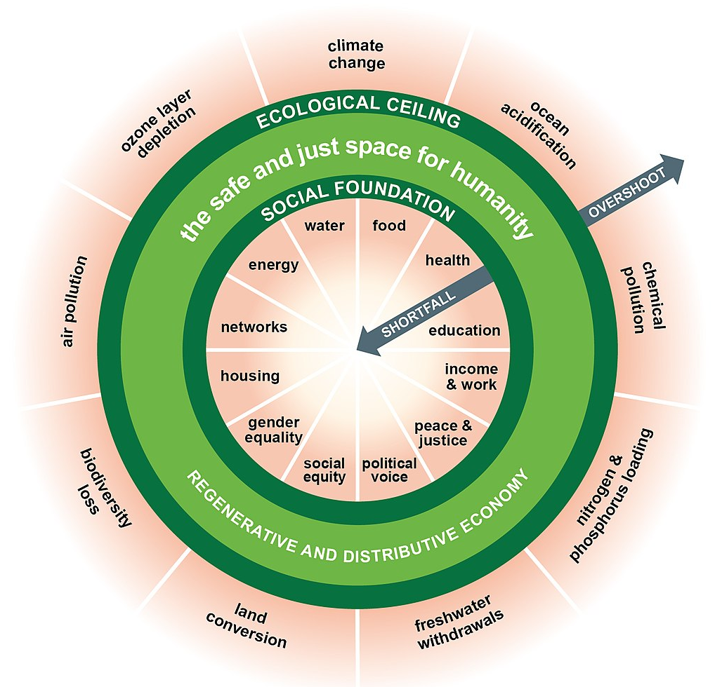
Figure 1 – Doughnut Economics
- Applying circular principles has the potential to elevate sustainable tourism from an environmental perspective and ensuring that tourism establishes itself within the safe and just space for humanity.

- Thereby, sustainable tourism is defined by the UNWTO as follows: “Tourism that takes full account of its current and future economic, social and environmental impacts, addressing the needs of visitors, the industry, the environment and host communities”.

- Whereas the concept of circular economy is defined by the World Economic Forum as “an industrial system that is restorative or regenerative by intention and design. It replaces the end-of-life concept with restoration, shifts towards the use of renewable energy, eliminates the use of toxic chemicals, which impair reuse and return to the biosphere, and aims for the elimination of waste through the superior design of materials, products, systems, and business models”.

- This report seeks to help policymakers understand how the tourism industry can ensure that humanity does not fall short on the income and work that tourism provides, while ensuring that not more negative environmental impacts are created than the Earth can absorb. The nine key circular economy principles and how they apply to the tourism industry will be outlined in the chapter 2.

1.4 Recovery from COVID-19 represents an opportunity to rebuild the tourism industry better

- In the quest to remain in the “safe and just space for humanity”, COVID-19 has the potential to accelerate the transition from a rather linear to a more circular economic model of tourism. While COVID-19 has been the worst crisis in the history of tourism, rebuilding the industry represents an opportunity to incorporate circular economic principles in a systematic and holistic way across the whole tourism value chain.

- 2020 was the worst year for the tourism industry. International arrivals dropped by 74% from almost 1.5 billion in 2019 to 380 million in 2020, representing an estimated loss of USD 1.3 trillion in export revenues and around 120 million direct jobs at risk. The restrictions established by governments globally to fight the COVID-19 pandemic, have led to a near standstill of all the parts of the tourism value chain. Amongst others, accommodations had to close, events were canceled, and the mobility of tourists was limited. Furthermore, the air traffic network as a whole in Europe declined by 65% in 2020 comparison to 2019. Back in December 2020, the United Nations General Assembly acknowledged tourism among the economic sectors hardest hit by COVID-19. Several economies in the pan-European region are especially highly vulnerable to broad disruptions in global tourism since revenues from the sector range from 5 to even 30% of GDP in most countries. Countries like Georgia, Albania, Croatia, Montenegro, Cyprus, Greece, Italy and Spain were the among the most affected by the contraction in the sector (the global GDP tourism contribution fell from 10.4% in 2019 to 5.5% in 2020).

- During the second half of 2021 the tourism has slowly started to recover, even though the virus still has significantly impacted the tourism industry. Globally, tourist arrivals have grown by 4% compared to 2020 in 2021 but were still 72% below pre-COVID-19 figures. The recovery is unevenly distributed amongst regions. For instance, in 2020, Southern Mediterranean Europe has seen a growth rate of 57%, falling short “only” by 54% below pre-COVID-19 figures. In 2022, the tourism industry is still expected to be 50% to 63% below pre-COVID-19 levels and 64% of experts believe that international arrivals will return to 2019 levels only in 2024 or later.

- As stated by Inger Andersen, Executive Director at UNEP “The sector has less than 10 years to accelerate the transition to low-carbon and circular business solutions; to create new opportunities in energy generation and halve transport emissions by 2030; and to integrate nature-based solutions into their operations”. This recovery process has the potential to rebuild the tourism industry in a more sustainable way by applying the circular economy principles. Especially, as the recovery is highly supported by governments and institutions, who can bound the support offered to sustainability objectives, and as collaboration across the tourism ecosystem is at the center of recovery plans. Many of such initiatives and collaborations can be observed. For instance, the European Tourism Manifesto alliance was recently established as a group of more than 60 public and private travel and tourism organizations and the voice of the sector in Europe, for the development of joint recommendations for EU Member States. The UNWTO is leading the “One Planet Vision for the Responsible Recovery of the Tourism Sector” program calling for a responsible recovery in the tourism sector, which is founded on sustainability, to build back better. Besides the One Planet Network, the tourism working group and the OECD tourism committee welcomed at the 2021 G20 Italy Presidency UNWTO’s recommendations for tourism’s green transformation. The recommendations present the main lines of action and showcase frontrunning initiatives of tourism businesses and destinations leading the way in achieving greater sustainability. Furthermore, transport initiatives for recovery plans are determinant to avoid a rebound of environmental pressures for different transport means. For instance, policy packages, such as those advocated by the Transport, Health and Environment Pan-European Program (the PEP), can help promote public transport in combination with walking and cycling as part of urban and eco-touristic destinations.

- Therefore, the recovery process from COVID-19, represents a real opportunity to rebuild the tourism better. In this report we outline how applying circular economy principles to tourism could be incorporated in the recovery process.

2 Opportunity: How applying circular economy principles can lead to a more sustainable tourism

2.1 Nine circular economy principles need to be considered for a more sustainable tourism

- UNEP’s circularity approach considers the following circularity principles which they group into four categories, going from most to least impactful. First category, ‘guiding principle’, involves “reduce by design”. Second category ‘user-to-user’, involves “refuse”, “reduce” and “reuse”. Third category ‘user-to-business’ involves “repair”, “refurbish” and “remanufacture”. The last category, ‘business’ to business involves “repurpose” and “recycle”. Figure 2 illustrates the principles.

Figure 2 – UNEP’s circular economy principles

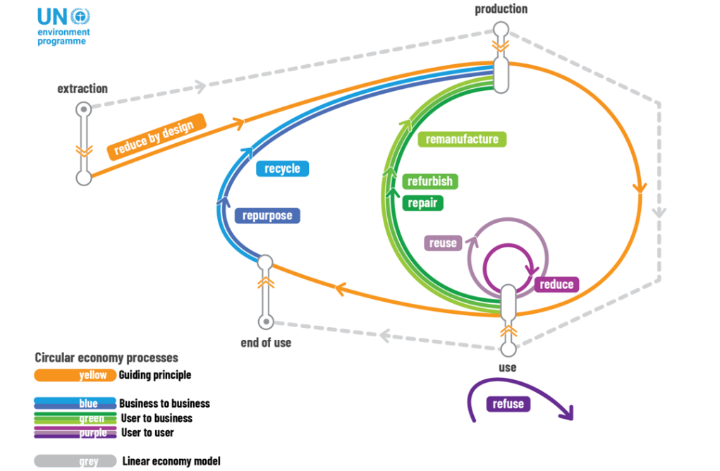

- In the following the “R” principles are defined:

  - “Reduce by design” requires using less materials per unit of production, especially virgin raw materials from the earliest stages of the design of products.

  - “Refuse” is linked to user choices opting to stop buying or using certain products.

  - “Reduce” requires people to rethink how to meet their own needs with the lowest burden on the planet and people around them.

  - “Reuse” refers to using again of a product, object or substance that is not waste, for the same purpose for which it was conceived, without the necessity of repair or refurbishment.

  - “Repair” refers to the fixing a product and/or replacing defective components, in order to make it fully a functional product to be used for its originally intended purpose. It is meant to extend the lifetime of the product. An important difference between repair and refurbish is that repairing can be done by different actors and may involve change in ownership.

  - “Refurbish” happens during maintenance operations and seeks an overall upgrade of the product. According to the Basel Convention, it refers to the modification of an object that is a waste or a product to increase or restore performance and/ or functionality or to meet applicable technical standards or regulatory requirements, with the result of making a fully functional product to be used for a purpose that is at least the one that was originally intended.

  - “Remanufacture” differs from refurbish as it implies a full product improvement where the complete structure of a multi-component product is disassembled, checked, cleaned and when necessary, replaced or repaired in an industrial process.

  - “Repurpose” requires the reuse of old/discarded components or materials to be adapted for another purpose (e.g., upcycling glass bottles into mugs).

  - “Recycle” is the last R and one where most value is lost. It refers to the relevant operations which prevent waste disposal and allows material to re-enter the loop. Recycling requires the use of expensive technology and infrastructure for processing of mixed post-consumer products or post-producer waste streams to remove impurities and improve material quality.

- Applying circular economy principles to tourism is an ongoing effort and so far, there is no consensus reached about how exactly a circular tourism model would look like. As foundation for discussions, the following subchapters propose how a circular tourism model could look like from a demand-side as well as from a supply-side perspective.

2.2 Applying circular economy principles to tourism from a demand-side perspective

- Unfortunately, circular economy is too often only discussed from a supply-side perspective. In the tourism industry however, the behavior and requirements from the tourists shape the industry. Therefore, applying circular economy principles at the demand-side (tourists) could result in a significant different tourist experience (which is seen as the product of tourism), that leads to a more circular tourism industry. In the following, the impact of the principles on each of the six key tourist experience activities are discussed.

- “Pre-travel” encompasses the planning of the journey. The tourist can apply the CE principle “Reduce by design” in various ways:

  - Distance to destination: By selecting tourism destinations that are closer to the tourist residency, the CO2 footprint can be drastically reduced. On the one hand, environmental unfriendly means of transport pollute less for shorter distances (e.g., short haul vs. long haul flights). On the other hand, more environmental travel options may become a viable alternative (such as taking the train).

  - Duration of stay: Increasing the number of days spent at the destination also reduces the environmental footprint. Fewer but longer stays throughout the year reduce the need for additional travel.

  - Moment of stay: Travelling off-season has the advantage that infrastructure capacities can be used more evenly throughout the year, reducing the infrastructure needed. Furthermore, reducing accumulation of tourists allows the ecosystem to recover and to absorb a larger part of the environmental burden created through tourism activity.

  - Type of tourism: The tourist may opt for a tourism type that reduces the burden on the environment. For example, “slow tourism” (e.g., walking, driving a camper van, cycling…) reduces the volume of resources consumed. Or changing “sun & beach” tourism to “cultural/educational” tourism has the potential to reduce the density of tourists and leverage infrastructures that are currently not fully leveraged.

Applying the “reduce by design” principle to the “pre-travel” planning activity might create the impression that “less is better”. Some might argue that the most sustainable tourism is “staycation” (staying at home instead of traveling). However, as outlined in chapter 1, the objective of the “optimist perspective” view to circular economy as adopted in this article, is to maintain the economic benefits of tourism to not fall short on the “social foundation”, while reducing the pressure on the “ecological ceiling”.

- “Travel” refers to tourist’s journey from its original location to the destination. Tourists can apply the “reduce” CE principle by opting for more environmentally friendly means of transport (e.g., train, bus…) and “reuse” CE principle by leveraging transportation sharing platforms (e.g., BlaBlaCar) to use the unleveraged capacity of travel assets.

- “Transportation” includes all movements with vehicles at the destination. The CE principle “reduce” can be achieved for instance with more energy efficient engines, the CE principle “reduce by design” applies when selecting electric instead of traditional cars, and the “reuse” CE principle refers for example to the practice to leverage sharing platforms for transportation similarly to the “travel” activity.

- “Accommodation” involves the residency during the tourism activity. The CE principle “reduce by design” refers to the choice of accommodation by the tourist. Either by leveraging accommodation sharing platforms (such as EcoBnB, HomeExchange, GoMore…) to leverage existing infrastructures (as long as they have not been especially constructed for sharing business models) or by selecting accommodations such as hotels that have a higher circular standard (e.g., hotels that use ReFood recycling solutions or solar panels for energy sourcing). The CE principle “reduce” is mainly driven by the tourist’s behavior within the accommodation (using less water, switching off the lights, recycling own waste, agreeing to not let the room cleaned every day…).

- “Food & Beverages” refers to the consumption of food and beverages during the stay within and outside the accommodation. The CE principle “reduce by design” can be applied by the selection of more circular Food & Beverage facilities. Furthermore, the tourist can “reduce” food waste through his/her behavior.

- “Activities” refers to tourism activities such as tours, excursions, wellbeing, etc. The environmental burden can be “reduced by design” by selecting less polluting activities or improving the activities. For instance, the concept of “cruise ships tourism 2.0” aims to extend the stays before and after the departing/arriving city, while leveraging the accumulation of tourists on a limited space on the ship to educate the tourists for more environmental behavior at the travel locations. However, it is critical to assess the circularity of the whole activity. While it is positive to see more sustainable behaviors emerge in cruise ship tourism, most cruise ships still are very polluting.

2.3 Applying circular economy principles to tourism from a supply-side perspective

- While the tourism industry is highly shaped by the demand-side customer experience, a transition to a more circular economic model for tourism is only possible by also incorporating a supply-side perspective. Tourists can only opt for circular tourism experiences when those are available (e.g., tourist can only “reduce by design” by leveraging accommodation sharing platforms when those are available at the destination). Especially as the circularity of an offered experience is highly dependent of the circularity of the ecosystem it is embedded in (e.g., a hotel that offers to “recycle” is dependent of the recycle infrastructure of the destination). Furthermore, while a demand-side driven pressure to move towards a more circular model is certainly valuable, tourist education is an important challenge by itself. Establishing a circular tourism offer landscape will allow to experience circular tourism to convince more tourist to join this more sustainable practice. Therefore, this sub-chapter outlines how CE principles could be applied to the supply-side of tourism.

- The complexity of the tourism industry represents a challenge to the application of CE principles. The large volume of interconnected and interdependent small-scale operators, collaborating over many layers and involving as well public as private stakeholders make an industry wide application challenging. Figure 3 provides an overview of the complex tourism industry.

Figure 3 – The tourism value chain
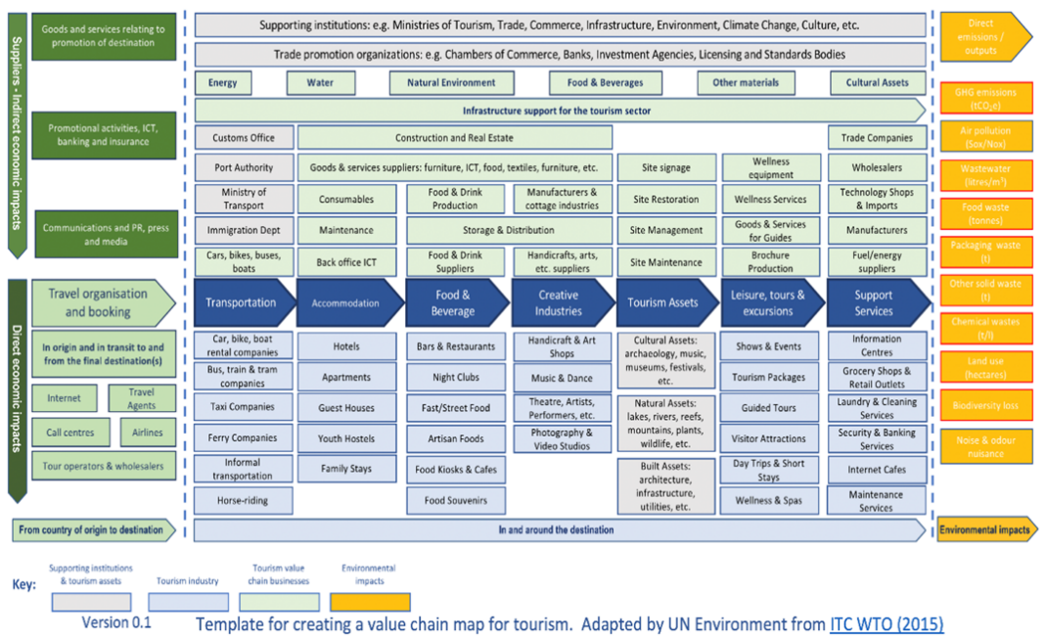

- Transitioning this complex industry towards a more circular economic model requires to shift the business logic. Private players need to adopt a stakeholder instead of shareholder optimization model, involving employees, suppliers and local communities as core stakeholders and partners. The strategy needs to focus on collaborative rather than competitive advantage, aiming to jointly benefit from the transition towards a circular economic model. The scope of reasoning needs to move from a siloed “winner-takes-it-all” competitive approach to a network-based value co-creation approach.

- Thereby, first movers can expect rewards through for example:

  - Lower CAPEX, through asset optimization and upstream supply chain servitization

  - Lower OPEX through resource and waste stream optimization

  - Lower OPEX through higher staff engagement and retention

  - Additional revenue streams through asset sharing and recirculation

  - Increased resilience through localized upstream side supply chain Strengthened innovation culture resulting in new revenue streams

  - Optimized risk profile and brand value

- Thereby, applying CE principles will differ between “asset light” and “asset heavy” tourism players.³³ “Asset light” players delivering non-tangible services (e.g., agencies, hotel operations…) play a central role in shaping circular business models, processes, supplier selection and building the circular narrative. While “asset heavy” players owning physical assets (e.g., accommodation facilities, transport infrastructures…) can more directly impact resource circularity (e.g., through sourcing and maintenance of materials, sharing of assets…). A typical hotel model may illustrate this argument. Often, the hotel is operated by an asset light brand (such as Accor), while the hotel infrastructure belongs to a hotel owner. While the hotel operator can incentivize tourists, employees, and suppliers to adopt more circular practices, only the hotel owner can optimize the resource efficiency of the facilities.

- Regardless of the players’ asset type, additional critical success factors involve:

  - Local employees’ and residents’ awareness of the importance of circular tourism is critical to promote the transition in practice, which is dependent of adequate awareness and training campaigns;

  - Ecosystem standards (e.g., CE supplier code of conduct) to align on circular principles to ease the identification of suitable circular economy partners;

  - Private and public infrastructures (e.g., recycling facilities, real estate, environmentally friendly transport offerings…) to allow for circular practices;

  - Policy making (e.g., tax systems supporting CE adoption, educational programs, legislation allowing for circular business models…) play a central role in establishing the needed business environment; and

  - Circular business model innovation (e.g., new consumptions models such as couch surfing, new value retention models such as pay-as-you-use…) to systematically change the value proposition, creation and retention logic of tourism players.

2.4 External drivers solving the demand-supply chicken-egg-problem

- The transition towards circular tourism needs to overcome a demand-supply chicken-egg-problem. Attractive circular tourism experiences are needed to convince tourists to join the more sustainable model. However, tourism players on their side require a strong demand before investing in the circular transition. To overcome this problem, policymakers play a central role to foster the transition (recommendations in chapter 5). However, also external drivers have the potential to speed up the transition, as outlined below.

- On a political level, the growing willingness of governmental bodies to move towards circular economy provides the needed context for environmental policymakers. For instance, the “EU taxonomy for sustainable activities”, established to meet the 2030 climate and energy targets of the EU, names “the transition to a circular economy” as one out of six key objectives.

- On an economical level, the increasing scarcity of resources coupled with fluctuating commodity prices, provide strong incentives for companies to leverage CE principles for higher resource efficiency and higher value retention of materials. For example, the circular economy combined with technological innovation could allow Europe to increase its resource productivity by up to 3% annually and could generate a net economic benefit of €1.8 trillion by 2030.

- On a social level, the raising environmental awareness of society (especially tourists, employees, shareholders, and residents) creates pressures to move towards a more circular economic model. For instance, in the latest research study from Booking.com, 83% of tourists think sustainable travel is crucial and 49% mentioning that there are not enough sustainable travel options available.

- On a technological level, technological advancements have the potential to support the transition. For example, advancements in data-driven technologies (sensors, artificial intelligence…) provide increasing transparency for better circular decision making (e.g., by assessing lifetime values of materials) and for automation (e.g., making “closing the loop activities” viable options).

- On an environmental level, climate change puts pressure on society and companies to act. For example, the latest sixth IPCC report calls for immediate action, insisting on reaching peak GHG emissions by 2025.

- On a legal level, efforts to establish a legal foundation is a key promoter. While environmental policymaker can influence legislation, it is still an external factor. For instance, through the “Aarhus Convention and its Protocol on Pollutant Release and Transfer Registers”, the UNECE has conducted substantial efforts to promote the key drivers of sustainable tourism, namely the rule of law, transparency, and effective, safe and inclusive public participation in decision-making on certain related policies, plans and projects

3 Current solutions: What has been done so far to move towards a circular tourism model

- Circular tourism solutions haven taken off over the past years, marking the beginning of the transformation of the so far linear tourism model. But more circular solutions with international commitments are needed. Solutions can be observed on a macroenvironmental level (can hardly be influenced by companies at a society/economy wide level), microenvironmental level (can indirectly be influenced by companies at the companies’ value chain and region level) and organizational level (can be directly influenced by companies). In this chapter, six existing solutions are described per level. The table 1 below provides an overview of the solutions, specifying their link to the CE principles and their regional application. Section 3.4 adds the perspective of indicators.

Table 1 – Overview of existing solutions
Level | Solution | CE principles | Scope
Macro | Decree Law 3/2022 for circularity in tourism | Reduce/Reuse/Recycle | Balearic Islands, Spain
 | CIRCULAR STEP, Stakeholder Engagement Platform | Refuse/Reduce/Reuse/Repair/ Refurbish/Remanufacture/  Repurpose/Recycle | UNECE region
 | Circular Economy Action Plan | Reduce/Reuse/Repurpose/  Recycle/Remanufacture/  Refurbish/Repair | European Union
 | UN Global Agreement of Plastic Pollution [mine] | Reduce by design/Reduce/  Recycle | Global
 | Regional Action Plan on SCP in the Mediterranean | Reduce by design/Reduce/ Reuse/Recycle | EU, Mediterranean
 | BS8001 | Reduce by design/Reduce/  Reuse/Recycle | Global
Micro | Global Tourism Plastics Initiative, One Planet Network | Reduce/Reuse/Recycle | Global
 | Glasgow Declaration- Climate Action in Tourism, One Planet Network | Reduce/Reuse/Recycle | Global
 | CEnTOUR Project | Refuse/Reduce by design/ Reduce/Reuse/Repurpose/  Recycle | Spain, Moldova, Greece, North Macedonia, Italy
 | Sustainable Tourism Interreg MED horizontal projects | Refuse/Reduce by design/ Reduce/Reuse/Repurpose/  Recycle | Europe (Mediterranean)
 | Urban Waste Europe | Reduce/Reuse/Recycle | EU cities
 | FACET Interreg 2 seas project | Refuse/Reduce by design/  Reduce/Reuse/Remanufacture/ Repurpose/Recycle | Coastal areas of various EU countries
Organizational | 4-star Crowne Plaza Copenhagen Hotel | Reduce/Reduce by design/  Reuse/Repurpose/Recycling. | Denmark
 | Belgian hotel  chain Martin’s Hotels | Reduce/Reuse/Recycling | Belgium
 | Green mobility at  Val d’Hérens | Reuse | Switzerland
 | Instock Restaurant | Reuse/Reduce/Repurpose/ Recycle | The Netherlands
 | Gust’eaux Restaurant | Reuse/Repurpose | Belgium
 | NH Hotels CORK2CORK initiative | Reuse/Repurpose | Spain, Italy

3.1 Six current solutions on a macro level

- Decree Law 3/2022 for circularity in tourism – To have a better management of the tourism destination and maintain a balance of natural resources, new tourist accommodation will be prohibited, and it will be compulsory for hotel companies to have circular economy action plan (investing in energy and water efficiency among other requirements).

- CIRCULAR STEP, Stakeholder Engagement Platform – The UNECE launched on April 6th, 2022, a platform for policy dialogue to bring together all 56 members states in the circular economy transition and support the achievement of SDG 12 on responsible consumption and production. This platform will facilitate exchanges of experience, share best practices, and engage stakeholders in accelerating the circular economy transition. This will play an important role in the development of circular economy roadmaps for tourism.

- Circular Economy Action Plan – As part of the European Green Deal, the European Commission has implemented a series of actions foreseen under the Circular Economy Action Plan in 2020 with regards to electronics and ICT, packaging, plastics, textiles, construction, buildings, and food which are highly relevant for the tourism industry. Tourism will need to accelerate its transition towards a circular economic model that reduces its consumption footprint, increases its material circularity, and gives back to the planet more than it takes.

- UN Global Agreement of Plastic Pollution – In March 2022 the UN Environment Assembly agreed to launch negotiations (until 2024) on a legally binding global agreement against plastic pollution. This agreement will consider all stages of the plastics life cycle form product design to disposal. This puts pressure across the tourism value chain to act towards the circularity of plastics.

- Regional Action Plan on SCP in the Mediterranean – A common regional action framework towards sustainable consumption and production (SCP) in the Mediterranean. The Contracting Parties are committed to apply the ecosystem-based approach as an integrated approach to enhance sustainable development in the region. The elaboration of the SCP regional action plan considers the 10-Year Framework of Programs on SCP Patterns and the 2030 Agenda for sustainable development. Tourism is one of the four priority areas.

- BS8001 – The first standard for implementing the principles of the circular economy in organizations. The British Standard (BS) system 8001 is a voluntary guidance standard. It is a set of comprehensive and practical guidelines for implementing the principles of the circular economy on an organizational level. This is a first step in helping tourism companies move towards the same direction in their transition towards becoming more circular. It serves as a first blueprint of circular economy standards, as no standards have been yet made specific for circular economy in the tourism sector.

3.2 Six current solutions on a micro level

- Global Tourism Plastics Initiative, One Planet Network – Provides a framework for businesses to formulate concrete and actionable targets (such as elimination of unnecessary and problematic plastics from their operations) and report annually on progress towards their implementation.

- Glasgow Declaration- Climate Action in Tourism, One Planet Network – It is a declaration of commitment to unite and align all tourism stakeholders in acting towards climate change. By signing the declaration tourism stakeholders voluntarily commit to halve emissions by 2030 and reach net zero before 2050.

- CEnTOUR Project – CEnTOUR is a COSME EU project which aims to support tourism SMEs across five European countries. This project is very important as SMEs play a key role in the growth of the tourism sector and often lack the necessary knowhow and tools to embrace circular economy in their operations. Among the many ongoing outcomes of the project, they have developed a database of best practices implemented by SMEs in the transition towards circular economy which can be easily filtered by providers (e.g., campsites, restaurants, resorts…) and by the different circular economy principles. They have also developed a handbook called “managing the transition to circular economy for tourism providers”.

- Sustainable Tourism Interreg MED horizontal projects – Provides a framework for businesses to formulate concrete and actionable targets (such as elimination of unnecessary and problematic plastics from their operations) and report annually on progress towards their implementation.

- Urban Waste Europe – This project took place between 2016 and 2019 with the aim of helping policymakers in developing strategies that aim at reducing the amount of municipal waste production and at further supporting the reuse, recycling, collection, and disposal of waste in cities with high levels of tourism. With the help of technology, they provided tourists and tourism service providers with a waste-app (the goal was to make the stay more sustainable while playing and winning awards), a food waste tracker (with the objective of tracking food waste in real time and prevent it) and interactive maps to show waste-free high performing tourism services.

- FACET Interreg 2 seas project – The project aims to facilitate and increase the adoption of circular solutions in the tourism sector by supporting entrepreneurs in shifting from linear to circular. Increasing awareness of companies in the tourism sector about the circular economy, creating new business models and other forms of cooperation is an important issue within the project. FACET provides expertise and supports in developing various locally practical, accessible, and small-scale pilot and demonstration projects to help entrepreneurs gain practical knowledge and experience on circular business model innovation.

3.3 Six current solutions on an organizational level

- 4-star Crowne Plaza Copenhagen Hotel – It is a carbon-neutral hotel awarded with the ‘Golden Nail’ by the UN Global Compact for being an innovative and environmentally friendly construction. It has built the largest integrated solar panel park in northern Europe (covering all the façades of the hotel) and has one of the world’s most advanced aquifer thermal energy storage systems. They have reduced their energy consumption by 53%. All food waste is grinded and sucked into a 10,000-litre tank in the basement. When full this is delivered to a biogas plant.

- Belgian hotel chain Martin’s Hotels – Martin’s Hotels is a Belgian chain with 14 hotels across Belgium. They are a great example of successful integration of circular economy in purchasing policies through strong supplier collaboration. A lifecycle approach applies to all purchasing decisions. For example, they constantly analyze the total cost of ownership and favor leasing/rental contracts for company cars, coffee machines, etc. Through their holistic, systemic thinking they are creating impact that goes beyond the resource flows of the firm.

- Green mobility at Val d’Hérens – The Maya boutique hotel has developed a collective approach to rethink tourist mobility. They have built a network of electric cars and charging stations available for hotel guests, throughout the entire valley in the Swiss Alps. They have implemented a “pay what you want” principle to nudge their clients in becoming active participants of their service and let them decide on the financial remuneration. The financial contribution is not perceived as an expense but as an appreciation of a valued service.

- Instock Restaurant – The Instock staff rescues from unnecessary disposal the food surplus of Albert Heijn supermarkets which is not expired but cannot be sold anymore for various reasons. The menu is thus dependent on what it is available from the unwanted but still good food form those supermarkets. Furthermore, they produce their own beers from potato peels and saved bread in partnership with a brewery.

- Gust’eaux Restaurant – This restaurant in Kuurne (Belgium) has managed to provide its visitors with high-quality drinking water which comes from their own wastewater using their purification system and advanced technology in collaboration with Tuincreatie Wouter Igodt, ECOZ, BOSAQ, Vlakwa and Ghent University. They have managed to close completely the water circle and are completely independent with regards to water use and consumption.

- NH Hotels CORK2CORK initiative – In 2011, the NH Hotel Group conceived the idea of recovering and reusing the cork stoppers from wine bottles with the leading producer of cork and cork covering materials Amorim. The recovered corks are turned into covering and insulation materials for subsequent use in the construction of new rooms. This initiative contributes to improve the hotel’s energy efficiency as it acts as a heat insulator avoid the need for artificial temperature controls.

3.4 Indicators to measure the progress towards circular tourism

- Circular tourism indicators are critical as they help tourism stakeholders measure the effectiveness and progress of the adopted solutions in moving towards circular economy (e.g., monitoring the carrying capacity of destinations).

- There are some first attempts towards developing specific indicators for measuring circular tourism. For instance, the INCIRCLE project aims to enhance the sustainability and attractiveness of Mediterranean touristic insular and low-density areas through circular tourism. The project has developed a set of indicators structured into 50-60 questions related to four types of capitals and five circular economy principles to measure overall circular tourism performance. However, the field of circular tourism indicators is still in its infancy, specifically at a Pan-European level.

- For the development of circular tourism indicators, the general sustainable tourism indicator could be leveraged, for instance:

  - the European Tourism Indicators System (ETIS) – for managing and monitoring the sustainability of destinations;

  - the Global Sustainable Tourism Council (GSTC) indicators – performance indicators for hotels and tour operators;

  - UNWTO and United Nations Statistics Division (UNSD) initiative “Towards a Statistical Framework for Measuring the Sustainability of Tourism” – with the aim of developing an international statistical framework for measuring tourism’s role in sustainable development.

- Furthermore, general circular economy indicators could be specified for the tourism industry, such as:

  - the European Commission Monitoring Framework for the Circular Economy – 10 indicators which cover the thematic areas of production and consumption, waste management, secondary raw materials and competitiveness and innovation;

  - the World Business Council for Sustainable Development (WBCSD) Circular Transition Indicators – business-oriented indicators applicable to all industries, sizes, value chain positions and geographies;

  - Ellen MacArthur Foundation Circulytics – supports a company’s transition towards the circular economy, regardless of industry, complexity, and size; and

  - Circularity Gap Report Global Circularity Metric – used to measure the circularity at national level, among others).

4 Challenges: Which challenges need to be addressed to move towards a circular economy in tourism

- Chapter 2 has already highlighted that the complexity and interdependency of the tourism industry, as well as the demand-supply chicken-egg-problem represent overarching challenges in moving towards a more circular economic model in tourism. To support environmental policymakers in the Pan-European region to take next best actions, this chapter outlines the currently most urgent and important challenges of moving towards a circular tourism model on a macro (12 challenges), micro (7 challenges) and organizational (15 challenges) level. The challenges have been identified in a study of 42 academic articles and involving 33 CE tourism experts. Furthermore, to help prioritize actions, the 10 most crucial challenges out of the 34 total challenges are described in detail in each of the sub-chapters. Thereby, challenges qualify for crucial when they had an average score of at least 3/4 in importance and urgency and were mentioned by at least 20% of the experts.

4.1 The 12 most urgent and important challenges on a macro level

- The 12 most urgent and important challenges on a macro level have been structured through the PESTEL framework (P = Political, E = Economic, S = Social, T = Technological, EN = Environmental, and L = Legal) and are illustrated in the figure 4 below.

Figure 4 – Macroenvironmental level challenges
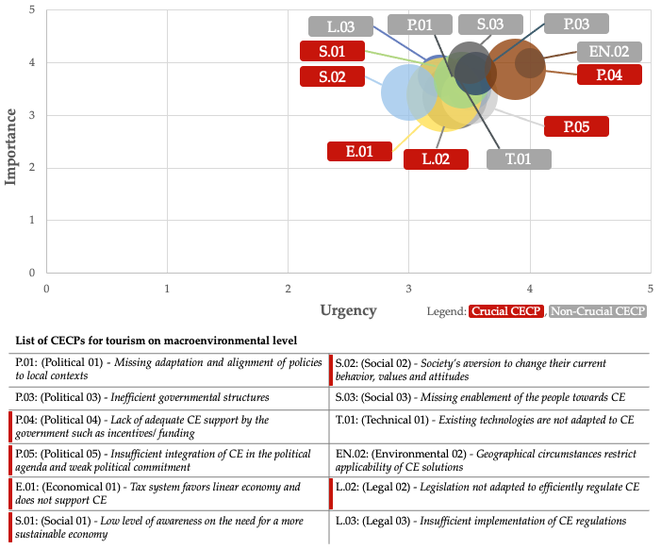

- Six of the 10 most crucial challenges are located on the macro level:

- Political - Lack of adequate CE support by the government such as incentives/funding: A key challenge is the lack of financial incentives established for tourism organizations (in particular SMEs) to become more circular. Specifically for the EU, there are a lot of “circular” funds available (such as Horizon2020, COSME), but the SMEs do not have the time and the expertise to understand the complex process for applying to these funds, making them unreachable for them.

- Political - Insufficient integration of CE in the political agenda and weak political commitment: The silo-mentality within governments hinders the implementation of a circular economy. There is a lack of integrated approach for policymaking and deficient institutional frameworks. Experts mentioned that politicians are not fully aware of the scale of the impacts caused by the tourism industry, which in turn does not create the willingness to focus on the tourism industry.

- Economic - Tax system favors linear economy and does not support CE: The current tax systems are not adapted for a circular tourism industry. For instance, secondhand furniture is taxed the same way as brand-new furniture, decreasing the incentives to switch towards circular economy procurement strategies for hotels. Also, the implementation of a green tourism tax has been seen as an opportunity for sustainable tourism incentivizing off-season/longer-stay tourism.

- Social - Low level of awareness on the need for a more sustainable economy: On the one hand, tourists are less aware of their behaviors when on holidays as to when they are at home. On the other hand, employees in the tourism sector have low levels of awareness and understanding on the opportunities and benefits that circularity can bring in tourism and how it can be implemented.

- Social - Society’s aversion to change their current behavior, values and attitudes: There is a rigidity in tourist behavior towards change and they tend to leave behind their “circular” attitudes. Tourists perceive circular practices less convenient and are not willing to make compromises on holidays. Furthermore, they find it often too difficult to adapt to the different waste systems at every destination they go.

- Legal - Legislation not adapted to efficiently regulated CE: According to the experts, existing regulations are interfering in the circular transformation of the tourism sector as the legal models are designed to favor the continuation of a linear economic model. For example, when it comes to the sharing of services/assets, i.e., hotel halls, hotel managers face legal barriers to do so. Another example is that certain regulations impede the reuse of materials as well as the end-of-life treatment of the waste to reincorporate appropriately into the supply chain. Furthermore, experts consider that there should be legal incentives to push citizens to choose the best environmental means of transportation, not only reflected in the price but through positive reward measures in place that induce more circular behaviors.

4.2 The seven most urgent and important challenges on a micro level

- The seven most urgent and important challenges on a micro level have been structured by Resources (R), Value Chain (VC) and Infrastructure (I). They are illustrated in the figure 5 below.

Figure 5 – Microenvironmental level challenges
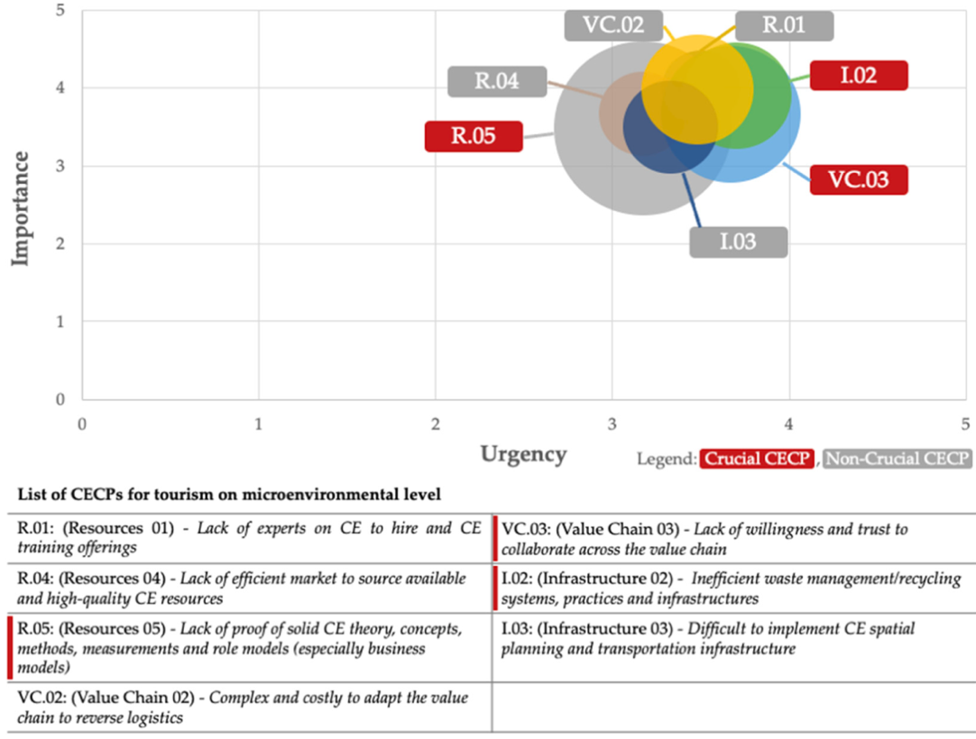
- Three of the 10 most crucial challenges are located on the micro level:

  - Resources - Lack of proof of solid CE theory, concepts, methods, measurements, and role models (especially business models): Experts argued that the practice of circular tourism is still in its infancy. For instance, too many different measures exist within the tourism sector and standardization of circular economy measurements is needed (e.g., to measure material flows). Another example is that no specific international certification on CE for tourism exists so far.

  - Value chain - Lack of willingness and trust to collaborate across the value chain: Network collaboration across the value chain to facilitate the implementation of CE all along remains complex. It is difficult to find and create the appropriate, trustworthy networks necessary for circularity. Especially as the tourism value chain consists of a great number of fragmented agents. The application of systems thinking is therefore critical. Furthermore, this complexity makes it difficult to achieve a coordinated as there is barely any cross-sectoral collaboration. For instance, it is possible to find solutions for the circularity of food, circularity of plastics, but not necessarily within the entire sector. To tackle this missing collaboration and coordination across the tourism value chain, experts have proposed that “transition brokers” are needed to make the transition effect when moving toward CE.

  - Infrastructure - Inefficient waste management/recycling systems, practices, and infrastructures: Inefficient waste management infrastructures are critical for the tourism industry. For instance, grey and black water recycling are highly relevant for the tourism industry in order to improve the water circularity across the hospitality sector, however the costs are very high compared to the costs of not doing so, making the adoption of this practice unattractive.

The 15 most urgent and important challenges on an organizational level

- The 15 most urgent and important challenges on an organizational level have been structured by Strategy (STRAT), Structure (STR), Culture (CULT), Customer Segment (CUSTS), Value Proposition (VP), Key Partners (KP), Key Resources (KR), Revenue Streams (RS) and Cost Structure (CS). They are illustrated in the figure 6 below.
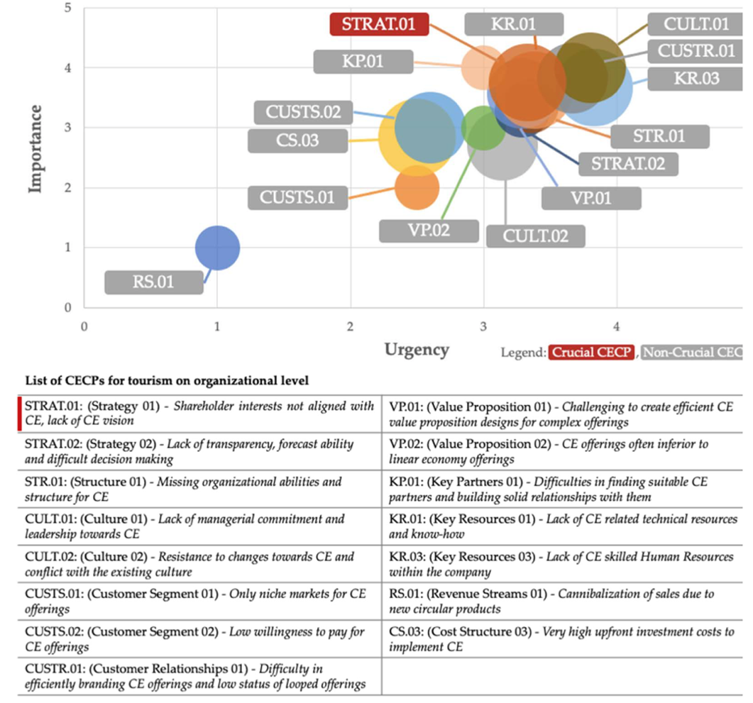
Figure 6 – Organizational level challenges

- One of the 10 most crucial challenges is located on the organizational level:

- Strategy - Shareholder interests not aligned with CE and lack of CE vision: The key players in moving the tourism industry toward CE are hotels. The hotel business is characterized by two main shareholders: hotel owners and the shareholders of the brands that operate the hotels. Brand shareholders are short-term oriented as they seek to optimize their share prize in the short term. Hotel owners on the other side, only have 1–3-year contracts with hotel brands. Thus, they have a great focus to perform well in this time to hopefully renew the contract. Short-term orientation of those two key shareholder groups represents a crucial challenge for moving toward a circular economy in the tourism industry.

5 Conclusion and recommendations: How to promote a more circular economic model in tourism

- This article argues that it is critical to move now towards a more circular tourism model. First, not to overshoot any longer our planet’s ecological ceiling through the polluting linear practices of our current tourism model, while ensuring tourism as important economic driver to not fall short on the social foundation. Second, as the tourism has a multiplier effect it can become a catalyst to move the whole economy more towards a circular model. Covid-19 represents an opportunity to build the tourism industry back better by systematically applying circular economy principles to the recovery efforts. This will require however a strong cooperation between the Pan-European countries, international organizations (e.g., UNEP, UNECE, UNWTO) and representatives from the private and public sector. It will be critical to augment existing solutions (chapter 3) and tackle the most urgent and important challenges (chapter 4). To conclude, this article proposes three actionable recommendations that are linked to the challenges and existing solutions.

Building a network of role-model circular tourism destinations

- Chapter 2 has outlined that the tourism industry is a highly fragmented and complex industry and that to move towards a circular model the demand-supply chicken-egg-problem needs to be solved. Instead of trying to transform the whole tourism model at once, this article argues that a network-effect strategy should be leveraged to build a network of role-model circular tourism destinations. Network-effects in this context means, on the demand-side, that focusing on a cluster of tourists allows to have positive spillovers of word-of-mouth and peer influence, and, on the supply-side, that each additional circular tourism destination increase the attractiveness of the offering ecosystem for tourists while offering synergy effects (especially of learning and in procurement) between the tourism destinations joining the network. This would allow to reach the critical mass to become relevant as approach for both tourists and tourism destinations, while leveraging network effects for systematic growth. Furthermore, specific role-model destinations would function as labs to develop further the still unmature understanding of circular tourism and serve as best practices for other destinations to join the transition.

- Existing solutions at destination level could be leveraged to build up on, such as the “Decree Law 3/2022 for circularity in tourism”, the “Regional Action Plan on SCP in the Mediterranean”, the “CEnTour Project”, the “Sustainable Tourism Interreg MED horizontal projects” (all of which are described in chapter 3), and many more projects not covered in this article. Furthermore, a digital platform to share best practices could leverage existing platforms. Such as the “Circular Step, Stakeholder Engagement Platform” and integrated in the “Circular Economy Action Plan” (both described in chapter 3).

- Once destinations have been selected and a best practice platform established, a value chain and hotspot analysis per destination would be useful to identify suitable areas within each value chain to start the transformation. “Food and beverages” and “built environment” (buildings and construction) could be priority areas for the integration of circular approaches in the tourism sector due to their centrality in tourism experience, their related environmental impacts, including material and carbon footprints, and their potential to influence the transformation of the sector and position tourism as an agent of change.
- Using the role-model circular tourism destinations as labs would allow to further develop the concept of circular tourism (tackling crucial challenge “R.05” on the micro level). At a smaller scale, it would allow to learn how to tackle other crucial challenges described in chapter 4 such as:

- How to establish collaboration schemes of tourism value chains in moving towards a circular model by for example funding dedicated “transition brokers” (tackling challenge “VC.03” on the micro level);

- How to build efficient waste management/recycling systems, practices and infrastructures, and over time harmonizing them across the network to establish a best practice standard (tackling challenge “I.02” on the micro level);

- How to design legal frameworks and tax systems adapted for circular tourism, for instance by experimenting with new legislations facilitating the sharing of services or assets or the reuse of materials; or by experimenting with tax benefits for purchasing second life materials/ products (tackling challenge “E.01” and “L.02” on the macro level);

- How to incentivize shareholders of tourism players to adopt a circular tourism vision by for example by establishing an investment fund allowing placement in green stocks of circular tourism players or by creating incentives to extend the average contract duration of hotel owners with hotel brands from 1-3 years to 5-10 years (tackling challenge “STRAT.01” on the organizational level);

- How to overcome tourists’ aversion to changing their holiday practices for more circular ones by for example recurringly educating with the same core messages across the network of role-model destinations to increase awareness of tourists and employees, achieving the same level of convenience for tourists to follow circular practices than for linear practices, and harmonizing practices across the network of role-model destinations to ease their application (tackling challenge “S.01” and “S.02” on the macro level); and

Establishing a shared circular tourism indicator framework

- Chapter 3 has illustrated that the field of circular tourism indicators is still underdeveloped. This represents a critical issue as indicators are key to measure the progress towards a more circular tourism model. Furthermore, transparency and information asymmetry are important barriers as they make it difficult for green investments to be rightfully placed, for tourism players to find adequate partners in the value chain and tourists to opt for more circular offerings. Therefore, it is critical that shared circular tourism indicators are developed for the entire Pan-European area. The indicators should be further detailed for regions and countries to account for each’s singularities and characteristics that cannot be equally measured.

- The circular tourism indicator framework should be developed in close collaboration with international tourism organizations (such as the Global Sustainable Tourism Council and the UNWTO) and build upon existing adjacent indicator systems (as outlined in chapter 3). Furthermore, the indicators should be linked to existing initiatives such as the BS8001, the Global Tourism Plastics Initiative or the Glasgow Declaration- Climate Action in Tourism (outlined in chapter 3). Once the indicators are established, they build the foundation for a circular tourism label that could be closely linked for example to the EU Eco-label.

- To gain momentum, existing discussions of circular communities should be leveraged to engage in a dialogue. For instance, the UNEP brought together more than 350 participants in November 2020 from the wider European region and other parts of the world, to discuss how to build back greener. One of the key outcomes identified reflects the opportunity to use digital platforms to harmonize indicators that allows for a comprehensive outlook. In this context, the establishment of a pan-European Shared Environmental Information System, by UNECE is an important step towards a shared vision.

- Establishing circular tourism indicators involving governmental bodies would show political commitment and allow to place the topic more prominently on the political agenda (tackling challenge “P.05” on the macro level). Furthermore, it could contribute to the UNECE 2030 SDG objective “12.b Sustainable Tourism Monitoring”, which has been flagged as lacking behind in the latest UNECE report of 2022.

Investing beyond digitalization in data- & AI-driven innovation

- Chapter 2 has introduced data- & Artificial Intelligence as a key technological driver for a more circular tourism model. Leveraging the technology has the potential to provide transparency for circular decision making (assessing lifetime values of materials) and for automation (e.g., by making “closing the loop activities” such as refurbishing and remanufacturing, economically viable options). The third recommendation is therefore to invest beyond digitalization in data- & AI-driven innovation.

- Existing solutions (described in chapter 3) such as the Sustainable Tourism Interreg MED horizontal projects that promote technologies and big data to support more sustainable tourism (e.g., Herit-data project) and the Urban Waste Europe project that offers waste reduction apps to tourists and tourism service providers can be leveraged as first pilots to build upon. Furthermore, the technologic scope should be strengthened in investment mechanisms for startups such as within the EU funded FACET project that supports circular economy entrepreneurship in tourism (tackling challenge “P.04” on the macro level).

- Finally, an integration into public initiatives to strengthen the data strategy of the Pan-European region should be achieved. For instance, EU’s strategy for data mentions “improve sustainability” as one of five objectives, within which the ambition to promote data- & AI-driven innovation to promote the transition towards a more circular tourism model could be embedded.

WTTC, https://wttc.org/Research/Economic-Impact
UNWTO, https://www.e-unwto.org/doi/epdf/10.18111/9789284422456
https://www.europarl.europa.eu/factsheets/en/sheet/126/tourism
OECD, Tourism Trends and Policies 2020, https://doi.org/10.1787/6b47b985-en
IMPACTUR Canarias 2020, https://www.exceltur.org/impactur-2/#
Stefan Gössling and Paul Peeters, “Assessing tourism’s global environmental impact 1900–2050”, Journal of Sustainable Tourism, vol. 23, No. 5 (March 2015), pp. 639–659; See also UNEP and UNWTO, Tourism in the Green Economy – Background report (Madrid, 2012).
Stefan Gössling, “New performance indicators for water management in tourism”, Tourism Management, vol. 46 (February 2015), pp. 233–244.
https://www.greenindustryplatform.org/blog/why-sustainable-tourism-matters
UNWTO (2008), Climate Change and Tourism-Responding to Global Challenges, https://doi.org/10.18111/9789284412341
UNWTO (2020), International Tourism Highlights, https://doi.org/10.18111/9789284422456
UNWTO, https://www.unwto.org/sustainable-development/unwto-international-network-of-sustainable-tourism-observatories/tools-energy-management
Sanaa I. Pirani and Hassan A. Arafat, “Solid waste management in the hospitality industry: A review”, Journal of Environmental Management, vol. 146 (December 2014), pp. 320–336
BLASTIC –Interreg Central Baltic (2016), https://www.blastic.eu/wp-content/uploads/2018/11/sources-and-pathways-of-marine-litter_background-report-2.pdf
UNEP, https://www.oneplanetnetwork.org/programmes/sustainable-tourism/global-tourism-plastics-initiative/tourisms-plastic-pollution-problem
Waste management in touristic regions (2015), https://doi.org/10.1177/0734242X15594982
WWF (2019), https://www.wwf.fr/sites/default/files/doc-2019-06/20190607_Rapport_Stoppons_le_torrent_de_plastique_WWF-min.pdf
Calisto-Friant, Vermeulen and Salomone. A typology of circular economy discourses: Navigating the diverse visions of a contested paradigm. Resources, Conservation and Recycling, https://doi.org/10.1016/j.resconrec.2020.104917
Raworth (2017), Doughnut economics: seven ways to think like a 21st century economist
https://www.unwto.org/sustainable-development
UNWTO (2020), International Tourism Highlights, https://doi.org/10.18111/9789284422456
Eurocontrol, https://www.eurocontrol.int/publication/eurocontrol-comprehensive-aviation-assessment
UN, https://undocs.org/en/A/RES/75/229
WTTC, https://wttc.org/Portals/0/Documents/EIR/EIR2021%20Global%20Infographic.pdf?ver=2021-04-06-170951-897
UNWTO, https://www.unwto.org/news/tourism-grows-4-in-2021-but-remains-far-below-pre-pandemic-levels
UNEP, https://www.unep.org/ar/node/30577
European Tourism Manifesto, https://tourismmanifesto.eu/europes-travel-tourism-sector-calls-on-eu-governments-to-chart-restart-plan-in-time-for-summer/
UNWTO, https://www.unwto.org/covid-19-oneplanet-responsible-recovery
UNWTO, https://www.unwto.org/news/g20-ministers-welcome-unwto-recommendations-for-tourism-s-green-transformation
UNECE, https://unece.org/transport-health-environment-pep-0
UNEP, https://www.unep.org/circularity
Sørensen, Flemming, and Jørgen Ole Bærenholdt. "Tourist practices in the circular economy." Annals of Tourism Research 85 (2020): 103027.
https://www.oneplanetnetwork.org/sites/default/files/tourism_value_chain_mapping_methodology_-_april_2019__1.pdf
Einarsson S. and Sorin, F. “Circular Economy in travel and tourism: A conceptual framework for a sustainable, resilient and future proof industry transition” , CE360 Alliance, 2020
EU Taxonomy, https://ec.europa.eu/info/business-economy-euro/banking-and-finance/sustainable-finance/eu-taxonomy-sustainable-activities_en
Mckingsey (2015), https://www.mckinsey.com/business-functions/sustainability/our-insights/europes-circular-economy-opportunity
Booking.com (2021), https://globalnews.booking.com/bookingcoms-2021-sustainable-travel-report-affirms-potential-watershed-moment-for-industry-and-consumers/
Carbonbrief (2022), https://www.carbonbrief.org/in-depth-qa-the-ipccs-sixth-assessment-on-how-to-tackle-climate-change
https://www.hosteltur.com/149879_baleares-y-una-ley-para-la-circularidad-contenido-plazos-y-sanciones.html
https://unece.org/media/Circular-Economy/press/366382
https://ec.europa.eu/environment/pdf/circular-economy/new_circular_economy_action_plan.pdf
https://www.unep.org/news-and-stories/story/what-you-need-know-about-plastic-pollution-resolution
https://wedocs.unep.org/bitstream/handle/20.500.11822/20731/unepmap_SCPAP_eng_web.pdf? sequence=1&isAllowed=y
https://www.bsigroup.com/en-GB/standards/benefits-of-using-standards/becoming-more-sustainable-with-standards/BS8001-Circular-Economy/
https://www.oneplanetnetwork.org/programmes/sustainable-tourism/global-tourism-plastics-initiative
https://www.oneplanetnetwork.org/programmes/sustainable-tourism/glasgow-declaration
https://circulartourism.eu
https://sustainable-tourism.interreg-med.eu/special-pages/projects/search-projects/fiche/11/70/
http://www.urban-waste.eu/project/
https://www.projectenportfolio.nl/wiki/index.php/PR_00319?project=FACET
Manniche et al., 2017 – Destination: A circular tourism economy. A handbook for transitioning toward a circular economy within the tourism and hospitality sectors in the South Baltic Region
https://travindy.com/2017/05/martins-hotels-circular-economy-supply-chain/
https://www.valdherens.ch/en/green-mobility.htm
https://www.agencecru.fr/instock-restaurant-cuisine-les-invendus-des-supermarches/
https://www.projectenportfolio.nl/wiki/index.php/FACET_Practice_PR_00016
https://tophotel.news/circular-economy-nh-hotels-recycling-bottle-corks-into-construction-materials/
https://ec.europa.eu/growth/sectors/tourism/offer/sustainable/indicators_en
https://www.gstcouncil.org/gstc-criteria/
https://www.unwto.org/standards/measuring-sustainability-tourism
https://ec.europa.eu/eurostat/web/circular-economy/indicators/monitoring-framework
https://www.wbcsd.org/Programs/Circular-Economy/Factor-10/Metrics-Measurement/Circular-transition-indicators
https://ellenmacarthurfoundation.org/resources/circulytics/overview
https://www.circularity-gap.world/methodology
Martínez-Cabrera and López-del-Pino (2021), The 10 Most Crucial Circular Economy Challenge Patterns in Tourism and the Effects of COVID-19, https://doi.org/10.3390/su13094940
One Planet Network, https://www.oneplanetnetwork.org/transforming-tourism-resilient-and-sustainable-post-covid-world-event-summary, and UNECE CEP webinar summary paper 2020
UNECE, https://unece.org/sites/default/files/2020-12/ece_cep_187_publication_.pdf
https://unece.org/media/press/366086
https://digital-strategy.ec.europa.eu/en/policies/strategy-data

