|  |  |  |  |
| --- | --- | --- | --- |
|  | United Nations | ST/SG/AC.10/C.3/2022/9 | |
| _unlogo | **Secretariat** | | Distr.: General  4 April 2022  Original: English |

**Committee of Experts on the Transport of Dangerous Goods  
and on the Globally Harmonized System of Classification  
and Labelling of Chemicals**

**Sub-Committee of Experts on the Transport of Dangerous Goods**

**Sixtieth session**

Geneva, 27 June - 6 July 2022  
Item 2 (i) of the provisional agenda

**Explosives and related matters: miscellaneous**

Introduction of a new entry for 5-Trifluoromethyltetrazole, sodium salt (TFMT-Na) in acetone as a desensitized explosive in the Dangerous Goods List of the Model Regulations

Submitted by the European Chemical Industry Council (Cefic)[[1]](#footnote-2)

Introduction

1. The title compound as shown in Figure 1 is a precursor of a new insecticide entering the market. Due to the explosive properties of the dry substance, it is only handled and transported as a homogenous solution in acetone. As sourcing involves international transport in increasing volumes from different countries, Cefic proposes the creation of an entry as a desensitized explosive in the Dangerous Goods List in 3.2.2 of the Model Regulations.



Figure 1: 5-Trifluoromethyltetrazole, sodium salt (TFMT-Na)

1. In this document, Cefic builds on previous discussions on this topic under proposals ST/SG/AC.10/C.3/2021/36 and informal document INF.21 (58th session). All experts in the Sub-Committee were invited to provide their comments, especially with respect to their experiences in toxicity testing of such explosives, as well as their guidance on the proposed amendments to 3.2.2 and the new packing instruction. During the December 2021 session, the proposal was supported in general, pending further consideration in the Explosives Working Group and results from toxicity testing. With additional data provided in response to feedback from delegations, Cefic is looking forward to the discussion in the working group.
2. The search for a toxicity testing institute capable of performing the tests turned out to be extraordinarily difficult and lengthy. Requests for testing submitted to several laboratories were denied for reasons such as insufficient experience with explosive compounds, unsuitable equipment, or lack of permit for handling of such substances.
3. Cefic thanks the expert from Poland for providing a contact for a laboratory for toxicity testing. Results from currently still ongoing tests will be provided in a subsequent informal paper in due time for the summer 2022 session.
4. Upon the request from industry, the German competent authorities have issued a temporary approval for the transport of the compound classified as UN 3379 DESENSITZED EXPLOSIVE, LIQUID, N.O.S. For a permanent solution, Cefic invites the Sub-Committee to create an entry for a corresponding classification in the Dangerous Goods List.
5. Detailed test reports and the data sheet to be submitted to the United Nations for new classification of substances can be found in annexes I through VII.
6. Beside the commercial packaging, the proposal below also contains a suggested packaging for the transport of samples of this compound. Such samples are frequently used for analytical purposes such as quality monitoring. However, general provisions for the transport of samples of desensitized explosives are not available in the Model Regulations.

Test data

1. All tests were performed according to the methods specified in the Manual of Tests and Criteria, sixth revised edition.
2. 5-Trifluoromethyltetrazole, sodium salt (TFMT-Na) is not manufactured with the view to producing a practical explosive or pyrotechnic effect. It is not an ammonium nitrate formulation either. TFMT-Na contains functional groups (N-N) indicating explosive properties in its chemical structure (see UN Manual of Tests and Criteria, Appendix 6, table A6.1) The dry compound is thermally stable (decomposition onset above 230 °C in differential scanning calorimetry (DSC) measurement), not sensitive to mechanical stimuli (impact, friction) and gives a positive result in test series 2.

Provisionally accepted in the Class of Explosives.

1. TFMT-Na is readily soluble in water and acetone. Water was not chosen as a desensitizer because it would evaporate in a fire, leaving an explosive residue behind, whereas the solution of TFTM-Na in acetone burns moderately (see below) and leaves no residue.
2. The saturation limit for a homogeneous solution of TFMT-Na in acetone is 53 % by weight. This solution was prepared by dissolving TFMT-Na at increased temperatures. Even though the solution is over-saturated at room temperature, crystallization was not observed over several weeks in a refrigerator. The upper TFMT-Na concentration limit in this proposal is 32 % (30 % aim + 2 % tolerance margin) which is a plentiful buffer to prevent crystallization. The solubility diagram in Annex VII shows that even at temperatures as low as -40 °C crystallisation will not occur at the proposed concentration.
3. In test series 2, TFMT-Na solutions of 27.3 % and 53 % (saturated) give a negative result (too insensitive for acceptance into this class).

Not an Explosive.

1. In a burning rate test of a TFMT-Na solution (30 %) in acetone according to chapter 51 of the UN Manual of Tests and Criteria, no hazardous effects (such as fireballs, jet flames, projection) at all were observed; burning proceeded slowly at a rate of 1.8 to 2.0 kg/min. This result corresponds to a classification as Desensitized Explosive, Category 4 in the Globally Harmonized System of Classification and Labelling of Chemicals (GHS); see Annex V. An interpretation of the experimental findings in terms of the methodologically related 6 (c) Test justifies the exclusion from Class 1 in agreement with section 2.1.3.6.3.
2. Details are specified in the test reports and flow charts in the annexes to this document, Annexes I and II for pure (crystalline) TFMT-Na and Annexes III and IV for the solution in acetone. Annex V describes the burning rate test according to chapter 51 of the UN Test Manual and its interpretation in terms of Test Series 6; Annex VI contains the data sheet.

Proposal

1. In 3.2.2 Dangerous Goods List create an entry as follows:

|  |  |  |  |  |  |  |  |  |  |  |  |
| --- | --- | --- | --- | --- | --- | --- | --- | --- | --- | --- | --- |
| UN No. | Name and description | Class or division | Subsi-diary hazard | UN packing group | Special provi-sions | Limited and excepted quantities | | Packagings and IBCs | | Portable tanks and bulk containers | |
| Packing instruction | Special packing provisions | Instructions | Special provisions |
| (1) | (2) | (3) | (4) | (5) | (6) | (7a) | (7b) | (8) | (9) | (10) | (11) |
| XX | TRIFLUOROMETHYLTETRAZOLE-SODIUM SALT IN ACETONE, with not less than 68 % acetone, by mass | 3 |  | I | 28,  132, 266 | 0 | E0 | PYYY | PP26 |  |  |

16. In 2.3.1.4 amend the last sentence to read as follows (new text in underlined and deleted text in strike through):

“Entries in the Dangerous Goods List for liquid desensitized explosives are: UN 1204, UN 2059, UN 3064, UN 3343, UN 3357, ~~and~~ UN 3379 and UN XX.”

17. In 3.3.1 amend special provision 28 to read as follows:

“This substance may be transported as a desensitized explosive under the provisions of class 3 or Division 4.1, respectively only if it is so packed that the percentage of diluent will not fall below that stated, at any time during transport (see 2.3.1.4 and 2.4.2.4).”

18. In 4.1.4.1 create a new packing instruction PYYY as follows:

|  |
| --- |
| PYYY PACKING INSTRUCTION PYYY |
| This instruction applies to UN No. XX |
| The following packagings are authorized, provided that the general provisions of 4.1.1 and 4.1.3 as well as 4.1.5.12 are met:   1. Plastics drum non-removeable head (1H1) of maximum capacity 250 litres 2. Combination packagings  Outer packagings: 4C2, 4D, 4F, 4Ga, 4H1, 4H2 with a maximum content of 2 litres   Inner packagings: glass inner packagings with a maximum net content of 1 litre cushioned on all sides with dry, absorbent, non-combustible material in a quantity sufficient to absorb the entire contents.  a Packagings shall be leakproof |
| **Additional requirements:**  Packagings shall be designed and constructed to prevent the loss of the content of the phlegmatizer.  The packagings shall be transported in an upright position. |
| **Special packing provisions:**  **PP26** For UN No. XX packagings shall be lead free. |

Justification

19. The fact that the product is carried in increasing quantities between different countries justifies a new entry in the Dangerous Goods List. The test results are clear, and a formal temporary approval has been issued for road and sea transport by the German competent authorities.

Annex I

Test report: Pure compound - Procedure for provisional acceptance in the class of explosives according to Figure 10.2 of the Manual of Tests and Criteria

**1.** **Name of substance**  : 5-Trifluoromethyltetrazole, sodium salt (TFMT-Na)

**2.** **General data**

2.1 Composition : 5-Trifluoromethyltetrazole, sodium salt (TFMT-Na), technically pure

2.2 Molecular formula : C2N4F3Na

2.3 Available oxygen content : Not applicable

2.4 Activator content : Not applicable

2.5 Physical form : Solid, crystalline

2.6 Colour : White

2.7 Apparent density : Not known

2.8 Particle size : Not determined

**3. Box 2 of the flow chart** : Is the substance manufactured with the view to producing a practical explosive or pyrotechnic effect?

3.1 Answer : No

3.2 Exit : Go to Box 3

**4. Box 3**  : Is it a candidate for ammonium nitrate emulsion suspension or gel, intermediate for blasting explosives, ANE?

4.1 Answer : No

4.2 Exit : Go to Box 4

**5. Box 4** : Test series 1

5.1 Propagation of detonation : Trauzl test (UN F.3) with initiation by detonator No. 8 acc. to 11.3.5 UN-MTC

5.2 Sample conditions : Ambient temperature

5.3 Observations : Lead block expansion 120-124 ml/10 g

Not low

5.4 Result : “+”, propagation of detonation in test 1 (a)

5.5 Effect of heating under : Koenen test (test 1(b))

confinement

5.6 Sample conditions : Mass 24.0-24.2 g

5.7 Observations : Limiting diameter > 16 mm

Fragmentation type "F" (time to reaction 16 s; duration of

reaction 0 s)

5.8 Result : “+”, shows some explosive effects on heating under confinement

5.9 Effect of ignition : Time/pressure test (test 1 (c) (i))

under confinement

5.10 Sample conditions : Ambient temperature

5.11 Observations : Maximum pressure: 3560 kPa

5.12 Result : “+”, substance is able to deflagrate

5.13 Exit : Go to Box 5

**6. Box 5** :Does it have explosive properties?

6.1 Answer from Test Series 1 : Yes

6.2 Exit : Go to Box 6

**7. Box 6** : Test Series 2

7.1 Sensitivity to shock : Trauzl test (UN F.3) with initiation by detonator No. 8 acc. to 12.3.4 UN-MTC

7.2 Sample conditions : Ambient temperature

7.3 Observations : Lead block expansion 120-124 ml/10 g

Not low

7.4 Result : “+”, sensitive to shock in test 2 (a)

7.5 Effect of heating under : Koenen test (test 2(b))

confinement

7.6 Sample conditions : Mass 24.0-24.2 g

7.7 Observations : Limiting diameter > 16 mm

Fragmentation type "F" (time to reaction 16 s; duration of

reaction 0 s)

7.8 Result : “+”, violent effects on heating under confinement

7.9 Effect of ignition : Time/pressure test (test 2 (c) (i))

under confinement

7.10 Sample conditions : Ambient temperature

7.11 Observations : Time for pressure rise from 690 to 2070 kPa: 1.9 – 3.9 ms

7.12 Result : “+”, substance is able to deflagrate rapidly

7.13 Exit : Go to Box 7

**8. Box 7** :Is it too insensitive for acceptance into this class?

8.1 Answer from Test Series 2 : No

8.2 Conclusion : Substance to be considered in this class (Box 10)

8.3 Exit : Go to Box 11

**9. Box 11** : Test Series 3

9.1 Thermal stability : DSC (UN-MTC section 20.3.3.3)

Screening test as alternative to test 3 (c)

9.2 Sample conditions : Heating rate 1 K/min in closed Hastelloy crucible

Sample mass 101 mg

9.3 Observations : Decomposition onset > 230 °C

9.4 Result : "-", thermally stable

9.5 Impact sensitivity : BAM Fallhammer test (test 3 (a) (ii))

9.6 Sample conditions : as above

9.7 Observations : Limiting impact energy >40 J

9.8 Result : "-", not unstable in the form it was tested

9.9 Friction sensitivity : BAM friction test (test 3 (b) (i))

9.10 Sample conditions : as above

9.11 Observations : Limiting load > 360 N

9.12 Result : "-", not unstable in the form it was tested

9.13 Ease of deflagration to : Small scale burning test (test 3 (d))

detonation transition

9.14 Observations : Not performed

9.15 Result : n/a

9.16 Exit : Go to Box 12

**10. Box 12** : Is it thermally stable?

10.1 Answer from test 3(c) : Yes

10.2 Exit : Go to Box 13

**11. Box 13** : Is it unstable in the form it was tested?

11.1 Answer from Test Series 3 : No

11.2 Exit : Go to Box 19

**12. Conclusion** : PROVISIONALLY ACCEPT INTO THIS CLASS

Annex II

Resulting flow chart for pure (dry) compound



Annex III

Test report: Solution of TFMT-Na in acetone (27.3 % and 53 % (saturated)) - Procedure for provisional acceptance in the Class of Explosives according to Figure 10.2 of the Manual of Tests and Criteria

**1.** **Name of substance**  : 5-Trifluoromethyltetrazole, sodium salt (TFMT-Na) in acetone

**2.** **General data**

2.1 Composition : 5-Trifluoromethyltetrazole, sodium salt (TFMT-Na), in acetone; concentration 27.3 % and 53 %

2.2 Molecular formula : C2N4F3Na

2.3 Available oxygen content : Not applicable

2.4 Activator content : Not applicable

2.5 Physical form : Homogenous solution

2.6 Colour : clear, colourless

2.7 Apparent density : Not known

2.8 Particle size : Not applicable

**3. Box 2 of the flow chart** : Is the substance manufactured with the view to producing a practical explosive or pyrotechnic effect?

3.1 Answer : No

3.2 Exit : Go to Box 3

**4. Box 3**  : Is it a candidate for ammonium nitrate emulsion suspension or gel, intermediate for blasting explosives, ANE?

4.1 Answer : No

4.2 Exit : Go to Box 6

**5. Box 6** : Test Series 2

5.1 Sensitivity to shock : UN gap test (test 2 (a))

5.2 Sample conditions : Ambient temperature

5.3 Observations : Witness plate slightly domed; no propagation

5.4 Result : "-", not sensitive to shock in test 2 (a)

5.5 Effect of heating under : Koenen test (test 2(b))

confinement

5.6 Sample conditions : Mass 26.0 g for 27.3 % solution

Mass 28.0 g for 53 % solution

5.7 Observations : Limiting diameter < 2 mm

Fragmentation type "O" (time to reaction 7 - 9 s; duration of

reaction 40 – 42 s) for 27.3 % solution

Fragmentation type "A" (time to reaction 9 s; duration of

reaction 55 - 59 s) for 53 % solution

5.8 Result : "-", no violent effects on heating under confinement

5.9 Effect of ignition : Time/pressure test (test 2 (c) (i))

under confinement

5.10 Sample conditions : Ambient temperature

5.11 Observations : Pressure of 2070 kPa gauge not reached for 27.3 % solution

Time for pressure rise from 690 to 2070 kPa: 300 – 420 ms for 53 % solution

5.12 Result : "-", substance shows no or slow deflagration

5.13 Exit : Go to Box 7

**6. Box 7** :Is it too insensitive for acceptance into this class?

6.1 Answer from Test Series 2 : Yes

6.2 Exit : Go to Box 9

**7. Conclusion** : NOT AN EXPLOSIVE

Annex IV

Resulting flow chart for the solution of TFMT-Na in acetone (27.3 % and 53 %)



Annex V

Test report: Solution of TFMT-Na in acetone (30 %) – Classification of liquid and solid desensitized explosives according to chapter 2.17 of the Globally Harmonized System of Classification and Labelling of Chemicals (GHS) (Section 51 of the UN Manual of Tests and Criteria)

**1.** **Name of substance**  : 5-Trifluoromethyltetrazole, sodium salt (TFMT-Na) in acetone

**2.** **General data**

2.1 Composition : 5-Trifluoromethyltetrazole, sodium salt (TFMT-Na), in acetone; concentration 30 %

2.2 Molecular formula : C2N4F3Na

2.3 Physical form : Homogenous solution

2.4 Colour : clear, colourless

2.5 Apparent density : Not known

**3. Figure 10.3 Procedure for assignment to a division of the class of explosives**

3.1 **Box 31** : Test series 6

3.2 **Boxes 32, 33** : Is the result a mass explosion?

: Is the major hazard that from dangerous projection?

3.3 Single package test : Test 6 (a)

Test 6 (a) waived acc. to section 16.2.3 UN-MTC in connection with the Note in section A6.3.2 of Appendix 6: decomposition energy is less than 800 J/g for a comparable concentration of TFMT-Na in acetone (26.1 %):

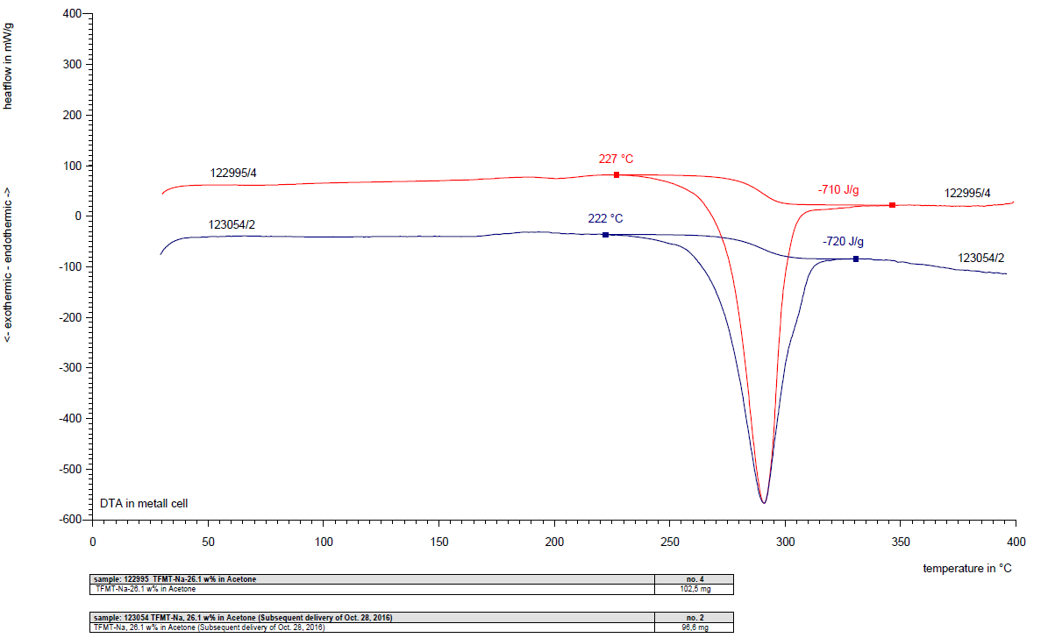

Heatflow in mW/g

Temperature in °C

Figure 1: DSC diagram of 26.1 % solution of TFMT-Na in acetone

3.4 Stack test : Test 6 (b)

3.5 : Waived according to section 16.2.2 (b) (ii) UN Manual of Tests and Criteria (UN-MTC)

3.6 Answer : No

3.7 Exit : Go to Box 34

**4. Boxes 34-38**

4.1 Burning rate test (external fire): acc. to section 51.4 UN-MTC /

External fire (bonfire) test Test 6 (c)

4.2 Sample & test conditions : Ambient temperature; 30 % solution of TFMT-Na in acetone; 50 kg package (1H1) on wooden pallet; wooden slats and intermediate wood wool soaked with mixture of gasoline and light fuel oil

4.3 Observations: : Slow burning, no fragmentation, little smoke

Burning time: First test: 27.0 min; rate 1.8 kg/min

Second test: 24.5 min; rate 2.0 kg/min



Figure 2: Burning rate test  
of TFMT-Na in acetone:

No fireball / jet / fiery projection

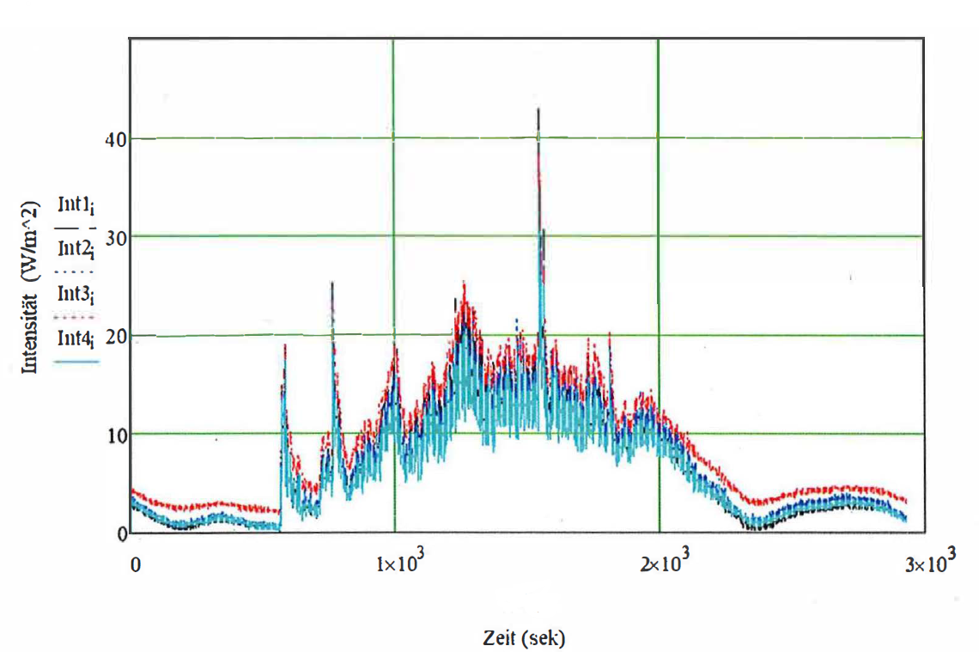

Intensity in W/m2

Time in s

Figure 3: Heat radiation during burning rate test

4.4 Corrected burning rate for

a quantity of 10000 kg : First test: Ac = 35 kg/min

Second test: Ac = 41 kg/min

In GHS: Desensitized Explosive, Cat. 4. (see UN-MTC, section 51.4.4.2)

**5** **Box 34** : Is the major hazard radiant heat and/or violent burning but with no dangerous blast or projection hazard?

5.1 Answer : No

5.2 Exit : Go to Box 35

**6 Box 35** : Would the hazard hinder fire-fighting in the immediate vicinity?

6.1 Answer : No

6.2 Exit : Go to Box 36

**7** **Box 36** : Does special provision 347 apply?

7.1 Answer : No

7.2 Exit : Go to Box 38

**8 Box 38** : Is the substance or article manufactured with the view of producing a practical explosive or pyrotechnic effect?

8.1 Answer : No

8.2 Exit : Go to Box 24

**9 Box 24 (Conclusion)** : NOT AN EXPLOSIVE

Annex VI

Data sheet to be submitted to the United Nations for new or amended classification of substances

Submitted by Cefic Date: March 17, 2022

Supply all relevant information including sources of basic classification data. Data should relate to the product in the form to be transported. State test methods. Answer all questions ‑ if necessary, state “not known” or “not applicable” ‑ If data is not available in the form requested, provide what is available with details. Delete inappropriate words.

**Section 1. SUBSTANCE IDENTITY**

1.1 Chemical name 5-Trifluoromethyltetrazole, sodium salt (TFMT-Na) in Acetone

1.2 Chemical formula C2N4F3Na



1.3 Other names/synonyms Sodium-5-trifluormethyl-1H-tetrazolate in Acetone

1.4.1 UN number 1.4.2 CAS number 1702-15-4

1.5 Proposed classification for the Recommendations

1.5.1 proper shipping name (3.1.2[[2]](#footnote-3)1) TRIFLUOROMETHYLTETRAZOLE-SODIUM SALT IN ACETONE, with not less than 68 % acetone, by mass

1.5.2 class/division 3 subsidiary risk(s)

packing group I

1.5.3 proposed special provisions, if any: SP 28, SP 132, SP 266 (see proposal)

1.5.4 proposed packing instruction(s): New PXXX suggested, see proposal.

**Section 2. PHYSICAL PROPERTIES**

2.1 Melting point or range: below -95 °C (acetone)

2.2 Boiling point or range 56 °C (acetone)

2.3 Relative density at:

2.3.1 15 °C 0.980 g/ml

2.3.2 20 °C 0.977 g/ml

2.3.3 30 °C 0.955 g/ml

2.4 Vapour pressure at:

2.4.1 50 °C 80 kPa

2.4.2 65 °C n/a

2.5 Viscosity at 20 °C**[[3]](#footnote-4)** 0.917 mPas

2.6 Solubility in water at 20 °C: completely miscible;  
solubility in acetone: 53 % (w/w) TFMT-Na in acetone (saturated)

2.7 Physical state at 20°C (2.2.1.1**1**) liquid**2**

2.8 Appearance at normal transport temperatures, including colour and odour:

Colourless liquid, smell of acetone

2.9 Other relevant physical properties: n/a

**Section 3. FLAMMABILITY**

3.1 Flammable vapour

3.1.1 Flash point (2.3.3**1**): -18 °C (closed cup)

3.1.2 Is combustion sustained? (2.3.1.3**1**) yes

3.2 Autoignition temperature: 465 °C

3.3 Flammability range (LEL/UEL): 2.5 – 14.3 Vol%

3.4 Is the substance a flammable solid? (2.4.2**[[4]](#footnote-5)1**) no

3.4.1 If yes, give details

**Section 4. CHEMICAL PROPERTIES**

4.1 Does the substance require inhibition/stabilization or other treatment such as nitrogen blanket to prevent hazardous reactivity? no

If yes, state:

4.1.1 Inhibitor/stabilizer used n/a

4.1.2 Alternative method n/a

4.1.3 Time effective at 55 °C n/a

4.1.4 Conditions rendering it ineffective n/a

4.2 Is the substance an explosive according to paragraph 2.1.1.1? (2.1**1**) no

4.2.1 If yes, give details n/a

4.3 Is the substance a desensitized explosive? (2.4.2.4**1**) yes

4.3.1 If yes, give details: Dry TFMT-Na is provisionally accepted in the Class of Explosives based on test results (see attached report for details).

The solution in acetone passes Test Series 2 and Test Series 6, and is therefore not to be classified as explosive; see test report.

4.4 Is the substance a self-reactive substance? (2.4.1**1**) no

If yes, state:

4.4.1 exit box of flow chart n/a

What is the self-accelerating decomposition temperature (SADT) for a 50 kg package? °C

Is the temperature control required? (2.4.2.3.4**1**) no

4.4.2 proposed control temperature for a 50 kg package °C

4.4.3 proposed emergency temperature for a 50 kg package °C

4.5 Is the substance pyrophoric? (2.4.3**1**) no

4.5.1 If yes, give details

4.6 Is the substance liable to self-heating? (2.4.3**[[5]](#footnote-6)1**) no

4.6.1 If yes, give details

4.7 Is the substance an organic peroxide (2.5.1**1**) no

If yes state:

4.7.1 exit box of flow chart n/a

What is the self-accelerating decomposition temperature (SADT) for a 50 kg package? °C

Is temperature control required? (2.5.3.4.1**1**) no

4.7.2 proposed control temperature for a 50 kg package °C

4.7.3 proposed emergency temperature for a 50 kg package °C

4.8 Does the substance in contact with water emit flammable gases? (2.4.4**1**) no

4.8.1 If yes, give details

4.9 Does the substance have oxidizing properties (2.5.1**1**) no

4.9.1 If yes, give details

4.10 Corrosivity (2.8**1**) to:

4.10.1 mild steel n/a mm/year at °C

4.10.2 aluminium n/a mm/year at °C

No corrosivity expected due to chemical structure

4.10.3 other packaging materials (specify)

n/a mm/year at °C

mm/year at °C

4.11 Other relevant chemical properties n/a

**Section 5. HARMFUL BIOLOGICAL EFFECTS**

5.1 LD50, oral (2.6.2.1.1**[[6]](#footnote-7)1**) mg/kg Animal species

5.2 LD50, dermal (2.6.2.1.2**1**) mg/kg Animal species

5.3 LC50, inhalation (2.6.2.1.3**1**) mg/litre Exposure time hours

or ml/m3 Animal species

5.4 Saturated vapour concentration at 20 °C (2.6.2.2.4.3**1**) ml/m3

5.5 Skin exposure (2.8**1**) results Exposure time hours/minutes

Animal species

5.6 Other data

5.7 Human experience

**Section 6. SUPPLEMENTARY INFORMATION**

6.1 Recommended emergency action

6.1.1 Fire (include suitable and unsuitable extinguishing agents)

Suitable extinguishing media: Water spray jet, alcohol resistant foam, extinguishing powder, carbon dioxide (CO2);

Unsuitable media: Full water jet.

6.1.2 Spillage: Dilute spilled product with water and absorb with liquid-binding material (e.g. sand, diatomaceous earth, universal binding agents). Take up mechanically and place in appropriate containers for disposal. Keep the content of the container wet with water.

6.2 Is it proposed to transport the substance in:

6.2.1 Bulk Containers (6.8**1**) no

6.2.2 Intermediate Bulk Containers (6.5**1**)? no

6.2.3 Portable tanks (6.7**[[7]](#footnote-8)1**)? no

If yes, give details in Sections 7, 8 and/or 9.

**Section 7. BULK CONTAINERS (only complete if yes in 6.2.1)**

7.1 Proposed type(s) n/a

**Section 8. INTERMEDIATE BULK CONTAINERS (IBCs) (only complete if yes in 6.2.2)**

8.1 Proposed type(s) n/a

**Section 9. MULTIMODAL TANK TRANSPORT (only complete if yes in 6.2.3)**

9.1 Description of proposed tank (including IMO tank type if known) n/a

9.2 Minimum test pressure

9.3 Minimum shell thickness

9.4 Details of bottom openings, if any

9.5 Pressure relief arrangements

9.6 Degree of filling

9.7 Unsuitable construction materials

Annex VII

Solubility of TFMT-Na in acetone

1. The solubility data were determined experimentally by concentrating a solution in vacuum until precipitation occurred. The mixture was equilibrated at the set temperature for 24 hours and the concentration in the supernatant liquid determined by the Fluorine-19 nuclear magnetic resonance spectroscopy (19F NMR). Two experimental runs were performed.

2. The result is shown in the table below:

|  |  |  |  |
| --- | --- | --- | --- |
| Temperature [°C] | Series 1 | Series 2 | Average |
| 20 | 45.0 % | 44.8 % | 44.9 % |
| 10 | 42.9 % | 43.2 % | 43.1 % |
| 0 | 41.9 % | 42.0 % | 42.0 % |
| -10 | 41.1 % | 41.1 % | 41.1 % |
| -20 | 40.3 % | 40.8 % | 40.6 % |

3. The average values are plotted in the subsequent graph as a function of temperature:

\_\_\_\_\_\_\_\_\_\_\_\_\_\_

1. A/75/6 (Sect.20), para. 20.51. [↑](#footnote-ref-2)
2. 1 This and similar references are to chapters and paragraphs in the Model Regulations on the Transport of Dangerous Goods. [↑](#footnote-ref-3)
3. *2* See definition of "liquid" in 1.2.1 of the Model Regulations on the Transport of Dangerous Goods. [↑](#footnote-ref-4)
4. *1* This and similar references are to chapters and paragraphs in the Model Regulations on the Transport of Dangerous Goods. [↑](#footnote-ref-5)
5. *1* This and similar references are to chapters and paragraphs in the Model Regulations on the Transport of Dangerous Goods. [↑](#footnote-ref-6)
6. *1* This and similar references are to chapters and paragraphs in the Model Regulations on the Transport of Dangerous Goods. [↑](#footnote-ref-7)
7. *1* This and similar references are to chapters and paragraphs in the Model Regulations on the Transport of Dangerous Goods. [↑](#footnote-ref-8)